1. Write a Python Program to Convert Celsius to Fahrenheit and vice –a-versa.
Code:
cals=int(input("Tempreture in cals :"))
fahr=(cals*1.8)+32
print("Tempreture in fahrenhit : ","%.2f"%fahr)

Output:

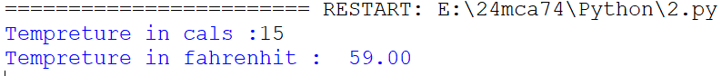

2. Write a python program to swap two variable without using third variable
Code:
a=int(input("Enter first number 1 :"))
b=int(input("Enter second number 2 :"))
print("\n")

print("Entered number 1: ",a)
print("Entered number 2: ",b)

print("\n")
print("swap numbers")
a=a+b
b=a-b
a=a-b
print("a = ",a)
print("b = ",b)

Output:

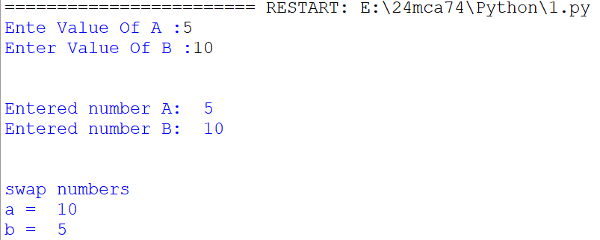
3. Write a Python Program to Convert Decimal to Binary, Octal and Hexadecimal.

Code:
num = int(input('Enter Number : '))
decimal = num
binary = bin(num)
octal = oct(num)
hexadecimal = hex(num)

print("Binary Number : " , binary)
print("Octal Number : " , octal)
print("Decimal Number : " , decimal)
print("Hexadecimal Number : " , hexadecimal)

Output:
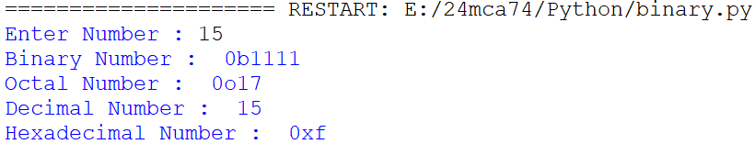

4. Write a program to make a simple calculator (using functions).

Code:
a=int(input("Enter Value Of A: "))
b=int(input("Enter Value Of B: "))

def add(a,b):
print("Addition Is ",a+b)

def sub(a,b):
print("Subtraction Is ",a-b)

def multi(a,b):
print("Multiplication Is ",a*b)

def div(a,b):
print("Division Is ",a/b)

add(a,b)
sub(a,b)
multi(a,b)
div(a,b)

Output:
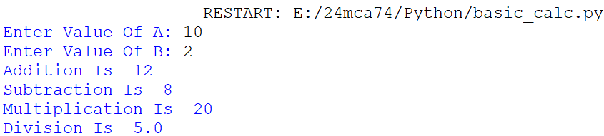

5. Write a program in python to find out maximum and minimum number out of three user entered number.

Code:
a=int(input("Enter first number A :"))
b=int(input("Enter second number B :"))
c=int(input("Enter second number C :"))

#Max
if(a>b and a>c):
print("A is maximum",a)
else:
if(b>c and b>a):
print("B is maximum",b)
else:
print("C is greater",c)

#Min
if(a<b and a<c):
print("A is minimum",a)
elif(b<c and b>a):
print("B is minimum",b)
else:
print("C is minimum",c)

Output:
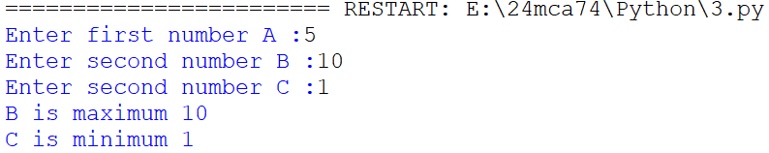

6. Write a program which will allow user to enter 10 numbers and display largest odd number from them. It will display appropriate message in case if no odd number is found.

Code:
i=0
num=0
maximum=0
n=10
while i<n:
num=int(input('Enter Number: '))
if num%2!=0:
if num>maximum:
maximum=num
i+=1
print('Largest Odd number is: ',maximum)

Output:

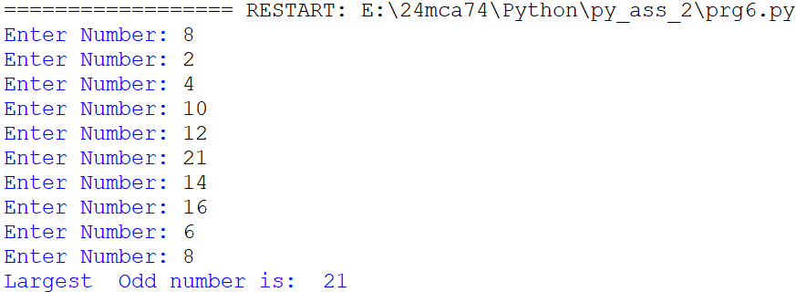

7. Write a Python program to check if the number provided by the user is an Armstrong number.

Code:
num=int(input('Enter the number: '))
sum=0
a=num
while a>0:
digit=a%10
sum += digit **3
if num==sum:
print('number is armstrong',num)
else:
print('num is not armstrong',num)

Output:
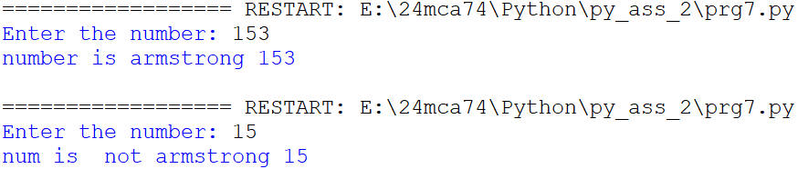

8. Write a Python program to check if the number provided by the user is a palindrome or not.

Code:
n=int(input("Enter number:"))
temp=n
rev=0
while(n>0):
dig=n%10
rev=rev*10+dig
n=n//10
if(temp==rev):
print("The number is a palindrome!")
else:
print("The number isn't a palindrome!")

Output:
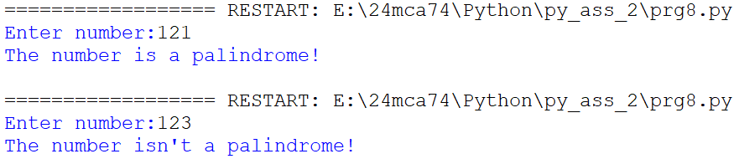

9. Write a Python program to perform following operation on given string input:

a) Count Number of Vowel in given string
Code:
String = input('Enter the string :')
count = 0

String = String.lower()
for i in String:
if i == 'a' or i == 'e' or i == 'i' or i == 'o' or i == 'u':
count+=1

if count == 0:
print('No vowels found')
else:
print('Total vowels are :' + str(count))

Output:

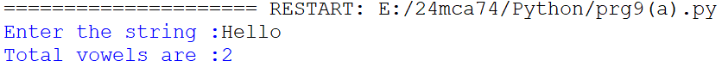

b) Count Length of string (do not use Len ())
Code:
s = input("Enter Any String: ")
l= sum(1 for i in s)
print(l)
Output:

c) Reverse string

Code:
s = input("Enter Any String: ")
rev = s[::-1]
print(rev)

Output:

d) Find and replace operation

Code:
s = input("Enter Any String: ")
select = input("Select Word To Replace: ")
repl=input("Enter Word To Replace: ")

s1 = s.replace(select,repl)
print(s1)

Output:
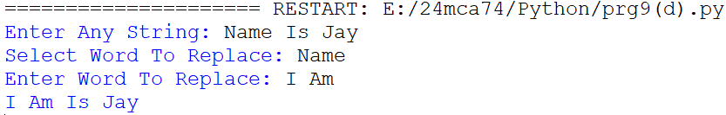

e) Check whether string entered is a palindrome or not

Code:
s = input("Enter Any String: ")

if s == s[::-1]:
print("String Is Palindrome")
else:
print("String Is't Palindrome")

Output:
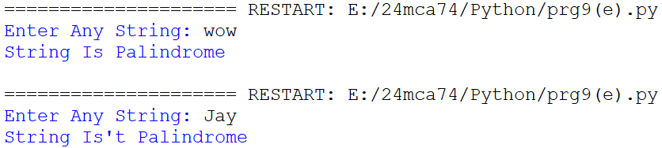

10. Define a procedure histogram () that takes a list of integers and prints a histogram to the screen.
For example, histogram ([4, 9, 7]) should print the following:
****
*********
*******
Code:
def histogram(inputList):
for i in range(len(inputList)):
print (inputList[i]*'*')

List = [5,10,3]
histogram(List)

Output:
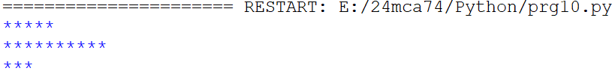

11. Write a program in python to implement Fibonacci series up to user entered number.(Use recursive Function)

Code:
def fibonacci(n):
if n <= 1:
return n
else:
return fibonacci(n - 1) + fibonacci(n - 2)

num = int(input("Enter the number: "))
print("Fibonacci series: ")
for i in range(num):
print(fibonacci(i))

Output:
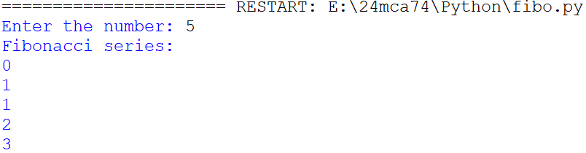

12. Write a program in python to implement Factorial series up to user
entered number. (Use recursive Function)

Code:
def factorial(n):
if n==0 or n==1:
return 1
else:
return(n*factorial(n-1))

number=int(input("ENTER A NUMBER: "))
print("THE FACTORIAL OF ",number," IS ",factorial(number))

output:
