Employee (eid, fname, lname, salary)

1.Use a Cursor for Loop inside a function to calculate and return total paid salary to all employees by the company.

**Create Function:**

CREATE OR REPLACE FUNCTION get_total_salary

RETURN NUMBER

IS

BEGIN

DECLARE

total_salary NUMBER := 0;

CURSOR c1 IS SELECT salary FROM Employee;

BEGIN

FOR c IN c1 LOOP

total_salary := total_salary + c.salary;

END LOOP;

RETURN total_salary;

END;

END get_total_salary;

/

**Function Call:**

**BEGIN**

DBMS_OUTPUT.PUT_LINE('Total salary paid by company: ' || get_total_salary);

END;

/

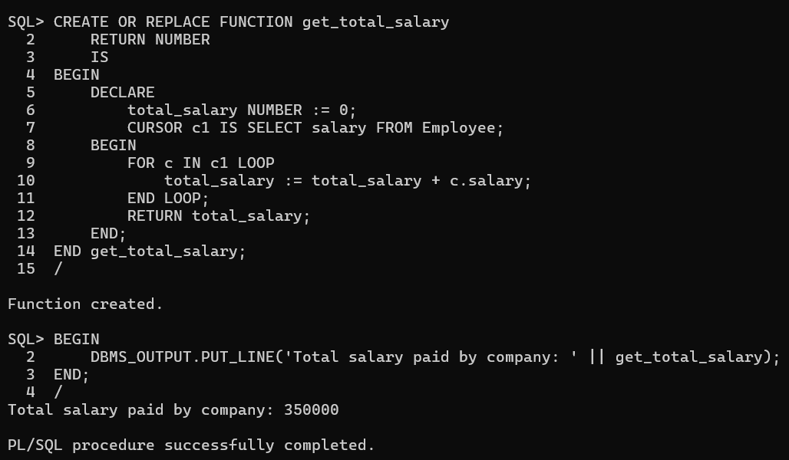

2.Modify the function created above to become a procedure and display the total paid salary from the procedure itself. Instead of calculating for all employees, calculate only for those employees whose name starts from a character passed as parameter to the procedure and hence to the cursor.

**Declare:**

CREATE OR REPLACE PROCEDURE get_total_salary_for_char (p_char VARCHAR2)

IS

total_salary NUMBER := 0;

CURSOR c1 (p_char VARCHAR2) IS

SELECT salary FROM Employee

WHERE fname LIKE p_char ||'%';

BEGIN

FOR c IN c1(p_char) LOOP

total_salary := total_salary + c.salary;

END LOOP;

DBMS_OUTPUT.PUT_LINE('Total salary paid by company for employees whose name starts from ''' || p_char || ''': ' || total_salary);

END get_total_salary_for_char;

/

**Call:**

BEGIN

get_total_salary_for_char('J');

END;

