SET-2

EMPLOYEE (emp_id, emp_name, birth_date, gender, dept_no, address, designation, salary, experience, email)

DEPARTMENT (dept_no, dept_name, location)

1.Create the EMP Table with all necessary constraints such as In EMP TABLE: Employee id should be primary key, Department no should be Foreign key

create table Emp(

emp_id int Primary Key,

emp_name varchar2(25),

birth_date date,

gender varchar2(5),

dept_no int,

Foreign Key (dept_no) References Dept(dept_no)

ON DELETE CASCADE,

address varchar2(50),

designation varchar2(25),

salary int,

experience int,

email varchar2(15)

)

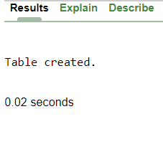

2.Create DEPT table with neccessary constraint such as

3. Department no should be primary key, department name should be unique.

Create table Dept(

dept_no int Primary Key,

dept_name varchar2(6),

location varchar2(6),

UNIQUE (dept_name)

)

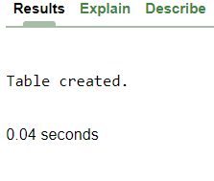

4. modify Employee table by adding the constraints as

5.‘Male’ or ‘Female’ in gender field and display the structure.

alter table Emp add check(gender in ('Male', 'Female', 'Unknown'))

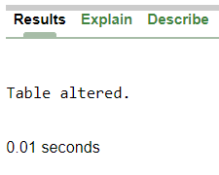

6.Insert proper data (at least 5 appropriate records) in all the tables.

**Employee:**

Insert Into EMP Values(1,'Jay','26-JUL-2002','Male',1,'Surat','Designer',2500,2,'jay26@gmail.com');

Insert Into EMP Values(2,'ABC','09-JAN-2003','Male',1,'Bardoli','Coder',2000,1,'abc@12gmail.com');

Insert Into EMP Values(3,'Riya','11-FEB-2001','Female',4,'Navsari','Manager',4000,3,'riya@gmail.com');

Insert Into EMP Values(4,'Krunal','6-MAY-2000','Male',1,'Surat','Tester',2500,2,'krunal@gmail.com');

Insert Into EMP Values(5,'Mukesh','22-DEC-2001','Male',2,'Valsad','Clerk',5000,4,'mukesh@gmail.com');

Insert Into EMP Values(6,'Axar','05-JUN-2003','Male',3,'Bardoli','Leader',6000,1,'axar02@gmail.com');

**Department:**

Insert Into Dept Values(1,'IT','Surat');

Insert Into Dept Values(2,'Finance','Ahmedabad');

Insert Into Dept Values(3,'Sales','Mumbai');

Insert Into Dept Values(4,'Administration','Bardoli');

Insert Into Dept Values(5,'MBA','Surat');

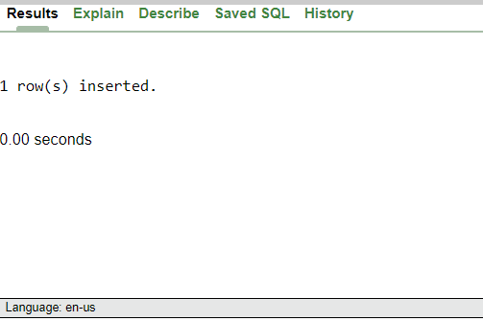

7.Describe the structure of table created

desc Emp

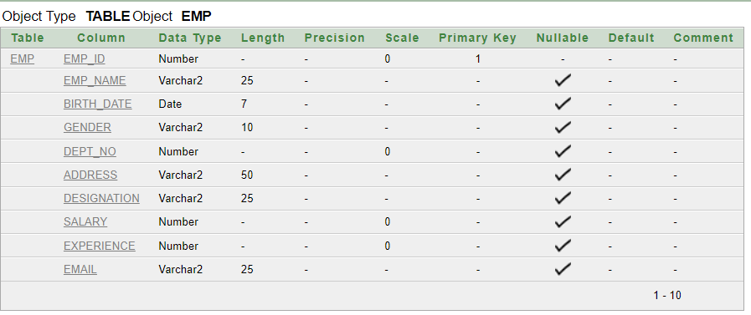

8.List all records of each table in ascending order.

**Department**

select * from dept Order By dept_name asc;

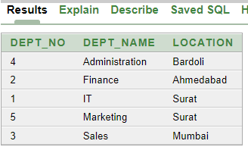

**Employee**

select * from Emp Order By emp_name asc;

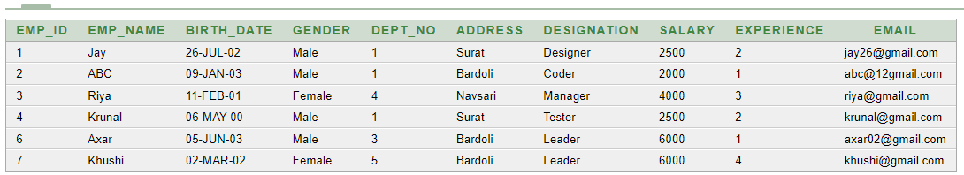

9.Delete the department whose location is Ahmedabad.

delete from Dept where location='Ahmedabad'.

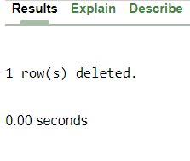

10.Display female employee list

select * from emp where gender='Female'



11.Display Departname wise employee Names

select d.dept_name, e.emp_name from Emp e join Dept d on d.dept_no=e.dept_no

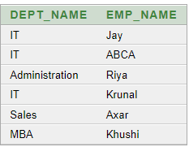

12.Find the names of the employee who has salary less than 5000 and greater than 2000.

select emp_name from Emp where salary <5000 AND salary >2000;

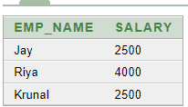

13.Display the names and the designation of all female employee in descending order.

select emp_name,designation from Emp where gender='Female' Order By designation desc.

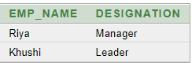

14.Display the names of all the employees who names starts with ‘A’ ends with ‘A’.

select * from Emp where emp_name like 'A%A' ;



15.Find the name of employee and salary for those who had obtain minimum salary.

select emp_name,salary from Emp where salary=(select min(salary) from Emp )



16.Add 10% raise in salary of all employees whose department is ‘IT’.

update employee set salary=salary+(salary*0.10)where dept_no=(select dept_no from department where dept_name='IT');

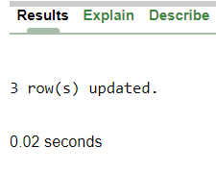 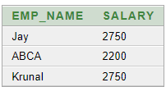

17.Count total number of employees of ‘IT’ department.

select count(*) as count,Dept_name from Emp

inner join Dept on Emp.Dept_no=Dept.dept_no where emp.dept_no=1

group by dept.dept_name



18.List all employees who born in the current month.

select emp_name from emp where to_char(birth_date,'MON')=to_char(sysdate,'MON');



19.Print the record of employee and dept table as “Employee works in department ‘MBA’.

select emp_name||' Works in Department', dept_name from Emp, Dept;

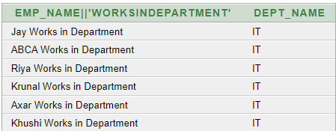

20.List names of employees who are fresher’s (less than 1 year of experience).

select emp_name from emp where experience <1



21.List names of employees who are fresher’s (less than 1 year of experience).

select d.dept_name, e.emp_name from Emp e, Dept d where experience >5 ORDER BY d.dept_name ASC;



22.Crete Sequence to generate department ID

CREATE SEQUENCE sequence_1 start with 1 increment by 1 minvalue 0 maxvalue 100 cycle;

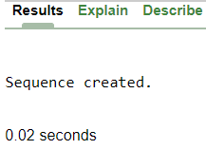

23.List department having no employees

select d.dept_name from Dept d WHERE NOT EXISTS(select * from Emp e where e.dept_no=d.dept_no);

