SET-3

Salesmen table (SNUM, SNAME , CITY , COMMISSION)

Customers (CNUM, CNAME , CITY , RATING , SNUM)

Orders (ONUM, AMOUNT, ODATE, CNUM, SNUM)

1.Write an Insert script for insertion of rows with substitution variables and insert appropriate data.

**Salesmen:**

insert into Salesmen Values(&snum,'&sname','&city',&commission);

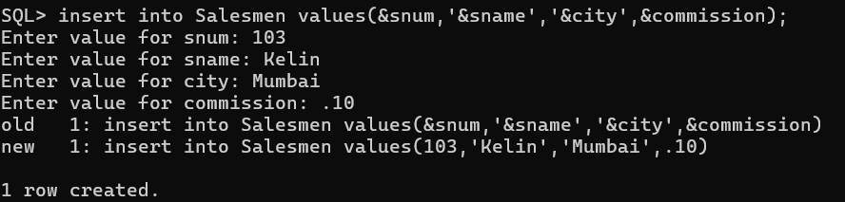

**Customers:**

insert into Customers values(&cnum,'&cname','&city',&rating,&snum);

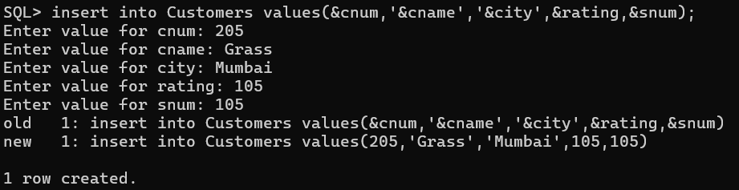

**Orders:**

insert into Orders values(&onum,&amt,’&odate’,&cnum,&snum);

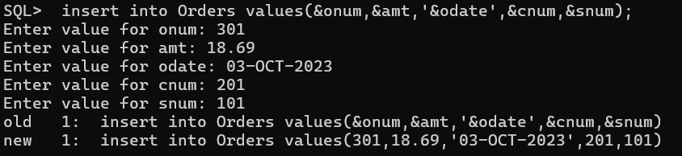

2.Produce the order no, amount and date of all orders

select onum,amount,odate from Orders;

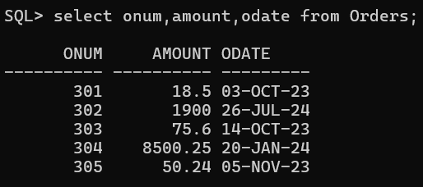

3.Give all the information about all the customers with a specific salesman number

SELECT * FROM customers where snum=101;

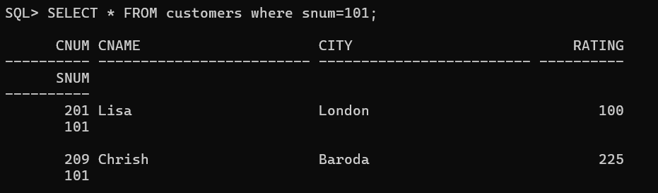

4.Display the following information in the order of city, sname, snum and commission.

select city,snum,sname,commission from Salesmen;

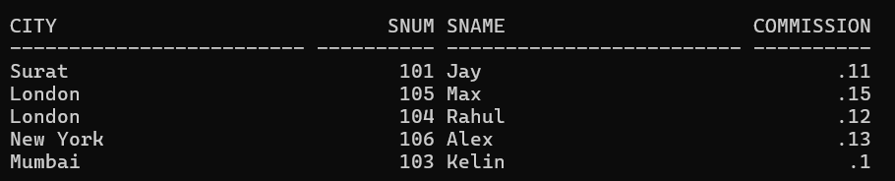

5.List of rating followed by the name of each customer in particular one city.

SELECT rating||' '||cname "employee rating" FROM customers WHERE city='Surat';

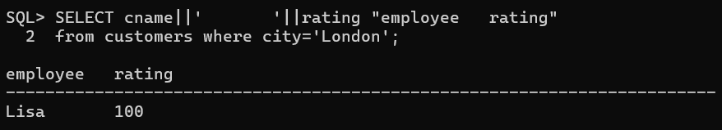

6.List of snum of all salesmen with orders in order table without any duplicates.

SELECT DISTINCT snum, onum FROM Orders ORDER BY snum;

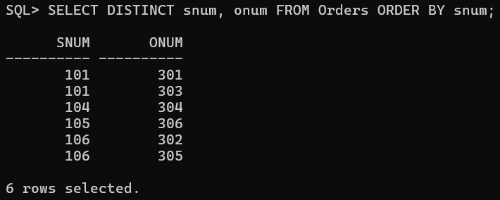

7.List of all orders for more than certain amount e.g. more than Rs. 1000.

Select * from orders where amount>1000;

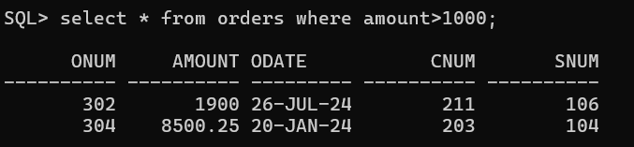

8.List of names and cities of all salesmen in one city.

SELECT sname, city FROM salesmen WHERE city='London' AND commission >.10;

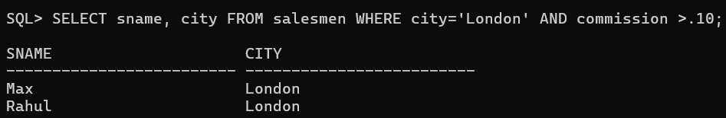

9.List all customers whose names begins with a letter 'C'.

select cname from Customers where cname like 'C%';

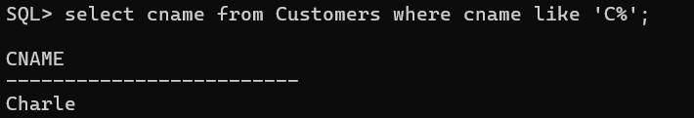

10.List all customers whose names begins with letter 'A' to'G'.

select cname from Customers WHERE cname >= 'A' AND cname <= 'G';

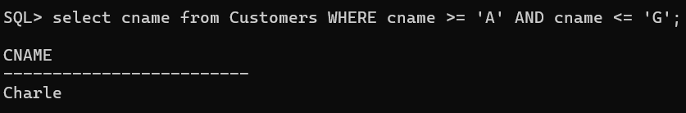

11.List all orders with zero or NULL amount.

select * from Orders where amount=0 || NULL;

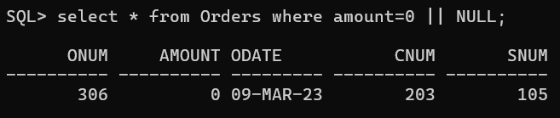

12.Find out the largest orders of salesman from two value

select MAX(amount) from Orders where snum=101 OR snum=106;

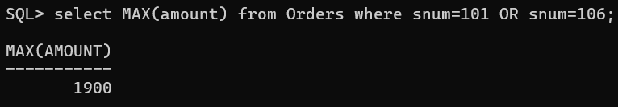

13.Count all orders of particular date

select * from Orders where odate='03-OCT-2023';

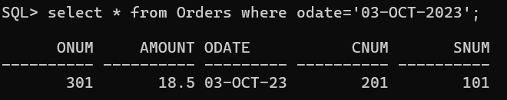

14. Calculate the total amount ordered.

select SUM(amount) from Orders;

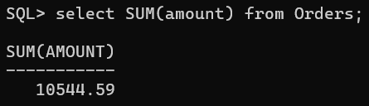

15.Calculate the average amount ordered.

select AVG(amount) from Orders;

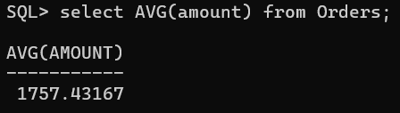

16.Count the no. of salesmen currently having orders.

select * from Orders where amount IS NOT NULL;

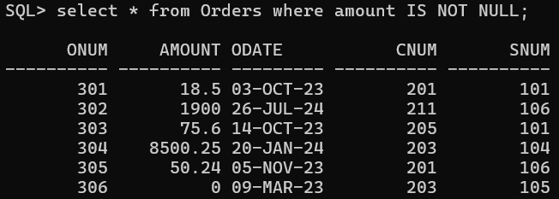

17.List all salesmen with their % of commission.

select sname,commission from Salesmen;

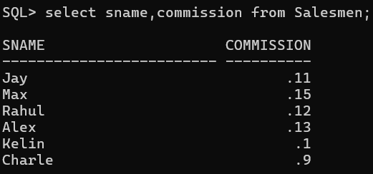

18.Assume each salesperson has a 15% commission. Write a query on the order table that will produce the order number, salesman no and the amount of commission for that order.

SELECT onum, snum, amount, (amount*15)/100 commission FROM orders;

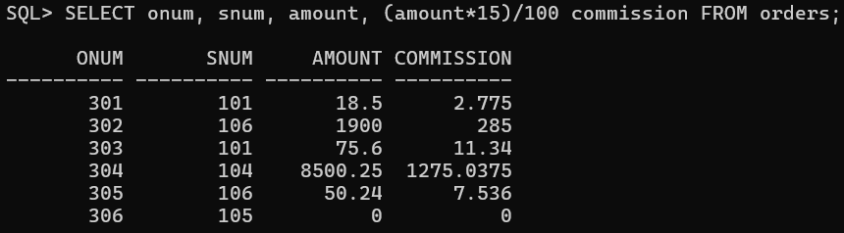

19.Find the highest rating in each city in the form : For the city (city), the highest rating is : (rating).

select city, MAX(rating) from Customers Group By city;

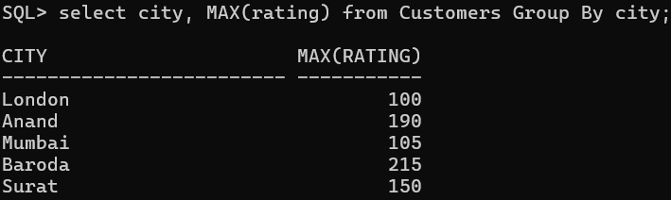

20.List all in descending order of rating.

select rating from Customers order by rating desc;

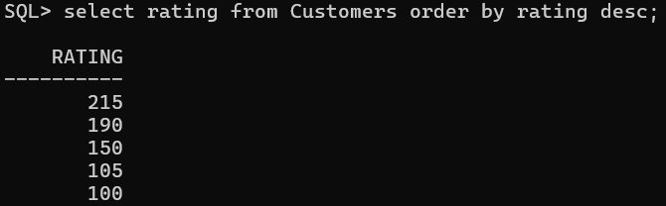

21.Calculate the total of orders for each day and place the result in descending order.

SELECT 'For ', odate, ' there are ', COUNT(*), ' orders' FROM Orders GROUP BY odate ORDER BY odate DESC;

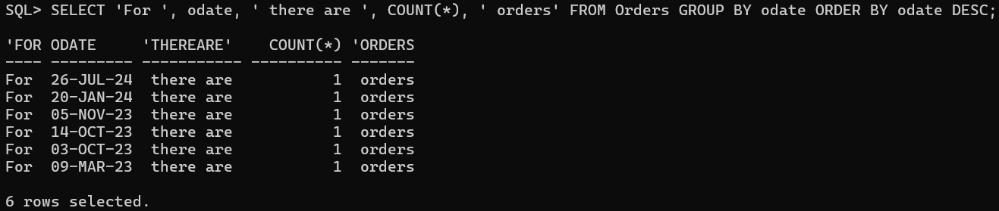

22.Show the name of all customers with their salesman's name.

select c.cname,s.sname from customers c join salesmen s on s.snum=c.snum;

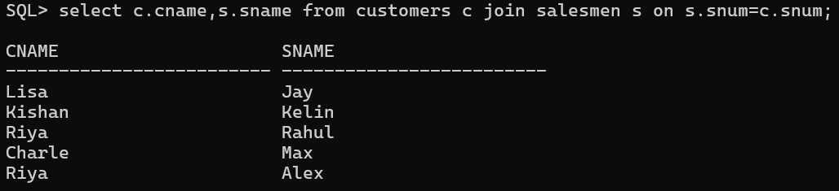

23.List all customers and salesmen who shared a same city.

select c.cname,s.sname from customers c join salesmen s on s.snum=c.snum where s.city=c.city;

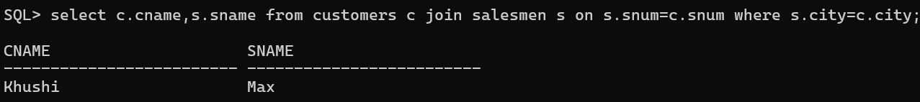

24.List all orders with the names of their customer and salesman.

select c.cname,s.sname from customers c inner join orders o on c.cnum=o.cnum inner join Salesmen s on o.snum=s.snum;

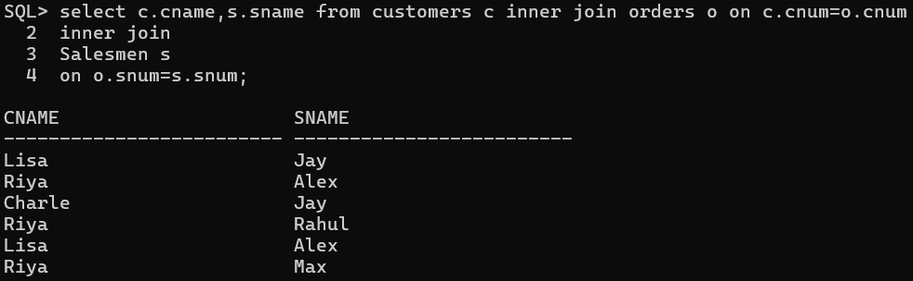

25.List all orders by the customers not located in the same city as their salesman.

select c.cname,s.sname from customers c inner join orders o on c.cnum=o.cnum inner join Salesmen s on o.snum=s.snum where s.city<>c.city;

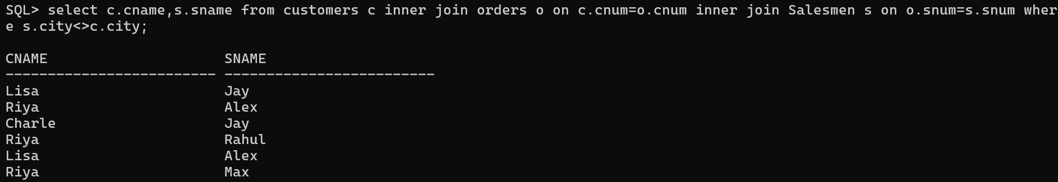

26.List all customers serviced by salespeople with commission above 15%.

select c.cname,s.sname from customers c inner join Salesmen s on c.snum=s.snum where s.commission >= 0.15;

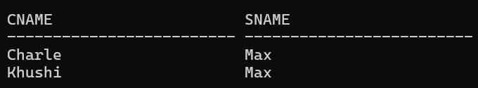

27.Calculate the amount of the salesman commission on each order by a customer with rating above 100.

SELECT amount, commission FROM salesmen JOIN customers using(snum) JOIN orders using(snum) WHERE rating>100;

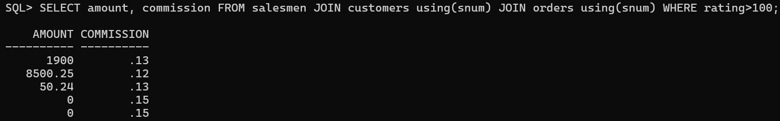

28.Find all pairs of customers having the same rating without duplication.

Select a.cname, b.cname,a.rating from cust a, cust b where a.rating = b.rating and a.cnum != b.cnum

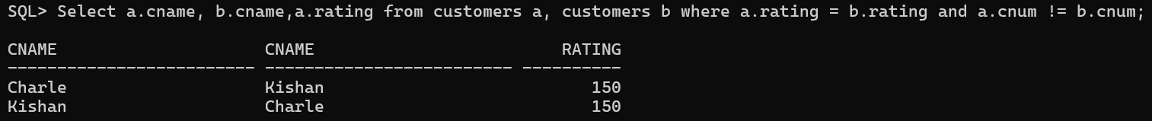

29.List all orders that are greater than the average of October 4,2023.

Select * from orders where amount > ( select avg(amount) from orders where odate='04-OCT-23');

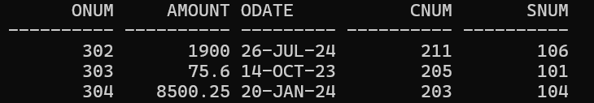

30.Find the average commission of salesmen in London.

select AVG(commission) from Salesmen where city='London';

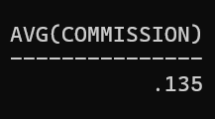

31.Find all orders attributed to salesmen in 'London' using both the subquery and join methods.

select o.onum,o.amount,o.snum,s.city from orders o join salesmen s on o.snum=s.snum where s.city in (select city from salesmen where city='London');

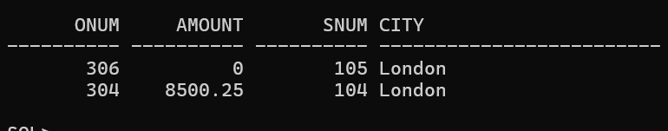

32.List the commission of all salesmen serving customers in 'London'.

select commission from salesmen where snum in(select snum from customers where city='London');

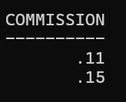

33.Find all customers whose cnum is e.g. 1000 above than the snum of name e.g. Sejal.

select cnum,cname from customers where cnum > (select snum+100 from Salesmen where sname='Jay');

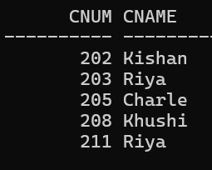

34.Count the no. of customers with the rating above than the average of one city

select cnum,rating from customers where rating > (select AVG(rating) from customers where city='London');

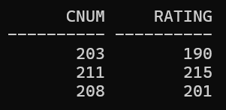

35.Find all salesmen with customers located in their cities using ANY and IN.

**ANY**

select sname from salesmen s where snum=any (select snum from customers c where s.city=c.city and s.snum=c.snum);

**IN**

select sname from salesmen s where snum in (select snum from customers c where s.city=c.city and s.snum=c.snum);

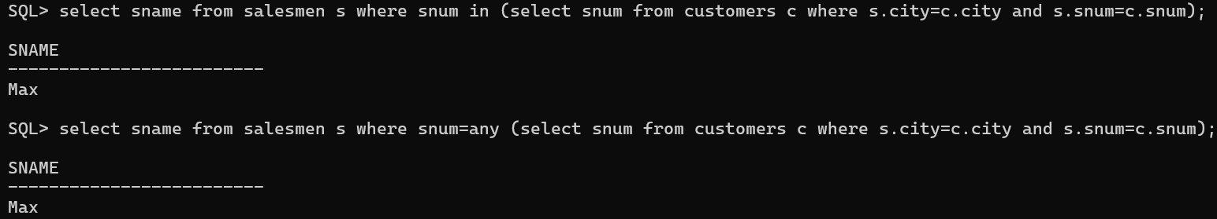

36.Find all salesmen for whom there are customers that follow them in alphabetical order.

select s.sname,c.cname from salesmen s,customers c where s.snum=c.snum order by s.sname asc;

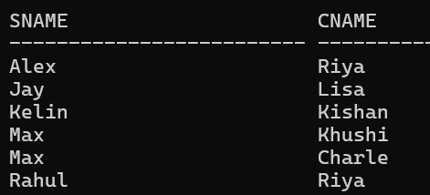

37.Find all customers having rating greater than any customer in particular city.

select c.cname from customers c where city='Baroda' and rating > (select max(rating) from customers where city !='Baroda');

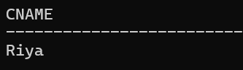

38.List all orders that has amount greater than atleat one of the orders from 6th October, 2023.

select onum,amount from orders where odate !='06-OCT-23' AND amount > (select min(amount) from orders where odate='06-OCT-23');

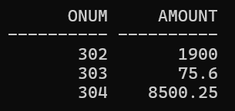

39.Find all orders with amounts smaller than any amount for a customer in 'London'.

select onum,amount from orders where amount < any (select amount from orders o,customers c where city='London' and o.cnum=c.cnum);

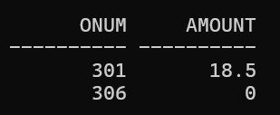

40.Find all the customers who have greater rating than every customer in one city

select cname,city,rating from customers where rating > ALL (select rating from customers where city='Surat');

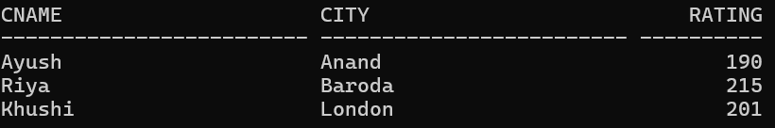

41.Create a union of two queries that shows the names, cities and ratings of all customers. Those with rating of >=200 should display 'HIGH RATING' and those with < 200 should display 'LOW RATING'.

select cname,city,rating,'Higher Rating' from customers where rating >=200

UNION

select cname,city,rating,'Lower Rating' from customers where rating < 200;

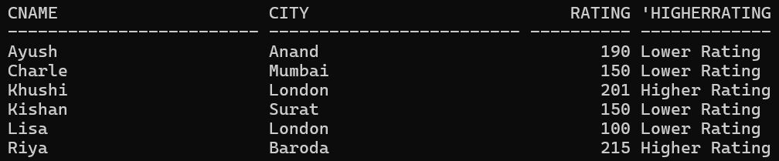

42.Produce the name and number of each salesman and each customer with more than one current order in the alphabetical order of names .

select c.cnum,cname from customers c where 1 < (select Count(*) from orders o where c.cnum=o.cnum)

UNION

select s.snum,s.sname from salesmen s where 1 < (select Count(*) from orders o where s.snum=o.snum) order by 2;

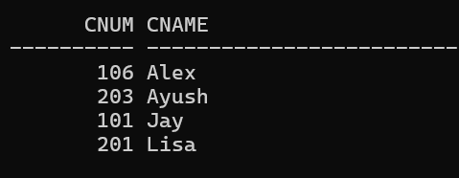

43.Create union of three queries. First select snum of all salesman in Surat, second, the cnum of all customers in 'Surat' and third, the onum of all orders of 3rd Oct. Retain duplicates between the last two queries but remove the duplicates between either of them and the first.

select snum from salesmen where city='Surat'

UNION

select Distinct snum from Orders where snum IN (select snum from Orders where odate like '03-OCT-%');

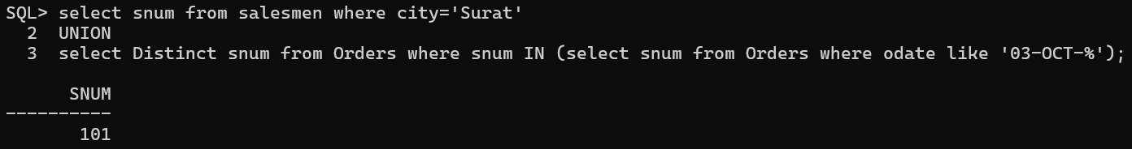

44.Remove all orders from customer Chirag from the orders table.

delete from Orders where cnum IN(Select cnum from customers where cname='Lisa');



45.Set the ratings of all the customers of Piyush to 400.

update customers set rating='400' where snum IN (select snum from Salesmen where sname='Jay');



46.Increase the rating of all customers in Rome by 100.

update customers set rating=rating+100 where cnum IN (select cnum from customers where city='Rome' );

