SET 4

EMP Table:

Create Table EMP(

empno int Primary key,

empnm varchar2(25),

empadd varchar2(50),

salary int,

date_birth date,

joindt date,

deptno int

);

JOB Table:

Create Table JOB(

jobid int Primary key,

type_of_job varchar2(20),

status varchar2(10)

);

ITEMS Table:

Create Table ITEMS(

itemno int Primary Key,

name varchar2(20),

color varchar2(15),

weight varchar2(25)

);

WORKER Table:

Create Table WORKER(

workerid int Primary key,

name varchar2(25),

wage_per_hour varchar2(25),

specialized_in varchar2(25),

manager_id int

);

1. Write a PLSQL block which will print Employee list (Empno and Name) EMP (empno, empnm, empadd, salary, date_birth, joindt, deptno)

DECLARE

CURSOR emp_cursor IS

SELECT empno, empnm FROM EMP;

v_empno EMP.empno%TYPE;

v_empnm EMP.empnm%TYPE;

BEGIN

OPEN emp_cursor;

LOOP

FETCH emp_cursor INTO v_empno, v_empnm;

EXIT WHEN emp_cursor%NOTFOUND;

DBMS_OUTPUT.PUT_LINE('Emp No: ' || v_empno || ', Name: ' || v_empnm);

END LOOP;

CLOSE emp_cursor;

END;

/

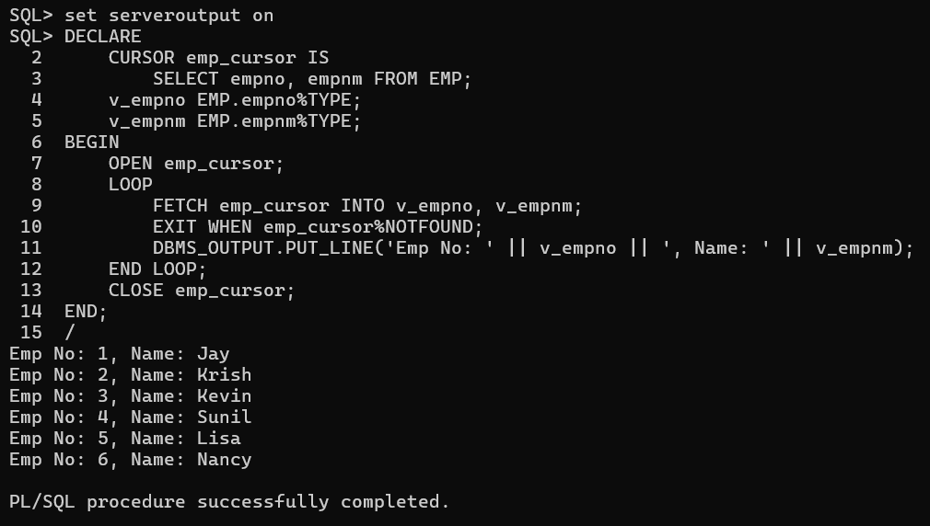

2. Write a function that returns total number of incomplete jobs, using table JOB (jobid, type_of_job, status)

**Function Declaration:**

CREATE OR REPLACE FUNCTION get_incomplete_job_count

RETURN NUMBER

IS

v_count NUMBER;

BEGIN

SELECT COUNT(*) INTO v_count FROM JOB

WHERE status = 'Incomplete';

RETURN v_count;

END;

/

**Function Call :**

BEGIN

DBMS_OUTPUT.PUT_LINE('Number of incomplete jobs: ' || get_incomplete_job_count);

END;

/

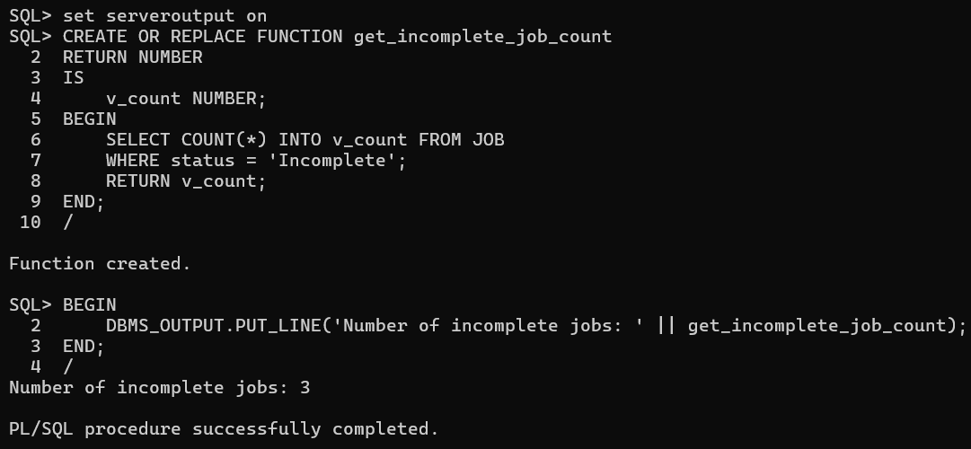

3. Write a function which displays the number of items whose weight fall between a given ranges for a particular color using table ITEM (itemno, name, color, weight)

**Function Declaration:**

CREATE OR REPLACE FUNCTION get_item_count(p_color VARCHAR2, p_min_weight VARCHAR2, p_max_weight VARCHAR2)

RETURN NUMBER

IS

v_count NUMBER;

BEGIN

SELECT COUNT(*) INTO v_count

FROM ITEMS

WHERE color = p_color

AND weight BETWEEN p_min_weight AND p_max_weight;

RETURN v_count;

END;

/

**Function Call:**

BEGIN

DBMS_OUTPUT.PUT_LINE('Number of items with color ''Black'' and weight between 0.1K.g and 2K.g: ' || get_item_count('Black', '0.1kg', '2kg'));

END;

/

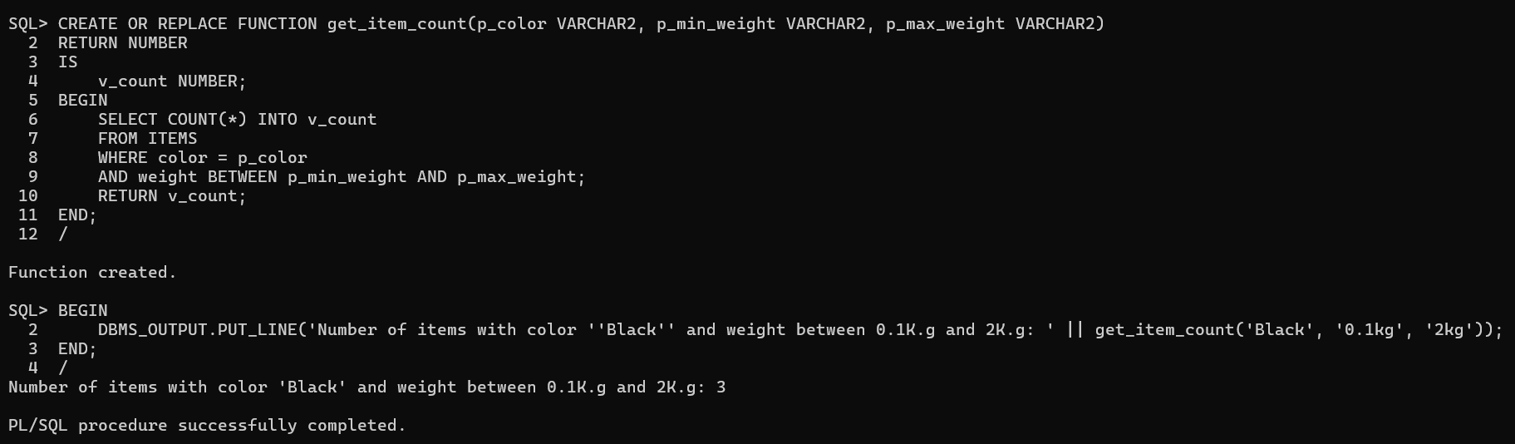

4. Write a procedure to display top five highest paid workers who are specialized in “PAINTING" using table WORKER (workerid, name, wage_per_hour, specialized_in, manager_id)

**Declaration:**

CREATE OR REPLACE PROCEDURE display_painters IS

CURSOR painting_cursor IS

SELECT workerid, name, wage_per_hour

FROM WORKER

WHERE specialized_in = 'Painting'

ORDER BY wage_per_hour DESC;

v_workerid WORKER.workerid%TYPE;

v_name WORKER.name%TYPE;

v_wage_per_hour WORKER.wage_per_hour%TYPE;

BEGIN

OPEN painting_cursor;

LOOP

FETCH painting_cursor INTO v_workerid, v_name, v_wage_per_hour;

EXIT WHEN painting_cursor%ROWCOUNT > 5 OR painting_cursor%NOTFOUND;

DBMS_OUTPUT.PUT_LINE('Worker ID: ' || v_workerid || ', Name: ' || v_name || ', Wage per Hour: ' || v_wage_per_hour);

END LOOP;

CLOSE painting_cursor;

END;

/

**Run Script:**

BEGIN

display_painters;

END;

/

