SET-5

APPLICANT (AID, ANAME, ADDR, ABIRTH_DT)

ENTRANCE_TEST (ETID, ETNAME, MAX_SCORE, CUT_SCORE)

ETEST_CENTRE (ETCID, LOCATION, INCHARGE, CAPACITY)

ETEST_DETAILS (AID, ETID, ETCID, ETEST_DT, SCORE)

1. Modify the APPLICANT table so that every applicant id has an ‘A’ before its value. E.g. if value is ‘1123’, it should become ‘A1123.

alter table applicant add check (aid like 'A%');

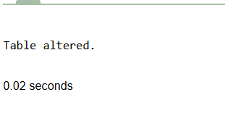

2. Display test center details where no tests were conducted.

select * from etest_center

where etcid not in (select etcid from etest_details group by etcid);

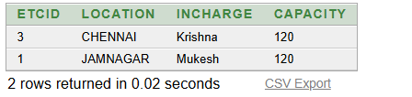

3. Display details about applicants who have the same score as that of Ajaykumar in ‘ORACLE FUNDAMENTALS’.

SELECT * FROM applicant a, etest_details e

WHERE a.aid = e.aid AND score IN(

SELECT e.score FROM applicant a, etest_details e,entrance_test e2

WHERE a.aid = e.aid AND e2.ETID = e.etid AND a.aname LIKE

'Sumit' AND e2.ETNAME LIKE 'GCET');

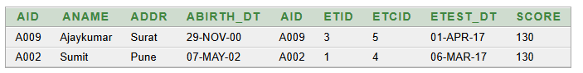

4. Display details of applicants who appeared for all tests.

SELECT a.aname,a.aid FROM applicant a WHERE a.aid IN(

SELECT aid FROM etest_details GROUP BY aid HAVING COUNT(aid) =(

SELECT COUNT(*) FROM( SELECT etid FROM etest_details GROUP BY ETID ))

);



5.Display those tests where no applicant has failed.

SELECT * FROM entrance_test WHERE etid NOT IN(

SELECT ed.etid FROM etest_details ed, entrance_test et

WHERE ed.etid = et.etid AND score < cut_score

);

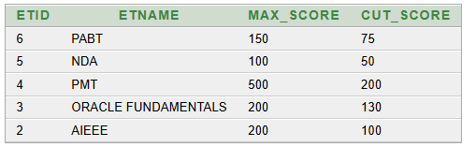

7. Display details of the applicants who scored more than the cut score in the tests they appeared in.

Select ed.etid,cut_score,score from etest_details ed, entrance_test et

where ed.etid=et.etid and score>cut_score

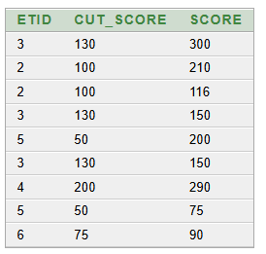

8. Display average and maximum score test wise of tests conducted at Mumbai.

select max(ed.score) "MAX", avg(ed.score) "AVG" from etest_details ed, etest_center et

where et.location='DELHI' and et.etcid=ed.etcid group by ed.etid;

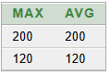

9. Display the number of applicants who have appeared for each test, test center wise

select ed.etid,ed.etcid,count(aid) from etest_details ed

group by ed.etid,ed.etcid order by etid;

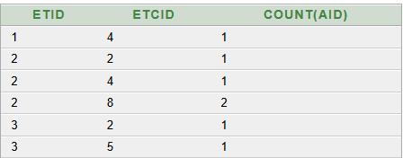

10. Display details about test centers where no tests have been conducted.

SELECT * FROM etest_center

WHERE etcid NOT IN( SELECT etcid FROM etest_details);

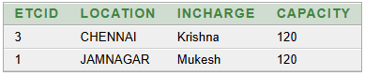

11. For tests, which have been conducted between 2-3-17 and 23-4-17, show details of the tests as well as the test Centre.

SELECT ed.etid, et.etname, et.max_score, et.cut_score, ec.etcid, ec.location, ec.incharge, ec.capacity FROM etest_details ed, entrance_test et,

etest_center ec

WHERE etest_dt > '2-MAR-2017' AND etest_dt < '23-APR-2017' AND et.etid = ed.etid AND ec.etcid = ed.etcid;

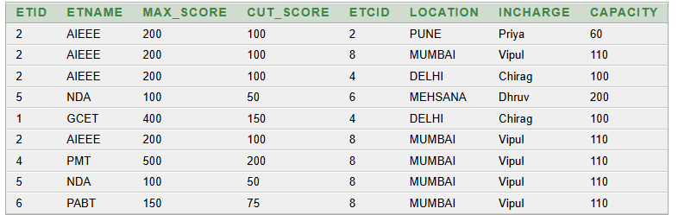

12. How many applicants appeared in the ‘ORACLE FUNDAMENTALS’ test at Chennai in the month of February ?

SELECT et.etname,COUNT(*) "No Of Applicant in CHENNAI" FROM etest_details ed, etest_center ec, entrance_test et

WHERE to_char(etest_dt,'MON')='FEB' AND ec.location='CHENNAI' AND ec.etcid=ed.etcid AND et.etid=ed.etid AND et.etname='ORACLE FUNDAMENTALS' GROUP BY et.etname;



13. Display details about applicants who appeared for tests in the same month as the month in which they were born

select * from APPLICANT a , etest_details e where a.aid = e.aid and to_char(e.ETEST_DT,'MON') = to_char(a.abirth_dt,'MON') ;

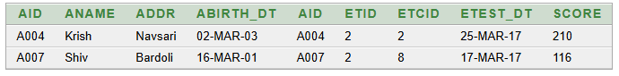

14. Display the details about APPLICANTS who have scored the highest in each test, test centre wise.

SELECT ed.etid,ec.location, ed.aid, MAX(ed.score) FROM etest_details ed, etest_center ec

WHERE ec.etcid = ed.etcid GROUP BY ed.etid, ed.aid, ec.location ORDER BY ed.etid;

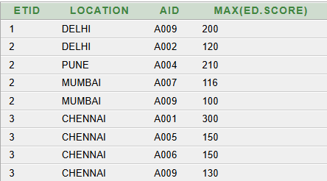

15. Display the details about APPLICANTS who have scored the highest in each test, test centre wise.

CREATE VIEW set_5 AS SELECT a.aid, aname, et.etid, et.etname FROM applicant a, etest_details ed, entrance_test et

WHERE a.aid = ed.aid AND et.etid = ed.etid WITH READ ONLY

