SET-7

CUSTOMER (cid, fname, lname, city, country, phone)

CREATE TABLE CUSTOMER

(

cid NUMBER PRIMARY KEY,

fname VARCHAR2(20),

lname VARCHAR2(20),

city VARCHAR2(20),

country VARCHAR2(20),

phone VARCHAR2(15)

);

ORDER (oid, oDate, oNumber, cid, oTotalAmount)

CREATE TABLE ORDERS

(

oid NUMBER PRIMARY KEY,

cid NUMBER,

oDate DATE,

oTotalAmount NUMBER,

FOREIGN KEY (cid) REFERENCES CUSTOMER(cid)

);

1.List the number of customers in each country. Only include countries with more than 100 customers.

SELECT country, COUNT(*) AS customer_count FROM CUSTOMER

GROUP BY country HAVING COUNT(*) > 10;

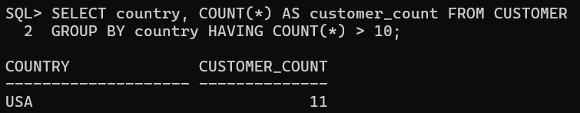

2.List the number of customers in each country, except China, sorted high to low. Only include countries with 5 or more customers.

SELECT country, COUNT(*) AS customer_count FROM CUSTOMER

WHERE country <> 'China'

GROUP BY country

HAVING COUNT(*) >= 5

ORDER BY customer_count DESC;

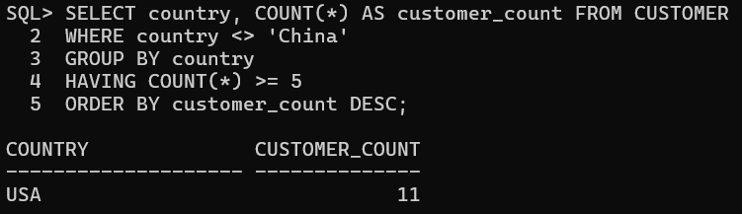

3.List all customers with average orders between Rs.5000 and Rs.6500.

SELECT cid, fname, lname FROM CUSTOMER

WHERE cid IN ( SELECT cid FROM ORDERS

GROUP BY cid

HAVING AVG(oTotalAmount) BETWEEN 5000 AND 6500

);

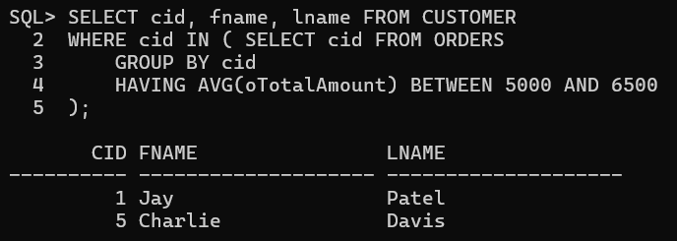

4.Create a trigger that executes whenever country is updated in CUSTOMER table.

CREATE OR REPLACE TRIGGER country_update_trigger

AFTER UPDATE OF country ON CUSTOMER

FOR EACH ROW

BEGIN

IF :NEW.country != :OLD.country THEN

DBMS_OUTPUT.PUT_LINE('Country updated for customer ID: ' || :OLD.cid);

END IF;

END;

/

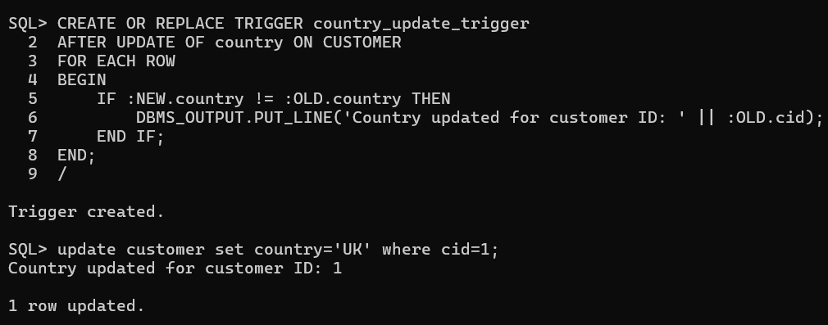

5.Create a function to return customer with maximum orders.

**Declaration:**

CREATE OR REPLACE FUNCTION get_customer_with_max_orders

RETURN VARCHAR2 IS

customer_name VARCHAR2(100);

BEGIN

SELECT fname || ' ' || lname INTO customer_name

FROM CUSTOMER

WHERE cid = (

SELECT cid

FROM (

SELECT cid, COUNT(*) AS order_count FROM ORDERS

GROUP BY cid

ORDER BY order_count DESC

)

WHERE ROWNUM = 1

);

RETURN customer_name;

END;

**Function Call:**

BEGIN

DBMS_OUTPUT.PUT_LINE(get_customer_with_max_orders);

END;

/

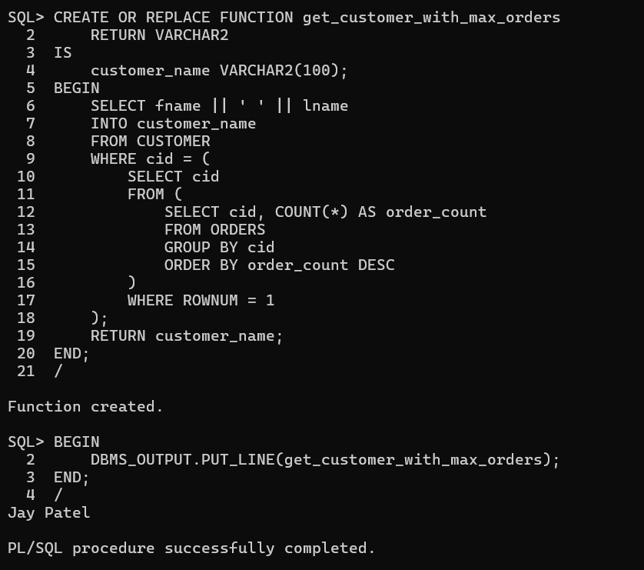

6.Create a procedure to display month names of dates of ORDER table. The month names should be unique.

**Procedure Create:**

CREATE PROCEDURE display_unique_month IS

CURSOR month_cursor IS

SELECT DISTINCT TO_CHAR(oDate, 'Month') AS month_name

FROM ORDERS;

BEGIN

FOR month_record IN month_cursor LOOP

DBMS_OUTPUT.PUT_LINE('Month: ' || month_record.month_name);

END LOOP;

END;

**Call Procedure:**

BEGIN

display_unique_month;

END;

