Set-1

DEPARTMENT (dept_no, dept_name, location)

1.Create the Simple DEPARTMENT Table.

create table Department(

dept_no int,

dept_name varchar2(25),

location varchar2(25)

);

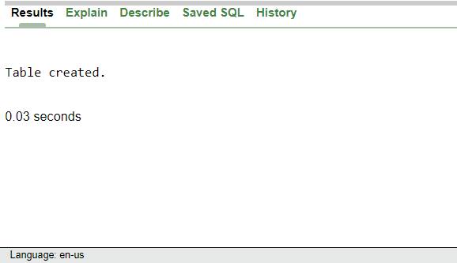

2.Display structure of department table.

DESC Department;

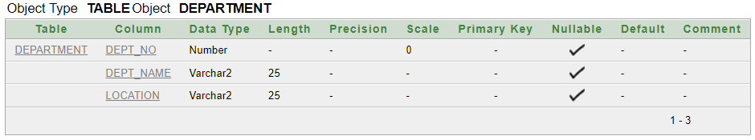

3.Insert below records into Department Table.

Insert into Department Values(10,'Account','NY');

Insert into Department Values(20,'HR','NY');

Insert into Department Values(30,'Production','DL');

Insert into Department Values(40,'Sales','NY');

Insert into Department Values(50,'EDP','MU');

Insert into Department Values(60,'TRG','');

Insert into Department Values(110,'RND','AH');

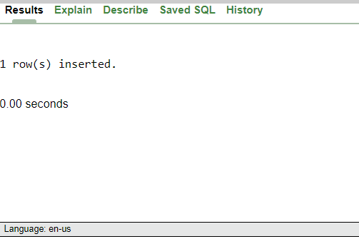

4.Display all records of Department table.

Select * from Department;

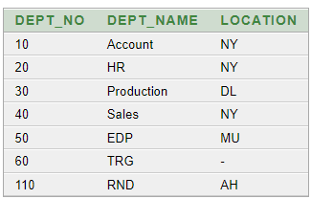

5.Display all department belonging to location 'NY' .

select dept_name from Department where location='NY'

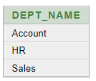

6.Display details of Department 10

select * from Department where dept_no=10



7.List all department names starting with 'A'

select dept_name from Department Where dept_name like 'A%';



8.List all departments whose number is between 1 and 100

select dept_name from Department Where dept_no between 1 and 100;

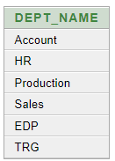

9.Delete 'TRG' department

Delete from Department where dept_name=’TRG’;

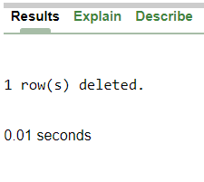

10. Change department name 'EDP' to 'IT

update Department set dept_name='IT' where dept_name='EDP'

