System
- elements are: a) components, b) attributes, and c) relationships; alter either energy, information or materials; can be either natural, or man-made; can be either physical or conceptual; are typically static or dynamic; set of interrelated components
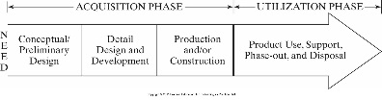
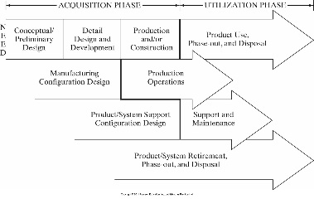
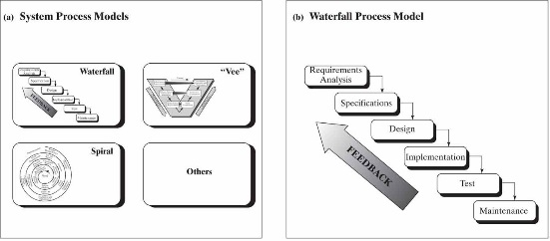
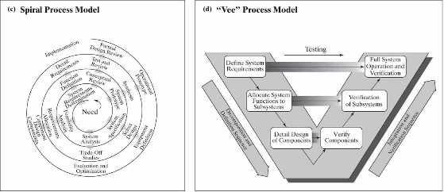
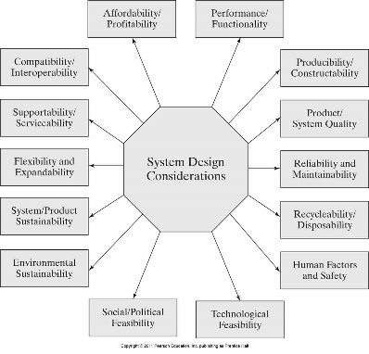
Problem statement
- [relatively] non-technical
- Uses “language” of customer
- Non-complex
Q’s to get well-made prob. stmt.
- Q the customer
- Differentiate their needs and wants
- Explore project boundaries
- Do I/O analysis
- Preview user interface
- Survey design attributes
- Identify conflicting needs
- Prepare draft operations manual
Sections of prob. stmt.
- Background/overview
- Overall design [not detailed]
- Deliverables
Prob. stmt. defines
- Who, what, why (insight)
Chars. of good prob. stmt.
- Short, avoids defining soln., not short list of reqs.
- Captures essence of prob./ need, includes qual. & quant.
Needs analysis
- When, what (sys. do & primary & secondary functions), where, how often?
Operational Requirements
- Mission def, environ. factors, oper. lifetime/deployment, utilization reqs. (freq. of use, hrs. of oper., capacity), perf. params. (mass, volume, range, velocity), effectiveness (MTBM, MDT, MTBF)
Identifying Technical Measures (TMPs)
- Quantitative values describe performances that stem from op. reqs., are Design Dependent Parameters (DDP) [e.g., MTBF, MTTR, MDT, MTBM, etc.], include weight, envelope, availability to perform/function as designed
Quality Function Deployment (QFD)
- (Dated) method to identify & capture prime desires of customer
- Uses cross-referenced matrices to perform comparisons of technical & design features resulting in weighted values for TMPs
- Goal: identify what customer wants, predict: how good/service/process will satisfy customer wants, relate: cust. wants to sys. hows, evaluate: importance ratings/values, compare: performance to desirable TPMs
- Leads designers into preliminary design phase, paves way for functional req. devel. (FFBDs), allows for functional allocation by partitioning major sys. elems., permits ident. of HW & SW items that multiple functions -> simplify overall sys. arch.
System Design Flow
- Abstract notion -> systemic form/function -> repeatable, producible system/product
- 4 design stages: concept.; system; prelim; critical (w/reviews)
- Design revs.: formal method of checking proposed design, provide common baseline for all project stakeholders, permits solving of any interface issues, creates record of design decisions & rationale, leads to greater prob. of a mature design for when production starts
- Reduces risk associated w/prod. phase w.r.t. meeting reqs.
QFD “House of Quality”
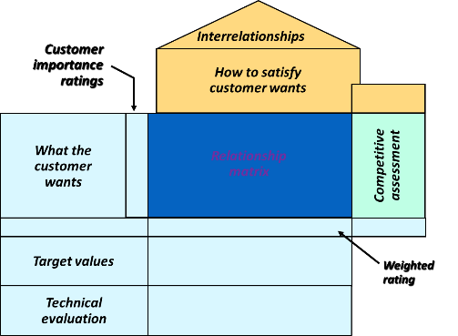
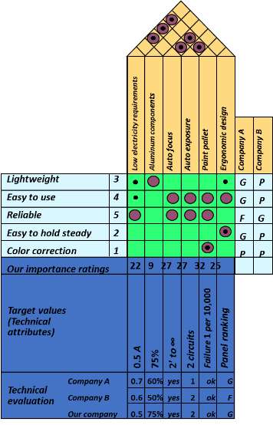
Requirements
- Statement that identifies a capability or function that is needed by a system to satisfy its customer’s needs
- Customer’s needs: solve prob., achieve obj. (cntrct, stanrd, spec)
- 3 sys. eng. Tasks: get reqs; design; verify
- No two sys. are alike but uniform & identifiable process for logically discovering reqs.
- Process is iterative: reqs. emerge throughout sys. life cycle and change, customer: “I’ll know it when I see it”, stakeholder priorities change, low-level -> other reqs. become priority
Functional Requirements
- What, how well, under what conditions one or more inputs must be converted to one or more outputs @ boundary in question to satisfy customer’s needs. Top-level reqs., basis for reqs. mgmt., the “what” of the system, organic/living, increases in complexity/detail as reqs. decomp. progresses
Functional Flow Block Diagram (FFBD)
- Captures functional reqs., time-seq. of operational & support seqs., organized by order of execution, can use Boolean logic
- Benefits: ident. pot. areas for trade study (AOO); dev., analyze, & flow down reqs. to lower levels; provide better pic. of how sys. under dev. is intended to function/work; ident. possible areas for oper. simplification w/in overall system
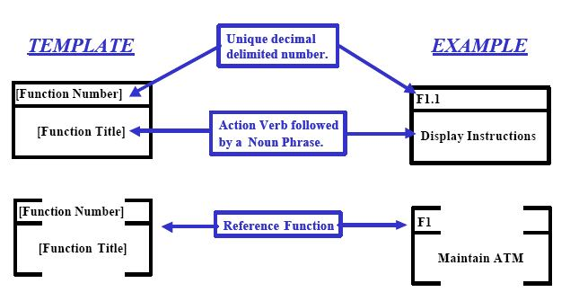
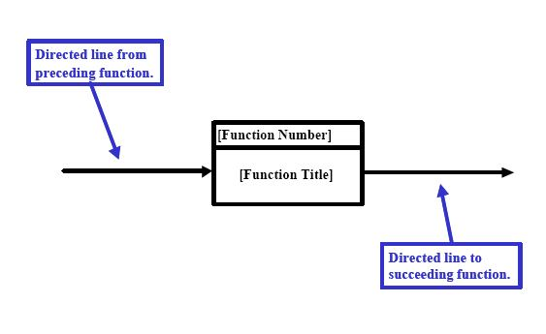
Typical spec. tree/hierarchy
Key Specification Terms
- Hierarchy: order of prec. or import. of each spec. in entire compliment of spec. docs. (us. in tree format); flow down: act of distributing reqs. from higher prec. docs. to lower level -> greater req. detail; traceability: ability to follow interconn. between reqs. w/in partic. spec. & other specs. either higher or lower in prec.; config. mgmt.: process of maint. accurate records & current vers. of all of a prog’s specs., drawings, & key docs.
Standard Specification format
- 1.0: intro, purpose, scope of spec.; 2.0: applicable docs., stds., reference docs; 3.0: spec. reqs.; 4.0: verif. of reqs.; 5.0: packaging/notes, etc.
Example of System Spec. Req.
- GPM shall enable accountants to generate following financial reports:
Feedback summary; fees summary; invoice summary; listings summary; user summary
- GPM will provide following capabilities
Example of Development Spec.
- End-User Characteristics, & General Constraints
Product Specification Example
- Physical and Operational Characteristics:
Performance Reqs.; Safety
Process Specification Example
- Product Mgr.; Project Mgr.; Reqs. Eng.; Developer
Sample Verification Cross-Reference Matrix
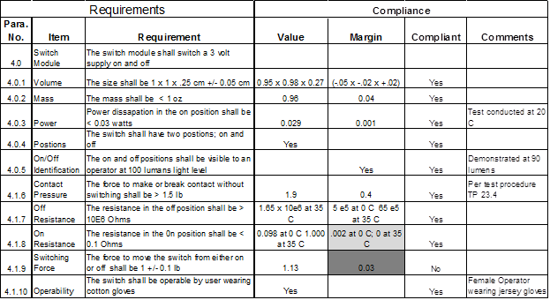
Why Perform a Trade Study?
- Gather & assess possible design sols. for new sys. that one is creating; determine whether to make/buy needed asset/tool/SW app.; methodically eval. attributes & chars. of each pot. design in light of sys.-level reqs.; reduce uncertainty & risk assoc. w/sys. dev.; arrive @ decision as to which pot. design sol. will provide “balanced” approach that results in sys. that’s both realizable & functional
Decision Process Map
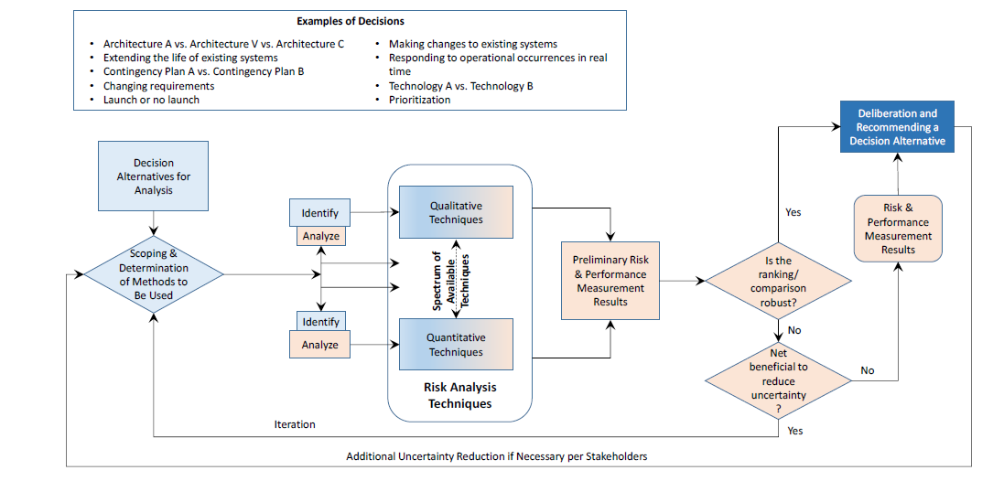
Examples of How Trade Studies Can be Applied
- Choosing how/where to allocated limited resources/budget w/in project; decide whether to proceed to next checkpoint/gate in sys. dev. process; what time to conduct required sys. project revs. (SRR, PDR, etc.); select which risk mgmt. methodology to apply to sig. proj. risks to sys. creation while considering costs, schedule, & tech. perf. of the emerging threat
Means to Conduct a Trade Study
- Qualitative: simplest, easiest; uses ling. descriptors to compare alts./attrs.; downside is possible subjective bias when making comparisons
- Quantitative: pairwise comparisons, decision trees, or AHP; advantage is less prone to analyst bias
Analytic Hierarchy Process (AHP)
- Pairwise comparisons of attr./chars.; uses matrix/lin. alg. to arrive @ opt. choice when considering (Mult.-Crit./Mult.-Alt.) MCMA descisions
- Objective: sits at head of hierarchy; criteria: upon which analysis will be performed (each has weight/importance factor as % & add up to 1); alternatives: different choices
- Info decomposed into hierarchy of alts. & dec. crit. -> rel. rank of alts.; quant. & qual. data can be compared; derive weights & priorities
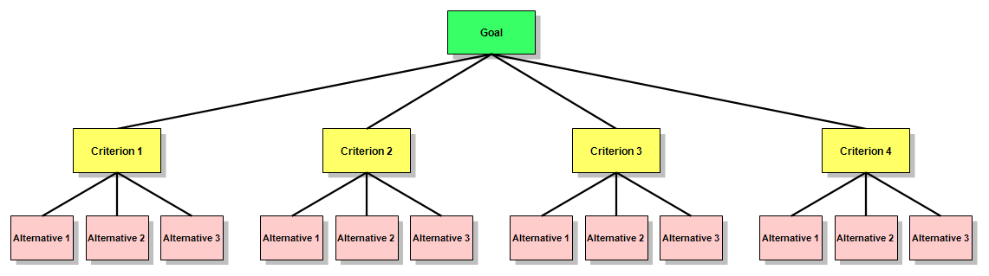
Handling Costs – Diff. From Economic Evaluation Method(s)
- Dangers of including cost as another criterion: political & emotional response? Separate benefits and costs into different hierarchical trees.
- Cost/Benefit eval.: choosing alt. w/best bens./cost ratio. Use RoR/BEP to properly consider decision from a cost POV
System Verification
- Validation: process of confirming that a set of reqs., design, or sys. meets the intent of dev. or cust. (does the sys. meet its req.?). Tends to be oriented toward analysis. Takes place: before design & during detailed design (ideally before Sys. Reqs. Rev.). Important b/c when verifying, want to verify the right reqs. & changing reqs. late neg. impacts cost & schedule. Determines correctness/completeness of end product (ensures actual needs of stakeholders are met)
- Verification: process of confirming that a req. or sys. is compliant (does the sys. meet this req.?). Ensures sys. complies w/sys. reqs. & conforms to its design. Done in Phase D (integration, right leg of Vee diagram). Prelim. Plan for how reqs. will be verified is created when the reqs. are gen by CDR -> prelim. verif. matrix. Reviews precede each key decision point. About confidence.
- Verification matrix specifies: req. statement; any assoc. verif. req. including “successful criteria”; method of verif. (inspection, analysis, demo, test); results of verif. as they become available.
- Verification plan: documents a project’s approach to verification (people, schedule, equip., facilities). Includes sys. qualification, site verification, post-op/disposal verification; needed support equipment
- Methods: inspection, analysis, demo, test (most important)
- Inspection: determine conform. to reqs. by visual exam. of drawings, data, or item using std. qual. ctrl. methods (no spec. lab procs./equip.)
- Analysis: eval. of data by gen. accepted analytic techs. to determine that item will meet reqs. (sys. eng. analysis, statistics, qual. analysis, similarity, sims.). Used when test or demos can’t adequately or cost-effectively address all conditions the sys. must perform can’t be shown to meet reqs. w/o analysis
- Demo: determines conform. to reqs. by operation, adjustment, or reconfig. of test article. Generally verify sys. chars such as human eng. features, services, access feats., transportability. Relies on observing & recording functional op. not requiring use of elab. instrum., spec. test equip., quant. eval of data
- Test: uses tech. means (spec. equip, instrum., sim. techs., etc.). Operation of all/part of sys. under limited set of controlled conditions to determine that quantitative design/perf. reqs are met. Analysis of data from tests shouldn’t be confused with the analysis method. Preferred when: analytic techniques don’t produce adequate res., failure modes exist, any components directly assoc. w/critical sys. interfaces. Space sys. go through rigorous ground-tests to sim. Launch/space evirons.
- Using heritage designs can save development time and money, but they should be validated and verified as if they represented new hardware. Simple procedural errors - like borrowing another project’s bolts - can lead to multi-million-dollar (or life threatening) accidents
Risk Management (RM)
- Risk: uncertain event or condition that, if it occurs, has a + or - effect on at least one project objective, such as time, cost, scope or quality
- Primary risk management processes: identification (stages: candidate, in process, baselined/active, closed/mitigated); assessment/analysis (how significant is this risk? Likelihood & impact. Prob. Impact Diag.); planning/handling (accept, transfer, mitigate, avoid); control (tracking); communication. Fundamental methods of assessment: qual/quant
- Qual. risk assessment: most prevalent form of RM (simple, intuitive, leverages SME knowledge from exp. IPT members). 2 Params: risk consequence; likelihood of occurrence L_{O}). Formula: consq x L_{O}
- Quant. RM (PRA): not use that much. Not meant to manage/determine status of prog. risks. Tool of system of safety and reliability eng. disciplines (predictive tool vs. descry.). Addresses random/probability. Requires sig. knowledge of stats/prob. theory.
- Tools: Monte Carlo Method (MCM) predicts range of outcomes/scenarios using rand. num. algo. to produce Gaussian dist. func., indicating probability of events outcomes
- Risk vs. Issue: risk in future, issue in past
- Acceptance: accept risk & its consequences part of doing business, transfer: move risk item to either another discipline or owner/team (doesn’t mean refusing risk), mitigate (apply program resources to lessen risk and/or impact), avoid (change req., alter design, something for risk to go away)
Risk Statement Example (antecedent) - (consequent)
- “Given that there is uncertainty in Howmet's ability to support RS-68A casting development and delivery requirements, there is a possibility that the hardware will not be available when needed”
- A good risk statement must be ACTIONABLE and have ONE condition and ONE or More consequents per statement
Risk Burndown Chart (aka “Waterfall Chart”): graphic/chart that indicates the time-phased progress in reducing the threat of a risk
Systems Engineering Work Model
- Evaluation, synthesis, analysis, go back to 1
Extra Vocabulary
- Components: parts of a system; attributes: characteristics of a system; relationships: how system components interact
House of Quality (HOQ): way to pull out customers' needs and find out what they want
Technical Performance Measures (TPMs): quantitative values that describe system performance
- stem from system operational requirements
- Design Dependent Parameters (DDP): when design is finally converged on, parameters drive what performance measurements (e.g., failure weight)
- can include: weight, envelope, and availability to perform/function as designed
Quality Function Deployment (QFD)
- somewhat dated (although still used)
- weighted values for TMPs using cross-referenced matrices
- primary goal: identify what customer wants
- how to get what customer wants (good/service/process)
- relates wants to ... hows?
- takes place in preliminary design phase of system development
System Design Flow
stages (each includes an associated review) (conceptual design, system design, preliminary design, critical design)
Three Systems Engineering Tasks: get reqs. design, verify reqs.
System Requirements
- Uniform & identifiable process for discovering system requirements
- Requirements emerge throughout system life-cycle (i.e., they can change)
Requirements Change
- Can't get all requirements upfront
- Requirements are emergent (2nd bullet point above)
- Customer, "I'll know when I see it"
- Customer/stakeholder priorities change over time
- Low-level requirements -> ...
Customer Usually Misstates Needs: May try to arrive at solution before thinking about problem
Types of Requirements
Primary: comes directly from a contractual agreement/commitment from the customer. Derived: comes internally from project/organization that's developing the system
Requirement Application
How is a particular requirement applied to the system that is being developed?
- Product: imposed on the "physical" product. Qualitative: description of what system is going to do. Quantitative: e.g., mean time to failure
- Program: applied on the program (concerned with execution). Tasks: developers must do "something." Compliance: how are we going to verify that a requirement has been met (objectively): Mandatory -> "Shall" (must have it, otherwise in violation of contract); Guidance -> "May" or "Will" (nice to have); Information -> "Should"; Regulatory: meeting laws/rules
Dog House Example
Your company is developing a dog house. Come up with some requirements.
Qualitative, Quantitative: The dog house shall remain standing during a Category Two storm on the Saffir-Simpson scale; the dog house shall remain standing after a 6.0 earthquake on the Richter scale
Requirement Quality: Complete, lack of ambiguity; scope (avoid motherhood statements “dog shall enjoy dog house”)
Types of Risk:
- Known known (tip of the iceberg): known risk, probability of occurrence known
- Known unknown (just beneath the water line): worst. Someone in org. knows that some risk exists but doesn’t say anything
- Unknown known (1/3 of the way under): unknown risk, prob. unknwon
- Unknown unknown (bottom 1/3)
Theory of Constraints (TOC)
- systems-oriented process improvement methodology that is based on the theory that a system has a single goal (which is to make money), and that such systems are composed of multiple linked activities, one or more of which acts as a constraint on the whole system.
- methodology to focus on removing and exploiting the constraint, in order to optimize throughput. Identification of constraints allows management to take action to alleviate the constraint in the future
- core idea is that every real system such as a profit-making enterprise must have at least one constraint
- Either you manage constraints or they manage you. The constraints will determine the output of the system
- constraint is anything that impedes a system from achieving its goal or the level of performance desired. Can be viewed as a structural bottleneck which determines the maximum capacity of a system
- Any system can only produce as much as its “critically constrained" resource
- Constraints can be internal to the project (i.e. something which can easily be controlled or changed) or external (i.e. a constraint for which the project has no immediate control, but is often something for which the project can take some action to resolve in the medium to long term)
- Extra costs exist when there is a significant variation between the capacities of different processes within a company. Processes with higher capacity will be underutilized, resulting in unnecessary depreciation, labor or operating expenses associated with those processes
- A key idea is that by identifying and resolving the most significant constraint in a system, it will allow for all of the other processes to operate at a higher volume. Significant value will be added, as this will lower fixed costs in producing the system/product (less depreciation, labor, factory overhead) while increasing production, thereby leading to higher revenue
- Applying TOC will prioritize solving whatever is the most significant constraint because solving that problem is likely to have the biggest positive impact compared to other possible improvements. A similar concept can also be applied within particular teams or processes
- Bottleneck: maximum speed of the process is the speed of the slowest operation involved in the process. Any improvements will be wasted, unless/until the bottleneck is relieved/eliminated
- Basic Steps of the TOC:
1. Identify the constraint: A system is like a chain so, if the goal is to increase the capacity of the chain, strengthening any link other than the weakest is a waste of time and effort. In order to identify the constraint, you should find a way to measure the capacity of each process step and then track throughput against the capacity, to determine where capacity utilization is the highest
2. Decide how to exploit the constraint: Once the constraint has been identified, the next step is to identify the key factors that determine the capacity of that process, and which of those can be manipulated to increase the capacity of the process
3. Subordinate everything else: At this stage, solving the constraint should be a top priority. This includes overcoming any resistance to solving the constraint, including any incorrect assumptions that prevent the constraint from being solved.
4. Elevate the constraint: The capacity of the constraining process needs to be increased up to above the next most significant constraint in the system in order to remove the bottleneck. Even better, it would be to elevate the capacity of the constraining process up to a level which is equal to the capacity of the entire system
5. Go back to step 1 and repeat: Continuous improvement process. When one constraint has been broken (weakest link of the chain has been strengthened) another constraint will always be created (new weakest link).
Activity Definition: Project schedules grow out of the basic documents that initiate a project. The Project Charter includes start and end dates and budget information. Scope Statement and WBS help define what will be done. Activity definition involves developing a more detailed WBS and supporting explanations to understand all the work to be done so you can develop realistic cost and duration estimates
Activity Lists and Attributes: An “activity list” is a tabulation of activities to be included on a project schedule that includes: activity name, activity identifier or #, brief description of activity. Activity attributes provide more information such as predecessors, successors, logical relationships, leads and lags, resource requirements, constraints, imposed dates, and assumptions
Milestones: a significant event that normally has no duration. Often takes several activities and a lot of work to complete. Useful tools for setting schedule goals and monitoring progress. E.g., include: obtaining customer sign-off on key documents or completion of specific products
Activity Sequencing: Involves reviewing activities and determining dependencies. A dependency or relationship is the sequencing of project activities or tasks. Must determine dependencies to use critical path analysis
Three Types of Schedule Dependencies: Mandatory dependencies: inherent in the nature of the work being performed on a project, sometimes referred to as hard logic. Discretionary dependencies: are defined by the project team; sometimes referred to as soft logic and should be used with care since they may limit later scheduling options. External dependencies: involve relationships between project and non-project activities
Network Diagrams: Network diagrams are the preferred technique for showing activity sequencing. A schematic display of the logical relationships among, or sequencing of, project activities. Two main formats are the arrow and precedence diagramming methods
Arrow Diagramming Method (ADM): AKA activity-on-arrow (AOA) network diagrams. Activities represented by arrows. Nodes or circles are the starting and ending points of activities. Can only show “finish-to-start” dependencies
Process for Creating AOA Diagrams:
1. Find all of the activities that start at node 1: Draw their finish nodes and draw arrows between node 1 and those finish nodes; put the activity letter or name and duration estimate on the associated arrow
2. Continue drawing the network diagram, working from left to right: Look for bursts and merges. Bursts: single node is followed by two or more activities. Merge: two or more nodes precede a single node
3. Continue drawing the project network diagram until all activities are included on the diagram that have dependencies
4. As a rule of thumb, all arrowheads should face toward the right, and no arrows should cross on an AOA network diagram
Precedence Diagramming Method (PDM): Activities are represented by boxes. Arrows show relationships between activities. More popular than ADM method and used by project management software (e.g. MS Project)
Better at showing different types of dependencies
Task Dependency Types:
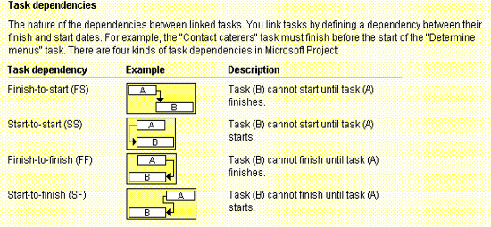
A Sample PDM Network Diagram
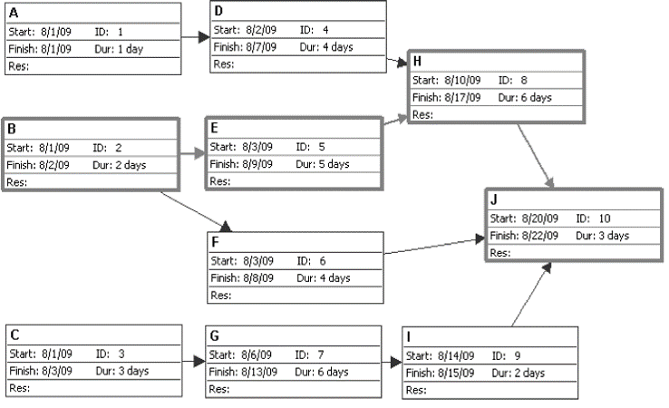
Gantt charts: provide a standard format for displaying project schedule information by listing project activities and their corresponding start and finish dates in a calendar format. Symbols include: Black diamonds: milestones. Thick black bars: summary tasks. Lighter horizontal bars: durations of tasks. Arrows: dependencies between tasks.
Boilerplate test flowchart
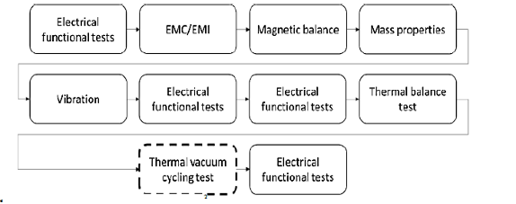
Fidelities of test hardware (models): Structural: mechanical design validation, Thermal: thermal design validation, Radio-electric: radio-frequency validation, Qualification: qualification level testing, Flight: will be launched. Tested at acceptance levels, Protoflight: Flight model on which a partial or complete protoflight qualification test is performed before flight
Qualification vs. acceptance testing: Qualification: formal proof that the design meets all requirements of the specification and the parameters agreed in the Interface Control Documents (ICD) including tolerances due to manufacturing imperfections, wear-out within specified life-time, faults etc. Acceptance: formal proof that the product identified by its serial number meets all requirements of the specification and is free of workmanship and material failures. Acceptance is based on the preceding qualification by reference to the used design / manufacturing documentation.
Testing progression FlowchartTest level decision matrix
Example of space hardware test flow
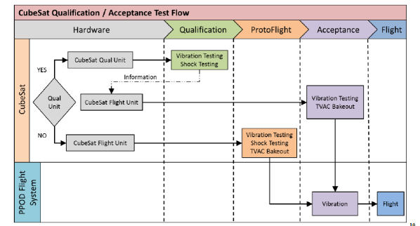
Conducted vs. radiated emi/EMC: Conducted emissions: EM energy created by a device and transmitted in the form of an electrical current through its power cord. This can potentially cause problems since power cords are connected to the entire power distribution network. Radiated Emissions:
EM energy created by a device and released as EM fields that propagate through air, away from the device. Electric devices that create radiated emissions have potential to interfere with other nearby electrical products

