Project Report on

**“Securing electronic components using Smart Bluetooth Energy Meter.”**

**SUBJECT: Embedded Systems (18IC311T)**

**6th Semester (B. Tech)**

**Submitted By: Team 5**

Jay Bhgaiya (18BIT040)

Jehil Thakkar (18BIT043)

Jai Lohana (18BIT035)

Deep Mistry (18BIT015)

Kathan Pathak (18BIT051)

**Submitted To:**

Dr. Hardik Patel

Assistant Professor

ICT, School of Technology,

Pandit Deendayal Petroleum University,



**Pandit Deendayal Energy University**

**School of Technology, Gandhinagar - 382426, Gujarat**

|  |  |  |
| --- | --- | --- |
| No. | Topic | Page No. |
| 1 | Introduction | 3 |
| 2 | Software Requirement and Specification | 3 |
| 3 | Components | 4 |
| 4 | Schematic in Proteus | 5 |
| 5 | Design Strategy | 6 |
| 6 | Results and Discussion | 8 |
| 7 | Simulation Videos and codes | 12 |

**Contents**

**Introduction**

The specific feature of smart energy meter is their ability to communicate the meter data to the supplier and consumer. Due to large network coverage, low cost and with negligible maintenance, availability, sending the data through Bluetooth is a useful and handy tool. Smart energy meter also prevent tempering and overloading.

Smart metering system comprising of a smart energy meter and a mobile phone acting as a central server receiving all the data sent by the energy meter. Other features of smart energy meter using Arduino are:

* Meter measures, record and integrate the energy consumption of the load connected
* It transmits the reading of voltage, current, power factor and kilo Watts to utility and customer through HC-05 Bluetooth module and Arduino.
* If customer is using the load above maximum demand limit, It turns the load off.
* It turns the load off, if customer tries to tamper the meter or tries to illegal activities with meter.

**Software Requirement and Specifications**

### **Arduino Software**

Before starting the coding, following libraries are included in Arduino IDE.

* EMON Library
* RTC Library
* Liquid Crystal Library

#### **EMON Library**

This Arduino library is for measuring Current and Power Factor values accurately.

#### **RTC Library**

This library is for Real Time Clock Module DS3231 which handles current date and time. It is necessary for energy calculations.

#### **Liquid Crystal Library**

Arduino LCD library is for displaying the results on LCD. This library supports the commands which are useful in displaying results on LCD.

* **Proteus 8**

Having lack of hardware we are using this software for simulation of the whole project. It has wide variety of components and it provide accurate simulation.

* **Serial Bluetooth Terminal**

This mobile app gets all the message on the terminal which is send by arduino via Bluetooth.

## Components

* Arduino Uno
* Bluetooth module HC – 05
* 20x4 Liquid Crystal Display (LCD)
* CT Sensor (Current measurement sensor)
* Lamp (Load)
* Relay Module
* Potentiometer
* Step Down Transformer
* AC Adapter
* Led
* Resistor, Capacitor, Diode

**Schematic in Proteus**

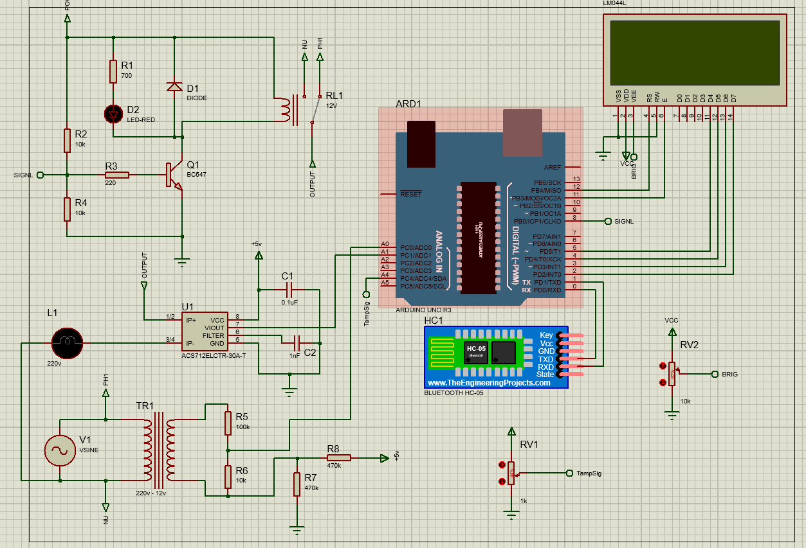Below image shows schematic diagram of smart energy meter using Bluetooth.

**Design Strategy**

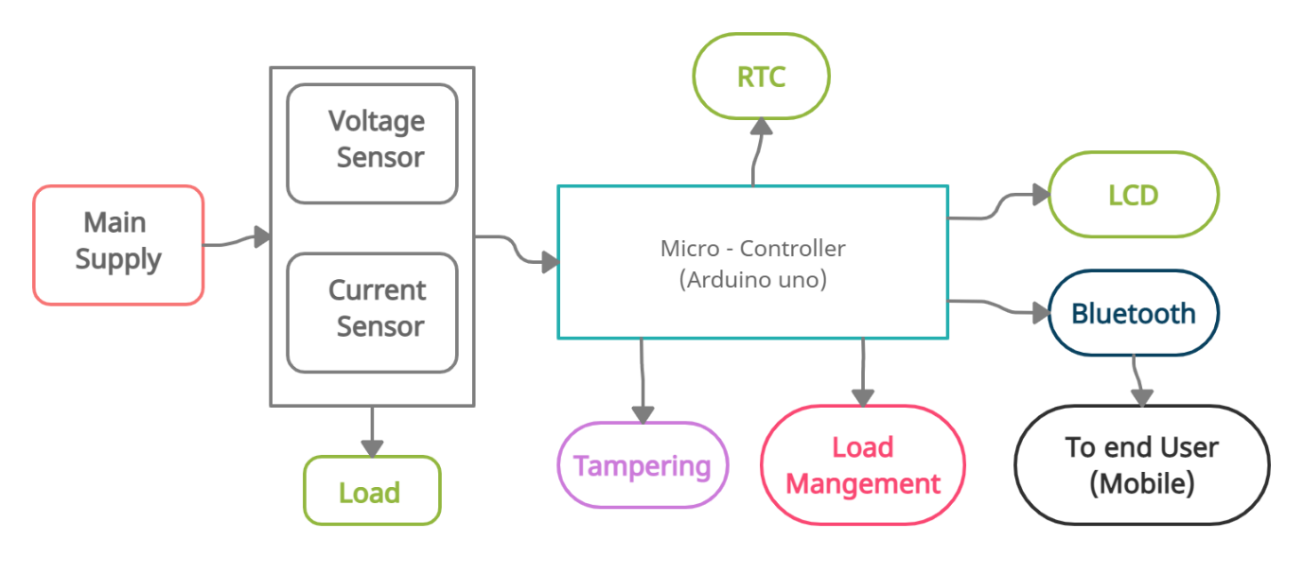

## Methodology

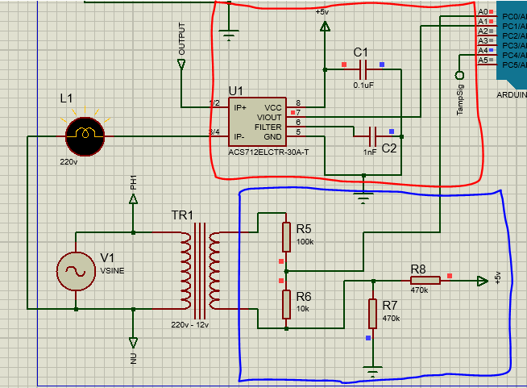There are two main measurement blocks. One is voltage measurement block and the other is the current measurement block.

### **Voltage Measurement Block**

In voltage measurement, main power supply is connected to the primary of a 230-4.5 V step down transformer. While secondary of the transformer is connected to a voltage divider circuit which consists of a two resistors of values 100k and 10k which divides the secondary voltage of the transformer into a ratio of 10:1. (Circuit diagram is shown in above image in blue box.)

The value of voltage across the low value resistor is taken to be fed to the analog pin of the Arduino but this AC signal contains both the positive and negative values. As Arduino can read only the positive values, so to convert the negative values of the incoming signal into positive values, a DC voltage shift is given to the incoming signal.

### **How to feed AC to Arduino?**

For this purpose, a 5V DC is supplied to the voltage divider circuit consisting of two 470k resistors dividing the voltage equally. This DC shift is added to the incoming voltage level so that the negative portion of the signal may be converted into positive. The voltage that has been now converted into the compatible range of the Arduino is given to the analog pin of Arduino.

### **Current Measurement Block**

When measuring current by CT we see some fluctuations in the output. For this reason and to overcome it we used current sensor. It simply connects in series with the load and its output signal pin is fed directly to the Arduino mega. It gives accurate values of current. (Circuit diagram is shown in above image in red box.)

### **Arduino**

The values of voltage and current are processed by the Arduino such that the relative time difference is measured between the voltage and current waveform. By considering the voltage waveform as the reference and the amount of the angle or time by which the current waveform lags behind the voltage waveforms. Which is calculated by detecting the zero crossing of the voltage and current waveforms.

### **Power Factor Measurements**

The time period of sine wave is 20msec for 50Hz system. The maximum time difference that can exist is 5 ms, so time difference gives us the information about power factor.  For a resistive load, the power factor is one because there is no time difference between the two waves. The real power of the load is equal to the product of root mean square values of voltage and current with power factor of the load.

### **Displaying Output on LCD**

The voltages, current and real power consumed, power factor, energy, billing information are displayed on the 20 x 4 LCD. The LCD is connected to the Arduino. The energy is measured by multiplying the real power consumed by the load with the time. The snap action switch has been used for tampering alert if unauthorized person tries to open the meter casing.

### **HC-05 Bluetooth Module for Communication**

The Bluetooth module is connected to the Arduino through the serial communication pins. TX and RX of the module with the pins 0 and 1 of the Arduino. The 5V supply to the Bluetooth module is separately provided by the Arduino.

## Results and Discussion

### **LCD Results**

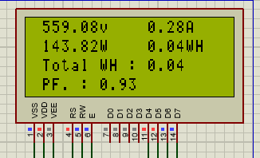The LCD displays different parameters such as Voltage, Current, Power, Energy and Power Factor on its screen. Arduino based Smart energy meter also provides load management and protection against tempering.

### **With Load Turned ON**

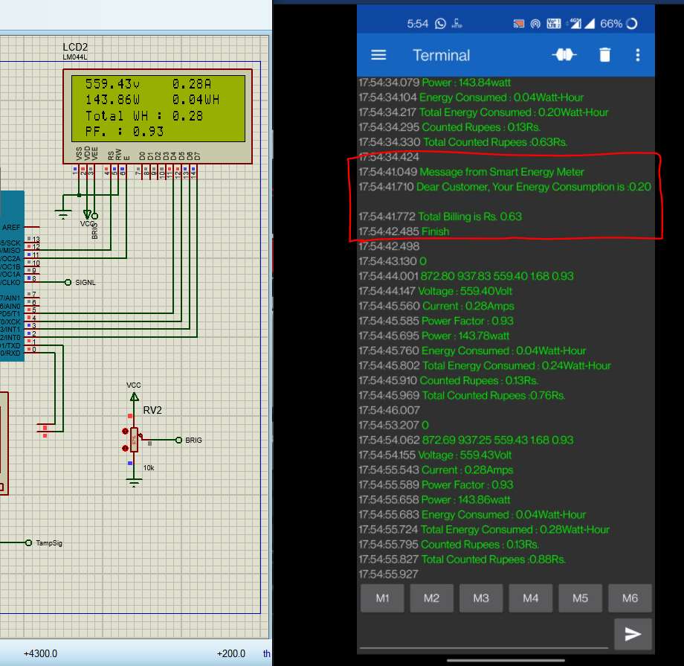When there is load, LCD displays all the parameters which include Voltage, Current, Power Factor, Power and Energy as in figure below. It sends message shown in red box after interval of every 25 seconds.

### **Load management in smart energy meter**

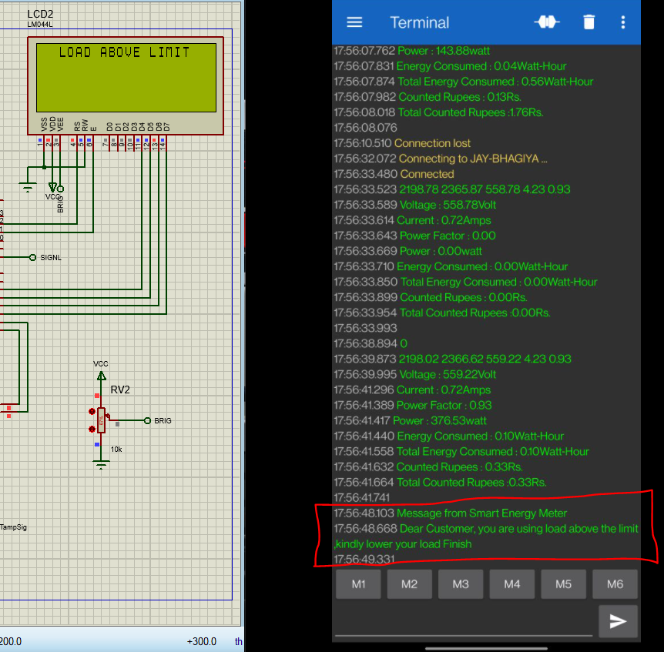When consumer load exceeds the maximum demand, meter sheds the load and alert message is on the LCD as in the figure below. It also turns of loads so damage can be controlled.

**Protection against Tampering**

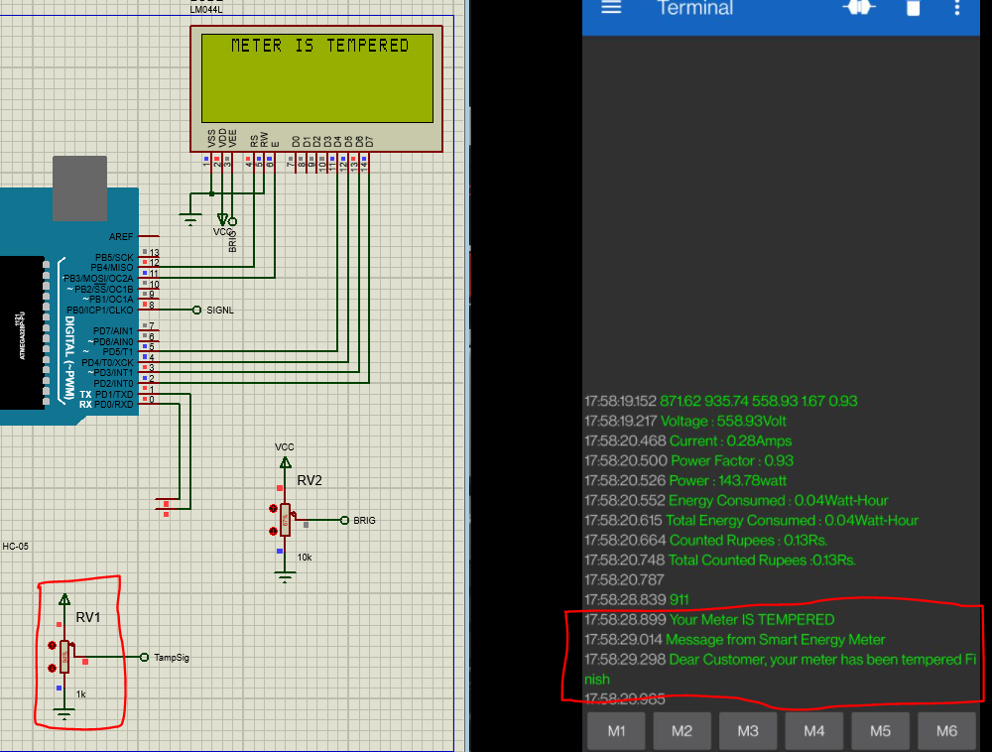If meter casing is being lifted, tampering alert message is displayed on LCD and sent to the consumer and service provider. When value of potentiometer goes above some saturation value it is shows that meter is tampered, so it shows message on both LCD and terminal as well.

**Simulation Videos and Codes**

Simulation videos of the project can be found in given below github link. Path is 11_Final_Project / demo-videos or 11_Final_Project / demo-gif. Or also you can see it on readme file as well.

<https://github.com/jayBhagiya/Embedded-Systems-Lab>

As we are using arduino, code is in .ino file which can be found [here](https://github.com/jayBhagiya/Embedded-Systems-Lab/blob/main/11_Final_Project/smart_bluetooth_energy_meter/smart_bluetooth_energy_meter.ino).

**Thank You**