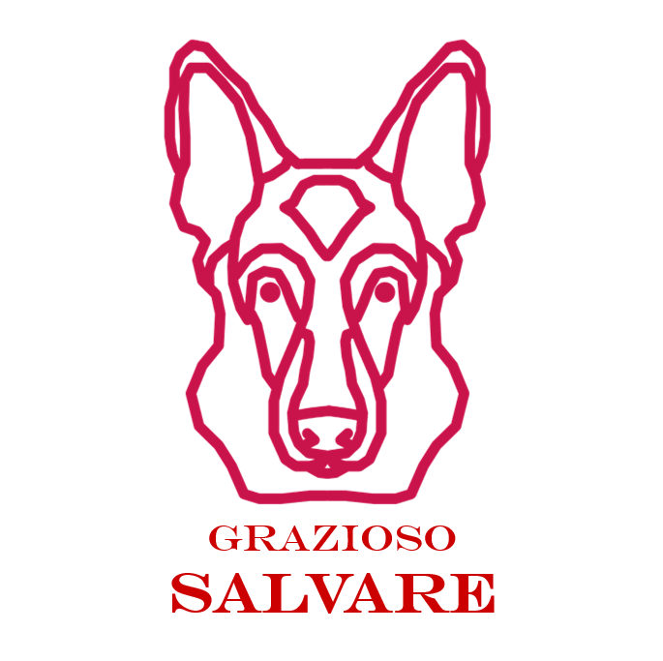
Grazioso Salvare Rescue Animal Dashboard
CS 340 Project Two README
Jason Guiste

Project Overview
This project completes the Grazioso Salvare rescue-animal dashboard for Global Rain. The application connects a Python Dash interface to the Austin Animal Center MongoDB database through the AnimalShelter CRUD module. Users can view shelter records, filter dogs by rescue type, review breed distributions, and view the selected animal's shelter location on an interactive map.

Required Functionality
- Display an unfiltered table of Austin Animal Center shelter outcome records.
- Allow the user to filter dogs for Water Rescue, Mountain or Wilderness Rescue, and Disaster or Individual Tracking.
- Provide a Reset option that returns the dashboard to the unfiltered state.
- Display the filtered results in an interactive, sortable, filterable, and paginated data table.
- Display a breed distribution chart that updates when the table data changes.
- Display a geolocation map for the selected animal.
- Include the Grazioso Salvare logo and a unique identifier containing the developer's name.

Dashboard Screenshots
Before submitting this README, replace each placeholder below with a screenshot taken while the dashboard is running in Codio/Jupyter. Each screenshot should clearly show the Grazioso Salvare logo, the Jason Guiste identifier, the filter controls, the data table, the breed chart, and the map.
Starting / Unfiltered Dashboard
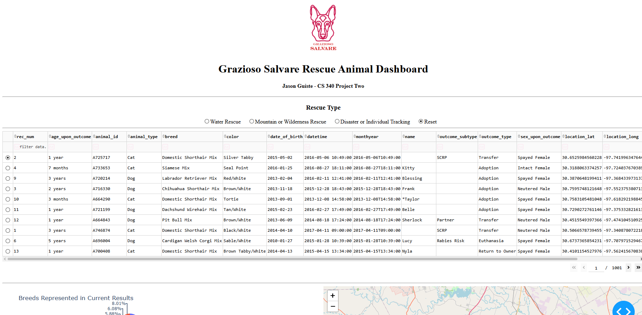

Water Rescue Filter
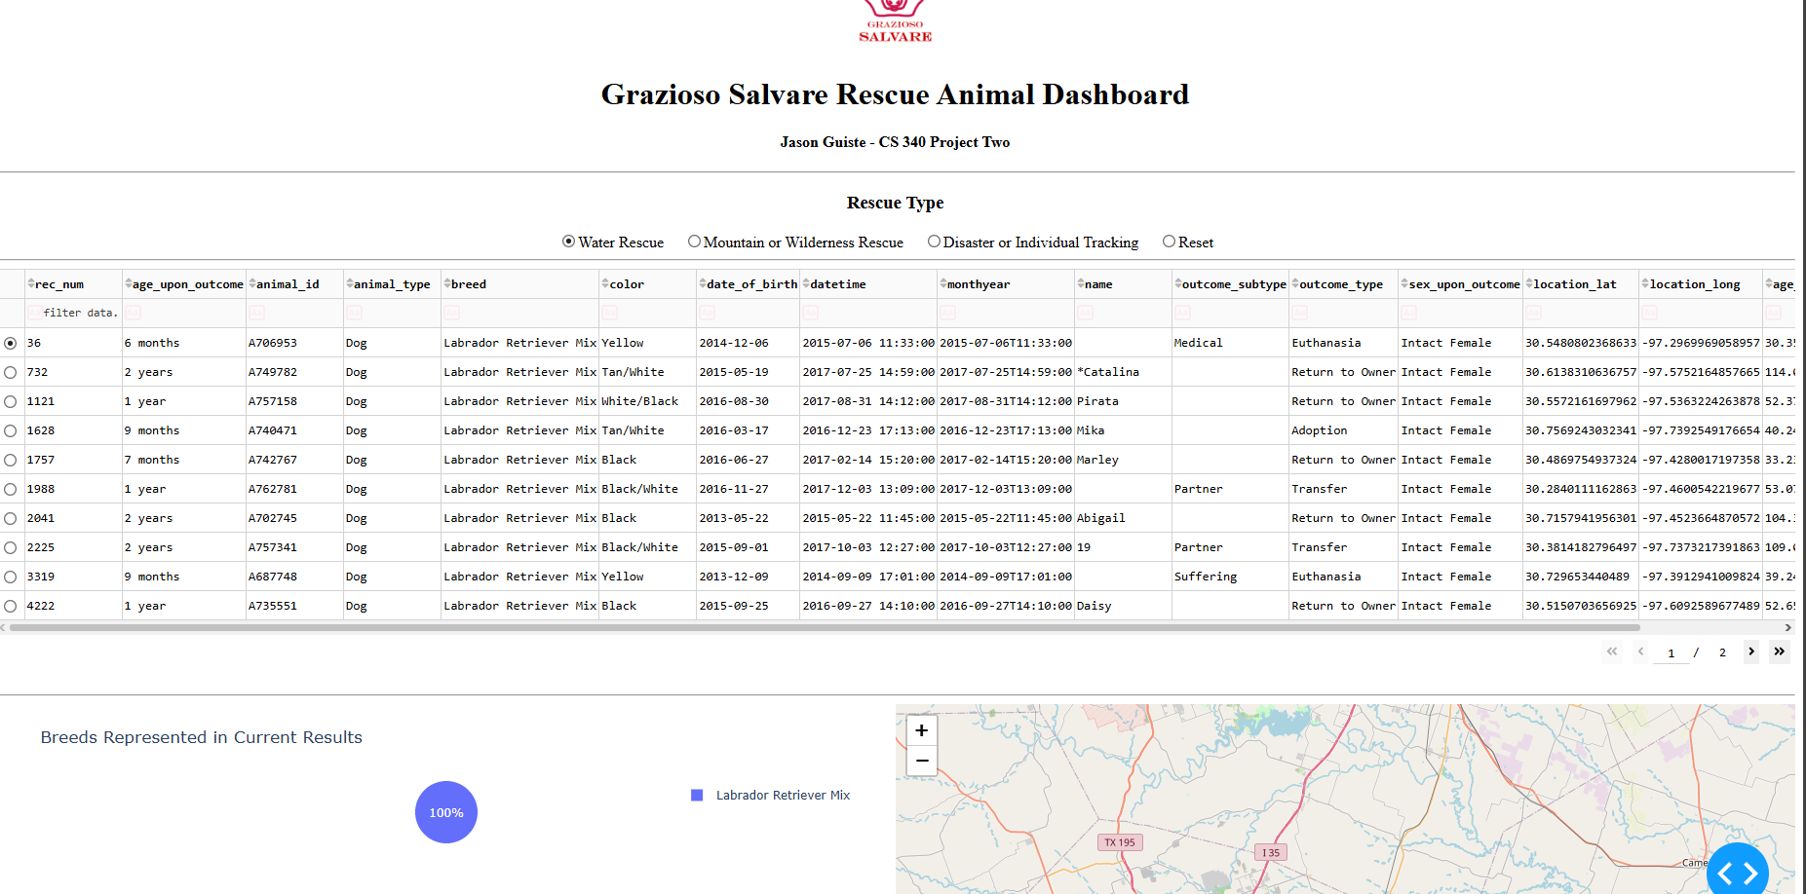

Mountain or Wilderness Rescue Filter
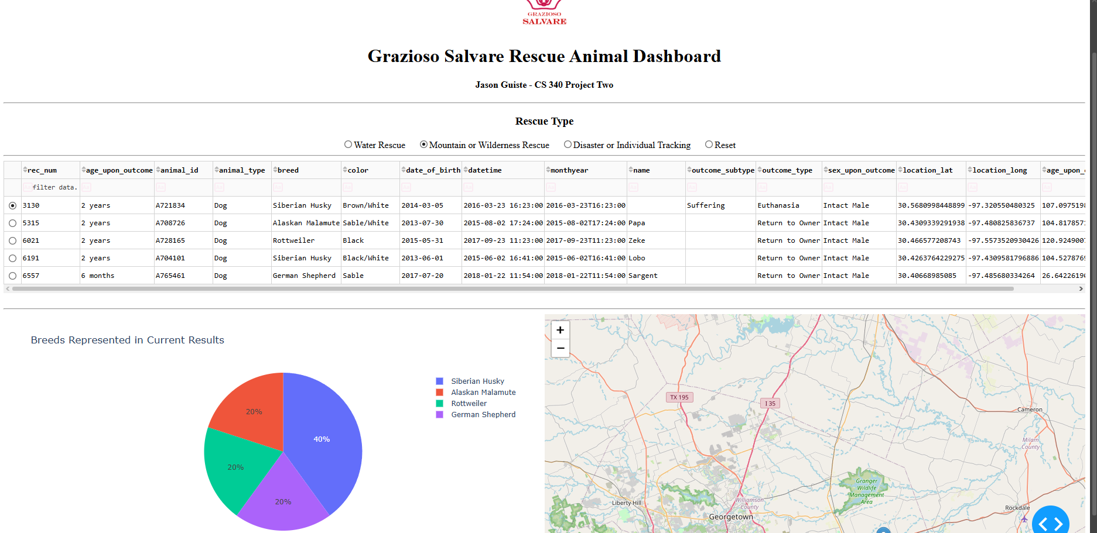

Disaster or Individual Tracking Filter
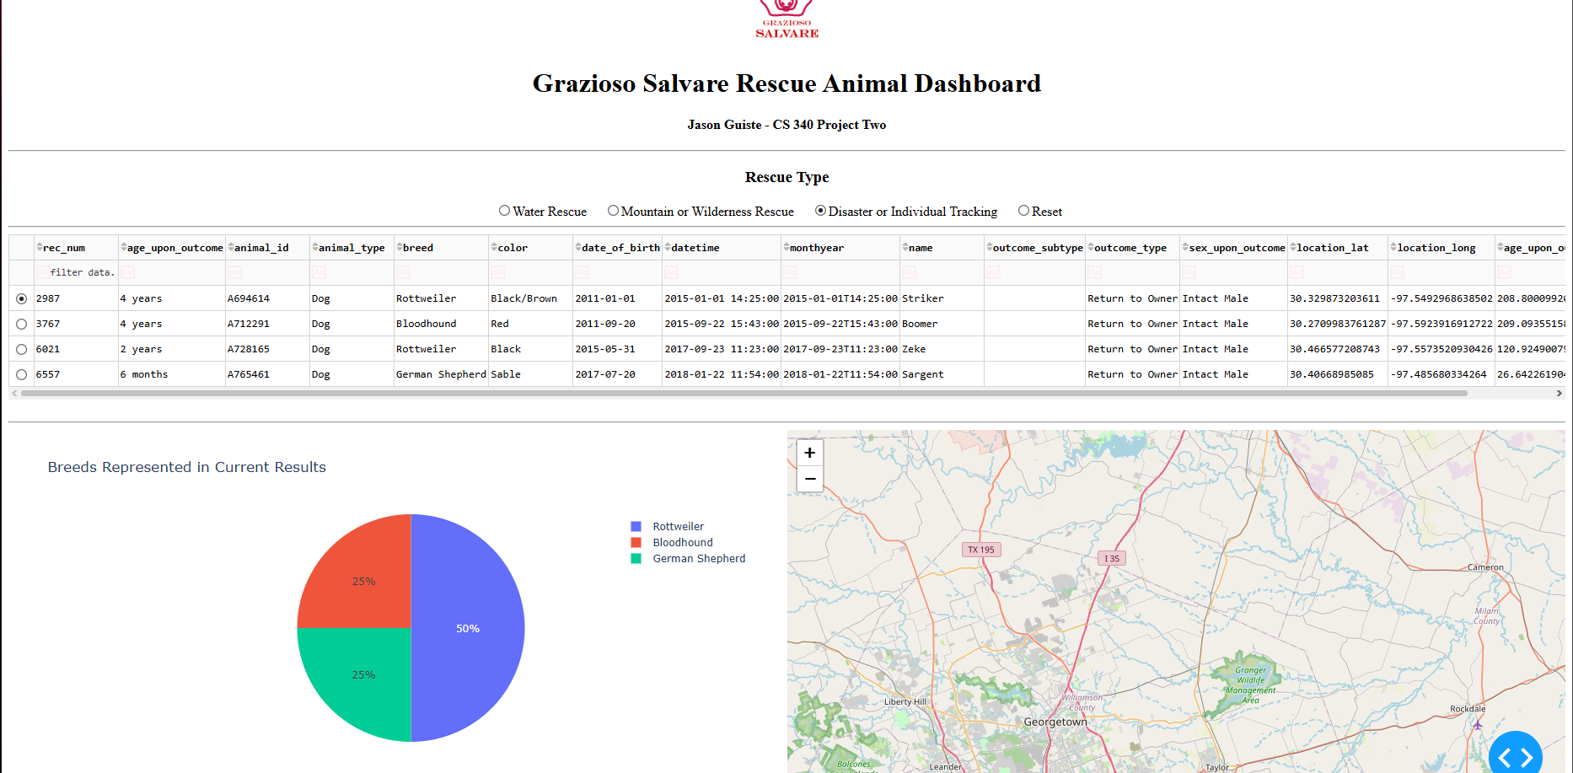

Reset / Returned to Unfiltered State
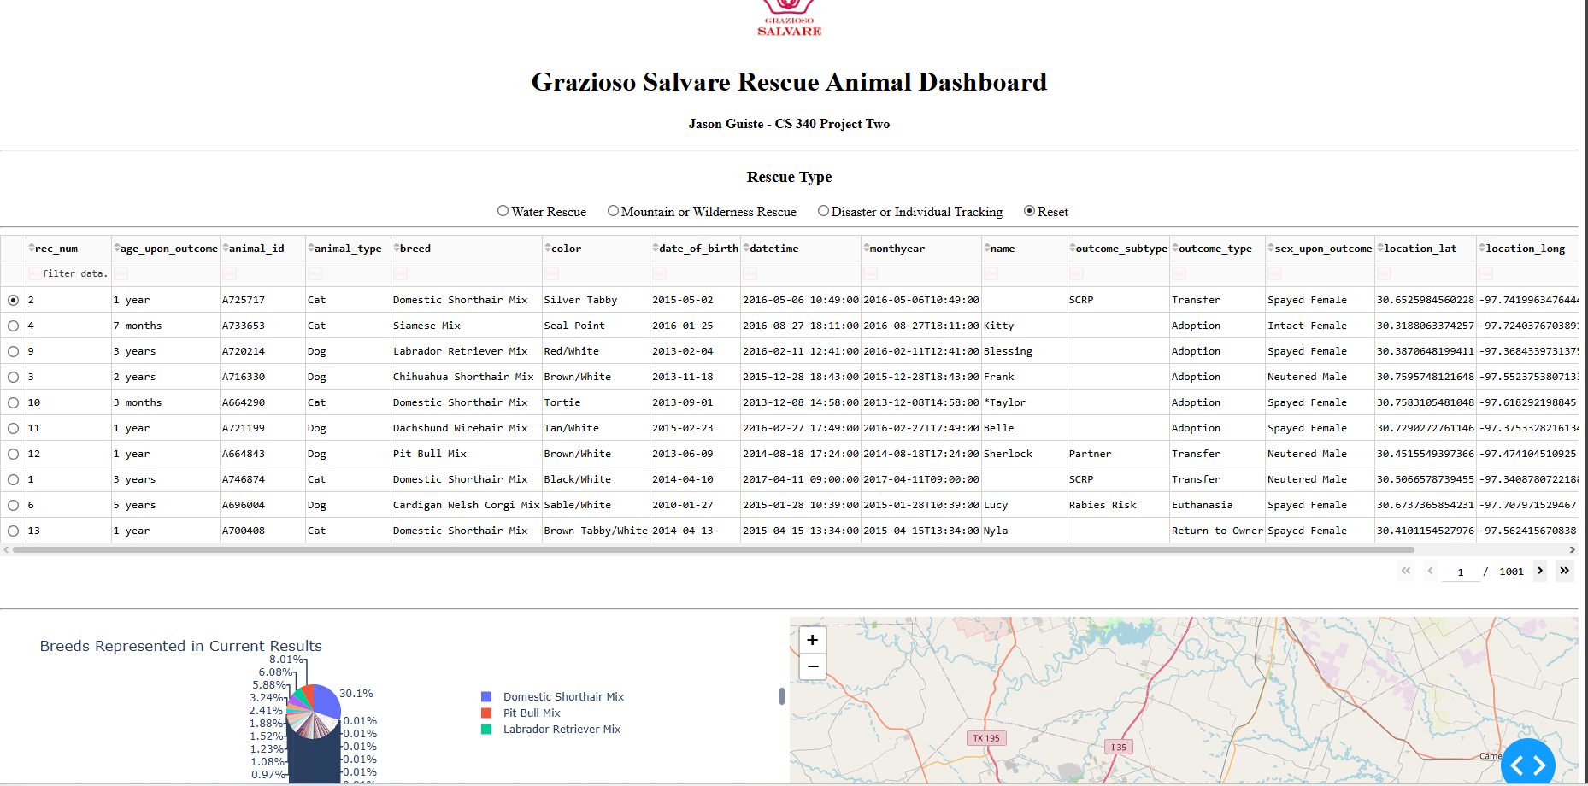

Tools Used and Rationale

MongoDB and PyMongo
MongoDB is used as the model because the animal shelter data is stored as documents and can be queried efficiently with fields such as breed, sex, age, and animal type. PyMongo provides the Python interface used by the CRUD module to connect to the database and perform queries.

AnimalShelter CRUD Module
The AnimalShelter class provides the Create, Read, Update, and Delete database operations. Project Two primarily uses the read() method so the dashboard can retrieve all records or records that match a rescue filter without placing MongoDB connection logic directly inside the dashboard callbacks.

Dash / JupyterDash
Dash provides the view and controller portions of the application. The layout defines the radio buttons, data table, chart, and map. Dash callbacks act as the controller by responding to user selections and updating the displayed data.

Pandas, Plotly Express, and Dash Leaflet
Pandas converts MongoDB query results into DataFrames for display and analysis. Plotly Express creates the breed distribution pie chart. Dash Leaflet provides the interactive map and marker for the selected shelter record.

Steps Taken to Complete the Project
- Reused the CRUD Python module from Project One and connected it to the aac database and animals collection.
- Loaded all shelter records into a Pandas DataFrame and removed the MongoDB _id field before sending the data to Dash.
- Built the dashboard layout with the Grazioso Salvare logo, developer identifier, rescue filters, data table, chart, and map.
- Added MongoDB queries for each rescue category and connected them to the radio-button controls with a Dash callback.
- Added a dynamic breed chart that responds to the currently displayed table data.
- Updated the geolocation callback so it safely handles the initial dashboard state and uses named latitude and longitude columns.
- Added pagination, sorting, filtering, and single-row selection to make the data table easier for the client to use.
- Tested the dashboard in its unfiltered state and with each rescue filter, then captured screenshots for documentation.

Challenges and Solutions
One challenge was keeping the dashboard synchronized when the user changed filters or selected a different row. This was handled with Dash callbacks that use the data table as the shared source for the chart and map. Another issue was MongoDB's _id field, which contains an ObjectId that Dash cannot serialize directly. The _id column is removed from the DataFrame before the records are displayed. The callbacks also check for empty or None values so the dashboard can load without failing before the user makes a selection.

How to Reproduce the Project
- Place ProjectTwoDashboard.ipynb, CRUD_Python_Module.py, and Grazioso Salvare Logo.png in the same Codio code_files directory.
- Verify that MongoDB is running and that the aac database contains the animals collection.
- Verify that the aacuser account and password in the CRUD module match the environment.
- Open ProjectTwoDashboard.ipynb in JupyterLab.
- Run the dashboard cell. If the default Dash port is already in use, restart the kernel or specify another available port.
- Use the rescue-type radio buttons to test Water Rescue, Mountain or Wilderness Rescue, Disaster or Individual Tracking, and Reset.
- Select a row in the table and verify that the map updates to the selected animal.

Project Files
- ProjectTwoDashboard.ipynb - Dashboard source code.
- CRUD_Python_Module.py - AnimalShelter CRUD class used to communicate with MongoDB.
- Grazioso Salvare Logo.png - Client logo displayed on the dashboard.
- Grazioso_Salvare_Project_Two_README.docx - Project documentation and reproduction instructions.

Resources
- MongoDB Documentation: https://www.mongodb.com/docs/
- PyMongo Documentation: https://pymongo.readthedocs.io/
- Dash Documentation: https://dash.plotly.com/
- Plotly Python Documentation: https://plotly.com/python/
- Dash Leaflet: https://www.dash-leaflet.com/

