Losing sleep – insomnia epidemic being driven by pandemic
More people are suffering as work patterns change, writes Bairbre Power
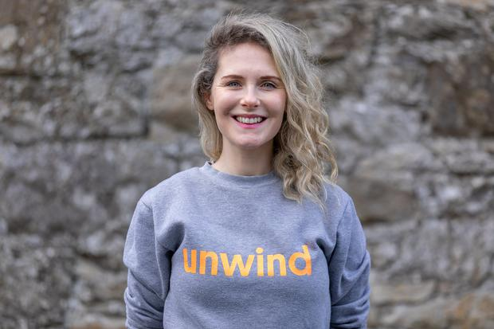

Bairbre Power

It was World Sleep Day yesterday but for Ireland’s ‘3am club’, who suffer from insomnia and other sleep problems, there wasn’t much shut eye to be had.
The problem of broken sleep is nothing new for Ireland’s night owls. One in five of us will suffer with sleep difficulties at some point in their lives but the Covid-19 pandemic has given rise to increased incidences of troubled sleep patterns which some victims have dubbed ‘Coronasomnia’.
People have been blaming an in ability to fall asleep or get good quality slumber during the pandemic on longer screen time, a blending of day and night while working at home, poor sleep hygiene, too much blue light time and indulging in a tipple or three.
The recent AGM of the Irish Sleep Society heard of a significant increase in the number of referrals since the start of the pandemic.
Dr John Garvey, consultant respiratory and sleep physician at St Vincent’s Hospital in Dublin, said: “We spend a third of our lives asleep and if there is something that is affecting that in a negative fashion, it will have consequences. People are now working from home.
“Their bedroom is doubling up possibly as an office and if they actually wake up in the middle of the night, they might catch glimpse of paperwork they need to deal with the following day so it has the potential to exacerbate the problem.
“All we should do in bed is sleep or have sex and if we’re not doing either, we should be out of bed is one of the tips you receive from sleep therapists in this regard.”

Read More
- ‘After cancer at 24, I was told I had the fertility of a 45-year-old — six months later I was pregnant with my miracle baby’
- Trouble sleeping? Wind down with a dreamy bedtime beauty ritual
While people suffer from insomnia, others can develop delayed circadian rhythm disturbance or early sleep phase disorder from working shifts. But if pandemic stress were not enough, the end of this month will bring another issue to lob into the unruly sleep equation – when the clocks will go forward by an hour in the early hours of March 28.
The disruption with the bi-annual clock change and that change in our circadian rhythm – which is our natural, internal process that regulates sleep – has been linked to a number of issue including weakened immunity and sleeping pattern, worsening of mood, anxiety and depression.

It can also have an impact on tired drivers, one reason why so many people around Europe supported the proposal to scrap daylight saving time in 2021.
EU law has required all countries in the bloc to observe daylight saving time since 2001, moving clocks forward by an hour on the last Sunday of March and back by an hour on the final Sunday in October.
The European Parliament voted in March 2019 in favour of ending the practice of seasonal time shifts. However, when it went to individual members states, there wasn’t agreement and Ireland was one of the countries that didn’t support the change.
Critics also warned Ireland would be looking at not only two currencies on the island but also the threat of having two different time zones.
MEP Seán Kelly, Ireland’s only member of the European Parliament’s working group on the bi-annual clock change, is a vocal supporter for change even though the project has effectively gone off the boil for now.
Mr Kelly maintains the seasonal clock change has “outlived its usefulness” and puts additional pressures on farmers and those with mental health difficulties.
“I don’t accept that we will have two time zones. I would expect that if the European Union move to stop clock change, the United Kingdom would do the same from a practical point of view.”
Deirde Clune, also a Fine Gael MEP for Ireland South, also supports scrapping daylight savings times said. She said: “It is for the commission to come with up another proposal and it has not been forthcoming so far. Maybe it is a matter for the parliament too to push them.”
Deirdre Hynds, who was diagnosed with chronic insomnia at age 17, has spent years researching ways she can achieve a good night’s sleep.
This week the young mum launched her unwind.ie website on which she shares slow moving night-time yoga and stretching sequences, guided evening meditations and original bedtime stories for grown-ups.
“I truly believe that the evening ritual is sacrosanct and that taking your time to slow down and ease into a more natural night-time rhythm is the way to achieve that zen feeling of rest and relaxation which we all crave,” said Ms Hynds who developed a range of bars using natural ingredients associated with feelings of relaxation and calm including chamomile flower and Montmorency cherry.

https://www.independent.ie/life/health-wellbeing/losing-sleep-insomnia-epidemic-being-driven-by-pandemic-40218242.html

