LIBRARY MANAGEMENT SYSTEM

DBMS PROJECT

Submitted by
Paidisetty suraj
RA1911003010887
Jonnala Chandra pujitha
RA1911003010890
Raparti Jaya Chaitanya
RA1911003010908

Library mangament system:

The Library Management System is gaining more importance as the number of its users are increasing rapidly.

The transactions like login, register, add , search, delete, issue are provided. The Library Management System stores the details like name, address, ID number , Date Of Birth of members working in the library and users who come to library. The details of books like book name, book number, subject to which it belongs , author, edition, year of publication , the total number of books that are present in the library etc are also stored.

Tables:
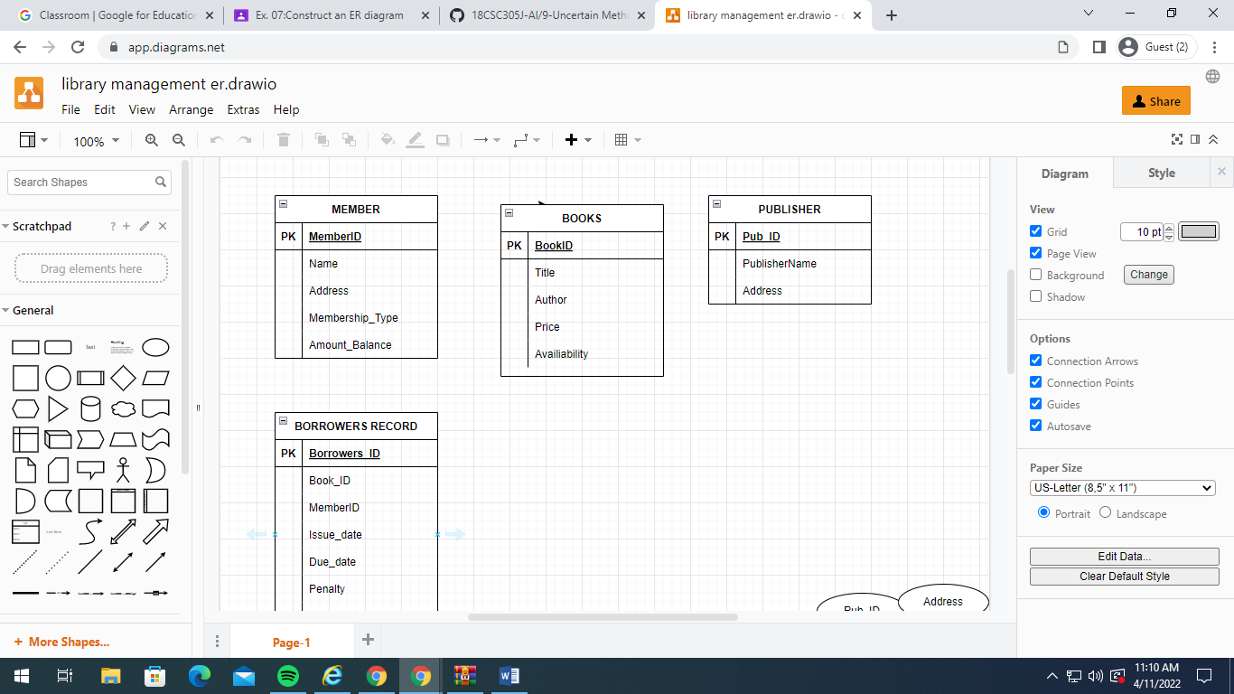

_Er daigram:
