1.Write a program to create an arraylist of double elements and add the elements.

sort the elements in descending order and print it.

package day13;

import java.util.*;

import java.util.Collections;

public class Qstn1 {

public static void main(String[] args) {

ArrayList<Double>list =new ArrayList<Double>();

list.add(50.50);

list.add(12.10);

list.add(78.88);

System.out.println("before sorting:");

for(double newlist:list)

{

System.out.println(newlist);

}

Collections.sort(list,Collections.reverseOrder());

System.out.println("AFTER SORTING:");

for(double newlist:list)

{

System.out.println(newlist);

}

}

}

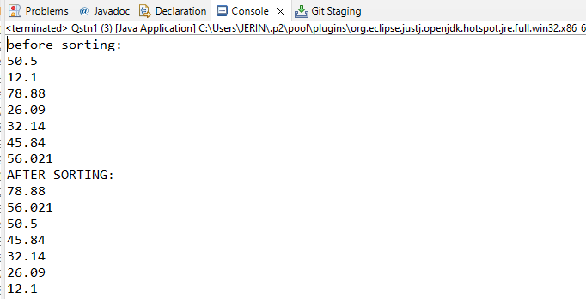

2.Create an arraylist of integers and find the sum and average of the entire list.

package day13;

import java.util.*;

public class Qstn2

public static void main(String[] args) {

List<Integer> list = new ArrayList<Integer>();

list.add(10);

list.add(90);

list.add(30);

list.add(40);

list.add(70);

list.add(100);

list.add(60);

System.out.println("Elements in List : " + list);

Integer a[] = new Integer[list.size()];

list.toArray(a);

System.out.print("Elements in List : ");

for (Integer obj : a) {

System.out.print(obj + " ");

}

int sum = sumOfArray(a, a.length - 1);

System.out.println();

System.out.println("Sum of elements : " + sum);

int avg;

avg = sum / 2;

System.out.println("Average:" + avg);

}

public static int sumOfArray(Integer[] a, int n) {

if (n == 0)

return a[n];

else

return a[n] + sumOfArray(a, n - 1);

}

}

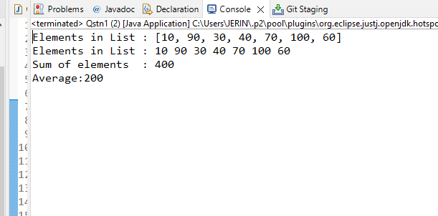

3.Create two arraylist of strings to take First_name and Last_name of the students,

and print their whole name.

package day13;

import java.util.*;

public class Qstn3 {

public static void main(String[] args) {

List<String> firstName = new ArrayList<String>();

List<String> lastName = new ArrayList<String>();

String string1 = "rincy";

firstName.add(string1);

String string2 = "bhanu";

firstName.add(string2);

// /////inserting last name

String string3 = "yaksh";

lastName.add(string3);

String string4 = "mathew";

lastName.add(string4);

Iterator<String> iterator = firstName.iterator();

Iterator<String> iterator1 = lastName.iterator();

List<String> name = new ArrayList<String>();

while (iterator.hasNext()&& iterator1.hasNext() )

{

name.add(iterator.next()+" "+iterator1.next());

}

Iterator<String> iterator11 = name.iterator();

while(iterator11.hasNext())

System.out.println(iterator11.next());

}

}

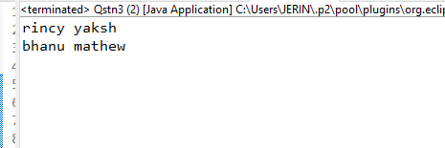

4.Write a program to check for the occurrence of a particular character in a string and display how many times it has occurred.

note: take the String and the character to be checked as an input from the user

.

package day8;

import java.util.*;

public class Qstn4 {

public static void main(String[] args) {

Scanner sc=new Scanner(System.in);

String s1;

int count =0;

System.out.println("Enter the string");

s1=sc.nextLine();

//s1=s1.replace(" ","");

System.out.println("Enter the element to be searched with count");

char c = sc.next().charAt(0);

for(int i=0;i<s1.length();i++)

{

if(s1.charAt(i)==c)

count++;

}

System.out.println(c +" appears "+count+" times");

}

}

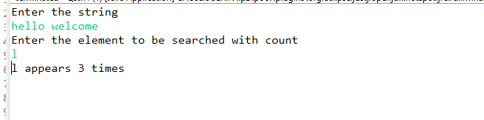

5.Write a program to take an input of a string with multiple words and convert it into a string array,

and check if every element of that array is a Palindrome.

Note: Palindrome is a word which when reversed also is the same.

package day8;

import java.util.Scanner;

public class Qstn5 {

public static boolean checkpalindrome(String str) {

int len = str.length();

for (int i = 0; i < len / 2; i++) {

if (str.charAt(i) != str.charAt(len - i - 1))

return false;

}

return true;

}

public static void main(String[] args) {

Scanner sc = new Scanner(System.in);

System.out.println("enter the sentence");

String str = sc.nextLine();

String[] arr = str.split(" ");

int n = arr.length;

for (int i = 0; i < n; i++)

if (Qstn5.checkpalindrome(arr[i])) {

System.out.println(arr[i] + " is palindrome");

} else

System.out.println(arr[i] + " is not a palindrome");

}

}

