1. Write a program to take an integer array from the user and give the user a choice to sort using bubble sort (or) selection sort. Sort the array elements according to the selected algorithm of the user and display the sorted array.

package day16;

import java.util.Scanner;

public class Qstn1 {

static void bubbleSort(int[] arr)

{

int temp=0,j=0,i;

for ( i = 0; i < ( arr.length - 1 ); i++)

{

for (j = 0; j < arr.length - i - 1; j++)

{

if (arr[j] > arr[j+1])

{

temp = arr[j];

arr[j] = arr[j+1];

arr[j+1] = temp;

}

}

}

}

static void selectionSort(int[] arr)

{

for (int i=0;i<arr.length-1;i++)

{

int index=i;

for(int j=i+1;j<arr.length;j++)

if(arr[j]<arr[index]) {

index=j;

}

int temp = arr[index];

arr[index] = arr[i];

arr[i] = temp;

}

}

public static void main(String[] args) {

Scanner sc = new Scanner(System.in);

System.out.println("Enter the array range");

int size = sc.nextInt();

int[] arr = new int[size];

System.out.println("Enter the elements of the array:");

for(int i=0; i<size; i++)

{

arr[i] = sc.nextInt();

}

System.out.println("Array elements before sorting:");

for(int i=0;i<size;i++)

{

System.out.print(arr[i]+ " ");

}

bubbleSort(arr);

System.out.println();

System.out.println("After Bubble Sort");

for(int i=0;i<size;i++)

{

System.out.print(arr[i]+" ");

}

selectionSort(arr);

System.out.println();

System.out.println("After Selection Sort");

for(int i=0;i<size;i++)

{

System.out.print(arr[i]+" ");

}

sc.close();

}

}

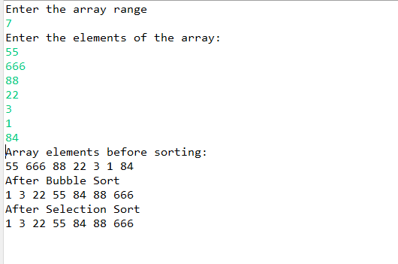

1. Write a program to implement insertion sort.

public class InsertionSort

{

public static void insertionSort(int array[])

{

int n = array.length;

for (int j = 1; j < n; j++)

{

int key = array[j];

int i = j-1;

while ( (i > -1) && ( array [i] > key ) )

{

array [i+1] = array [i];

i--;

}

array[i+1] = key;

}

}

public static void main(String[] args)

{

int[] arr1 = {9,145,31,2,13,10,58,22};

System.out.println("Before Insertion Sort");

for(int i:arr1)

{

System.out.print(i+" ");

}

System.out.println();

insertionSort(arr1);//sorting array using insertion sort

System.out.println("After Insertion Sort");

for(int i:arr1)

{

System.out.print(i+" ");

}

}

}

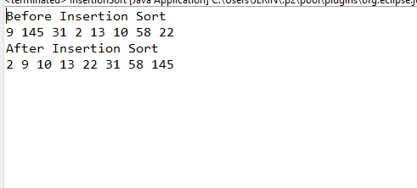

1. Write a program to implement Hashtable and add atleast 4 values into it, implement the putIfAbsent() method.

package day18;

import java.util.Hashtable;

public class Qstn3 {

public static void main(String[] args) {

Hashtable<Integer,String> hm=new Hashtable<Integer,String>();

hm.put(101, "abc");

hm.put(107, "shine");

hm.put(105, "merit");

hm.put(209, "jhgf");

System.out.println("current table is:" +hm);

hm.remove(209);

System.out.println(" after removal:" +hm);

System.out.println(hm.getOrDefault(102, "Not Found"));

hm.putIfAbsent(102, "mathew");

System.out.println("updated table:" +hm);

hm.clone();

System.out.println("clone method :" +hm);

int hashcode=hm.hashCode();

System.out.println("hashcode of the table" +hashcode);

hm.clear();

System.out.println("ah=fter clear method:" +hm);

}

}

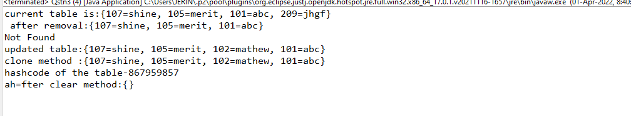

1. Create a class of Books with attributes:

a)id

b)name

c)author

d)publisher

e)quantity sold.

Implement a Hashtable to implement the objects of Books type. Print all the details of books by traversing through the Hashtable.

package day18;

import java.util.\*;

class Book {

int id;

String name, author, publisher;

int quantity;

public Book(int id, String name, String author, String publisher, int quantity) {

this.id = id;

this.name = name;

this.author = author;

this.publisher = publisher;

this.quantity = quantity;

}

}

public class HashtableExample {

public static void main(String[] args) {

Hashtable<Integer, Book> map = new Hashtable<Integer, Book>();

// Creating Books

Book b1 = new Book(101, "Let us C", "Yashwant Kanetkar", "BPB", 8);

Book b2 = new Book(102, "Data Communications & Networking", "Forouzan", "Mc Graw Hill", 4);

Book b3 = new Book(103, "Operating System", "Galvin", "Wiley", 6);

// Adding Books to map

map.put(1, b1);

map.put(2, b2);

map.put(3, b3);

// Traversing map

for (Map.Entry<Integer, Book> z : map.entrySet()) {

int key = z.getKey(); // key=3

Book b = z.getValue(); // b=b3

System.out.println(key + " Details:");

System.out.println(b.id + " " + b.name + " " + b.author + " " + b.publisher + " " + b.quantity);

}

}

}

