**Section A**

1. Create Database project_movie_data and deploy table data according to the ER diagram.

CREATE DATABASE project_movie_data;

USE project_movie_data;

1. Create 9 tables which are presented in the ER model and load the data with their foreign key and primary key values.

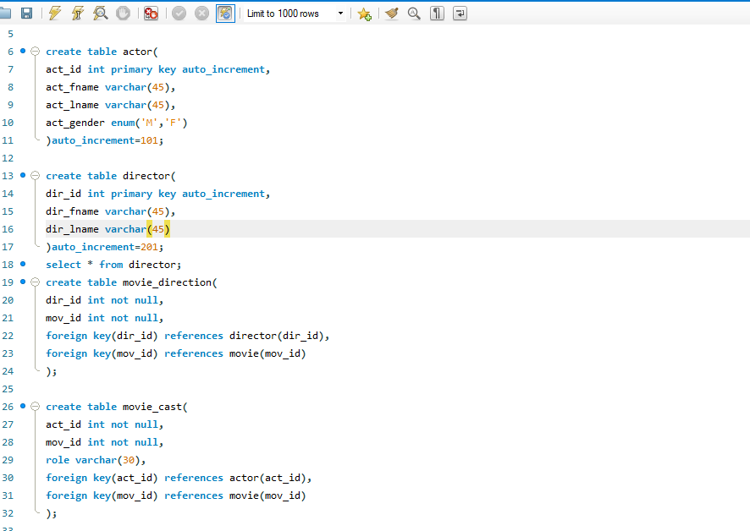

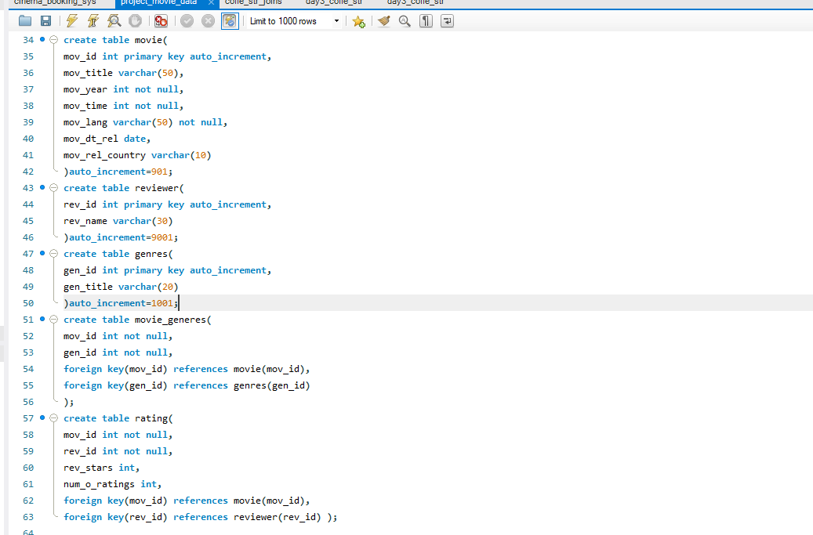

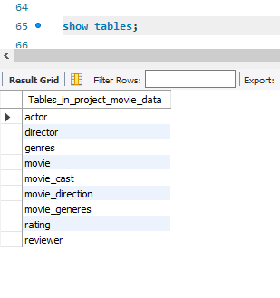

1. Write a query in SQL to list the Horror movies?

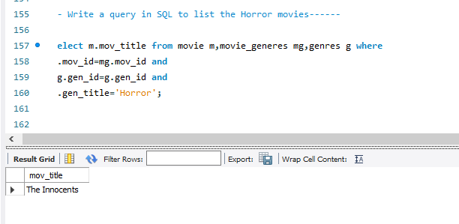

1. Write a query in SQL to find the name of all reviewers who have rated 8 or more stars?

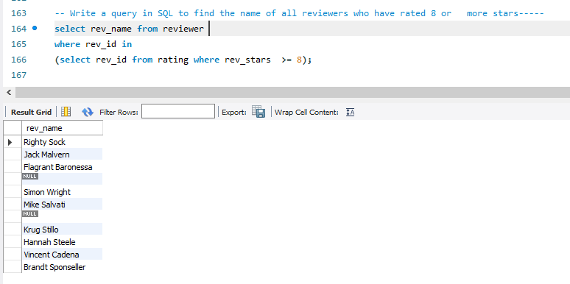

1. Write a query in SQL to list all the information of the actors who played a role in the movie ‘Deliverance’

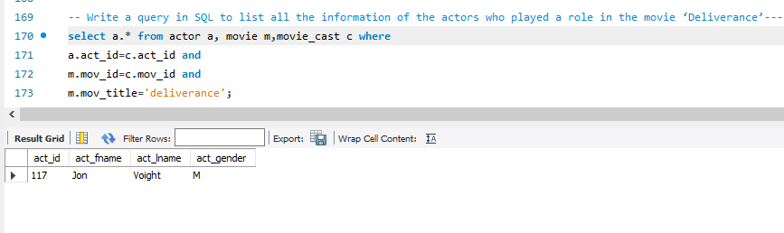

1. Write a query in SQL to find the name of the director (first and last names) who directed a movie that casted a role for ‘Eyes Wide Shut’. (using subquery)

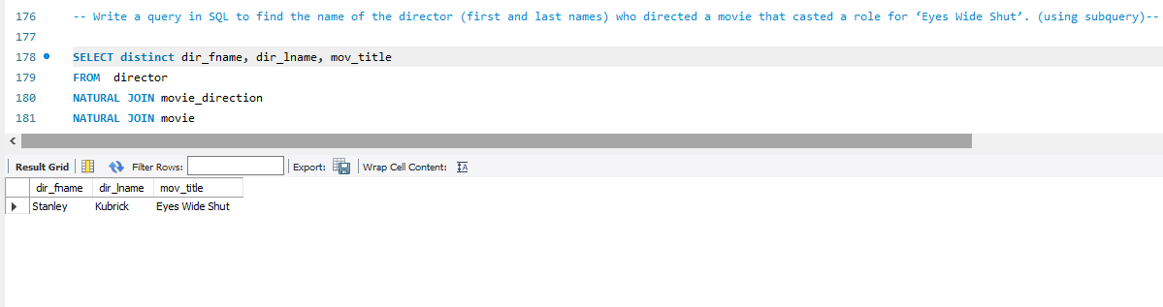

1. Write a query in SQL to find the movie title, year, date of release, director and actor for those movies which reviewer is ‘Neal Wruck’

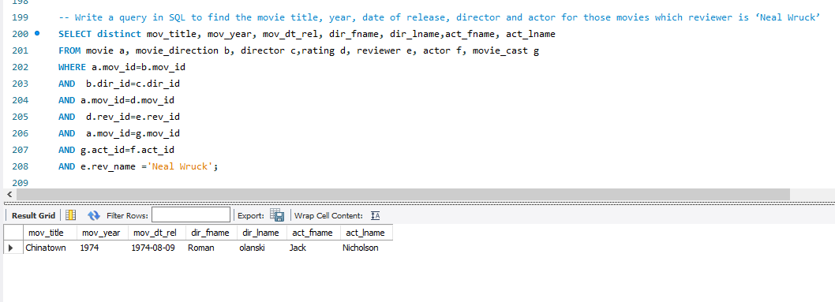

1. Write a query in SQL to find all the years which produced at least one movie and that received a rating of more than 4 stars.

