1.Create an arraylist of user-defined data type Book. it should have:-

i)Name of the Book

ii)Author of the book

iii)year of publication of the book

iV)number of copies sold.

sort the array list based on the year of publication.

package day13;

import java.util.ArrayList;

import java.util.Collections;

import java.util.Comparator;

class Pbook{

private String name,author;

private Integer cpy,year;

public Pbook(String name,String author,Integer cpy, Integer year) {

this.name=name;

this.author=author;

this.cpy=cpy;

this.year=year;

}

public Integer getYear() {

return year;

}

@Override

public String toString() {

return " date="+year+", name="+name+", author="+author+", cpy="+cpy+"\n";

}

}

public class QstnQ4 {

public static void main(String[] args) {

ArrayList<Pbook> bk=new ArrayList<Pbook>();

bk.add(new Pbook("wings of fire","APJ ABDUL kALAM",400,2000));

bk.add(new Pbook("an i deniel","ashlin",120,1997));

bk.add(new Pbook("Tw States","Chethan Bhagat",500,2003));

bk.add(new Pbook("The Alchemist","Paulo Coelho",1500,1988));

System.out.println(" beforesorting:"+bk);

bk.sort((source,target) -> {return (source.getYear() - target.getYear());});

bk.sort(Comparator.comparingInt(Pbook::getYear));

System.out.println(bk);

}

}

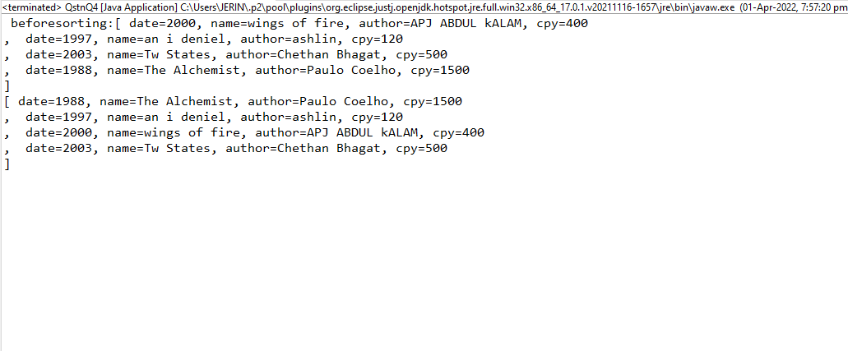

2.Write a program to create, write and read from a file.

package day14;

import java.io.File;

import java.io.IOException;

import java.io.PrintWriter;

public class Qstn1 {

public static void main(String[] args) {

try

{

File file=new File("Qstn1.txt");

if(!file.exists())

{

file.createNewFile();

}

//content for file

PrintWriter pw= new PrintWriter(file);

pw.println(" here is the content");

pw.println("file exists");

pw.close();

System.out.println("Done");

}

catch (IOException e) {

e.printStackTrace();

}

}

}

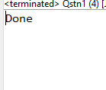

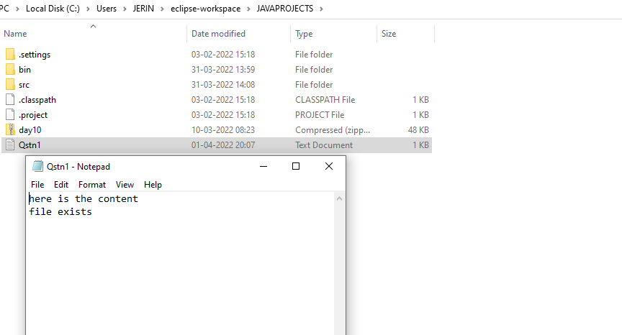

3.Write a program to get the information about the file.

package day14;

import java.io.\*;

public class Qstn2 {

public static void main(String[] args) {

File f=new File("C:\\Users\\JERIN\\eclipse-workspace\\JAVAPROJECTS\\Qstn1.txt");

if(f.exists())

{

System.out.println("File Name :"+f.getName());

System.out.println("File Path :"+f.getAbsolutePath());

System.out.println("File Free Space :"+f.getFreeSpace());

System.out.println("File Writable :"+f.canRead());

System.out.println("File Readable :"+f.canWrite());

System.out.println("File useSpace :"+f.getUsableSpace());

System.out.println("File TotalSpace :"+f.getTotalSpace());

}

else

{

System.out.println("file doesn exists");

}

}

}

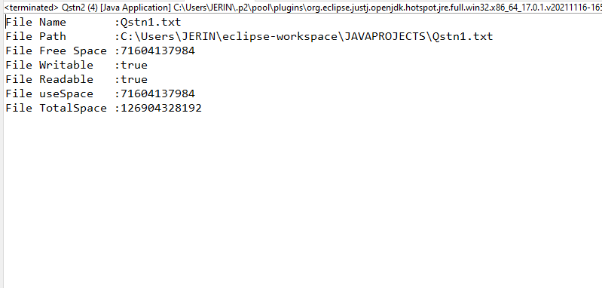

4.Write a program Implement the filereader until the file ending character is “-1” and print all the data of the file.

package day14;

import java.io.\*;

import java.io.FileReader;

public class Qstn3 {

public static void main(String[] args) throws IOException

{

try

{

FileReader file=new FileReader("C:\\Users\\JERIN\\eclipse-workspace\\JAVAPROJECTS\\Qstn1.txt");

int data=file.read();

while(data!=-1) {

System.out.print((char)data);

data=file.read();

}

file.close();

}

catch (FileNotFoundException e)

{

e.printStackTrace();

}

}

