Task 2: Automate PNG Transfer Between S3 Buckets Using AWS Lambda

🎯 Objective
Create a serverless automation using AWS Lambda that triggers on file upload to 'bucket1', filters for '.png' files, and copies them to a designated folder in 'bucket2'. This should include error handling.
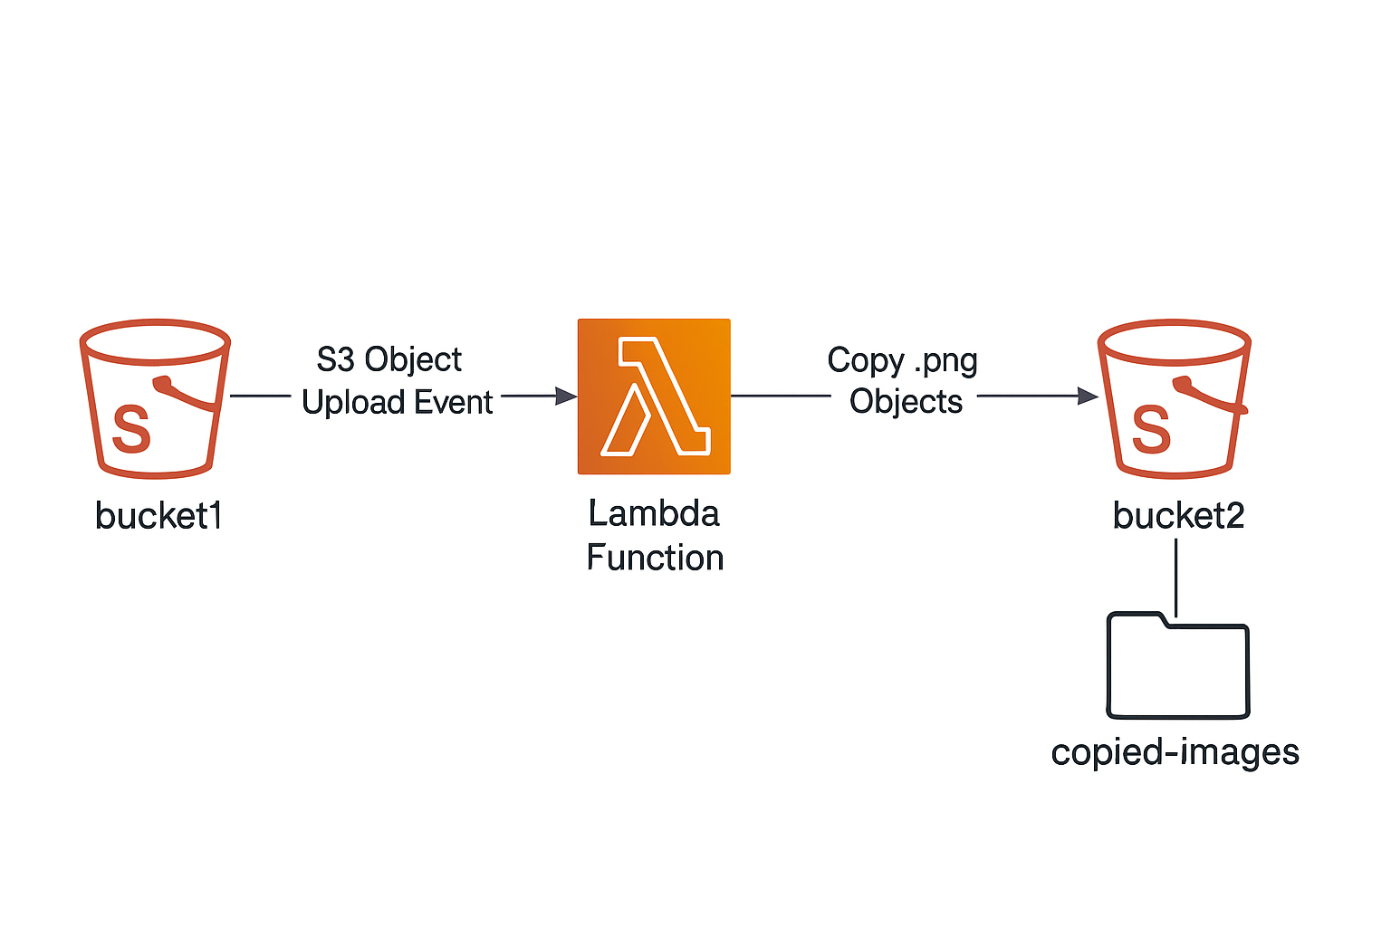

✅ Step-by-Step Instructions

Step 1: Create Two S3 Buckets
- Go to the AWS S3 console.
- Create two buckets:
- - bucket1 – source bucket
- - bucket2 – destination bucket
- Keep them in the same region to avoid cross-region costs or permissions complexity.
- 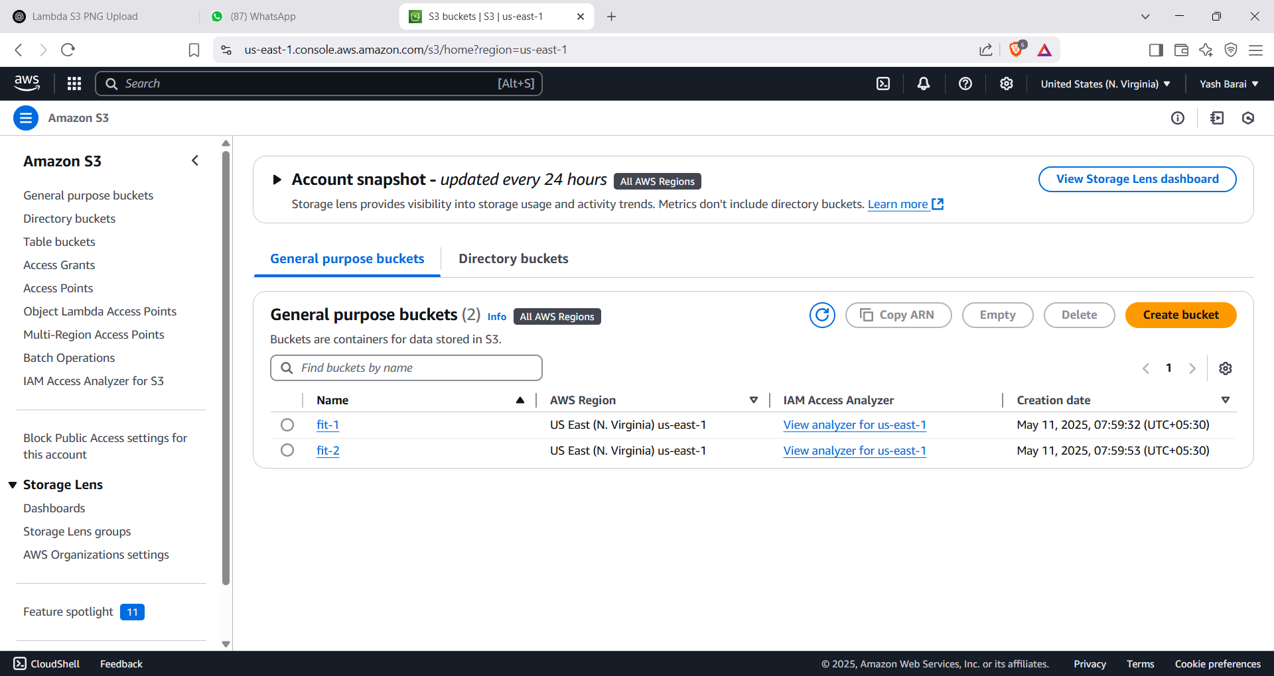

Step 2: Create the Lambda Function
- Go to the AWS Lambda console.
- Click “Create function”.
- Choose 'Author from scratch', give a name (e.g., CopyPNGtoBucket2), choose Python 3.12
- Create a new role with basic Lambda permissions.
- Click 'Create Function'.
- 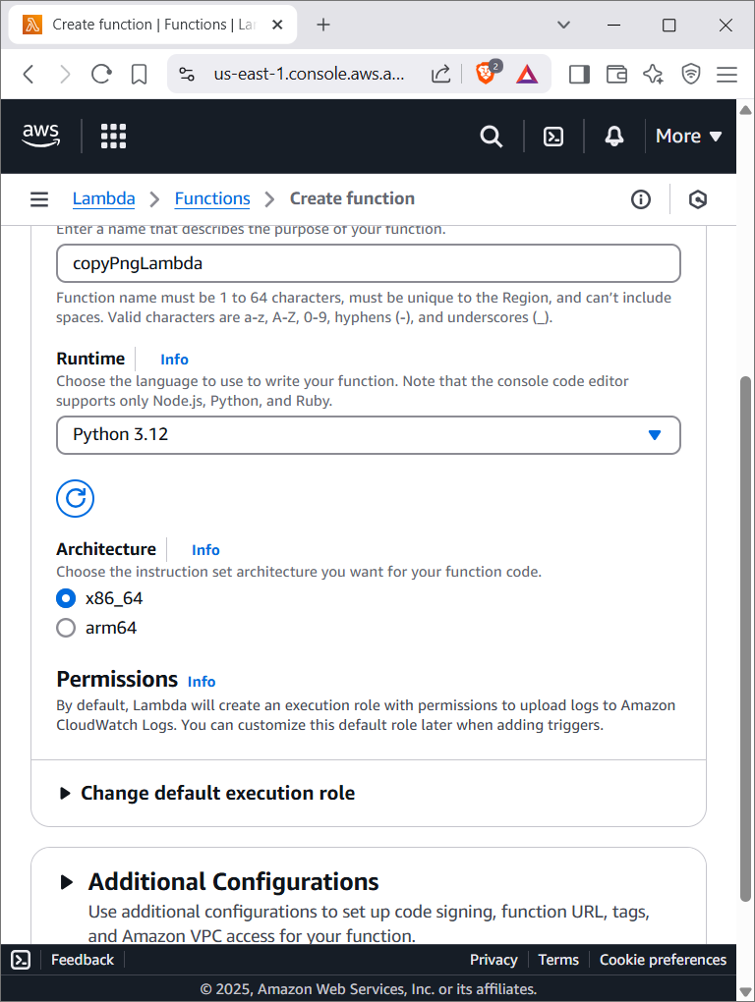

Step 3: Add S3 Trigger to Lambda
- In Lambda's 'Designer' section, click '+ Add trigger'.
- Select S3, choose 'bucket1', set event type to 'PUT'.
- Enable the trigger.
- 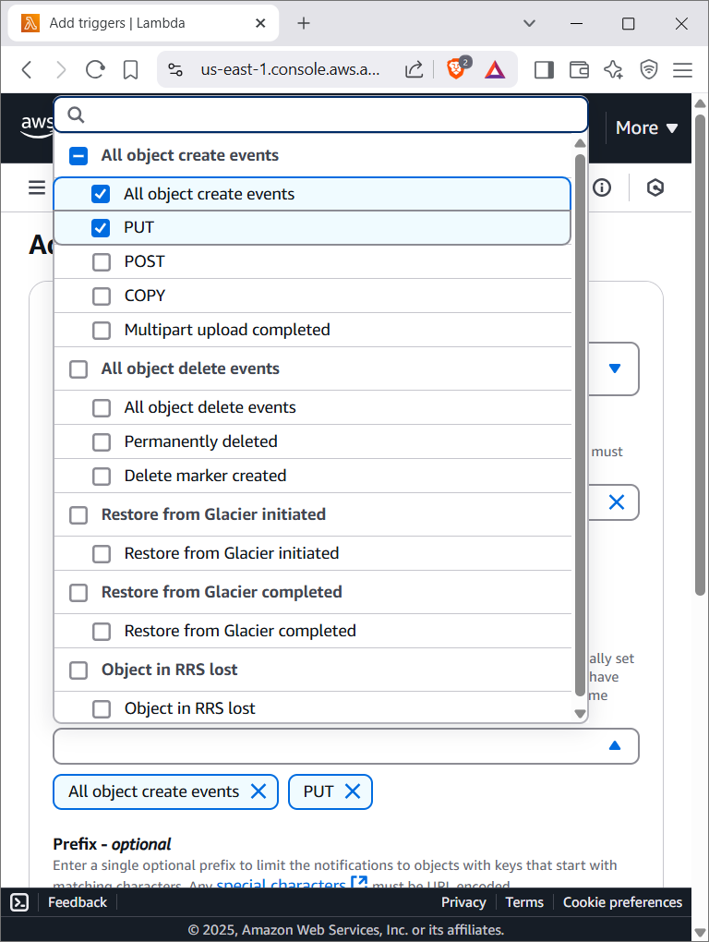
- You should choose only put here

Step 4: Update IAM Role Permissions
- Go to IAM → Roles → [Your Lambda Role] → Add permissions.
- Attach the following inline policy:
- {
"Version": "2012-10-17",
"Statement": [
{
"Effect": "Allow",
"Action": ["s3:GetObject"],
"Resource": "arn:aws:s3:::bucket1/*"
},
{
"Effect": "Allow",
"Action": ["s3:PutObject"],
"Resource": "arn:aws:s3:::bucket2/*"
}
]
}
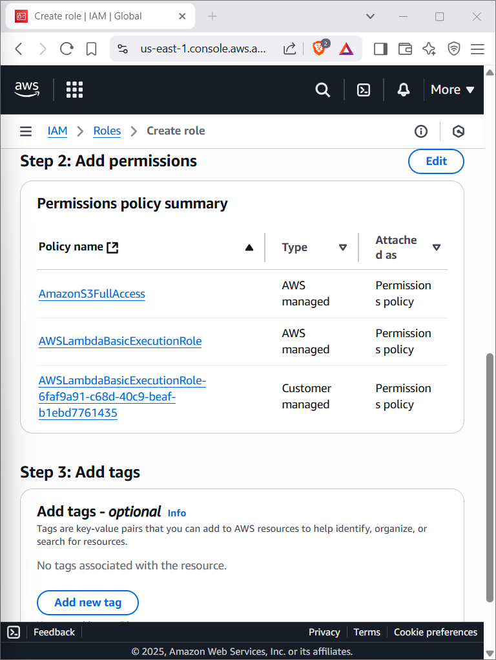

Step 5: Lambda Function Code
- Paste this code in the Lambda editor:
import boto3
import urllib.parse

s3 = boto3.client('s3')

def lambda_handler(event, context):
try:
source_bucket = event['Records'][0]['s3']['bucket']['name']
key = urllib.parse.unquote_plus(event['Records'][0]['s3']['object']['key'])

if not key.lower().endswith('.png'):
print(f"Not a PNG file: {key}")
return

destination_bucket = 'bucket2-yourname'
destination_key = f"copied-images/{key.split('/')[-1]}"

s3.copy_object(
CopySource={'Bucket': source_bucket, 'Key': key},
Bucket=destination_bucket,
Key=destination_key
)

print(f"Copied {key} to {destination_bucket}/{destination_key}")

except Exception as e:
print(f"Error copying {key}: {e}")
raise e

- 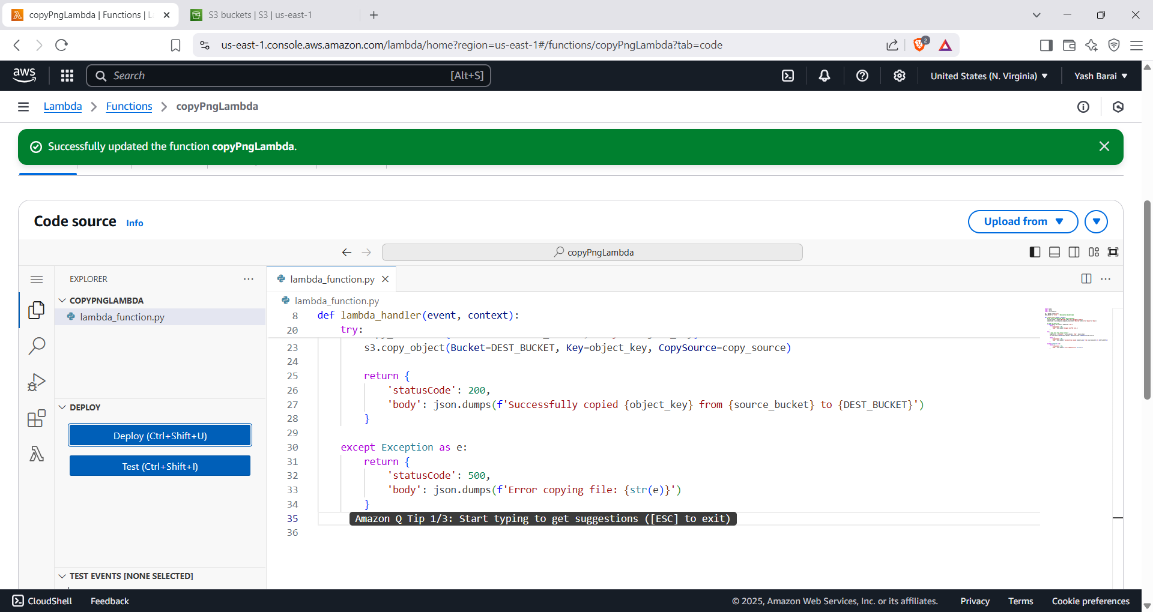

Step 6: Test the Setup
- Upload a '.png' file to 'bucket1'.
- Check 'bucket2/copied-images/' for the file.
- Verify non-PNG files are ignored.
- 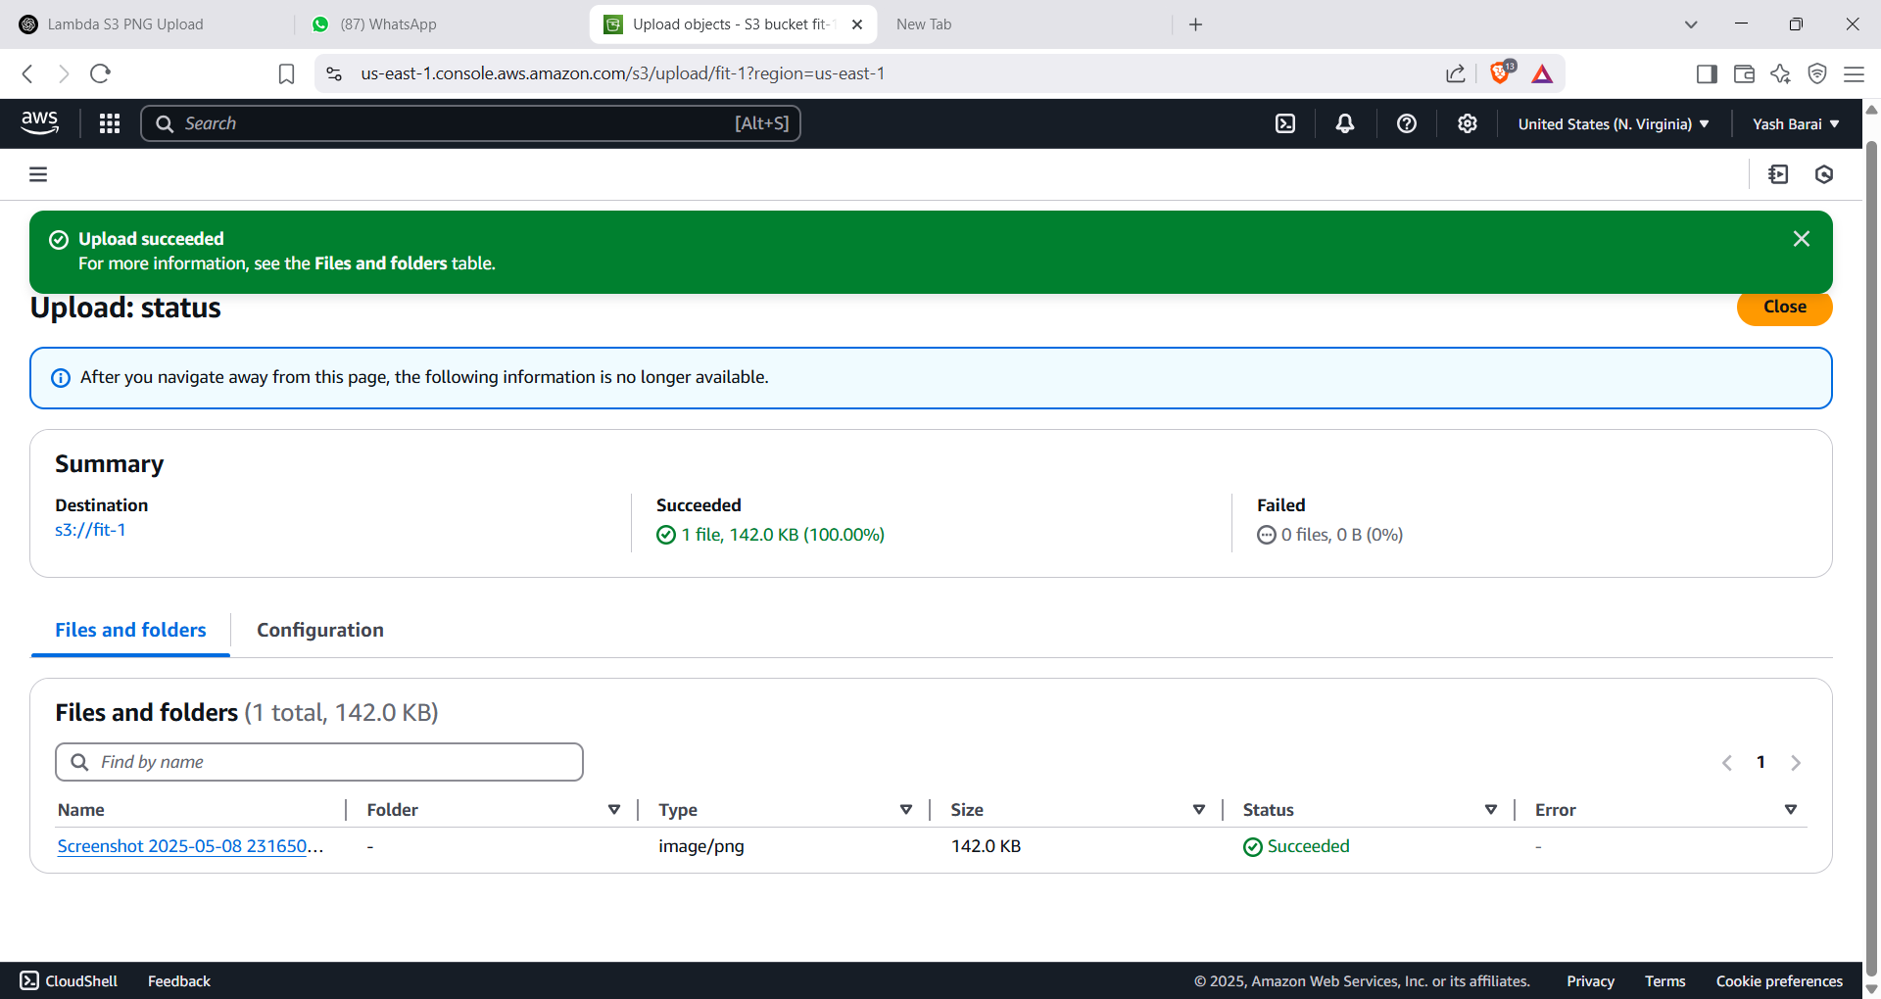

Successfully image is getcopied in fit-2
