Yatta

While browsing the eclipse.org/downloads for latest versions of eclipse.

I came across this interesting feature Yatta Profile.

The setup is very simple.

We need to extract the exe and launch it.

1. At first , we get a user agreement screen

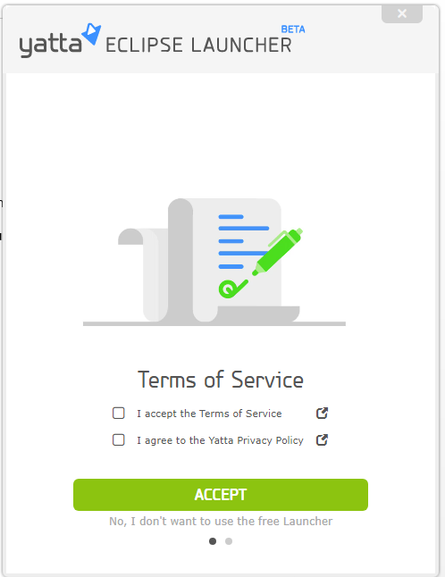

1. Check the check boxes after reading through the Terms and conditions and accept.

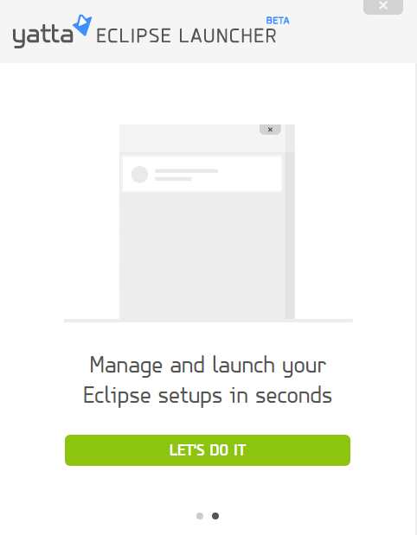

1. Select the Packages tab

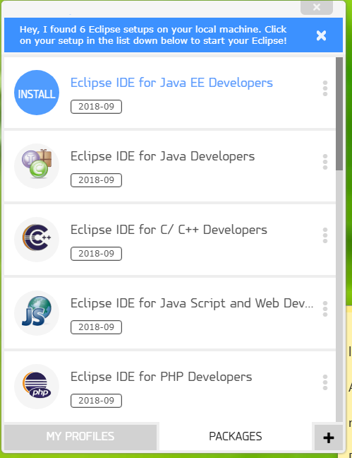

1. We are working on Java EE for our project, click on the first option

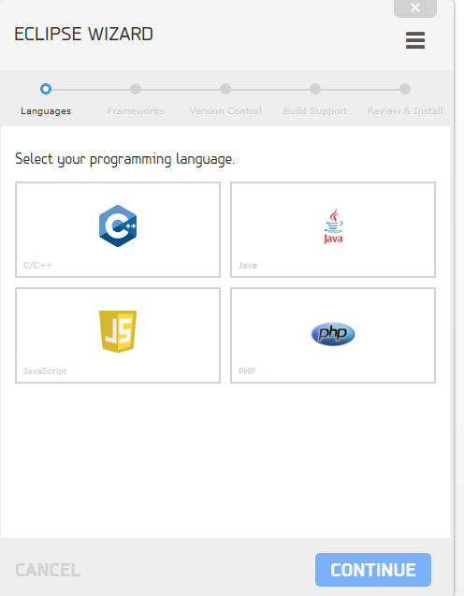

1. In the Create eclipse profile link, we can select the programming language
2. Select the framework here in the next page
3. 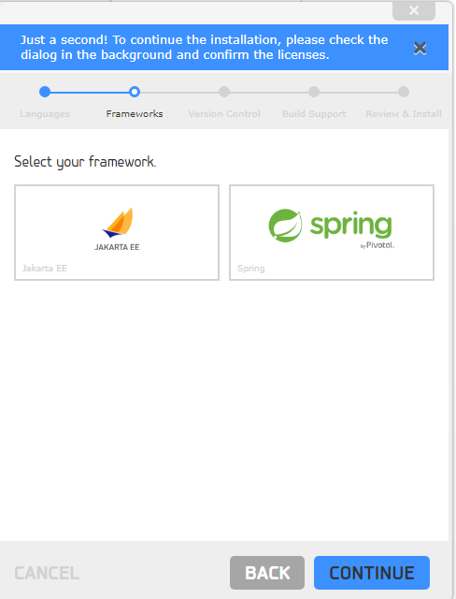
4. Select the version control used in our project

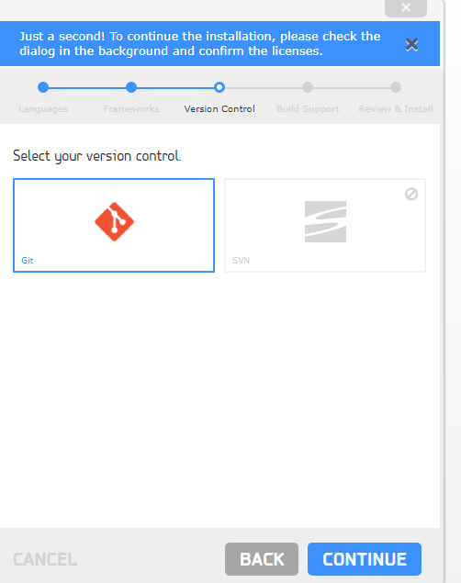

1. Build tools to be selected in the next tab
2. 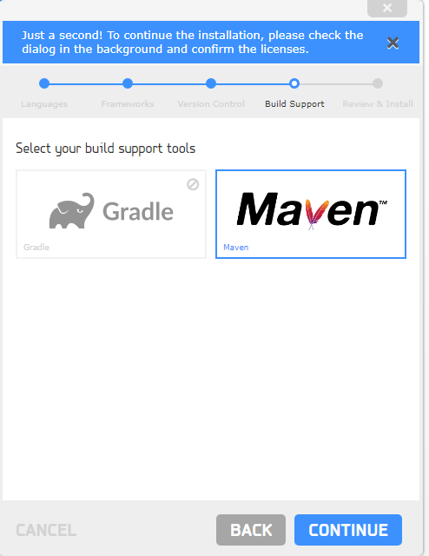
3. Finally click install click accept license

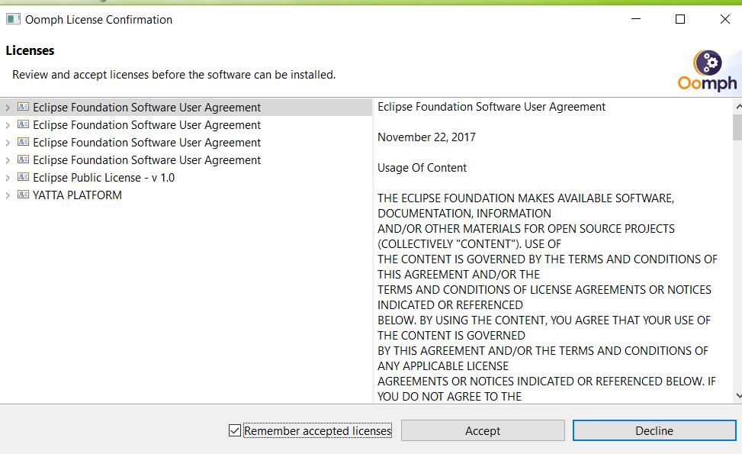

The setup is ready now.

We have the settings which could be shared with the team and they could import and setup

Firstly, we create Yatta account and upload our profile giving necessary visibility settings.

Once this is done, we can import the profile from Eclipse MarketPlace as well.

Advantages

Saves a lot of time to setup

Useful in agile environment especially when a module development moves across different developers, they can get started to code very soon.

Its worth spending time on researching on this tool and see if that helps your project.