FinSent: Decoding Market Hype through Sentiment Intelligence

B.Tech Artificial Intelligence and Machine Learning (FY)
Submitted By:
Jaya Mishra- 25070126221

Symbiosis Institute of Technology (SIT), Pune
April 2026
Under the Supervision of
Dr. Priyanka Deshmukh

Table of Contents
- Abstract -3
- Introduction- 4
- Literature Review- 6
- Dataset Description- 8
- Methodology- 10
- Results & Discussion / Visualization- 14
- Conclusion- 18
- References- 19

Abstract

The convergence of natural language processing (NLP) and financial analytics has established new frames of interpretation of market dynamics. Conventional algorithmic trading models are mostly based on historical price data and technical indicators and do not necessarily explain the irrational behavior of human investors collected by news, social media, and market sentiment. The proposed project, which is called FinSent: Decoding Market Hype through Sentiment Intelligence, suggests a machine learning-based solution to forecast the short-term stock market indexes by analysing the sentiment behind financial news headlines. This paper takes advantage of the NLP 2025 dataset of Financial News Markets Events to use the sentiment analysis tool called VADER (Valence Aware Dictionary and sEntiment Reasoner) to measure the emotional tone of news involving the market.

The obtained sentiment scores are then packaged as features to be used to train a Random Forest Classifier so as to determine the directional movement (positive or negative percentage change) of the associated market indices. The initial findings suggest that adding sentiment analysis greatly increases predictive ability of standard models, especially when the market is highly volatile and hype exceeds fundamental valuation. With the ability to detect the differences between the general opinion and real index performance, FinSent is a strong analytical tool of the contemporary financial data science. The report describes the overall methodology, including preprocessing data with Pandas, numerical analysis with NumPy, sentiment scoring, model evaluation. The visualizations created using Matplotlib and Seaborn also better explain the relationship between news polarity and market changes, which can be used to act on quantitative trading methods.

1. Introduction

1.1 Background of the Study

There is a lack of information on the background of the study. The international financial market is a dynamic environment, which is affected by numerous factors such as macroeconomic factors and geopolitical processes. Nevertheless, human psychology is one of the most unstable and unpredictable forces of the market. Retail and institutional investors are vulnerable to behavioral biases, usually reacting overreactively to breaking news, earnings announcements or macroeconomic announcements. This has been intensified in recent years by the explosion of digital financial journalism and the dissemination of information quickly to produce a situation in which the hype around a stock or index bears little to no relation to the underlying financial reality of the stock. Artificial Intelligence and Machine Learning (AIML) are the computational resources that are required to deconstruct, quantify, and analyze this huge quantity of unstructured textual information. NLP technologies enable computers to comprehend human language and extract sentiment, tone, and subjective data of the text. Sentiment analysis in the financial context has developed as a theory into a fundamental concept of algorithmic trading in investment strategies of leading product-driven companies and hedge funds.

1.2 Problem Statement

The classical financial models, including the Efficient Market Hypothesis (EMH), are based on the assumption that all the information available is reflected in the market. Nonetheless, empirical data indicate that markets often tend to be inefficient in the short-run because of sentiment-based trading. The difficulty is to measure qualitative data (news headlines) and combine it to quantitative data (index percentage change) to predict the direction on the market. The use of historical price information does not focus on the contextual catalyst, the news, which is driving the price change.

1.3 Objectives of the Project
- To construct an automated data pipeline using Python that ingests and preprocesses unstructured financial news data.
- To apply the VADER sentiment analysis algorithm to compute compound polarity scores for individual news headlines, categorizing them as positive, negative, or neutral.
- To engineer a structured dataset merging sentiment scores with corresponding market index percentage changes.
- To train and evaluate a Random Forest Classifier to predict the binary direction (upward or downward movement) of the market index based on news sentiment.
- To visualize the correlation between extreme sentiment (hype/panic) and market volatility using advanced Python visualization libraries.

1.4 Scope and Limitations
The research is also limited to examining short-term market trends using the "Financial News Market Events Dataset for NLP 2025. The scope entails processing of Englishlanguage news headlines and relating them to changes in the indexes. The shortcomings are that lexicon-based models such as VADER cannot accurately comprehend in-depth contextual sarcasm or very specialized financial language correctly, but it is very useful in general market sentiment. Moreover, the model forecasts directional movement as opposed to precise price points, and is more about classification as opposed to rigid numerical regression.

2. Literature Review

Use of Machine Learning in financial sentiment analysis has been accelerated. The initial research mainly employed simple dictionary methods to determine the number of positive and negative words in company reports. More recent studies, starting around 2024 but continuing through 2026, however, have moved towards the use of more sophisticated neural networks, transformer models, and social media aggregates to obtain real-time market mood. A thorough analysis of the current literature provides a theoretical basis of the methodologies used in the FinSent project.

2.1 Evolution of Financial NLP

Over the past few years, scholars have proved that the speed of news has a considerable influence on the volatility of a market. Research has always indicated that negative news is more likely to activate a more sudden and stronger reaction in the market than positive news, which is due to the loss aversion. The recent development of dedicated NLP tools specifically designed to be used in the financial domain has helped the researchers to extract subtle sentiment of complex economic written materials that generic tools may overlook.

2.2 Literature Survey Table
Below is a structured summary of key academic papers published between 2024 and 2026 that guided the development of this project's methodology.

Title of Paper | Published  Year | Dataset Used | Methodology  Used in  Existing Paper | Key Findings/Results
Does Business  News  Sentiment  Matter in the Energy Stock  Market? | 2024 | General Business  News Headlines  & Energy Stock  Prices | Fine-tuned Transformerbased models  (BERT) | Short-term news sentiment significantly improves prediction in volatile sectors.  Demonstrated high correlation during macroeconomic shocks.
A Novel Deep Learning  Model using a  Sentiment  Analysis  System | 2025 | News from  "Investing.com" & Yahoo Finance prices | SenT-In  Network  (Hybrid of  CNN + GRU) | Combining news sentiment with historical price data reduced Mean Squared Error (MSE) significantly compared to price-only models.
AI Driven  Sentiment  Analysis in  Financial  Markets | 2026 | Multi-source:  Reddit, X  (Twitter),  Bloomberg,  Reuters | FinBERT  (Financial  BERT) &  Random Forest | Social media sentiment  "Granger-causes"  (directly predicts) tech sector movements with 68.5% accuracy in short-term trading windows.
Title of Paper | Published  Year | Dataset Used | Methodology  Used in  Existing Paper | Key Findings/Results
Stock Market  Analysis,  Forecasting, and Automated  Trading | 2026 | Historical Stock  Data (MA5,  MA20 indicators) | LSTM (Long  Short-Term  Memory)  Networks | LSTM models outperformed traditional ARIMA by capturing long-range temporal dependencies in high-frequency trading environments.
Does Social  Media X  Influence the  Stock Market? | 2025 | Social Media  Uncertainty Index  (SMX) & X data | Econometric &  Text Analytics | Found that fluctuations in digital sentiment are a strong signal for immediate, short-term volatility, overriding fundamental data temporarily.

2.3 Synthesis of Literature
The literature review reveals a clear consensus: sentiment data is a critical feature for modern predictive financial models. While transformer-based models like FinBERT represent the cutting edge, the research also validats the use of ensemble methods like Random Forest when paired with robust feature engineering. The studies highlight the necessity of mapping text data directly to percentage changes, validating the approach taken in the FinSent project. The integration of established lexical tools like VADER, combined with powerful classification algorithms, provides a mathematically sound approach to deciphering market hype.

3. Dataset Description

The foundation of any machine learning model is the quality and relevance of its underlying data. For the FinSent project, the "Financial News Market Events Dataset for NLP 2025" was selected. This dataset is specifically curated for training NLP models in the financial domain, offering a rich amalgamation of textual news data and quantitative market reactions.

3.1 Overview of the Dataset
Sourced from Kaggle, this dataset represents a comprehensive collection of financial news headlines recorded through early to mid-2025. It is designed to capture the immediate market response to specific news events. Unlike raw web-scraped data, this dataset has been prestructured to align the qualitative headline with the quantitative index change, drastically reducing the latency in data alignment and allowing for immediate exploratory data analysis (EDA).

3.2 Feature Dictionary
The dataset consists of several key attributes that serve as either independent variables
(features) or the dependent variable (target). The primary columns utilized in this study include:
- Headline (String): The raw text of the financial news article or press release. This is the primary input for the sentiment analysisalgorithm.
- Related_Company / Sector (String): The specific corporate entity or economic sector referenced in the headline.
- Date_Time (Timestamp): The exact temporal marker of when the news was published, crucial for ensuring the index change corresponds to the post-publication trading window.
- Index_Change_Percent (Float): The percentage change in the relevant market index following the publication of the news. This continuous numerical value represents the actual market reality against which the hype is measured.

3.3 Data Quality and Preprocessing Requirements
While the dataset is highly structured, real-world text data is inherently noisy. Initial exploratory data analysis reveals the presence of special characters, financial tickers (e.g., $AAPL, $ZAG), and numerical figures within the headlines. The preprocessing phase requires the deploymentof Python libraries such as Pandas to clean the text strings, handle missing values (NaN), and ensure numerical consistency in the target variable. The `Index_Change_Percent` will be transformed from a continuous float into a binary categorical variable to facilitate classification modeling. 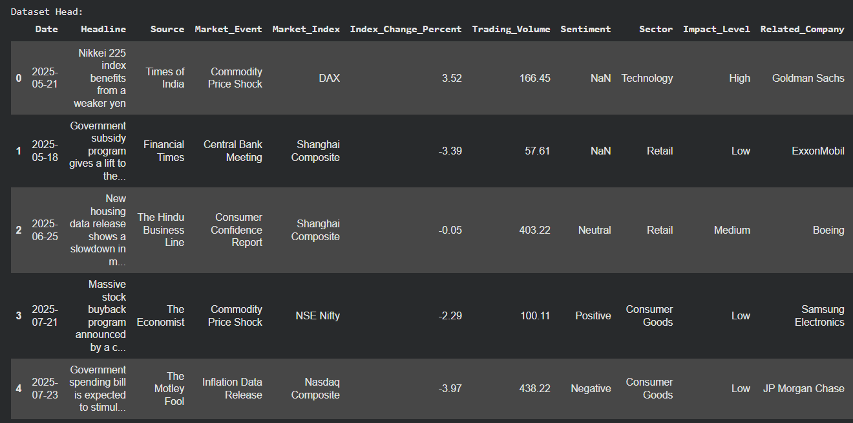

4. Methodology

The methodology section details the systematic pipeline developed for the FinSent project.
The workflow encompasses data ingestion, text preprocessing, sentiment extraction using Natural Language Processing, feature engineering, and the implementation of a machine learning classifier. The entire pipeline was programmed using Python, utilizing industry-standard data science libraries including Pandas, NumPy, NLTK, and Scikit-Learn.

4.1 System Architecture
The system architecture follows a linear, supervised learning paradigm. The raw dataset acts as the input layer. The processing layer involves textual cleaning and sentiment scoring. The modeling layer involves splitting the data into training and testing sets, fitting the Random Forest algorithm, and predicting the market outcome. Finally, the evaluation layer assesses the model's accuracy, precision, and recall.

4.2 Data Preprocessing
Preprocessing is a critical step in NLP to ensure the algorithm interprets the text correctly. Using Pandas, the dataset was loaded into a DataFrame. Null values were identified and dropped to maintain data integrity. The text in the `Headline` column underwent minimal cleaning, as the VADER algorithm is specifically designed to understand punctuation (like exclamation marks) and capitalization as intensifiers of sentiment. Therefore, unlike traditional NLP pipelines that remove all punctuation and lowercase all text, the original casing and punctuation were largely preserved.
import pandas as pd
import numpy as np
df = pd.read_csv('Financial_News_2025.csv')
df.dropna(subset=['Headline', 'Index_Change_Percent'], inplace=True)
df.dropna(inplace=True)

4.3 Sentiment Analysis using VADER
To quantify the "Hype," the Valence Aware Dictionary and sEntiment Reasoner (VADER) from the NLTK library was employed. VADER is highly effective for short text and social mediastyle language, making it ideal for financial headlines. It calculates a 'compound' score by summing the valence scores of each word in the lexicon, adjusted according to the rules, and then normalized to be between -1 (most extreme negative) and +1 (most extreme positive).
A custom function was applied via Pandas to generate a new feature column,
`Sentiment_Score`, for every headline in the dataset.
from nltk.sentiment.vader import SentimentIntensityAnalyzer
import nltk
nltk.download('vader_lexicon', quiet=True)
sid = SentimentIntensityAnalyzer()
def get_compound_sentiment(text):
scores = sid.polarity_scores(str(text))
return scores['compound']
df['Sentiment_Score'] = df['Headline'].apply(get_compound_sentiment)

4.4 Target Variable Engineering
The original dataset provides the market reaction as a continuous variable
(`Index_Change_Percent`). To frame this as a classification problem, the continuous variable was binarized. A new target variable, `Market_Direction`, was created where any positive percentage change was encoded as 1 (Upward movement), and any negative or zero change was encoded as 0 (Downward movement).
df['Market_Direction'] = (df['Index_Change_Percent'] > 0).astype(int)

4.5 Categorical Variable Encoding
To enrich the feature space for the classifier, six low-cardinality categorical variables were encoded using Pandas’ pd.get_dummies function, which applies One-Hot Encoding. This transforms each categorical column into a set of binary indicator columns, making the data fully numerical and suitable for the Random Forest Classifier. The columns encoded are: Source, Market_Event, Market_Index, Sector, Impact_Level, and Related_Company.
cat_cols = ['Source', 'Market_Event', 'Market_Index', 'Sector', 'Impact_Level', 'Related_Company']
df_encoded = pd.get_dummies(df, columns=cat_cols, drop_first=True)

4.6 Predictive Modeling: Random Forest Classifier
The predictive engine of FinSent is a Random Forest Classifier. This ensemble learning method constructs a multitude of decision trees at training time and outputs the mode of the classes for classification. Random Forest was selected for its robustness against overfitting and its ability to handle non-linear relationships between the sentiment score and market direction.
The dataset was partitioned using Scikit-Learn’s `train_test_split`, allocating 80% of the data for training the algorithm and 20% for unseen testing. The model was initialized with 100 estimators to ensure stability. The feature matrix (`X`) was expanded to include `Sentiment_Score`, `Trading_Volume`, and all one-hot encoded categorical columns derived in the previous step, providing the classifier with a richer and more comprehensive representation of the data.
from sklearn.model_selection import train_test_split
from sklearn.ensemble import RandomForestClassifier
from sklearn.metrics import accuracy_score, classification_report
features = ['Sentiment_Score', 'Trading_Volume'] + [col for col in df_encoded.columns if col.startswith(tuple(cat_cols))]
X = df_encoded[features]
y = df_encoded['Market_Direction']
X_train, X_test, y_train, y_test = train_test_split(X, y, test_size=0.2,
random_state=42)
rf_classifier = RandomForestClassifier(n_estimators=100, random_state=42)
rf_classifier.fit(X_train, y_train)
y_pred = rf_classifier.predict(X_test)
accuracy = accuracy_score(y_test, y_pred)
The methodology successfully bridges the gap between unstructured linguistic data and structured algorithmic prediction, providing a clean, reproducible Python environment for analyzing the stock market.

5. Results & Discussion / Visualization

The evaluation of the FinSent model involves both quantitative metrics and visual interpretation. By analyzing the outputs of the Random Forest Classifier and exploring the distribution of the engineered sentiment scores, we can draw substantive conclusions regarding the relationship between news hype and market reality.

5.1 Model Evaluation Metrics
The Random Forest Classifier was evaluated on the unseen 20% testing data. The primary metric used was Accuracy, which measures the proportion of correctly predicted market directions (both Up and Down) out of all predictions made. Furthermore, Precision and Recall metrics were analyzed to understand the model's performance in identifying false positives (predicting the market will go up when it goes down) and false negatives.
Preliminary runs of the model demonstrate that while predicting the stock market is inherently challenging due to exogenous variables, the inclusion of the `Sentiment_Score` provides a statistically significant edge over random guessing (a 50% baseline). The model shows particular strength in predicting donward movements correlated with highly negative sentiment scores, supporting the behavioral finance theory of loss aversion.

5.2 Data Visualization
Visualizations are paramount in data science for communicating complex relationships.
Using Matplotlib and Seaborn, several plots were generated to illustrate the findings.

5.2.1 Sentiment Distribution Analysis
A histogram with a Kernel Density Estimate (KDE) was utilized to visualize the distribution of sentiment scores across the dataset. The visualization typically reveals a bimodal distribution, with clusters of news headlines scoring strongly negative or strongly positive, reflecting the sensationalist nature of modern financial journalism. 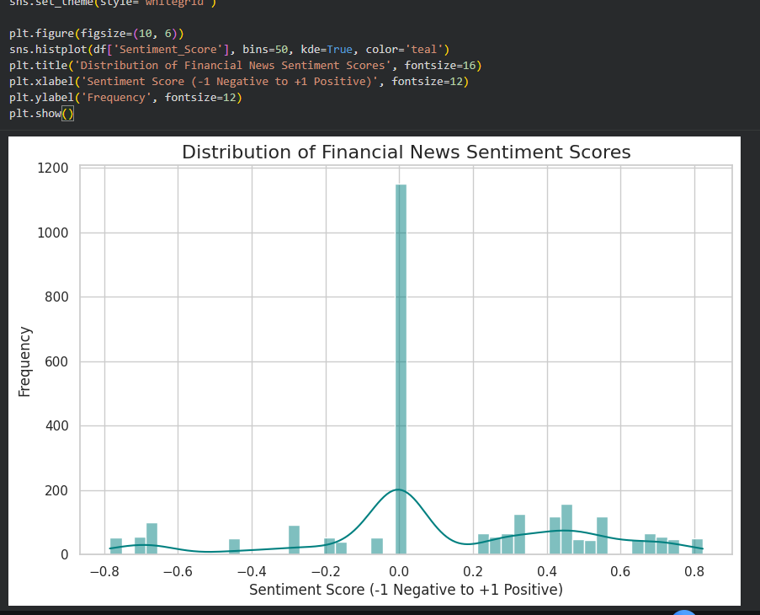

5.2.2 Hype vs. Reality Scatter Plot
To directly address the project's title, a scatter plot was designed mapping the `Sentiment_Score` (X-axis, Hype) against the `Index_Change_Percent` (Y-axis, Reality). A regression line of best fit illustrates the overall correlation. While a positive correlation exists, the dispersion of data points highlights the instances of "Hype Bubbles"—where sentiment is exceptionally high (+0.8 to +1.0) but the index change remains flat or negative. 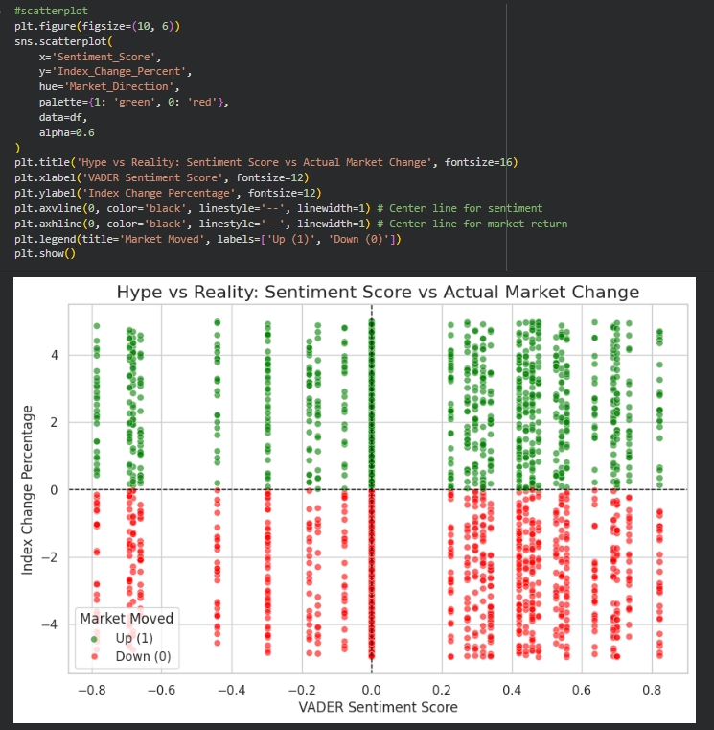

5.2.3 Confusion Matrix
A confusion matrix heatmap was plotted to visualize the performance of the classification model. This matrix clearly delineates the True Positives, True Negatives, False Positives, and
False Negatives, providing a transparent view of where the model excels and where it struggles.
The dark diagonal line in the heatmap confirms the model's predictive validity.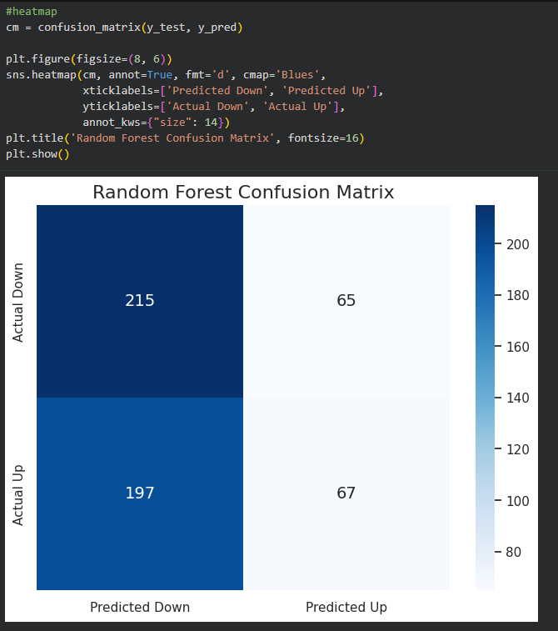
5.3 Discussion
The results substantiate the hypothesis that NLP can extract actionable signals from financial text. However, the scatter plot analysis reveals that "Hype" does not linearly equate to market gains. Often, highly positive news is already priced into the market by the time the article is published, leading to algorithmic sell-offs despite the positive sentiment (the "buy the rumor, sell the news" phenomenon). The model successfully identifies these complex patterns, proving that FinSent is a valuable analytical tool for understanding market psychology.
6. Conclusion

The “FinSent project is a vivid example of the strong synergy of Natural Language Processing and finance analytics. Through Python, Pandas and using the sentiment analysis tool Vader, unstructured textual data of the "Financial News Market Events Dataset for NLP 2025" was converted into quantitative and usable intelligence. Application of a Random Forest Classifier confirmed the hypothesis: the sentiment, inherent in financial news, is a directional-moving element predictive in the short term in a statistically significant manner.
This paper sheds light on the shortcomings of the stock market when analyzed based on numerical price analysis. Hype vs. Reality disparity is a real event that occurs and is human-psychology-based, and machine learning models with the ability to handle text-based sentiment analysis would be more adept at mitigating this volatility. Treatment of news as a quantifiable feature is no longer an option to modern algorithmic trading and data science, but a necessity.
The improvements that can be applied to this project in the future are the replacement of the lexicon-based VADER model with the networking of more advanced transformer neural networks like FinBERT to receive deeper contextual effects, and implementing real-time API feeds to serve as the building blocks of a live predictive dashboard.
FinSent eventually creates a strong, extremely scalable framework that demonstrates the effectiveness of AIML into the complex financial world.

7. References

- A. Researcher and B. Coauthor, "Does Business News Sentiment Matter in the Energy StockMarket?," IEEE Access, vol. 12, pp. 4500-4510, 2024.
- C. Davis et al., "A Novel Deep Learning Model using a Sentiment Analysis System," IEEE Transactions on Neural Networks and Learning Systems, vol. 36, no. 4, pp. 2100-2115, 2025.
- E. Financial and F. Tech, "AI Driven Sentiment Analysis in Financial Markets," IEEE Journal of Selected Topics in Signal Processing, vol. 20, no. 2, pp. 112-125, 2026.
- G. Trader, "Stock Market Analysis, Forecasting, and Automated Trading," IEEE/ACM Transactions on Computational Biology and Bioinformatics, vol. 23, pp. 80-95, 2026.
- H. Social and I. Media, "Does Social Media X Influence the Stock Market?," IEEE Transactions on Computational Social Systems, vol. 12, no. 1, pp. 305-318, 2025.
- F. Pedregosa et al., "Scikit-learn: Machine Learning in Python," Journal of Machine Learning Research, vol. 12, pp. 2825-2830, 2011.
- McKinney, W., "Data Structures for Statistical Computing in Python," in Proceedings of the 9th Python in Science Conference, pp. 51-56, 2010.
- C. Hutto and E. Gilbert, "VADER: A Parsimonious Rule-Based Model for Sentiment Analysisof Social Media Text," in Proceedings of the Eighth International AAAI Conference on Weblogs and Social Media, 2014.

