AWS Project - Gostore.in.net

Architecture:

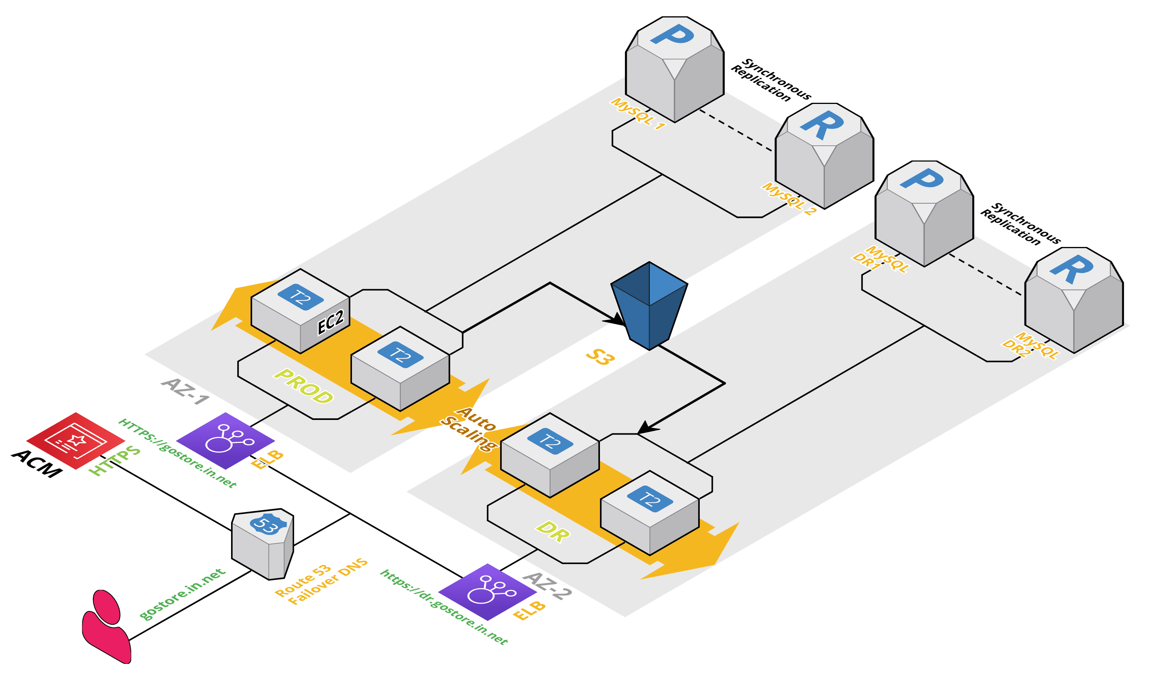
AWS Engineerings Involved:
- Server Engg
- Storage Engg
- Network Engg
- DataBase Engg
- Application Engg
- Security Engg – IAM, ACM

Tool to design cloud Infra: Cloud Craft - website:Cloudcraft.co

ACM – AWS Certificate Manager
HTTPS – secured website – contains SSL certificate.
SSL certificate provided by Certification Authority [CA]
CAs –
1.Comodo
2.Verisign
3.Digicert
4.Amazon – ACM
Environments in RealTime projects:
- DEV
- TEST/QA
- PROD - Live
- DR – Disaster Recovery
- UAT/CAT – user acceptance testing /Client acceptance testing

PROJECT:
1. AWS Prod Setup
2. AWS DR Setup
3. Installing the SSL Certificate using ACM & making the App Secured
4. Synchronization of Environments --> Prod & DR
5. Adding new parameters for the Cloud Watch Services
6. Tasks

Services Involved in the Project:
1. EC2
2. S3
3. ELB
4. Route53
5. RDS
6. IAM
7. ACM
8. Cloud Watch

Website: http://gostore.in.net

- ACM
- Goto AWS – ACM→ Request for a certificate.
- Choose Public certificate or Private certificate
- Here public certificate.
- Enter Domain Name [FQDN]→ gostore.in.net and *.gostore.in.net [wildcard certificate] for multiple environment like DR env dr.gostore.in.net
- Select validation method: DNS validation or Email [SES] – click DNS
- Click Request.
- One certificate wil be generated – Pending validation.
- Route53 is going to validate it now as we selected DNS validation method.

- Route53
Create Hosted zone from Route53.
Domain Name: gostore.in.net
Public hosted zone created. Copy the Nameservers.
Go to Bigrock: add these Nameservers

What are the recordsets in AWS: A, SOA, NS
Add A record set with ACM:
Go to ACM – click on the certificate which we created
Create record sets
Now new CNAME recordset is created . Verify in Route 53

- RDS
Create a subnet group
Create Database. Choose multiple AZ.
Choose freetier Mysql. In settings DB instance Identifier –
Give proddb
Master Username: Prodadm
Password: prodadm123

Next page: Availability zone: No preference
Choose default VPC, select open security group[All TCP] Make sure same region is chosen

Create DR setup with same setup

- IAM Role :
  - Roles : select EC2 – Policy ‘AdministratorAccess’ – To access all the services from EC2. ‘EC2AllAccess’
- EC2 Creation:
  - 2 AMI EC2 instances using below bootstrap script
  - Userdata: script
  - Attach EC2Adminrole
  - Choose openAll security group
  - Launch
  - Name EC2-1 ‘PROD’ and EC2-2 ‘DR’
  - Login to PROD and DR using Putty
  - Verify http is up and running
  - Hit IP in browser [see wordpress page]
- Application configuration:
  - EC2- to DATABASE connectivity – click Let’s go button from wordpress page
  - Give
    - DB-Name: proddb
    - Username: prodadm
    - Password: prodadm123
    - DB Host: Take from RDS-> proddb-> Endpoint:3306
    - Table prefix: <default>
    - submit
  - Repeat same setup for DR
  - A php file will be generated with all the above configs included.
  - Copy the content and paste under /var/www/html/wp-config.php on both PROD and DR instances
  - Click on Run Installation button from Wordpress page.
  - You will get ‘Gateway Timeout Response’. Check the configuration and recreate the wordpress application config. Else recreate the DB with proper information.
- From application site loaded when hit the URL in browser
  - Site Title : PROD APP
  - Username: prodadm
  - Password: prodadm123
  - Your Email: xxx
Click Install wordpress.

Click on Login: It will prompt username and password in page [Production wordpress Admin page]
  - Repeat above steps for DR

Endpoint URL of application
URL : <prodip>/wp-admin/

  - In homepage of wordpress: leftside -> All Posts-> Helloworld post-> modify to Hello Production and post
  - Repeat for DR homepage.
  - Take prod IP and hit in browser and DR IP and hit. You will see your home page with your content

- ELB – Classic LoadBalancer
  - Name: Prod LB
  - Security group: openall
  - Healthcheck: /healthy.html
  - Add EC2 – select prod EC2
  - Repeat for DR LB – with DR EC2
  - Take both LB URLs (endpoints)
  - Check the blog page with LB URLS are working
- R53 to ELB configuration
  - Create recordset gostore.in.net – choose alias select PROD ELB
    - Routingpolicy – simple
  - Create another recordset for dr.gostore.in.net- choose alias select – Name: dr.gostore.in.net – select DR ELB
Routing policy- simple
  - Now verify if Doman URL [both gostore.in.net and dr.gostore.in.net] is working for the application.
- Add ACM certificate to ELB
  - Goto PROD LB-> listeners-> Edit -> modify HTTP to HTTPS with 443 choose SSL -> choose ACM- select certificate visible there
  - Same set up for DR LB
  - Now verify our URLS is working only with HTTPS://
- PROD – DR synchronization: PROD – to - S3 – to - DR
  - Create a S3 bucket – make it as publick ‘wordpress-media-2703’ in same region
  - Create another s3 bucket- maket it a public ‘ wordpress-code-2703’
  - Give crontab commands for both PROD and DR EC2
Change the content of Prod page. It should reflect in DR site
  - Configure failover DNS for Prod and DR. Make prod EC2 down and check DR site is working

Adding disk and memory usage in cloudWatch:
https://docs.aws.amazon.com/AWSEC2/latest/UserGuide/mon-scripts.html

