**Qmetry Hackathon Inspirations**

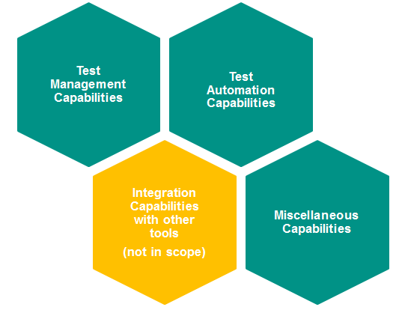

**Detailed Use Cases - Test management Capabilities**

Test Management between Qmetry and JIRA

* + Requirement module, adding, managing requirements between Qmetry and JIRA
  + Adding Test Goals in Qmetry from JIRA
  + Adding test cases from external tools, execute manual test cases
  + Maintain execution results, maintaining test evidences

Capabilities in agile/testing process

* Create Scrum model – release/projects/scrum teams, Sprints
* Create Sprint level test execution and regression execution
* Manage Sprint and the test execution status in Qmetry in post Sprint review

Traceability between requirement, Test cases and execution

* Build a traceability between requirement/test goals/test case/test result/defects

Import/export functionality in various modules

* Import test case from external sources, excel etc.
* Export execution report, update test one pager
* SYNC information to update JIRA, Test Goals, Bugs

**Detailed use Cases - Test Automation Capabilities**

Exploring Open API for importing test results

* Execution with Data Parameterization
* Import Automation test results(J-unit/TestNG, HP UFT etc.)
* Integrate UFT/Protractor/Selenium with Qmetry**(NOT IN SCOPE)**

Integration in CI/CD pipeline

* Making use of Jenkin plugin within Qmetry for uploading test reports and traceability

BDD

* Test Using frameworks, Cucumber

**Detailed use Cases - Integration Capabilities with Other tool**

Integration with Jenkins ,JIRA, XLR,TDM

* How to set up an integration with JIRA(with Qmetry instance)
* How to set up an integration with Jenkins(with Qmetry instance)
* How to set up an integration with XLR/TDM portal**(NOT IN SCOPE)**

Integration with Bit-Bucket, ALM, Confluence**(NOT IN SCOPE)**

* Set up an integration with Bit-Bucket
* Set up an integration with ALM(only for migration)
* Set up an integration with Confluence

Integration with an Automation Framework

* ATAF integration(result import)

Integration/Uploading from NFR testing**(NOT IN SCOPE)**

* Set up integration with Jmeter
* Check feasibility of integration with Load runner execution
* Set up integration for Security testing tools

Integration with Splunk**(NOT IN SCOPE)**

* Check feasibility of integration with Splunk to reflect Continuous Testing status

**Detailed use Cases – Miscellaneous**

Migration of ALM to Qmetry for existing projects**(NOT IN SCOPE)**

* Try out migration of Data from ALM to QM
  + - Requirements
    - Test cases
    - Execution reports
    - Defects

Exploratory testing capabilities/Automation/reporting (Get Qmetry Voyager Add-on)

* Export Exploratory testing result to pdf
* Automate exploratory test steps using HP Sprinter**(NOT IN SCOPE)**

Metrics and dashboard Capabilities

* Generate metrics
  + - Traceability
    - Test coverage
    - Defects per Sprint
    - Defects per release