**CS5334.0251/0252, Advanced Information Processing, Spring, 2016 Programming Project**

**“The most important applications in the Internet is Internet searching.”**

**Websites Used:**

The Internet Websites which are used to extract Information from the search results are:

1. **Walmart** [**http://www.walmart.com**](http://www.walmart.com)
2. **Amazon** [**http://www.amazon.com**](http://www.amazon.com)
3. **eBay http://www.ebay.com**

**STEP 1:**

Creating an **HTML Page** which allows the user to enter any Electronic product.

**STEP 2:**

**Parsing the Data:**

To parse the data obtained from the websites we implement libcurl for raw web search which enable **PHP** script to search the Internet.

**DOM (Document Object Model) parse** is used to parse the HTML source code obtained from the webpages.

**STEP 3:**

**Database Used: j_k201**

Create a table **Search_Info** to store the details retrieved from the websites used to search the Internet.

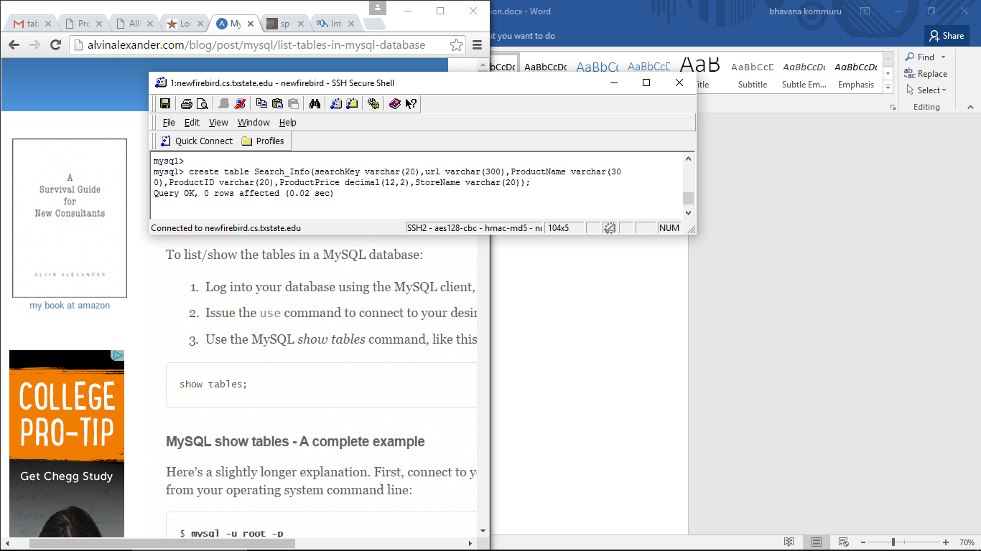

The Description of the table is as follows:

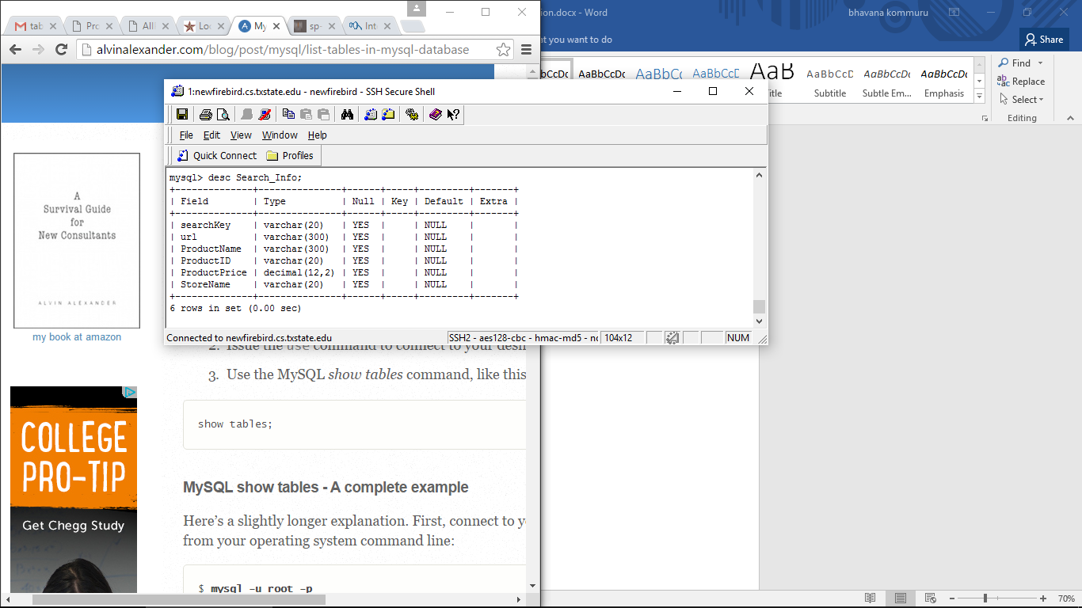

**Storing Data in the Database:**

Based on the user search all the parsed data is stored in the **Search_Info** table in the **MYSQL** database.

**Search_Info:**

* SearchKey -
* url – Stores the URL of the webpage of a particular product.
* ProductName - Stores the name of the Product.
* ProductID - Stores the ID of the Product.
* ProductPrice – Stores the Price of the product.
* StoreName – Stores the name of the website.

**STEP 4:**

**Rating Policy:**

**“Displaying the products based on the Descending Order of the price of the product.”**