**Experiment No: 6**

**Title:** Study & Implementation of

* Group by & Having Clause
* Order by Clause
* Indexing

**LAB PRACTICE ASSIGNMENT:**

* Creating Tables and inserting data

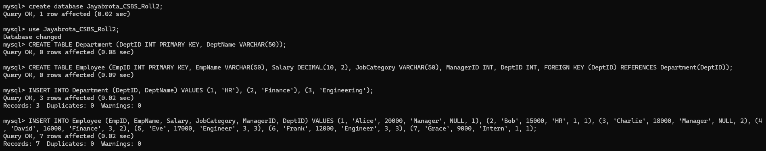

* Display Total Salary Spent for Each Job Category

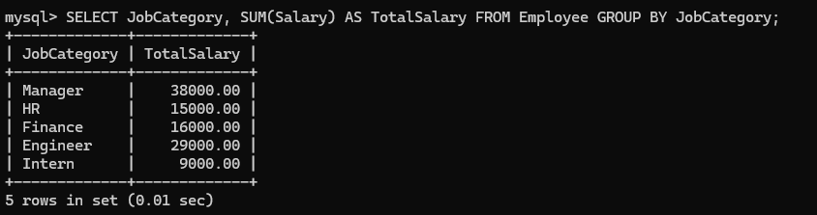

* Display Lowest Paid Employee Details Under Each Manager

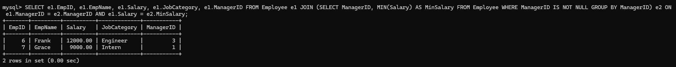

* Display Number of Employees Working in Each Department and Their Department Name

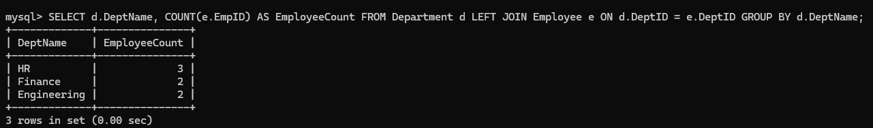

* Display Details of Employees Sorting the Salary in Increasing Order

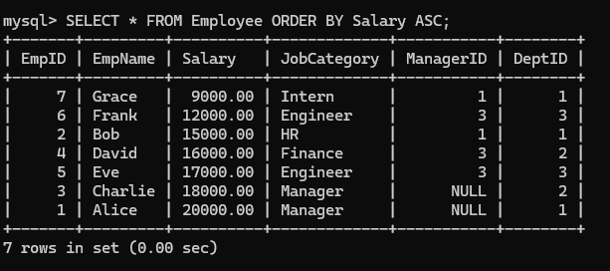

* Show Records of Employees Earning Salary Greater Than 16000 in Each Department

