Apache installation in aws ec2-redhat enterprise linux:

Login into aws account:

Launch instance

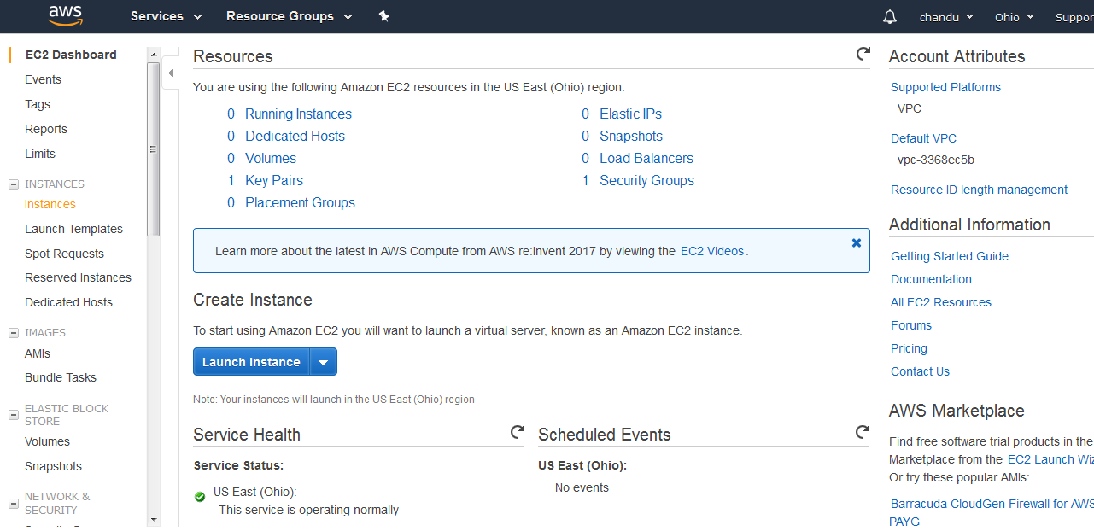

Select free tier and redhat enterprise linux 7.4

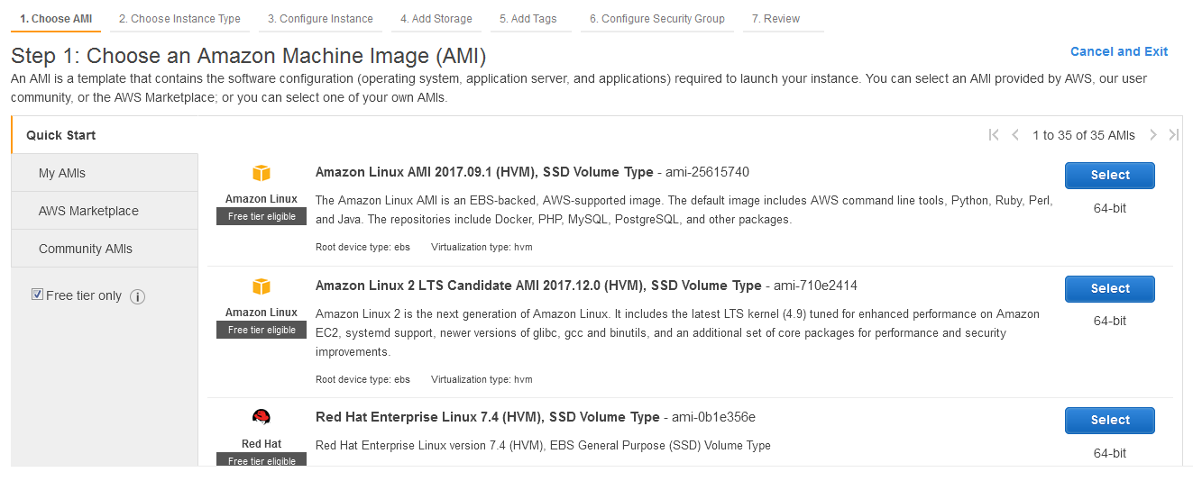

Choose an instance type:

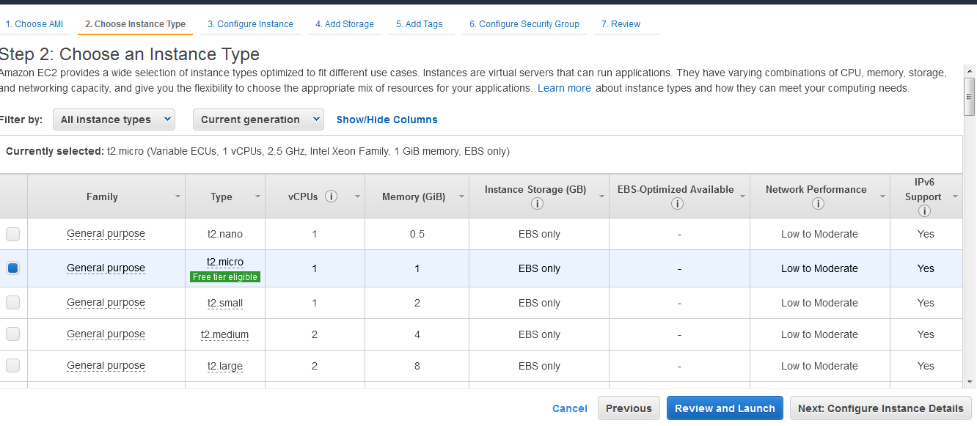

Configure instance type

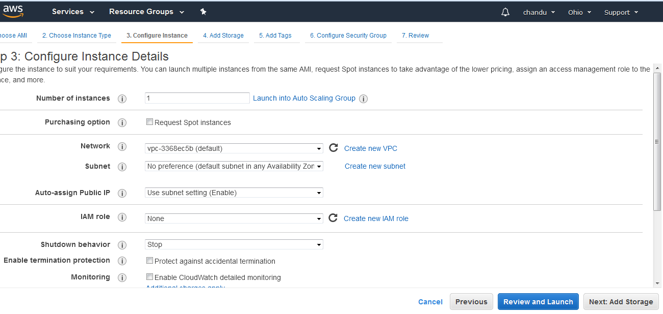

Add storage of instance:

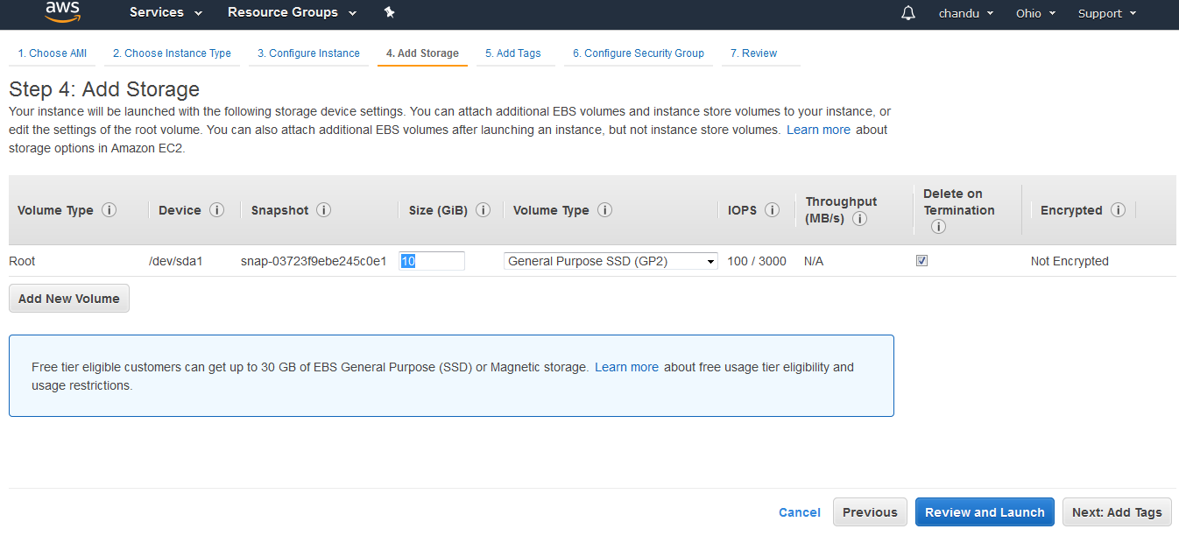

Add tags any name of instance

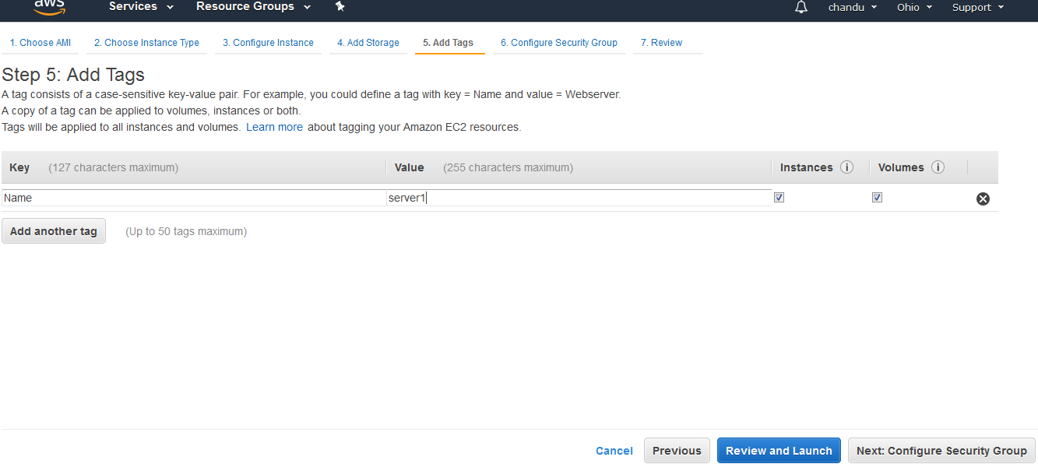

Configure security group means firewall

Ssh—22—anywhere give name and description for security group

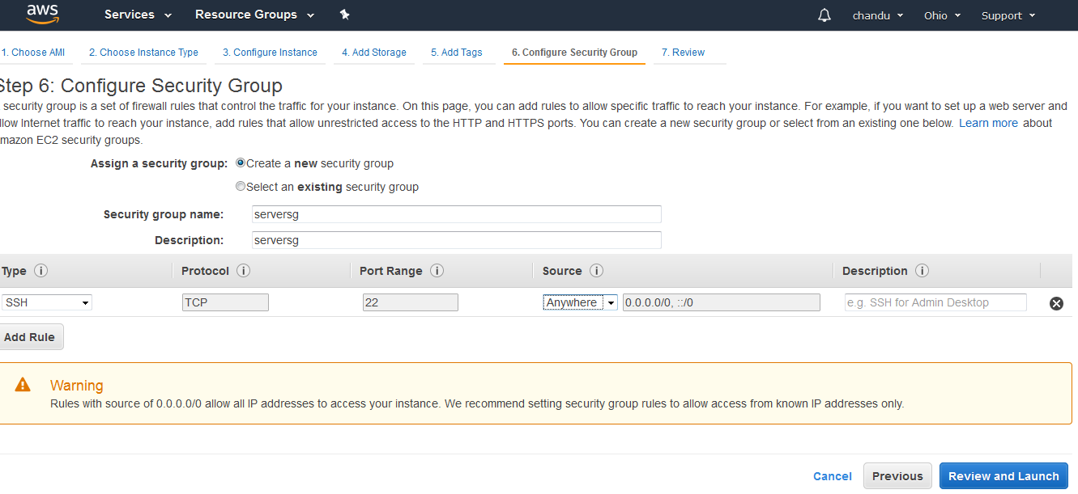

Review and launch

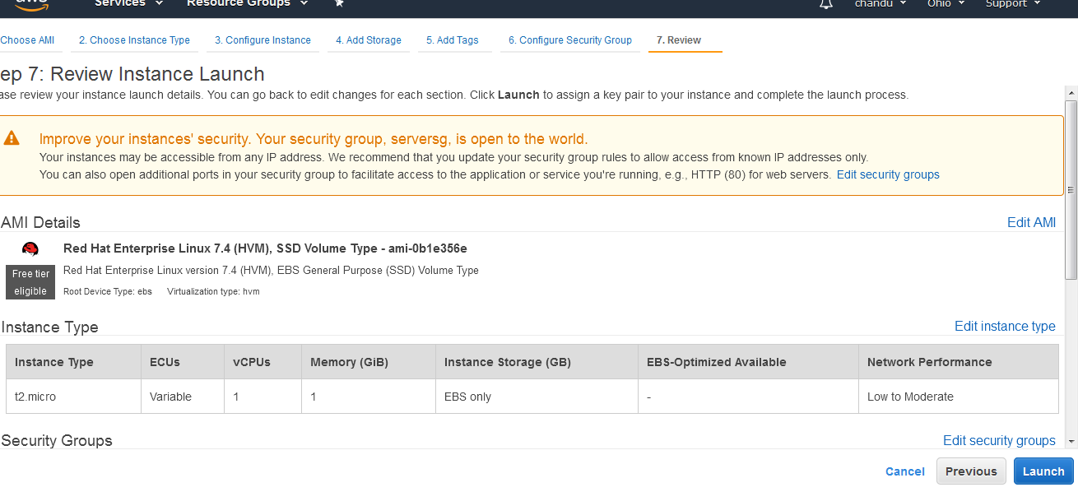

Launch and download key

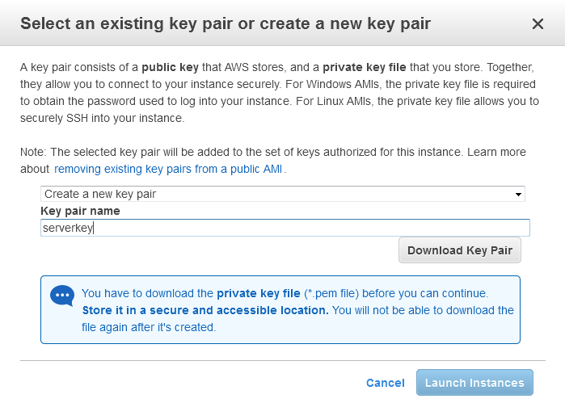

Launch instance



Launched instance

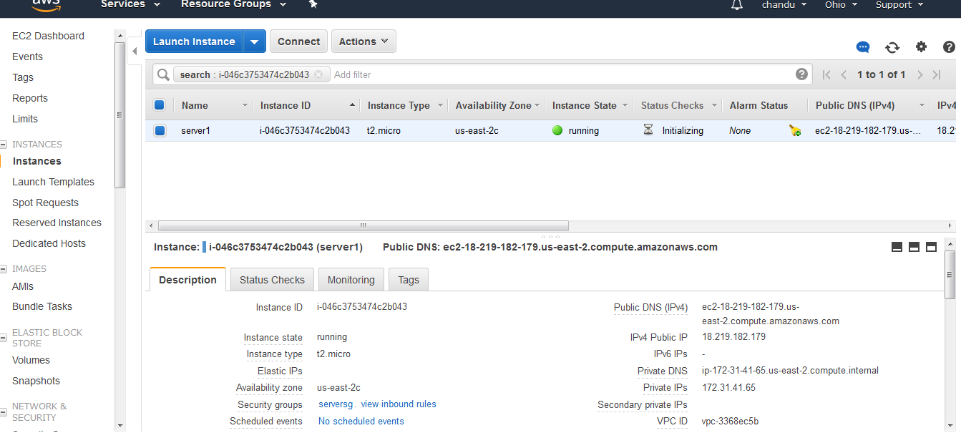

Download putty from browser

Install putty and go to start button --🡪puttygen--🡪select loadkey-🡪

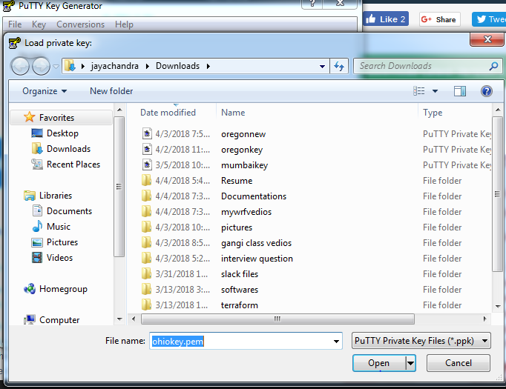

Open and save as privatekey



Select putty and give public ip of instance

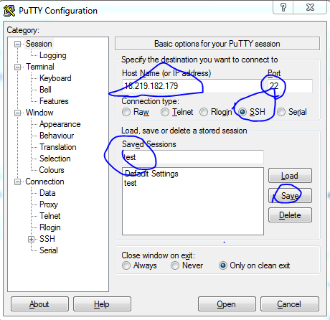

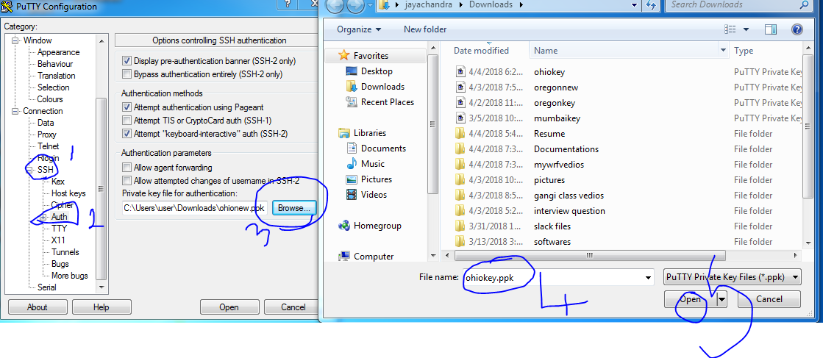

Open and login as ec2-user

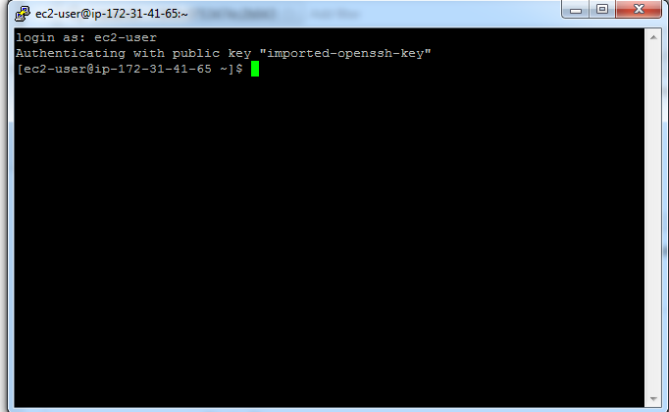

Now we are connecting to ec2-user redhatclinux server

Now install apache in this server

In terminal follow commands

Sudo yum install httpd –y

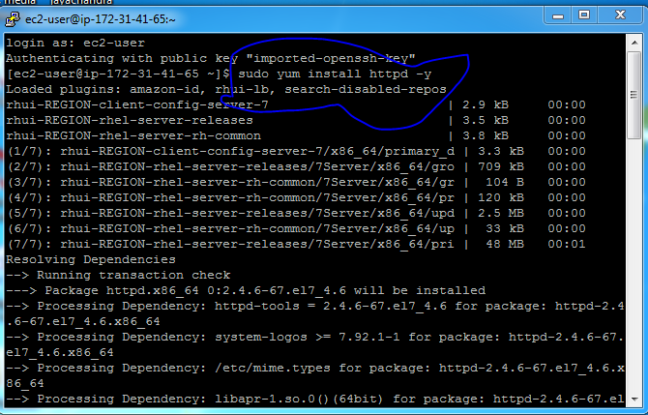

Now we installed apche in this server

Check is it running or not

Sudo systemctl status httpd

Sudo systemctl start httpd

Ps –ef | grep httpd

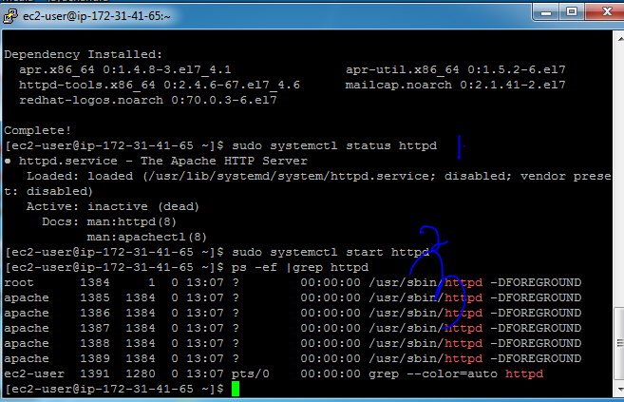add http—80—anywhere in security group

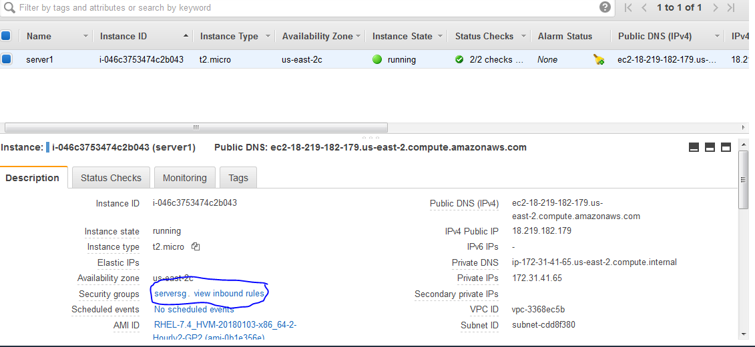

Select serversg and select inbound rule and edit and add http—80—anywhere

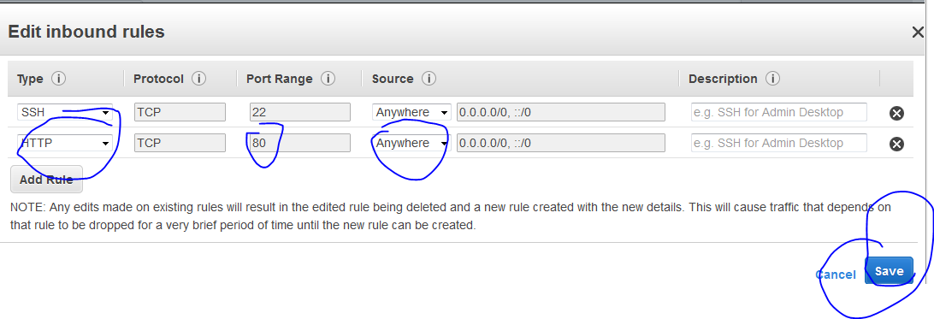

Now take public ip of ec2-instance and check it in browser and will see apache page

