Tomcat installation

Launch instances

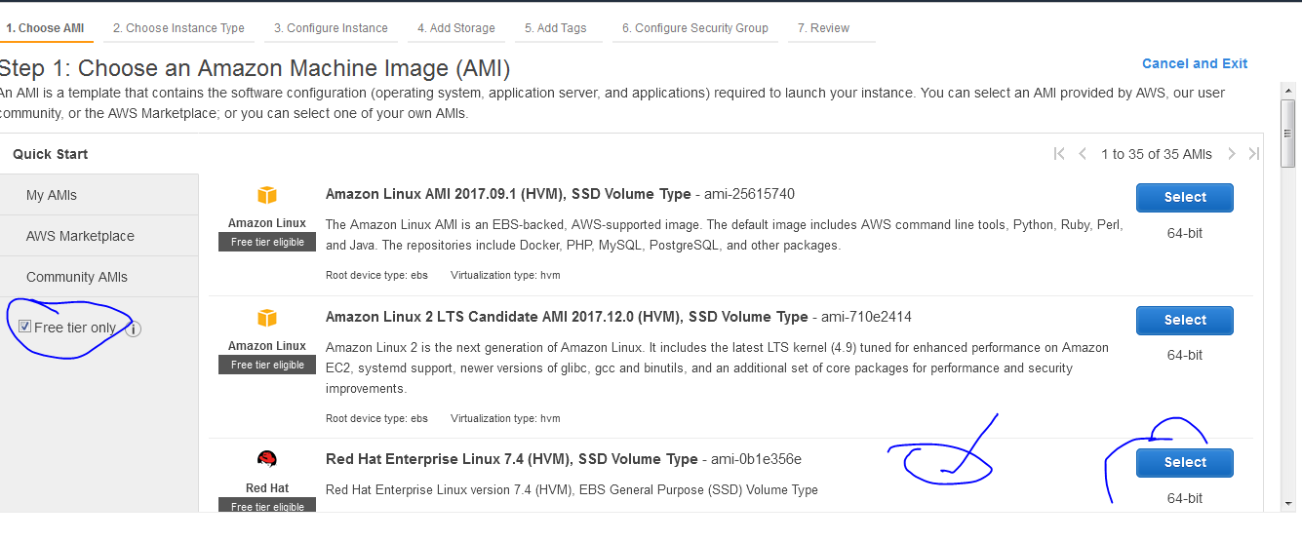

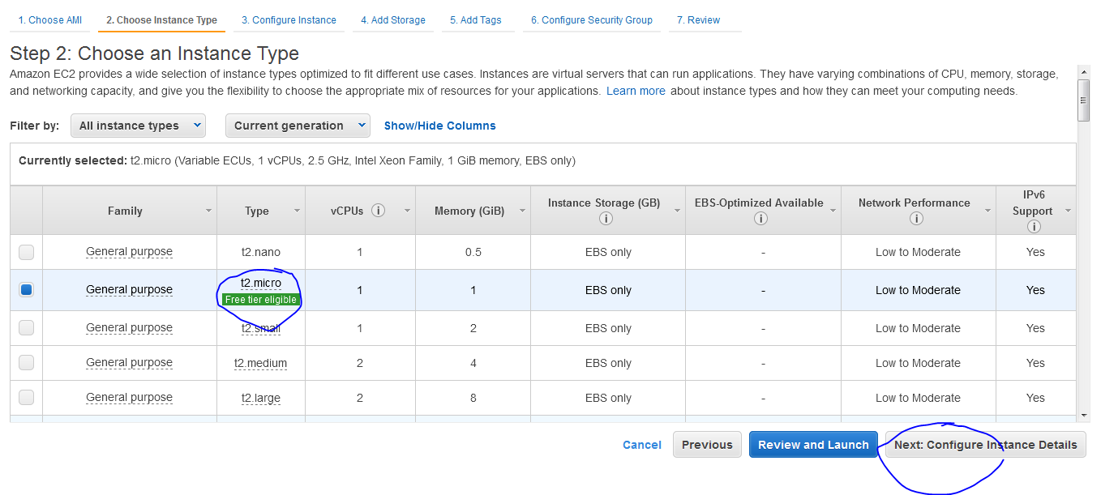

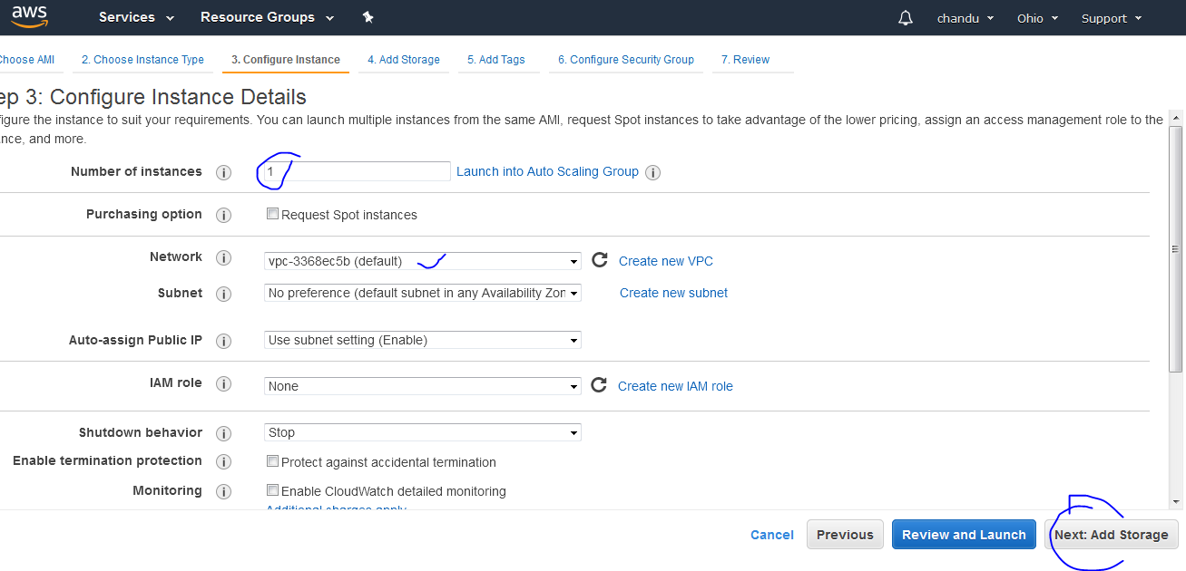

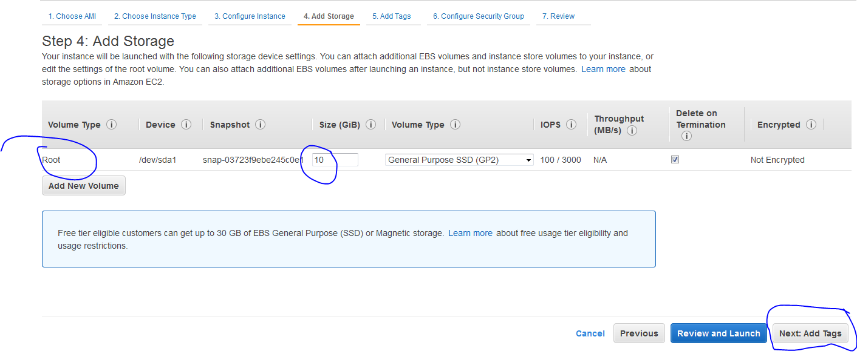

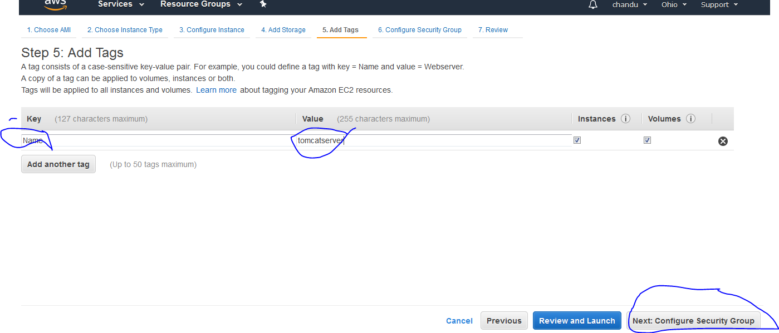

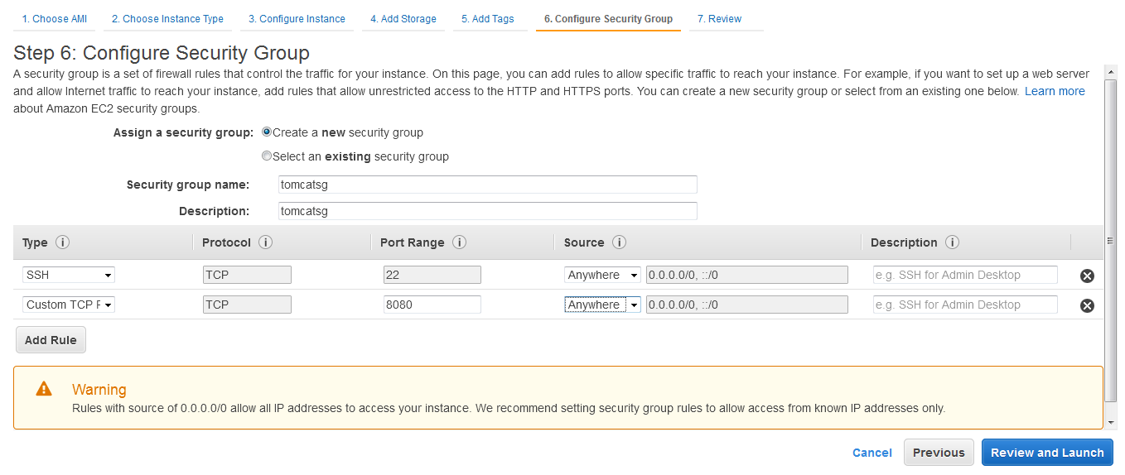

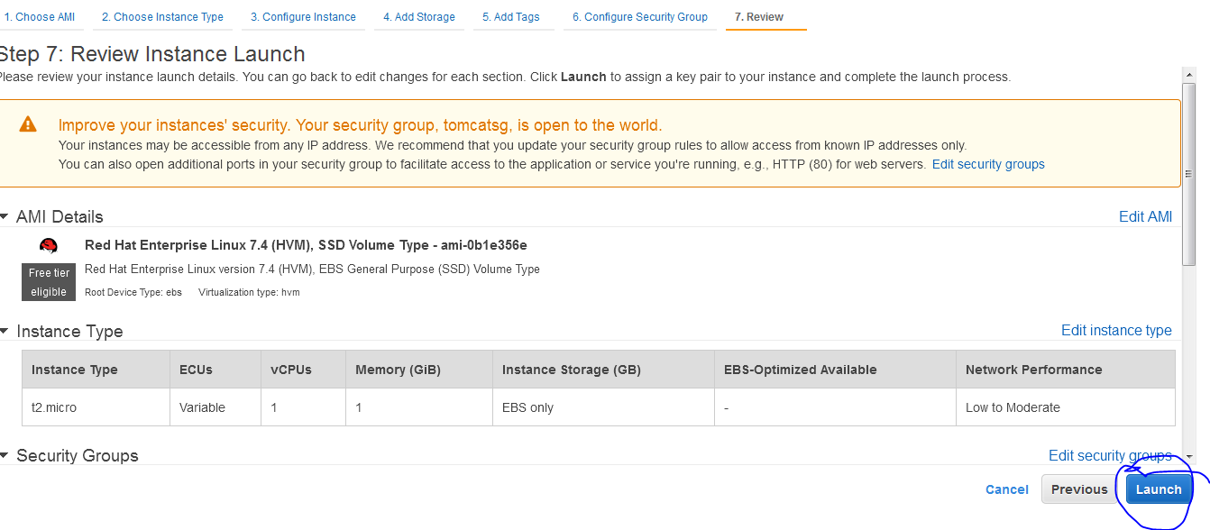

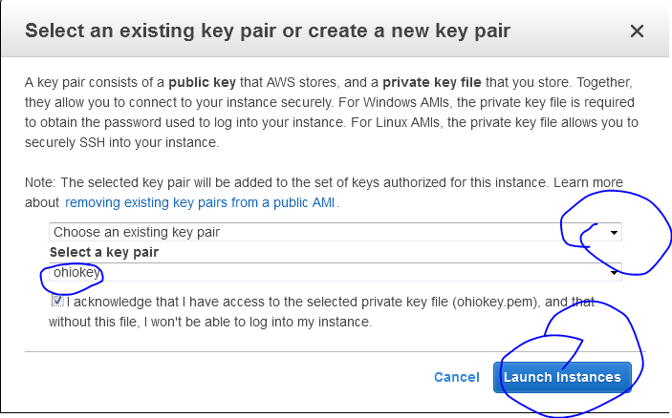

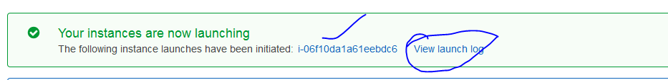

Now connect to ec2-instance using gitbash in windows

Download gitbash and go to downloaded key path

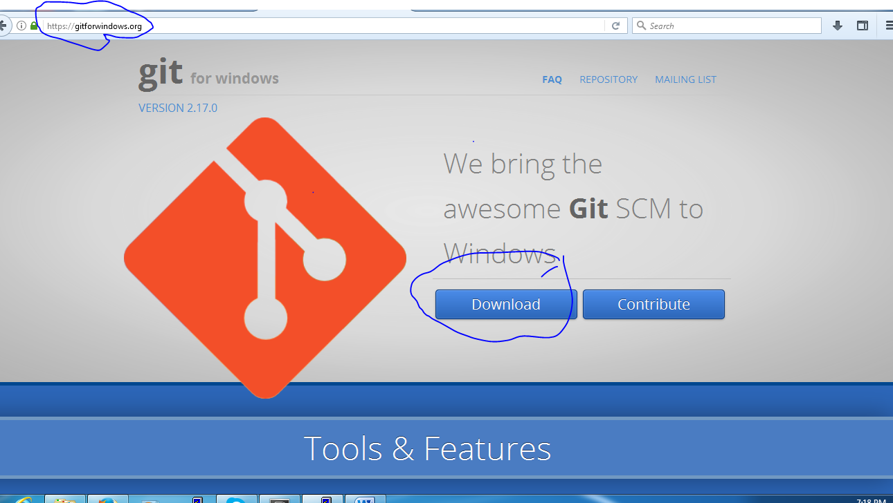

open gitbash at key downloaded path

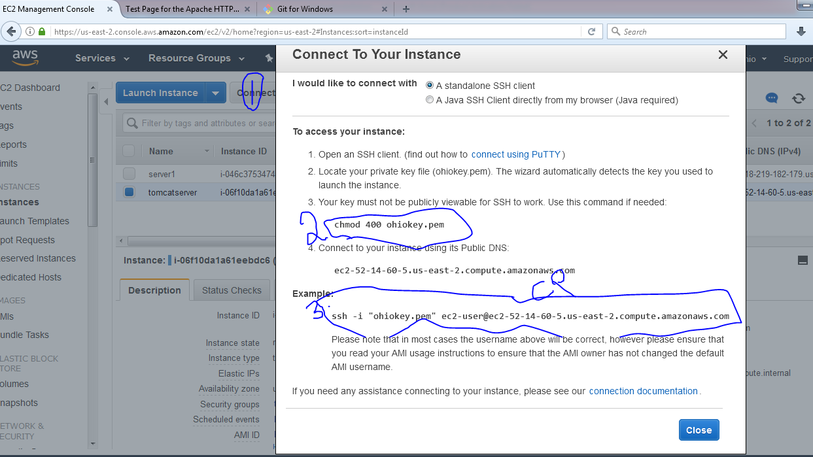

Change permisions for key and run folloing command

Chmod 400 ohiokey.pem

Ssh –I ohiokey.pem ec2-user@publicip/dnsname

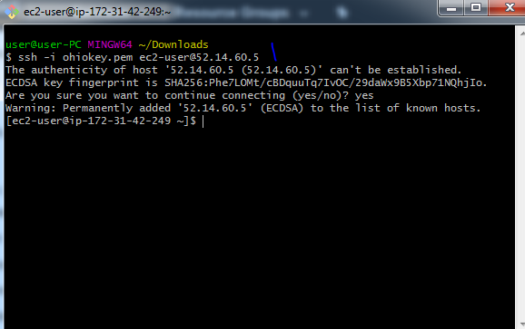

Now we are connected to ec2-instace

Tomcat installation :

Prerequired is java download

Sudo yum install java –y

Java –version

Now install tomcat from internet

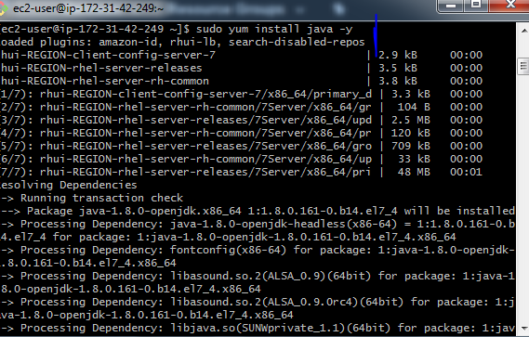

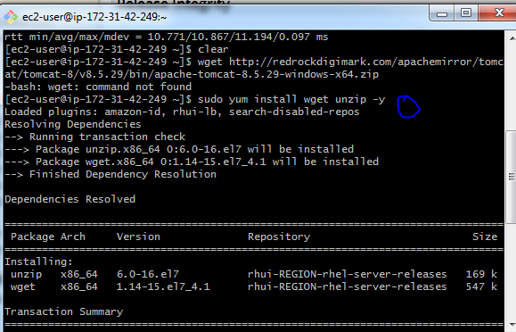

Tomcat download from internet and run following commands

Sudo wget tomcatur

Sudo wget <http://redrockdigimark.com/apachemirror/tomcat/tomcat-8/v8.5.29/bin/apache-tomcat-8.5.29-windows-x64.zip>

9 sudo yum install wget unzip -y

10 sudo wget http://redrockdigimark.com/apachemirror/tomcat/tomcat-8/v8.5.29/bin/apache-tomcat-8.5.29-windows-x64.zip

11 ll

12 sudo mv apache-tomcat-8.5.29-windows-x64.zip /opt

13 ll

14 cd /opt

15 ll

16 sudo unzip apache-tomcat-8.5.29-windows-x64.zip

17 ll

18 mv apache-tomcat-8.5.29 tomcat

19 sudo mv apache-tomcat-8.5.29 tomcat

20 ll

21 cd tomcat

22 cd bin

23 ll

24 chmod 755 \*.sh

25 sudo chmod 755 \*.sh

26 ll

27 sudo ./startup.sh

28 ps -ef |grep tomcat

29 history

Tomcat started and check it in browser with publicip:8080

Publicip:8080

