HCC Assurance Framework
Assurance Workbench (AWB)
Financial Crime (FC) & Conflict of Interest (COI) Implementations
High-Level Design (HLD) & Low-Level Design (LLD)
Platform: Pega Infinity '25 — Constellation UI Architecture
OOTB Email Channel & Email Triage, Dynamic Class Referencing, Shared Case Table, AI-Enabled Intent Classification
Organization: HCC
Prepared for: Solution Architecture & Business Analysis Review
Version 1.1 | Draft for Discussion

Table of Contents
Table of Contents 2
1. Executive Summary 3
2. Business Context & Objectives 3
2.1 Business Drivers 3
2.2 Design Objectives 3
3. Application & Class Naming Structure 5
4. High-Level Design (HLD) 8
4.1 Solution Overview 8
4.2 OOTB Email Channel & Email Triage (Shared Application) 8
4.3 Mailbox-to-Case Resolution: Dynamic Class Referencing 9
4.4 Key Components 9
4.5 AI-Driven Intent Classification 10
4.6 Integration Architecture 10
4.7 Non-Functional Requirements 11
5. Low-Level Design (LLD) 12
5.1 Class Hierarchy 12
5.1.1 Implementing the Shared Class Group — Build Sequence 13
5.2 Data Model 14
5.2.1 Mailbox-to-Process Mapping (HCC-AWB-Data-MailboxMap) 14
5.2.2 Process Configuration (HCC-AWB-Data-ProcessConfig) 14
5.2.3 Case Data (defined on HCC-AWB-Work-, inherited by Implementation classes) 14
5.3 Shared Case Lifecycle (Defined Once in the Shared Application, Inherited by Implementation) 15
5.4 Sample Mailbox and Routing Configuration 15
5.4.1 Mailbox Mapping 15
5.4.2 Category Routing (Within the Case) 15
5.5 Security Model 16
5.6 Extensibility: Onboarding a New Assurance Process 16
5.7 Shared Data Storage: Class Group (Work Pool) 16
5.8 Configuration & Reference Data Model 17
6. Risks & Mitigations 19
7. Appendix — Glossary 19

1. Executive Summary
This document presents the High-Level Design (HLD) and Low-Level Design (LLD) for HCC's reusable Assurance case management capability on Pega Infinity '25, using the Constellation UI architecture. The design uses a two-tier application model — a Shared application and Implementation applications — with two implementation applications in initial scope: Financial Crime (FC) and Conflict of Interest (COI), both built on a shared application, Assurance Workbench (AWB), which also hosts the Email Channel and Email Accounts directly.
This version reflects a refinement agreed with the architecture team: inbound assurance mail arrives across multiple mailboxes — for example, two mailboxes for Financial Crime and one for Conflict of Interest — all attached to a single Email Channel configured within the Assurance Workbench shared application. Pega's out-of-the-box (OOTB) Email Triage (ET) process captures each email automatically. From within the ET case's processing, HCC resolves which mailbox the email arrived on and, using Dynamic Class Referencing (DCR), creates the business case directly in the correct Implementation-layer class — HCC-AWB-Work-FC or HCC-AWB-Work-COI — with no intermediate case type created in the shared application.
The Assurance Workbench shared application's role is not to own a case type of its own, but to define the shared case stages, AI classification logic, and routing rules once, which every Implementation-layer case type inherits through standard Pega class inheritance. All resulting cases, across Financial Crime, Conflict of Interest, and any future process, are stored in a single shared database table using Pega's Class Group (work pool) capability, keeping the data footprint simple for HCC's low-to-medium case volumes.

2. Business Context & Objectives

2.1 Business Drivers
- Assurance functions at HCC (Financial Crime, Conflict of Interest, and future processes) each handle inbound correspondence manually today, leading to inconsistent SLAs and limited audit trail.
- Each new assurance process currently needs a bespoke build, increasing time-to-market.
- Regulatory expectation of fast, consistent, and auditable handling of sanctions-related correspondence.
- Opportunity to use Pega Infinity '25's native Email Channel and AI capabilities instead of building custom mailbox-listening logic.

2.2 Design Objectives
- Use the OOTB Email Channel and Email Triage (ET) process as the single entry point for assurance correspondence, avoiding custom email-polling code.
- Route each mailbox directly to the correct Implementation-layer case type using Dynamic Class Referencing, avoiding an unnecessary intermediate case.
- Define the reusable case stage skeleton and AI classification logic ONCE in the shared application (Assurance Workbench), inherited by every Implementation application.
- Store all assurance cases, across every process, in one shared database table to keep the data footprint simple given low-to-medium volumes.
- Design for Constellation from day one: DX-API-driven, reusable embedded views, App Studio-first configuration.
- Provide a clear path for onboarding future assurance processes as new Implementation applications on the same Assurance Workbench shared application.

3. Application & Class Naming Structure
Assurance Workbench (AWB) is a Shared application: it hosts the Email Channel and Email Accounts directly, in addition to the shared rules, and is the root of the shared Class Group, so the physical case table effectively lives under it, even though no case is ever created directly on its class. Financial Crime and Conflict of Interest remain Implementation applications, each with its own Ruleset. Only Implementation application classes are ever instantiated as cases.
Case type class names carry the Assurance Workbench prefix (HCC-AWB-Work-) even for Implementation-layer case types. This is a deliberate, Pega-required naming convention, not a governance change: Pega's Class Group mechanism — used here so all assurance cases share one physical database table — requires that every member class's name literally begin with the class group's name. Ownership is unaffected by this: each case type class is still saved in, and maintained by, its own Implementation application's Ruleset (FC or COI), completely independent of the class name.
Layer | Application Name | Application ID | Ruleset | Case Type Class
Shared | Assurance Workbench | AWB | AWB | HCC-AWB-Work- — class group root, hosts Email Channel & shared rules, no cases created here
Implementation | Financial Crime | FC | FC | HCC-AWB-Work-FC — cases created here
Implementation | Conflict of Interest | COI | COI | HCC-AWB-Work-COI — cases created here
Future assurance processes follow the same convention: a new Implementation application (e.g., Whistleblowing, ID: WB, Ruleset: WB) with case type class HCC-AWB-Work-WB, built on the same Assurance Workbench shared application, inheriting the same shared stage skeleton, and sharing the same physical table.
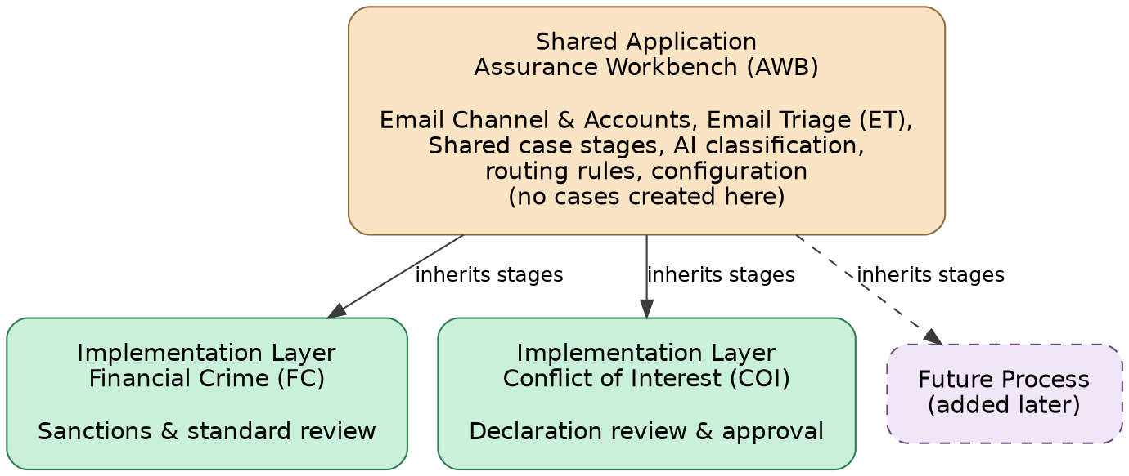
Figure 1: Application types — Shared and Implementation
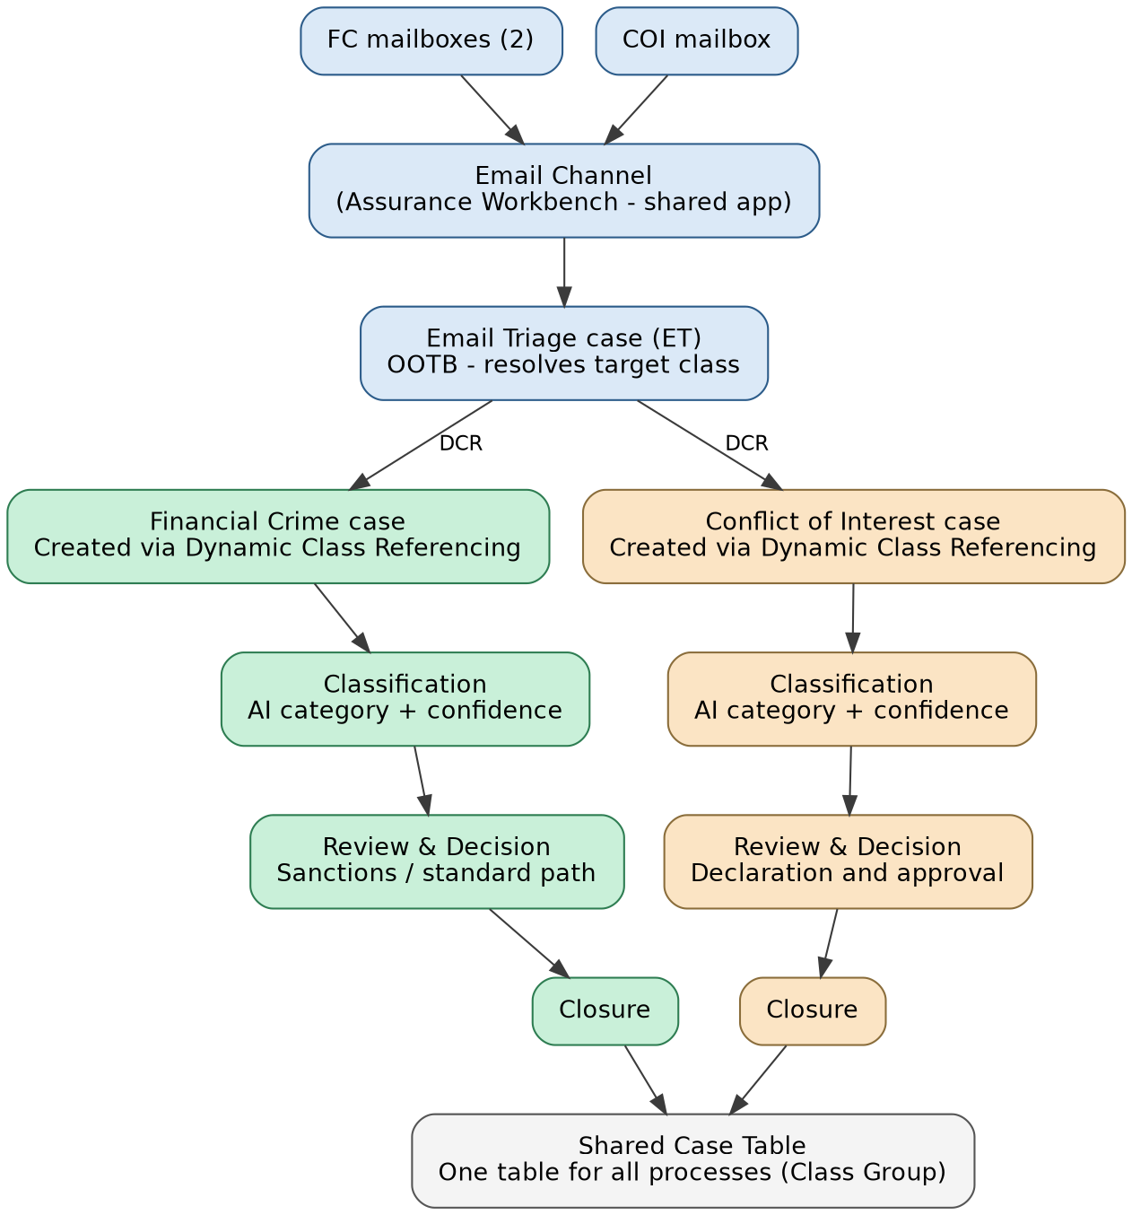
Figure 2: End to end process

4. High-Level Design (HLD)

4.1 Solution Overview
Inbound assurance emails arrive at one or more mailboxes managed within the Assurance Workbench shared application — HCC will configure two mailboxes for Financial Crime and one for Conflict of Interest, all attached to a single Email Channel. Pega's OOTB Email Triage (ET) process captures each email and its attachments automatically. Within the ET case's pyExecuteAction activity for the CreateCase class, HCC resolves which mailbox received the message and, using Dynamic Class Referencing, creates the business case directly in the matching Implementation-layer class. AI classification of the specific category (for example, Sanction vs Non-Sanction) then runs as the first stage inside that case, using logic defined once in the shared application and inherited by every Implementation application.

4.2 OOTB Email Channel & Email Triage (Shared Application)
Pega Infinity '25 provides a native Email Channel that can be configured with multiple Email Accounts (mailboxes) under a single channel. When an Email Channel is set up, Pega automatically creates an Email Listener that watches every configured mailbox and, for each inbound message, creates an Email Triage (ET) case with the email body and attachments already attached — this requires configuration, not custom code.
The ET case follows Pega's built-in Email Triage process, which runs through three stages, each with extension points where HCC can plug in custom logic without changing the OOTB flow:
Stage | Purpose | HCC Extension
PreTriage | Initial capture of the email; text analysis runs to extract topics, sentiment, and entities. | TBD
Triage | Applies routing rules to decide the outcome: reply, route, or create a case. | TBD
PostTriage | Finalizes the outcome and updates the ET case status. | TBD
The ET process exposes four standard outcome actions; HCC uses them as follows:
ET Action | How HCC uses it
Automatic Reply | Sends an acknowledgment to the sender confirming receipt (optional, process-configurable).
Route to Work Queue | Fallback only, for mail that does not match any configured mailbox mapping.
Route to User | Not used in the primary flow; reserved for edge cases requiring named-user attention.
Create Case | Primary path for all assurance correspondence — creates the case directly in the class resolved during the ET case lifecycle (HCC-AWB-Work-FC or HCC-AWB-Work-COI).
Reference: Pega Platform documentation, Email Triage process (docs.pega.com, Conversational Channels). HCC's build reuses this OOTB process as-is within the Assurance Workbench shared application and only extends it at the documented extension points — the ET case type itself is not modified.

4.3 Mailbox-to-Case Resolution: Dynamic Class Referencing
Rather than routing every mailbox to one generic intake case, HCC resolves the target Implementation case class directly during the ET case life cycle, using Dynamic Class Referencing (DCR) — the standard Pega mechanism for deciding a case's class at runtime instead of design time. A configuration mapping (Email Account to Process and Case Class) drives this resolution, so onboarding a new mailbox or process is a configuration change, not a code change.
- Each Email Account is mapped to a ProcessID and a target case class, e.g., FC mailbox 1 and FC mailbox 2 both map to HCC-AWB-Work-FC; the COI mailbox maps to HCC-AWB-Work-COI.
- The ET case's processing reads the mapping, resolves the class, and creates the case directly in that class — no separate case is created in the shared application at any point.
- Because HCC-AWB-Work-FC and HCC-AWB-Work-COI both inherit their stage skeleton from HCC-AWB-Work-, the newly created case automatically starts on the shared first stage (classification), with no additional wiring needed.
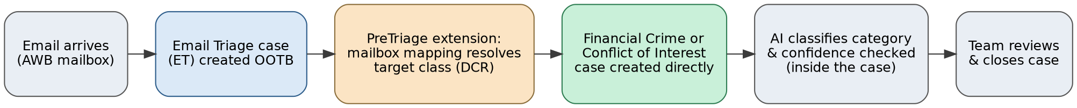
Figure 3: End-to-end flow — Email Channel to business case, via Dynamic Class Referencing

4.4 Key Components
Component | Layer | Responsibility
Email Channel & Email Accounts | Shared (AWB) | OOTB mailbox connections; multiple accounts per process attached to one channel.
Email Triage (ET) case | Shared (AWB) — OOTB class | Captures email/attachments; runs PreTriage, Triage, PostTriage; resolves target class and triggers Create Case.
Mailbox-to-Class Mapping | Shared (AWB) configuration | Data object mapping each Email Account to a ProcessID and target Implementation case class, read during ET case processing.
Shared Case Stages (Case Type rule) | Shared (AWB) — defined on HCC-AWB-Work- | Defines the common stage skeleton (classification, review, decision, closure) inherited by every Implementation case type; never instantiated itself.
AI Intent & Classification Service | Shared (AWB) | Reads email body and attachment text inside the case; returns category, confidence score, and rationale.
Categorization & Routing Rules | Shared (AWB) | Decision tables/strategies mapping AI output + Process Configuration to a review team within the Implementation case.
Financial Crime case (HCC-AWB-Work-FC) | Implementation (FC) | Inherits shared stages; adds sanctions/standard review, decision, and closure specific to Financial Crime.
Conflict of Interest case (HCC-AWB-Work-COI) | Implementation (COI) | Inherits shared stages; adds declaration review, materiality assessment, approval, and closure specific to COI.
Shared Case Table (Class Group) | Data layer — rooted at HCC-AWB-Work- | Single physical table storing case instances for every Implementation case type.
Constellation UI | All layers | Reusable case views, triage workspace, and configuration screens built via App Studio and DX components.

4.5 AI-Driven Intent Classification
Since the mailbox itself now determines the process (Financial Crime vs Conflict of Interest), AI's role shifts to classifying the specific category within that process — for example, Sanction vs Non-Sanction for Financial Crime. This runs as the shared first stage of the case, using logic defined once in the shared application and inherited by every Implementation case type, so the classification behavior stays consistent without being duplicated per process. Each prediction carries a confidence score. Above a configurable threshold, the case proceeds straight to the review stage; below threshold, it is routed to a manual triage queue for a human to confirm. Every classification, automated or human-confirmed, is logged on the case for audit and future model tuning.

4.6 Integration Architecture
Integration | Direction | Purpose
Email Channel / Email Accounts (Exchange, O365) | Inbound | Source mailboxes configured within the Assurance Workbench shared application; OOTB Email Listener creates ET cases.
Pega GenAI / LLM Service | Outbound / Inbound | Executes category classification against email and attachment text from within the business case.
Sanctions Screening System (e.g., watch-list provider) | Outbound | Optional secondary check to corroborate an AI-flagged Sanctions case.
HR / Conflict Register | Outbound | Validates declared relationships for Conflict of Interest cases.
Corporate GRC / Regulatory Reporting | Outbound | Case outcome and audit feed from Implementation applications.

4.7 Non-Functional Requirements
Category | Design Response
Security | Role-based access groups per Implementation application; field-level access control on sensitive data; encryption at rest for attachments.
Auditability | ET case and the resulting business case are linked, giving an unbroken audit trail from the original email to the final decision.
Scalability | OOTB Email Channel and case processing scale using Pega's standard node scaling; classification logic is decision-table driven to avoid rule-count growth.
Extensibility | New process = new mailbox mapping entry + new Implementation application inheriting the shared stage skeleton; add an Email Account to the Email Channel; no change to the ET case or shared application rules.
Resilience | OOTB Email Triage handles retry and manual fallback (Route to Work Queue) if the mailbox mapping or AI classification is unavailable.
Data footprint | All Implementation case types share one physical table via a Class Group rooted at HCC-AWB-Work-, keeping storage simple for low-to-medium volumes.

5. Low-Level Design (LLD)

5.1 Class Hierarchy
HCC-AWB-Work- holds the shared stage skeleton and is the root of the shared Class Group; it is never instantiated directly as a case. HCC-AWB-Work-FC and HCC-AWB-Work-COI are siblings that inherit from it — through pattern inheritance, since their names literally begin with the parent's name — and every case in the system is created in one of these Implementation classes (or a future sibling), resolved during the ET case's processing using Dynamic Class Referencing. Despite the shared naming prefix, each Implementation class is saved in, and governed by, its own Implementation application's Ruleset.
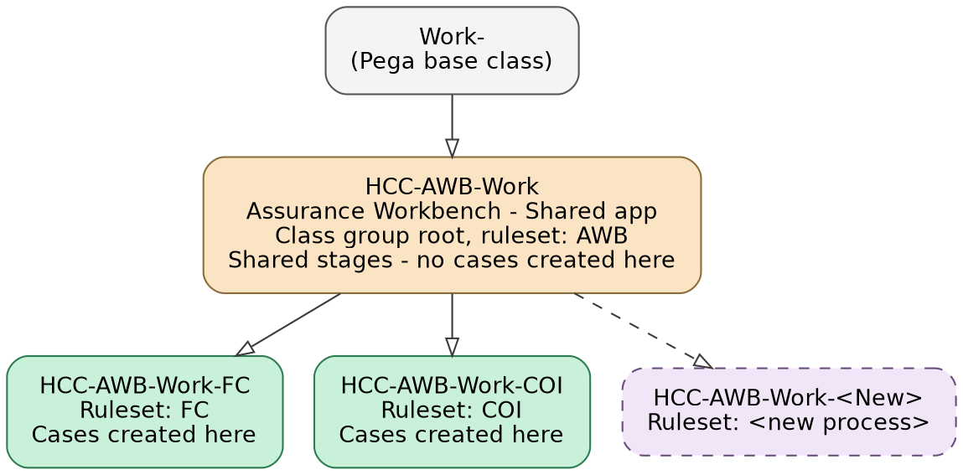
Figure 4: Work- class hierarchy — cases are created only at the Implementation layer, all sharing one class group
Class | Layer / Ruleset | Purpose
HCC-AWB-Work- | Shared / AWB | Shared base for the Assurance Workbench: holds the Case Type rule (stage skeleton), common fields, AI classification logic, and reusable UI sections. Class Group root (see 5.1.1). No case is ever created directly on this class.
HCC-AWB-Work-FC | Implementation / FC | Financial Crime case type: inherits the shared stage skeleton via pattern inheritance and adds sanctions/standard review, decision, and closure.
HCC-AWB-Work-COI | Implementation / COI | Conflict of Interest case type: inherits the shared stage skeleton via pattern inheritance and adds declaration review, approval, and closure.
HCC-AWB-Work-<New> | Implementation (future) | Pattern for onboarding a new assurance process as a sibling Implementation application, inheriting the same shared stages and sharing the same table.
HCC-AWB-Data-, HCC-AWB-Data-FC, HCC-AWB-Data-COI | All layers | Parallel Data class structure for configuration and reference data at each layer.
Build note: for stage inheritance to appear correctly in Case Designer, the Financial Crime and Conflict of Interest applications must have their 'Built On' setting chained to the Assurance Workbench application. This is standard Pega multi-layer application configuration, not custom development.

5.1.1 Implementing the Shared Class Group — Build Sequence
Pega's Class Group mechanism requires that a member class's name literally begin with the class group's name; this is independent of, and in addition to, the Parent Class (directed inheritance) used for rule resolution. The following sequence sets this up correctly and should be completed before any case types are built, to avoid renaming classes that already hold data:
- Confirm the class group root: HCC-AWB-Work- is set to 'is a class group', with a Data-Admin-DB-Table mapping to the target physical table (e.g., pc_hcc_awb_work) and a suitable Keys array (the default pyID-based key is sufficient).
- Before creating any case types, set each Implementation application's default/base work class to the class-group-compatible name: HCC-AWB-Work-FC for the Financial Crime application, HCC-AWB-Work-COI for Conflict of Interest.
- On each case type class definition: set 'This Class' to 'belongs to a class group' with Class group = HCC-AWB-Work-; keep 'Find by name first (Pattern)' checked; the Ruleset field stays set to that application's own Ruleset (FC or COI), not the shared application's.
- Build the Case Type (stages and processes) in App Studio as usual — the inherited stages from HCC-AWB-Work- appear automatically, with process-specific stages added after them.
- Add HCC-AWB-Work- to the 'Work Pools' list (Advanced tab) on every Access Group that needs to create or view cases — Financial Crime and Conflict of Interest reviewer/approver groups alike — otherwise users will not be able to create cases in the shared pool even with the class configured correctly.
- 6. Repeat steps 2-5 for each future process, using the same HCC-AWB-Work-<ProcessID> pattern.

This sequence should be completed in a pre-build or early-build environment. Renaming a class that already has saved case instances is a data migration exercise (via Pega's Clone Class Group tooling), not a simple configuration change.

5.2 Data Model

5.2.1 Mailbox-to-Process Mapping (HCC-AWB-Data-MailboxMap)
Field | Type | Description
EmailAccountID | Text (Key) | Identifier of the Email Account (mailbox) configured on the Email Channel.
ProcessID | Text | Resolved process, e.g., FC, COI.
TargetCaseClass | Text | Case class to create via Dynamic Class Referencing, e.g., HCC-AWB-Work-FC, HCC-AWB-Work-COI.
ActiveFlag | True/False | Enables/disables a mailbox without deleting configuration.

5.2.2 Process Configuration (HCC-AWB-Data-ProcessConfig)
Field | Type | Description
ProcessID | Text (Key) | Unique code, e.g., FC, COI.
ProcessName | Text | Display name shown in Constellation UI.
IntentCategories | Page List | Valid AI category outcomes for this process, e.g., Sanction, Non-Sanction.
ConfidenceThreshold | Decimal | Minimum AI confidence (%) for straight-through processing to Review.
RoutingMatrixRef | Text (Rule Ref) | Decision Table used for team/queue routing within the case.
SLAGoals | Page List | SLA targets per category, e.g., Sanction = 4 hrs, Non-Sanction = 24 hrs.
ActiveFlag | True/False | Enables/disables the process without deleting configuration.

5.2.3 Case Data (defined on HCC-AWB-Work-, inherited by Implementation classes)
Field | Type | Description
pyID | Text | Case ID — the only ID for the case; no separate intake case ID exists.
SourceETCaseID | Text | Reference to the originating Email Triage (ET) case for audit.
SourceEmailAccountID | Text | Mailbox the email arrived on, used for the DCR lookup and retained for audit.
EmailSubject / EmailBody | Text | Correspondence content carried over from the ET case.
AttachmentList | Page List | Attachment metadata and extracted text, carried over from the ET case.
AIIntentResult | Page (embedded) | Category, ConfidenceScore, Rationale, ModelVersion.
ClassificationSource | Text | 'AI-Auto' or 'Manual-Triage', for audit.
AuditLog | Page List (embedded) | Every classification/override/approval event with timestamp and actor.

5.3 Shared Case Lifecycle (Defined Once in the Shared Application, Inherited by Implementation)
Stage | Owner | Purpose
1. Classification | Shared application | Runs AI category classification and confidence check immediately after case creation.
2. Review | Shared application skeleton; Implementation fills in | Financial Crime adds Sanctions/Standard review paths; Conflict of Interest adds declaration review.
3. Decision & Approval | Shared application skeleton; Implementation fills in | Each Implementation application defines its own approval matrix and decision outcomes.
4. Closure | Shared application (minor per-process variation) | Common closure handling; each Implementation may add its own closure reason list.
Because no case is ever created in the shared application, this table describes a Case Type rule inherited by HCC-AWB-Work-FC and HCC-AWB-Work-COI, not a case lifecycle that runs independently.

5.4 Sample Mailbox and Routing Configuration

5.4.1 Mailbox Mapping
Email Account | ProcessID | Target Case Class
nonprosukcompliance@tmhcc.com | FC | HCC-AWB-Work-FC
nonprodtmecompliance@hcc.com | FC | HCC-AWB-Work-FC
nonprodcoi@hcc.com | COI | HCC-AWB-Work-COI

5.4.2 Category Routing (Within the Case)
ProcessID | Category | Confidence | Action
FC | Sanction | >= 85% | Proceed to Sanctions Specialist review
FC | Non-Sanction | >= 85% | Proceed to Standard review
FC | Any | < 85% | Manual triage queue
COI | Declared Relationship | >= 85% | Proceed to review based on materiality
COI | Any | < 85% | Manual triage queue

5.5 Security Model
Access Group / Role | Layer / Scope | Key Permissions
AWB:Administrator | AWB-wide | Manage mailbox mapping, Process Configuration, routing rules, AI classification settings.
FC:SanctionSpecialist | Financial Crime, Sanction category | Review/decision on Sanction-categorized cases.
FC:StandardReviewer | Financial Crime, Non-Sanction | Review/decision on Non-Sanction cases.
COI:Reviewer / COI:Approver | Conflict of Interest | Review and approval based on materiality rating.
AWB:TriageAgent | AWB-wide, Classification stage only | Confirms/overrides low-confidence AI classification.

5.6 Extensibility: Onboarding a New Assurance Process
- Create a new Implementation application (e.g., Whistleblowing, ID: WB) with classes HCC-AWB-Work-WB / HCC-AWB-Data-WB, built on Assurance Workbench so it inherits the shared stage skeleton.
- Add one or more Email Accounts for the new process and map each to ProcessID = WB and TargetCaseClass = HCC-AWB-Work-WB in the mailbox mapping.
- Add a Process Configuration record with WB's categories, confidence threshold, and SLA goals.
- Add the new class as a member of the existing Class Group so its cases land in the same shared table.
- If it's a new mailbox, create an Email Account and attach it to the Email Channel; the ET case processing and the shared application's Case Type rule remain unchanged.

5.7 Shared Data Storage: Class Group (Work Pool)
All Implementation case types are members of a single Class Group rooted at HCC-AWB-Work-, so every case — regardless of process — is stored in one physical database table. This is a native Pega capability, not custom development, and is well suited to HCC's low-to-medium case volumes. The build sequence to set this up correctly, including the class naming convention it requires, is covered in section 5.1.1.
- Only genuinely common fields should be exposed as physical columns on the shared table; process-specific fields remain in the case BLOB and do not need their own columns.
- Reports scoped to a single process (e.g., all Financial Crime cases) run against the specific Implementation class; cross-process reports (e.g., all assurance cases by SLA status) run against the Class Group.
- The Class Group assignment should be finalized before go-live — changing it after cases have accumulated is disruptive and should be avoided.

5.8 Configuration & Reference Data Model
Beyond case data, the solution also needs reference and configuration data — lookup lists, approval rules, closure reasons, and similar tables that support workflow processing. Not all of this data should be modelled the same way: the right storage pattern depends on whether the data's structure (its fields) is genuinely shared across processes, or only its structure's usage overlaps while values differ, or whether it is only ever relevant to a single process.
The decision is driven by two questions: is the data type used by more than one process, and if so, do all processes need the same fields? The answers place a given data type into one of three patterns:
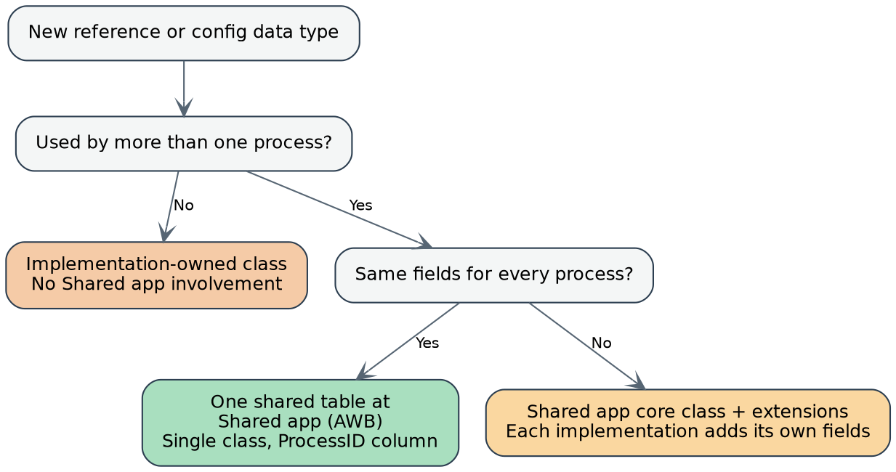
Figure 5: Decision tree for where a configuration or reference data type should live
Data type | Schema shared? | Recommendation
Mailbox-to-Process Mapping | Yes — used internally by the shared application | Single table in the Shared application (HCC-AWB-Data-MailboxMap), keyed by Email Account.
Process Configuration | Yes — same fields, different values per process | Single table in the Shared application (HCC-AWB-Data-ProcessConfig), keyed by ProcessID.
Closure reasons / decision categories | Yes — Code, Description, and ActiveFlag are identical everywhere | Single table in the Shared application, with a ProcessID column as a discriminator. No class group needed — just one class.
Approval matrix / approval rules | No — Financial Crime needs risk-tier fields, Conflict of Interest needs materiality-band fields | Shared application core class holds the common fields; each Implementation extends it with its own additional fields.
Sanctions reference/watch-list categories | No — Financial Crime only | Implementation-owned entirely (HCC-FC-Data-SanctionsCategory); no involvement from the shared application.
Materiality bands / conflict categories | No — Conflict of Interest only | Implementation-owned entirely (HCC-COI-Data-MaterialityBand).

Note the difference from the Work- class decision in section 5.1.1: there, the driver for a single shared table was case volume, and the Class Group naming convention was the only way to achieve it. For reference and configuration data, volume is rarely a concern — even a handful of separate tables at a few dozen rows each is trivial. So when a data type's schema genuinely diverges per process, it is usually simpler to let each Implementation keep its own separate table rather than forcing the same class-group naming convention used for cases; that convention is only worth repeating for reference data if HCC specifically wants one unified configuration-admin screen across every process.
- Where a data type does need siloed edit access — for example, only Financial Crime compliance officers should edit Financial Crime's own reference values — prefer an Implementation-owned class even if the schema is identical elsewhere, since Pega enforces access control on data primarily at the class level.
- Data Pages that expose shared-schema reference data should be defined once in the shared application, parameterized by ProcessID rather than by class — for example, D_ClosureReasons(ProcessID). Because the Data Page rule is inherited by every Implementation application, both Financial Crime and Conflict of Interest cases call the same rule, passing their own ProcessID, with no duplicate Data Page definitions.
- Only the 'Shared application core class + extensions' pattern needs class-based resolution similar to Dynamic Class Referencing, since the underlying Data class itself differs per process there; that resolution reuses the same Process Configuration class mapping already built for case creation.

6. Risks & Mitigations
Risk | Mitigation
Dynamic Class Referencing in PreTriage requires a small custom activity, unlike the no-code Create Case wizard | Keep this logic isolated to a single, well-documented extension point; drive its decisions entirely from the mailbox mapping data object so no process-specific logic is hardcoded in the activity itself.
AI misclassifies a true Sanctions case as Non-Sanction | Conservative confidence threshold for the Sanction category; periodic QA sampling of auto-routed Non-Sanction cases.
Mixed schema in the shared Class Group table as more processes are added | Keep only common fields as exposed columns; govern additions to the shared table through a schema review as part of onboarding any new process.
Class Group decision made too late, after case volume has accumulated | Confirm and lock the Class Group design during this build phase, before Financial Crime and Conflict of Interest go live.
Case type class names (HCC-AWB-Work-FC, HCC-AWB-Work-COI) read as if Financial Crime and Conflict of Interest are owned by the Assurance Workbench (AWB) team | Document and communicate that the Ruleset field, not the class name, determines ownership — each Implementation application keeps full governance of its own case type via its own Ruleset.
Traceability gap between ET case and business case | Enforce mandatory cross-referencing (SourceETCaseID, SourceEmailAccountID) at case creation, validated in testing.

7. Appendix — Glossary
Term | Meaning
AWB | Assurance Workbench — Shared application; hosts the Email Channel and Email Accounts, holds shared rules, and is the root of the shared case table, no case instances of its own.
FC / COI | Financial Crime / Conflict of Interest — Implementation-layer applications where cases are actually created.
ET | Email Triage — Pega's OOTB case type (Work-Channel-Triage-Email) created automatically by the Email Channel.
DCR | Dynamic Class Referencing — Pega's mechanism for resolving a case's class at runtime rather than design time.
Class Group / Work Pool | A Pega mechanism that stores instances of multiple related case classes in a single database table. Requires member class names to begin with the class group's name.
Pattern Inheritance | Pega's mechanism for automatically resolving rules from a parent class found by truncating the class name from the right; works alongside Class Group naming.
Ruleset | The unit of rule packaging and ownership in Pega; determines which application/team governs a rule or class, independent of the class's name or position in the class hierarchy.
PreTriage / Triage / PostTriage | The three built-in stages of Pega's Email Triage process.
Constellation | Pega Infinity's DX-API-driven, component-based UI architecture.

