Pega – Microsoft Azure Connectivity

Email Channel: Email Account, Email Listener & Service Email over OAuth 2.0
Reference document for Solution Architecture and Data Protection review

1. Purpose
This document explains how Pega connects to a Microsoft 365 / Exchange Online mailbox through Azure Active Directory (Azure AD / Microsoft Entra ID) to send and receive email as part of a Pega case-processing application. It is written for readers who do not work with Pega day-to-day and for the Data Protection & Security team, so it favours plain explanation over Pega-specific jargon, and calls out explicitly where credentials and data are stored and protected.

2. Audience & Scope
Intended for: Non-Pega solution architects, Enterprise integration/security architects, and the Data Protection / Information Security team.
In scope: The Email Account, Authentication Profile, Email Listener and Service Email rule instances in Pega; the corresponding Azure AD app registration, API permissions and mailbox configuration; the OAuth 2.0 client-credentials authentication flow; and how the client secret is stored in Pega.
Out of scope: Business processing logic inside the Service Email rule, case-type design, and Exchange Online tenant-wide policies unrelated to this integration.

3. Solution Overview
Pega does not use a personal mailbox login. It connects as an application (a “service identity”), registered in Azure AD, that is granted narrowly-scoped, application-level permission to one specific mailbox. Pega authenticates to Azure AD using the OAuth 2.0 “Client Credentials” grant — a machine-to-machine flow with no end user involved — and uses the resulting access token to read and send mail over Microsoft Graph (or EWS/IMAP with OAuth, depending on protocol chosen). No mailbox password is ever used or stored; only the Azure AD application’s client secret is stored, and that is held encrypted inside Pega.

4. Components at a Glance
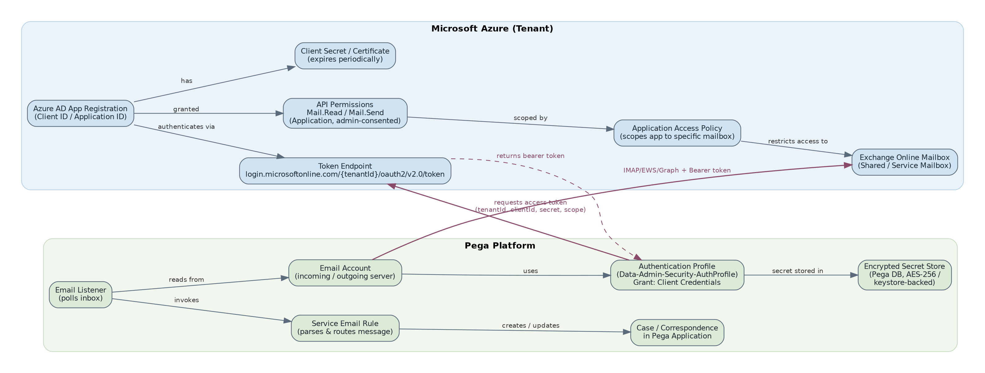
Figure 1: Relationship between Pega rule instances and Azure AD / Exchange Online objects

Component | Where it lives | What it does
Azure AD App Registration | Azure AD (tenant) | The identity Pega authenticates as. Has a Client ID (Application ID) and one or more client secrets/certificates.
API Permissions | Azure AD (tenant) | Application-level Graph/Exchange permissions (e.g. Mail.Read, Mail.Send) granted to the app and approved via admin consent.
Application Access Policy | Exchange Online | Restricts the app registration to one or a small set of mailboxes, so it cannot read every mailbox in the tenant.
Authentication Profile | Pega (Data-Admin-Security-AuthProfile) | Stores the OAuth2 configuration: token endpoint, tenant ID, client ID, client secret, scope, grant type.
Email Account | Pega (Data-Admin-Connect-EmailAccount) | Defines the mail server/protocol (Graph, EWS or IMAP/SMTP) and references the Authentication Profile.
Email Listener | Pega (background service) | Polls the mailbox on a schedule using the Email Account and hands new messages to a Service Email rule.
Service Email Rule | Pega application rules | Parses the inbound email and creates or updates a case/correspondence.

5. Authentication Model — OAuth 2.0 Client Credentials

The Pega Authentication Profile is configured with the “Client Credentials” grant type, which is the standard OAuth 2.0 pattern for one back-end system authenticating to another without a human sign-in. The key fields configured on the Authentication Profile are:
Field | Value / Purpose
Grant Type | Client Credentials — no user logs in; Pega authenticates as the application itself.
Access Token Endpoint | https://login.microsoftonline.com/{tenantId}/oauth2/v2.0/token — the tenantId identifies which Azure AD directory issues the token.
Client Identifier (Client ID) | The Application (client) ID of the Azure AD app registration — not secret, acts like a username.
Client Secret | The confidential credential for the app registration. Treated as sensitive data (see Section 8).
Scope | https://graph.microsoft.com/.default (or the equivalent resource scope for EWS/IMAP) — tells Azure AD to issue a token covering the application permissions already admin-consented for this app.

At runtime, the Email Account (via its Authentication Profile) sends the tenant ID, client ID, client secret and scope to the Azure AD token endpoint and receives a short-lived, signed bearer access token in return. Pega attaches that token to every mailbox request; no username/password is sent to Exchange.

6. Authentication Flow
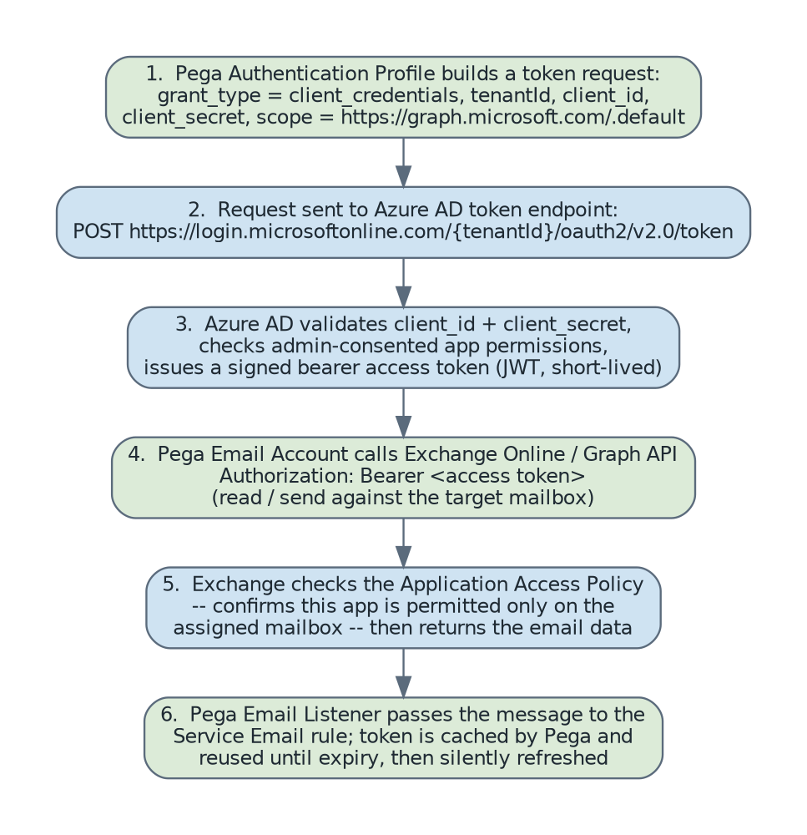
Figure 2: Step-by-step OAuth 2.0 client-credentials flow between Pega and Azure AD / Exchange Online
The access token is short-lived (typically around 60 minutes). Pega caches it and requests a new one automatically when it expires or is close to expiring — no manual re-authentication is needed under normal operation.

7. Azure AD & Exchange Configuration (done by the Azure/M365 admin)
Step | Action
1 | Register an application in Azure AD (App registrations). Note the Application (Client) ID and the Directory (Tenant) ID.
2 | Create a client secret (or upload a certificate) for the app registration and record its expiry date.
3 | Add the required Application (not Delegated) API permissions on Microsoft Graph — typically Mail.Read and/or Mail.Send — and have a tenant admin grant admin consent.
4 | Identify or create the target mailbox (usually a shared/service mailbox rather than a named employee mailbox).
5 | Create an Exchange Online Application Access Policy that scopes the app registration to only that mailbox, so the credential cannot be used against any other mailbox in the tenant.
6 | Confirm modern authentication (OAuth) is enabled and legacy basic authentication is disabled for the mailbox/protocol in use.
7 | Hand the Tenant ID, Client ID, client secret and target mailbox address to the Pega team through a secure channel (never email or chat).

8. Pega Configuration (done by the Pega team)
Step | Action
1 | Create an Authentication Profile, set Grant Type = Client Credentials, and enter the Token Endpoint (with tenant ID), Client ID, Client Secret and Scope.
2 | Create an Email Account, choose the mail protocol (Microsoft Graph API is recommended over legacy IMAP/EWS), point it at the target mailbox address, and reference the Authentication Profile above.
3 | Validate the connection using the Email Account’s built-in “test connectivity” action, which performs a live token request and mailbox check.
4 | Create/configure an Email Listener referencing the Email Account, set the polling interval, and map it to the Service Email rule that will process incoming messages.
5 | Secure the Authentication Profile and Email Account rules with appropriate Access Control (only authorised roles can view/edit; the secret itself is never displayed once saved).

9. How the Client Secret Is Stored in Pega

- Entry: The client secret is entered once, on the Authentication Profile rule, over an HTTPS-protected Pega Designer Studio / Dev Studio session.
- Storage: Once saved, Pega encrypts the value and persists it in the Pega database as ciphertext, not plain text. It is encrypted using Pega’s platform encryption (AES-256), keyed off the environment’s encryption keystore.
- Masking: The field is a masked “password” type in the UI: after saving, the value is never redisplayed in the rule form, in rule exports/RAPs, or in application/case logs.
- Key management: The encryption/decryption key material lives in the system’s keystore configuration (managed at the Pega node/cluster level), separate from the application database export, so a database or RAP export alone does not expose usable secrets.
- Access control: Rules that reference the secret (Email Account, Authentication Profile) can be locked down with role-based Access Control Policies so only designated admins can view or modify the configuration.
- Alternative pattern: For environments with a centralized secrets policy, the same Authentication Profile pattern can instead reference a certificate held in a keystore rule, or the client secret can be sourced from an external vault (e.g. HashiCorp Vault, Azure Key Vault) via a custom integration, if that is the organisation’s standard — confirm current requirement with the security team.
- Rotation: Secrets should be rotated on a defined schedule (aligned with the Azure AD secret expiry) and immediately on staff turnover or suspected compromise; rotation only requires updating the Authentication Profile, with no code change.

10. Data Protection Considerations
Topic | Control / Answer
Data in transit | All calls (Pega → Azure AD token endpoint, Pega → Exchange/Graph) occur over TLS 1.2+. No credentials or email content travel unencrypted.
Data at rest – credentials | Client secret stored as encrypted ciphertext in the Pega database (Section 9); never stored in Azure or transmitted to Pega logs.
Data at rest – email content | Retrieved email content/attachments are persisted in Pega only where the Service Email/case design explicitly stores them, subject to the application’s normal data retention and classification rules — this integration does not introduce a separate copy.
Least privilege | The Azure AD app is granted only the specific Mail permissions needed, is application-scoped (no delegated user rights), and is restricted to a single mailbox via the Exchange Application Access Policy.
No standing user credentials | Client-credentials grant means no individual’s username/password is used or exposed; the integration uses a dedicated non-human service identity.
Auditability | Azure AD sign-in/audit logs record every token issuance by the app; Pega audit trail records changes to the Authentication Profile/Email Account rules (who changed what, when).
Secret lifecycle | Client secret has a defined Azure AD expiry; rotation is a config change in Pega with no source-code or deployment impact.
Blast radius if secret is compromised | Limited to the single mailbox covered by the Application Access Policy and to the permissions granted — not tenant-wide mailbox access.

11. Summary
Pega connects to the Azure-hosted mailbox as a registered application, not as a human user. Authentication uses OAuth 2.0 Client Credentials: Pega presents the tenant ID, client ID, client secret and scope to Azure AD’s token endpoint and receives a short-lived bearer token, which it then uses to call the mailbox. On the Azure side, the app’s reach is deliberately narrowed to one mailbox and a small set of Mail permissions. On the Pega side, the only long-lived secret — the client secret — is stored encrypted in the Pega database, masked in the UI, and access-controlled, with rotation handled as a configuration change.

