Reusable Assurance Case Framework
Financial Crime & Conflict of Interest Processes
High-Level Design (HLD) & Low-Level Design (LLD)
Platform: Pega Infinity '25 — Constellation UI Architecture
AI-Enabled Intent Classification (Sanction / Non-Sanction) & Configuration-Driven Routing
Prepared for: Solution Architecture & Business Analysis Review
Version 1.0 | Draft for Discussion

Table of Contents

1. Executive Summary
This document presents the High-Level Design (HLD) and Low-Level Design (LLD) for a reusable Assurance Case Management framework built on Pega Infinity '25 using the Constellation UI architecture. The initial scope covers two Assurance processes — Financial Crime (FinCrime) and Conflict of Interest (COI) — but the framework is architected as a configurable, extensible platform so that future assurance processes (e.g., Whistleblowing, Regulatory Breach, Trade Surveillance) can be onboarded primarily through configuration, with minimal or no new case-type code.
The framework standardizes four capabilities that are common across all assurance intake processes: (1) mailbox creation and email listening, (2) AI-driven categorization of inbound correspondence and attachments to derive business intent, (3) rules-driven routing and assignment, and (4) a configurable case lifecycle. A concrete example is used throughout this document: an inbound email is analyzed by AI to determine whether it represents a Sanctions-related matter or a Non-Sanctions matter, and is automatically routed to the correct review team.
The design follows Pega's recommended layered application architecture, uses configuration data objects instead of hard-coded rules wherever business variability exists, and leverages Pega GenAI capabilities for intent classification, with a human-in-the-loop fallback for low-confidence predictions.

2. Business Context & Objectives

2.1 Business Drivers
- Assurance functions (Financial Crime, COI, and future processes) each run their own manual mailbox triage today, causing inconsistent SLAs, duplicate effort, and limited audit trail.
- Each new assurance process currently requires a bespoke case type build, increasing time-to-market and total cost of ownership.
- Regulatory expectation for demonstrable, auditable, and consistent handling of sanctions-related correspondence, with fast identification and escalation of true sanctions matters.
- Desire to reduce manual triage effort using AI to read email body and attachments and derive intent, confidence-scored, with routing to the correct team.

2.2 Design Objectives
- Build ONE reusable, configurable case type (a framework/skeleton) that services multiple assurance processes, rather than one case type per process.
- Externalize everything that varies by process — mailbox, keywords/intents, routing targets, SLAs, stages, forms, approval matrix — into configuration data, not case-type code.
- Use Pega GenAI / AI Agents to classify inbound email + attachment intent (e.g., Sanction vs Non-Sanction) with a confidence score, feeding straight-through routing where confidence is high and human triage where it is not.
- Design for Constellation from day one: DX-API-driven, embedded/dynamic UI, channel-agnostic components, App Studio-first configuration for BAs.
- Provide a clear extensibility path: onboarding a new assurance process should be a configuration exercise (new Process Configuration record + decision table entries + UI view assembly), not a new class/case-type build.

3. Guiding Design Principles
Principle | What it means in this design
Configuration over customization | Business variability (routing, SLAs, stages, keywords, teams) lives in Data Objects and Decision Rules, never in Activities/code.
Single reusable case type | One abstract, parameterized case type ("Assurance-Framework-Work-") specialized per process via configuration and a thin subclass, not a full rebuild.
AI-assisted, human-governed | AI proposes intent + confidence; only high-confidence predictions auto-route. Everything else goes to a triage queue for human confirmation, and every AI decision is logged for audit and model feedback.
Constellation-native | UI built as reusable embedded views / dynamic containers driven by App Studio Case Designer, using DX API, so both business users and future channels (portal, mobile) share the same view models.
Separation of concerns (Pega layering) | Enterprise layer (shared org rules) → Assurance Framework layer (this build) → Process implementation layer (FinCrime, COI, future) — enabling rule resolution and clean upgrades.
Auditability by design | Every classification, routing decision, and manual override is captured against the case for regulatory traceability.

4. High-Level Design (HLD)

4.1 Solution Overview
The solution is a single Pega Infinity '25 application, built Constellation-first, organized as a reusable 'Assurance Framework' that sits beneath process-specific implementations. Inbound emails land in process-specific shared mailboxes but are processed by one common intake-and-classification pipeline. AI determines the business intent of the correspondence (including reading attachments), a configuration-driven routing service decides the specialized case type/team, and a common case shell carries the work through configurable stages to closure.
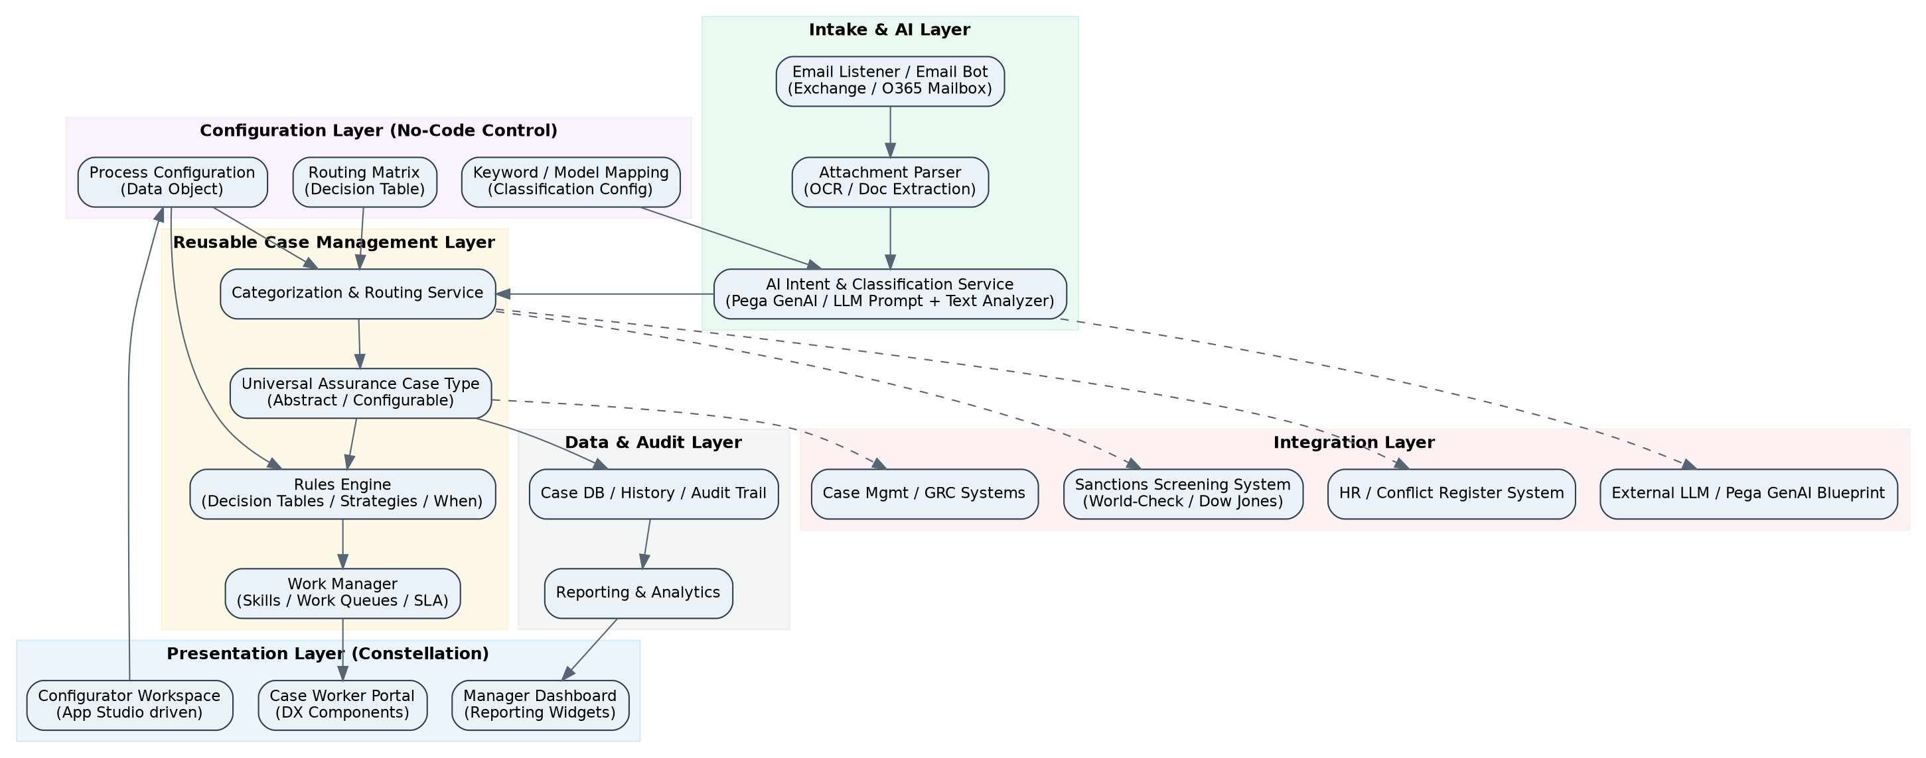
Figure 1: Layered High-Level Architecture

4.2 Pega Application Layering
The application is organized using Pega's standard layered (rule-resolution) approach so that shared capability is upgraded once and consumed everywhere:
Layer | Application Name (example) | Contents
Enterprise Layer | EnterpriseFoundation | Org-wide security, integrations (Email/O365, LDAP), enterprise data types, common UI shell, GenAI connection setup.
Assurance Framework Layer | AssuranceFW | Abstract case type, universal stages, Process Configuration data model, AI classification service, routing/decision framework, generic Constellation views.
Process Implementation Layer | AssuranceFinCrime, AssuranceCOI | Thin specialization: process-specific data fields, additional views/sections, process-specific decision table rows, keyword/intent config records.
Future Process Layer(s) | AssuranceWhistleblowing, etc. | Added later using the same pattern — new implementation layer + configuration, reusing the Framework layer unchanged.

4.3 Reusable Case Framework Concept
Rather than building a new case type per process, the framework defines ONE abstract, universal case type with generic stages: Intake, Triage/Classification, Categorization & Routing, Review, Decision, and Closure. Each process (FinCrime, COI, future processes) is represented as a lightweight specialized class that inherits this structure and layers on process-specific data and views. All process-specific behavior — which mailbox to listen to, which keywords/intents apply, which team to route to, what SLA applies, which approval matrix to use — is held in a 'Process Configuration' data object, not in the case type definition itself.
- Onboarding a brand-new assurance process (future state) becomes: create a Process Configuration record, add routing/decision table rows, assemble a UI view from existing reusable sections, and (only if new data is truly needed) add a thin data class.
- No new flows, no new AI prompts, no duplicated mailbox/routing logic.

4.4 Key Components
Component | Pega Capability | Responsibility
Mailbox / Email Listener | Email Account (Service Email) + Email Bot | Connects to shared O365/Exchange mailbox(es); one listener configuration per process, reusing a common email-processing ruleset.
Attachment Extraction | File/Attachment processing, OCR (Pega Document/Intelligent OCR or Text Analyzer) | Extracts text from attached documents (PDF/Word/scanned images) so AI classification considers both body and attachment content.
AI Intent & Classification Service | Pega GenAI (Prompt rules / AI Agent), Text Analyzer, Model Rule | Derives business intent (e.g., Sanction vs Non-Sanction; FinCrime vs COI) and returns a structured result with a confidence score and rationale.
Categorization & Routing Service | Decision Table / Decision Strategy, Data Pages | Maps AI intent + business rules + Process Configuration into a target case subtype, team/queue, and SLA.
Universal Case Type | Case Type (abstract, parameterized stages) | Carries the work item through its lifecycle; stage/step visibility and required actions are configuration-driven.
Business Rules Engine | Decision Tables, Decision Trees, When Rules, Circumstancing | Encapsulates all variable business logic (eligibility, thresholds, escalation, approval routing) outside of code.
Work Manager | Work Queues, Skills, SLA Rules | Assigns cases to the correct team/individual based on skill, workload, and configured SLA.
Constellation UI | App Studio, DX Components, Embedded Data Views, Dynamic Containers | Renders case views, triage workbaskets, and configurator screens; reusable across processes and channels.
Configuration Workspace | App Studio + custom Data Object UI | Lets BAs/admins manage Process Configuration, keyword/intent mapping, and routing matrices without code changes.

4.5 AI-Driven Intent Classification
The classification pipeline is designed as a two-stage check: an automated AI proposal, followed by a confidence gate that decides between straight-through processing and human triage. This keeps the framework fast for the majority of clear-cut cases while keeping a human in the loop for ambiguous ones — an important control point for a financial-crime/sanctions process.
Figure 2: End-to-End Email-to-Case Process Flow
- Input to the AI service: email subject/body text, sender domain/metadata, and extracted attachment text.
- Output from the AI service: a structured JSON result — process guess (FinCrime/COI/etc.), sub-category (e.g., Sanction/Non-Sanction), confidence score (0-100), and a short rationale used for audit and for the triage agent's context.
- Confidence threshold (configurable per process, e.g., 85%) determines auto-route vs manual-triage; thresholds are held in Process Configuration, not hardcoded.
- Every AI decision — including overrides by a human triage agent — is captured to build a feedback/training data set for continuous improvement of the prompt/model.

4.6 Integration Architecture
Integration | Direction | Purpose
Exchange / Microsoft 365 Mailbox | Inbound | Source of assurance correspondence per process (dedicated shared mailbox per process, or sub-folder routing).
Pega GenAI Blueprint / LLM Service | Outbound (request) / Inbound (response) | Executes the intent-classification prompt against email + attachment text; may call an Anthropic/OpenAI/Azure OpenAI-backed model via Pega's GenAI connectors.
Sanctions Screening System (e.g., World-Check, Dow Jones, internal watch-list) | Outbound | Optional secondary check to corroborate an AI-flagged Sanctions case before final categorization.
HR / Conflict Register (for COI) | Outbound | Validates declared relationships/interests for Conflict of Interest cases.
Enterprise Case/GRC or SIEM | Outbound | Case outcome and audit feed to enterprise GRC or regulatory reporting systems.
Identity/Access (LDAP/SSO) | Bidirectional | Access group and role resolution for Constellation portal access.

4.7 Non-Functional Requirements
Category | Design Response
Security | Role-based access groups per process (FinCrime reviewer, COI reviewer, Sanctions specialist); field-level access control on sensitive data (e.g., sanctions rationale); PII/attachment data encrypted at rest.
Auditability | Full history of AI classification, confidence, rationale, human overrides, approvals, and SLA timers retained against the case; immutable audit log exposed to compliance reporting.
Scalability | Stateless AI service calls, queue-based intake, horizontally scalable via Pega's standard node scaling; decision tables avoid rule-count growth by keying off Process Configuration rather than per-process case types.
Extensibility | New process = configuration + thin subclass, not a re-platform; target under 2 weeks to onboard a new assurance process end-to-end.
Resilience | Email Bot retry/replay on failures; dead-letter queue for unparsable emails; manual fallback triage queue if AI service is unavailable.
SLA Management | Per-process, per-category SLA goals configured in Process Configuration and enforced via standard Pega SLA rules and escalation chains.

5. Low-Level Design (LLD)

5.1 Class Structure & Case Type Hierarchy
A single abstract case type carries the universal stage structure. Process-specific classes are thin: they add only the data/views that are truly unique to that process. Sub-categorization (e.g., Sanction vs Non-Sanction) is modeled as a case-status/stage variant driven by configuration and AI output — not as a separate case type — to avoid class proliferation.
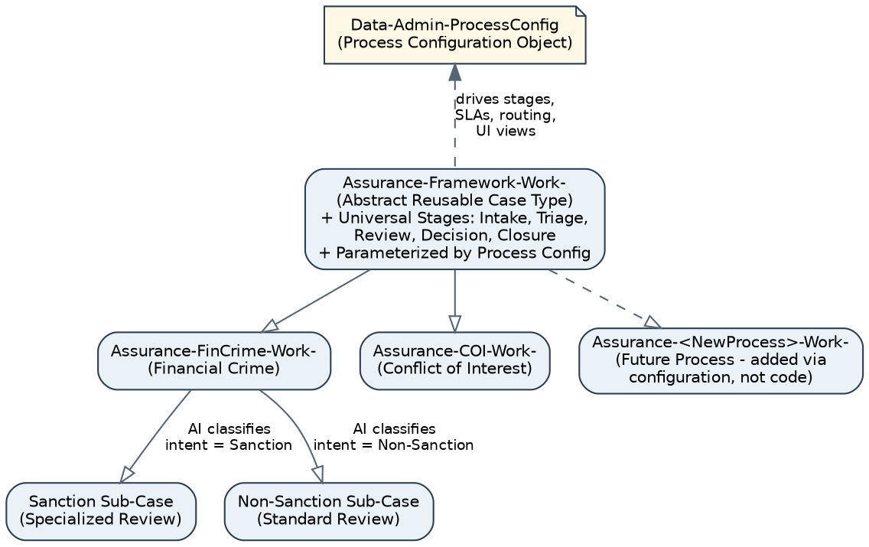
Figure 3: Reusable Case Type / Class Hierarchy
Class | Type | Purpose
Assurance-Framework-Work- | Abstract case type | Defines universal stages (Intake, Triage, Categorization, Review, Decision, Closure), shared fields (Source Mailbox, AI Intent, Confidence Score, Routing Target, SLA Goal), and shared flows/harnesses.
Assurance-FinCrime-Work- | Concrete case type (extends Framework) | Adds FinCrime-specific fields (Sanctions List Hit, Screening Reference, Regulatory Category) and specialized review steps for Sanction vs Non-Sanction sub-flows.
Assurance-COI-Work- | Concrete case type (extends Framework) | Adds COI-specific fields (Declared Relationship, Business Unit, Materiality Rating) and a manager-attestation step.
Assurance-<NewProcess>-Work- | Future concrete case type | Created only when genuinely new data/steps are needed; otherwise the process runs entirely on Framework + configuration.
Data-Admin-ProcessConfig | Data class | Holds all per-process configuration: mailbox, keywords/intents, routing matrix reference, SLA goals, stage list, approval matrix, UI view bindings.
Data-Admin-ClassificationModel | Data class | Holds AI prompt template reference, confidence threshold, model version, and list of valid intent categories per process.

5.2 Data Model

5.2.1 Process Configuration (Data-Admin-ProcessConfig)
Field | Type | Description
ProcessID | Text (Key) | Unique code, e.g., FINCRIME, COI.
ProcessName | Text | Display name shown in Constellation UI.
MailboxAddress | Text | Shared mailbox monitored by Email Bot for this process.
IntentCategories | Page List | Valid AI intent outcomes for this process, e.g., Sanction, Non-Sanction.
ConfidenceThreshold | Decimal | Minimum AI confidence (%) for straight-through auto-routing.
RoutingMatrixRef | Text (Rule Ref) | Name of the Decision Table used for team/queue routing.
StageListRef | Page List | Ordered list of stages/steps applicable to this process (subset/superset of universal stages).
SLAGoals | Page List (Category → Hours) | SLA targets per intent category, e.g., Sanction = 4 hrs, Non-Sanction = 24 hrs.
ApprovalMatrixRef | Text (Rule Ref) | Decision Table controlling approval levels by risk/materiality.
UIViewBinding | Text | Name of the Constellation case view / embedded sections to assemble for this process.
ActiveFlag | True/False | Enables/disables the process without deleting configuration.

5.2.2 Case Data (Assurance-Framework-Work-)
Field | Type | Description
pyID | Text | Standard Pega case ID.
ProcessID | Text | Foreign key to Process Configuration.
SourceMailbox | Text | Mailbox the triggering email arrived in.
EmailSubject / EmailBody | Text | Captured inbound correspondence.
AttachmentList | Page List | Attachment metadata + extracted text reference.
AIIntentResult | Page (embedded) | Structured AI output: PredictedCategory, ConfidenceScore, Rationale, ModelVersion.
FinalCategory | Text | Confirmed category after auto-route or human triage (e.g., Sanction).
RoutedTeam / RoutedQueue | Text | Result of routing decision table.
ClassificationSource | Text | 'AI-Auto' or 'Manual-Triage', for audit.
SLADeadline | Date/Time | Computed from Process Configuration SLA goal + category.
DecisionOutcome | Text | Final case decision, e.g., Escalate to Regulatory, No Further Action, Closed - Confirmed COI.
AuditLog | Page List (embedded) | Every classification/override/approval event with timestamp and actor.

5.3 Case Lifecycle — Universal Stages
Stage | Purpose | Configuration Hooks
1. Intake | Case created from email/attachment; metadata captured. | Mailbox binding, attachment parsing rules.
2. AI Classification | AI derives intent + confidence. | ClassificationModel record, prompt template, threshold.
3. Categorization & Routing | Confirms category (auto or manual); resolves target team. | RoutingMatrix decision table, SLA goals.
4. Review | Subject-matter team investigates (e.g., Sanctions Specialist, COI Reviewer). | Process-specific view bindings; checklist per IntentCategory.
5. Decision & Approval | Outcome recorded; approval routed by risk/materiality. | ApprovalMatrix decision table; delegation of authority rules.
6. Closure | Case closed; outcome fed to reporting and (optionally) AI feedback loop. | Closure reason list; regulatory reporting flag.
Note: Stage visibility, required steps, and even the fields shown per stage are driven by StageListRef and UIViewBinding in Process Configuration, so a new process can reorder/omit stages without touching the case type rule.

5.4 Configuration-Driven Design Approach
- Dynamic stage/step behaviour: Universal case type stages read from Process Configuration at runtime (via a Data Page) to determine which optional steps to display, avoiding per-process flow rule copies.
- Decision Table–driven routing: A single 'Route-To-Team' decision table keyed on ProcessID + IntentCategory + Risk Rating returns the target Work Queue / Skill — adding a new process is a new table row, not new logic.
- Keyword / intent configuration: A supporting data object maps process-specific keywords and example phrases into the AI prompt dynamically, so classification vocabulary can be tuned by a BA without a prompt-engineering change.
- Reusable Constellation views: Case views are composed from a shared library of embedded sections (Correspondence Summary, AI Classification Panel, Decision Panel, Audit Trail) plus a small process-specific section, assembled per ProcessID via UIViewBinding.
- Circumstancing / rule resolution: Where a truly process-specific rule variant is unavoidable (e.g., a specialized validation), Pega circumstancing on ProcessID is used ahead of creating a new class, preserving one rule with situational variants.

5.5 Key Pega Rule Types Used
Rule Type | Used For
Case Type / Stages & Processes | Universal Assurance case shell and its 6 configurable stages.
Service Email / Email Bot | Mailbox listener per process; converts inbound mail to case-create or correspondence-update.
Text Analyzer / Extraction Rule | Attachment text extraction and lightweight rule-based pre-checks (e.g., known sanctioned entity keyword hit).
Prompt / GenAI Agent (Pega GenAI) | Sends email + attachment text to an LLM for structured intent classification with confidence and rationale.
Decision Table | Routing matrix, approval matrix, SLA lookup.
Decision Tree / When Rules | Conditional stage visibility, escalation triggers, validation logic.
Data Transform | Mapping AI JSON response into case fields; assembling Process Configuration into runtime context.
Data Page | Cached read of Process Configuration and Classification Model records used at case-creation time.
Work Queue / Skill / SLA Rule | Assignment and escalation of cases to the correct reviewer team.
Access Group / Role / Access Control Policy | Segregation of duties between processes and between triage/review/approval steps.
Constellation Case View / Embedded Data View / Dynamic Container | Composable, reusable UI for case work, triage, and configuration screens.

5.6 Sample Routing Decision Table
Illustrative structure of the 'Route-To-Team' decision table referenced by the Categorization & Routing Service:
ProcessID | IntentCategory | Confidence | Risk Rating | Routed Team / Queue | SLA (hrs)
FINCRIME | Sanction | >= 85% | Any | FinCrime-Sanctions-Specialist Queue | 4
FINCRIME | Non-Sanction | >= 85% | Any | FinCrime-Standard-Review Queue | 24
FINCRIME | Any | < 85% | Any | FinCrime-Manual-Triage Queue | 2
COI | Declared Relationship | >= 85% | High | COI-Senior-Reviewer Queue | 24
COI | Declared Relationship | >= 85% | Low/Medium | COI-Standard-Review Queue | 48
COI | Any | < 85% | Any | COI-Manual-Triage Queue | 4

5.7 Security Model
Access Group / Role | Scope | Key Permissions
AssuranceFW:Administrator | Framework-wide | Manage Process Configuration, Routing/Approval matrices, Classification Model settings.
FinCrime:Sanctions Specialist | FinCrime process, Sanction sub-category only | Review/decision on Sanction-categorized cases; restricted view of screening details.
FinCrime:Standard Reviewer | FinCrime process, Non-Sanction only | Review/decision on Non-Sanction cases.
COI:Reviewer / COI:Approver | COI process | Review and multi-level approval based on materiality rating.
Assurance:Triage Agent | Framework-wide, Triage stage only | Confirms/overrides low-confidence AI classification; cannot see final decision fields.
Assurance:Auditor | Read-only, all processes | Full read access to audit trail and AI rationale for regulatory review, no edit rights.

5.8 Sequence: Email Intake to Case Assignment
- 1. Email Bot polls/receives event from process mailbox → creates a transient work object.
- 2. Attachment parser extracts text from each attachment; combined text passed forward.
- 3. Data Transform assembles the AI request payload (email text + attachment text + ProcessID + valid IntentCategories from Process Configuration).
- 4. GenAI Prompt/Agent rule invokes the LLM; response parsed into AIIntentResult (category, confidence, rationale).
- 5. Decision Rule checks ConfidenceThreshold: high → auto-set FinalCategory; low → create Triage assignment.
- 6. Routing decision table resolves RoutedTeam/Queue + SLA using ProcessID + FinalCategory + Risk Rating.
- 7. Case is created/updated as Assurance-FinCrime-Work- or Assurance-COI-Work- (or future subclass), assigned to the resolved Work Queue with SLA timers started.
- 8. All of the above steps are appended to AuditLog with timestamp, actor ('System-AI' or user), and rationale.

5.9 Extensibility: Onboarding a New Assurance Process
Target operating model for adding a new process (e.g., Whistleblowing) with no case-type code changes:
- Create a new Process Configuration record: mailbox, intent categories, confidence threshold, SLA goals, stage list.
- Add rows to the Routing and Approval decision tables for the new ProcessID.
- Add/extend Classification Model configuration with new intent categories and example phrases for the AI prompt.
- Assemble a Constellation case view from existing reusable sections; add a small process-specific section only if new fields are truly required.
- Create access groups/roles for the new process's reviewer/approver population.
- Only if genuinely new data is needed: create a thin Assurance-<NewProcess>-Work- class extending the Framework class.

6. Risks & Mitigations
Risk | Mitigation
AI misclassifies a true Sanctions case as Non-Sanction (false negative) | Conservative confidence threshold specifically for Sanction category; secondary rule-based keyword/watch-list check; periodic sampling/QA of Non-Sanction auto-routed cases.
Over-reliance on AI erodes reviewer scrutiny | Rationale + confidence always shown to reviewer; mandatory periodic human audit sample even for high-confidence auto-routed cases.
Configuration sprawl reduces the 'no-code' benefit over time | Governance process for Process Configuration changes; configuration change is reviewed like a rule change, with versioning.
Attachment formats not parseable (scanned/image-only) | Fallback to OCR; unparsable attachments flagged and routed to manual triage rather than silently dropped.
Class hierarchy still grows if processes are more different than expected | Governance checkpoint at design time: only add a subclass when a genuine structural difference exists, not for cosmetic UI differences.

7. Phased Delivery Roadmap (Indicative)
Phase | Scope
Phase 1 — Framework Foundation | Abstract case type, universal stages, Process Configuration data model, Constellation shell views, Email Bot integration pattern.
Phase 2 — FinCrime Pilot | FinCrime subclass, AI intent classification (Sanction/Non-Sanction), routing matrix, Sanctions/Standard review queues.
Phase 3 — COI Rollout | COI subclass reusing the same Framework, proving configuration-only onboarding.
Phase 4 — AI Feedback & Tuning | Model/prompt tuning using audit feedback; threshold optimization; expanded intent taxonomy.
Phase 5 — Additional Processes | Onboard further assurance processes using the established configuration playbook.

8. Appendix — Glossary
Term | Meaning
HLD / LLD | High-Level Design / Low-Level Design.
COI | Conflict of Interest.
FinCrime | Financial Crime.
Sanction / Non-Sanction | AI-derived sub-category indicating whether correspondence relates to a sanctions matter.
Process Configuration | Data object holding all per-process variability (mailbox, routing, SLA, stages, UI).
Constellation | Pega Infinity's DX-API-driven, component-based UI architecture.
GenAI / Prompt Rule / AI Agent | Pega's generative-AI rule types used to call an LLM for structured classification.
Straight-Through Processing (STP) | Fully automated routing without human triage, applied above the confidence threshold.

