Trinity Claims FNOL Application
First Notice of Loss - Production Release 1 | High-Level Journey & Feature List

1. Overview
This document summarises the end-to-end journey being delivered in the first production release of the Trinity Claims FNOL (First Notice of Loss) application, built on Pega Constellation. It covers the journey from an end user's perspective, through to how the claim handler works the case in Pega and hands it off to the Libra system for investigation.
The release spans two connected journeys: (1) the End User Journey - a self-service, anonymous web form for reporting a claim, and (2) the Claim Handler Journey - the backend processing, AI-assisted enrichment, and manual investigation handoff that follows a claim's creation.
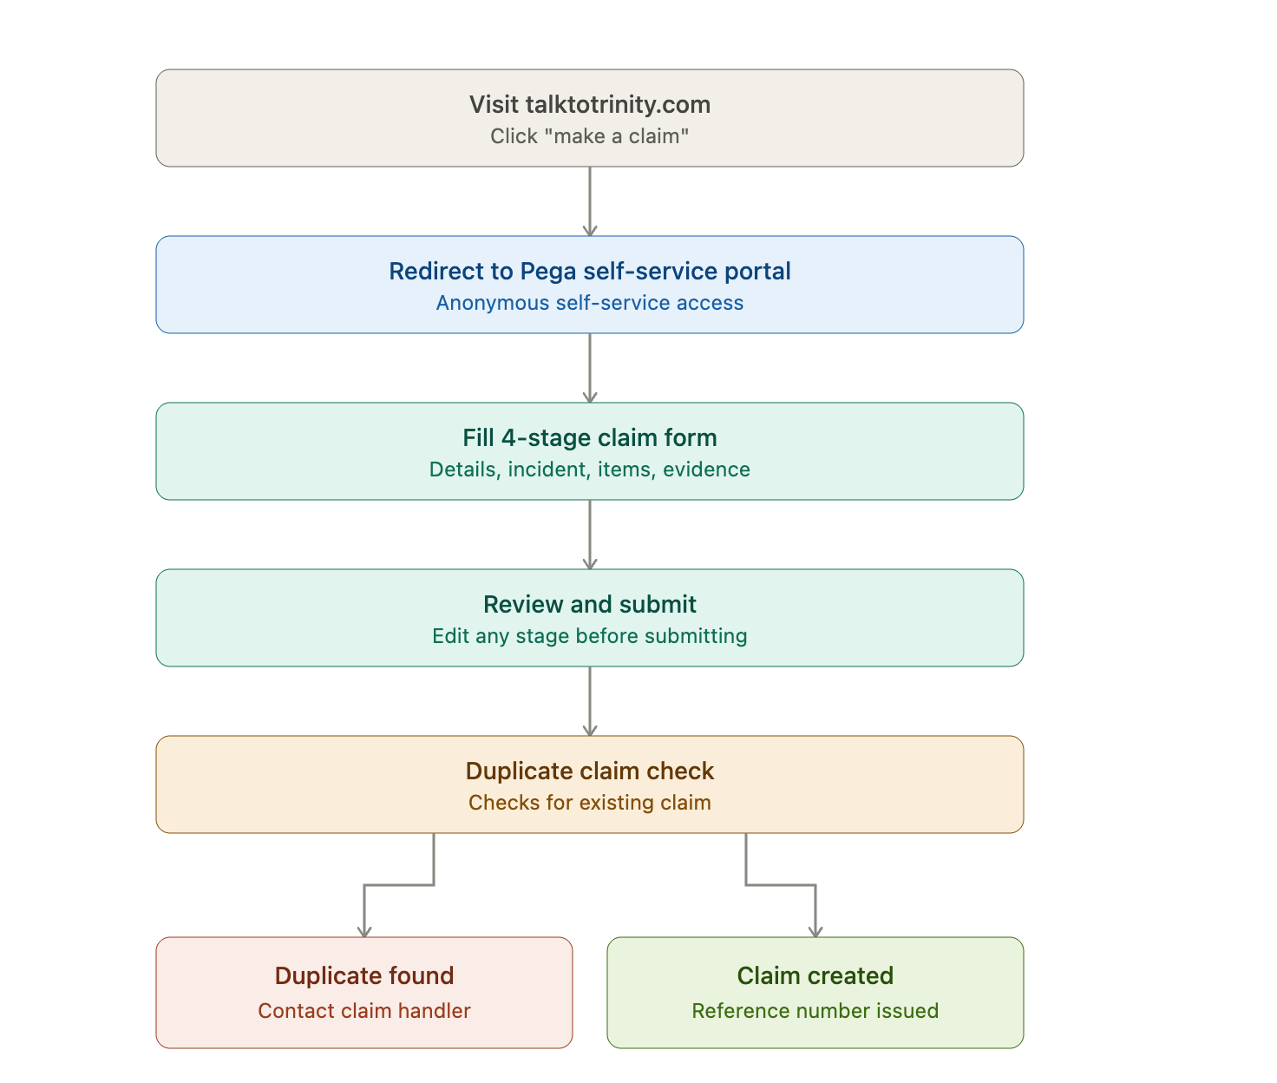

This covers the front door through claim creation. Now the backend intake and AI-enrichment flow once the claim lands in Pega:
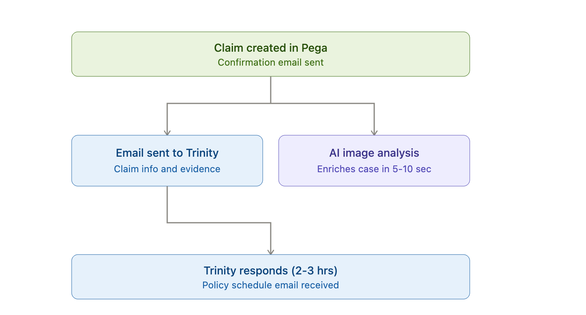

2. End User Journey - Feature List
The claimant (or someone authorised to act on their behalf) reports a claim entirely through a self-service, anonymous web experience, with no login required.
# | Feature | Description | Owner
1 | Public entry point | Anonymous "Make a claim" call-to-action on talktotrinity.com that redirects into the Pega self-service portal (trinity.tmhcc.com). | Trinity / Pega
2 | Custom Constellation DX web form | Purpose-built, branded landing page and web form built as a custom Constellation DX component (not OOTB Pega UI). | Pega
3 | 4-stage guided capture | Your details, What happened, Items affected, Evidence - a single guided flow that lets the claimant (or an authorised person on their behalf) capture as much incident detail as possible. | Pega
4 | Third-party / authorised submission | Form supports submission either by the policyholder directly or by an authorised person acting on the policyholder's behalf. | Pega
5 | Flexible evidence capture | At least one affected item is mandatory; supporting evidence/documents are optional and can be skipped if unavailable. | Pega
6 | Review and edit before submit | A review screen summarises all captured information and lets the user jump back to any stage to correct it before final submission. | Pega
7 | Automated duplicate detection | On submission, the system checks for an existing matching claim; if found, the user is informed on-screen and directed to contact the claims team by phone or email. | Pega
8 | Claim confirmation | On successful, non-duplicate submission, the user is shown a claim reference number on screen and receives a confirmation email, which they can quote in any future contact. | Pega

3. Claim Handler Journey - Feature List
Once a claim is submitted, Pega drives a structured, semi-automated process: notifying Trinity, enriching the case using AI where possible, and preparing the case for manual investigation via Libra.
# | Feature | Description | Owner
1 | Automated outbound notification to Trinity | On successful claim creation, a predefined-format email is auto-generated to hello@talktotrinity.com containing all claim details captured by the user plus any evidence attachments. | Pega
2 | Structured case view | All claimant-entered data (personal details, claim details, attachments, etc.) is organised into dedicated tabs on the Pega case for the claim handler. | Pega
3 | Attachment viewing and download | Uploaded evidence/attachments are viewable and downloadable directly from the case's attachments tab. | Pega
4 | AI-powered image analysis | If the claimant uploaded images of the damaged item(s), an AI image analysis process runs in parallel with the Trinity email wait (approx. 5-10 seconds) and enriches the case with its output for the handler's review. | Pega + AI service
5 | Inbound email parsing | When Trinity responds (typically within 2-3 hours) with the policy schedule and related information, Pega automatically parses the inbound email to locate the policy schedule document. | Pega
6 | AI-powered document extraction | AI is used to extract content from the policy schedule document and enrich the corresponding information directly on the case UI. | Pega + AI service
7 | Full email and attachment audit trail | Regardless of extraction outcome, all inbound and outbound emails and attachments are retained on the case - attachments via a dedicated tab, emails via the OOTB email/utilities widget. | Pega
8 | Investigation stage handoff | Case progresses to an Investigation stage. No automation exists here yet in this release; it is a manual handoff point. | Pega
9 | Manual Libra case creation | Claim handler manually creates the corresponding claim entry in Libra using the information available on the Pega case. | Claim handler
10 | Libra ID linkage (local action) | Once the Libra entry exists, the claim handler updates the case with the Libra ID using a dedicated local action, closing the loop between the two systems for this release. | Pega

4. Known Manual Steps / Out-of-Scope for This Release
These are called out explicitly so expectations are set correctly for this first production release.
- No automated integration between Pega and Libra - the Libra entry and ID linkage are manual steps in this release.
- No automation implemented yet at the Investigation stage beyond the manual Libra ID local action.
- Trinity's policy schedule response is asynchronous and time-bound only by business process (approx. 2-3 hours), not a hard SLA enforced by the system.

5. At a Glance - Journey Summary
End User Journey: talktotrinity.com → Pega self-service portal → 4-stage form → review → submit → duplicate check → claim reference number + confirmation email.
Claim Handler Journey: claim created → email to Trinity + parallel AI image analysis → Trinity reply parsed → AI extracts policy schedule → case enriched → investigation stage → manual Libra entry → Libra ID linked via local action.

