Components comparizon and choice

Displaying VM Memory component comparizon (64x64 color display)
Component | Pros | Cons | Price
ADA3649 Adafruit 64x64 Led Matrix  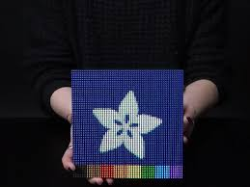  16x16 cm | + Clean  + Pixels visible  + Size | - Expensive  - Non-standard, existing library doesnst handle 5 pins addressing  - Already a circuit itself.  - Consume 4A | $ 74.95  € 66,85
WS2812B Addressable LEDs (strips or individual)  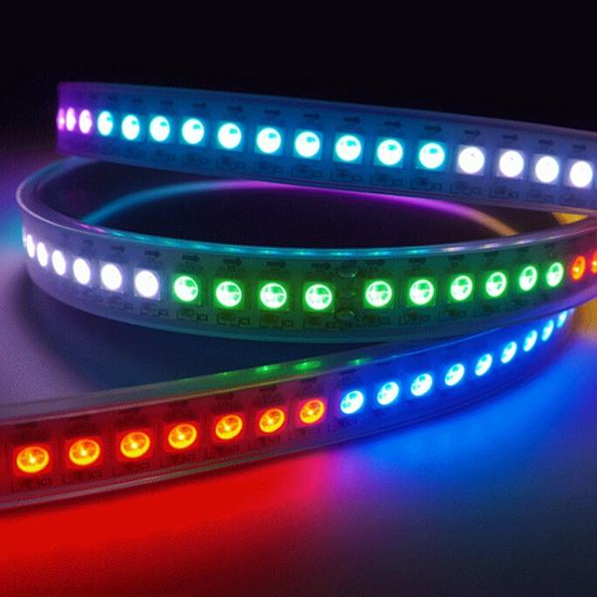 | + We craft the display  + Simple addressing | - TOO much Expensive  - Making a soo big panel with individual leds, or putting strips together will take too much time  - Strips have big width  - bad reviews/additional requiered components  - Consume 20 to 60 mA * 4096 | > $ 600
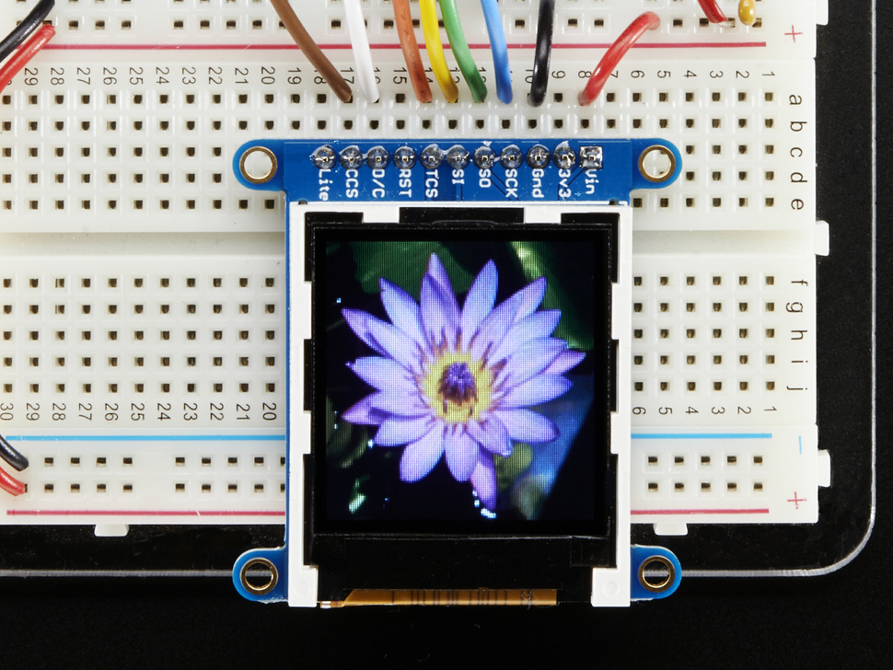  ST7735R Color TFT Display with MicroSD  Card Breakout  128x128 pixels  33mm x 45mm | + divisible by 64x64 (4 pixel per memory)  + extra resolution  + cheap  + library available  + few pins  + low consumption : 25 mA max | - no space between pixels  - include MiniSD holder, we want a separate one  - VERY SMALL | $ 14.95

Text Display
Component | Pros | Cons | Price
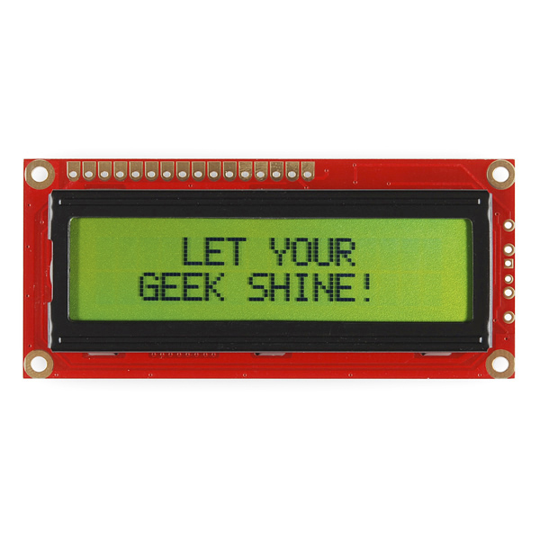  Basic 16x2 Character LCD 3.3V | + Few pins | - Style  - Only 3.3V  - pins need ? | $16.95
RGB backlight positive LCD 16x2  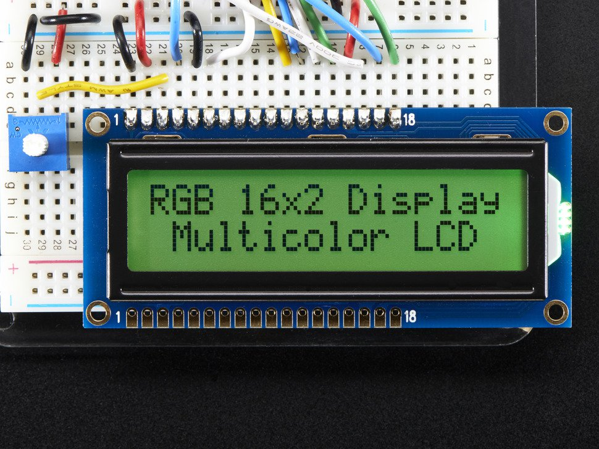 | + Style ?  + Can change back color  + tutorial | - Style ?  - Lots of pins needed (understandable) | $12.95
RGB backlight negative LCD  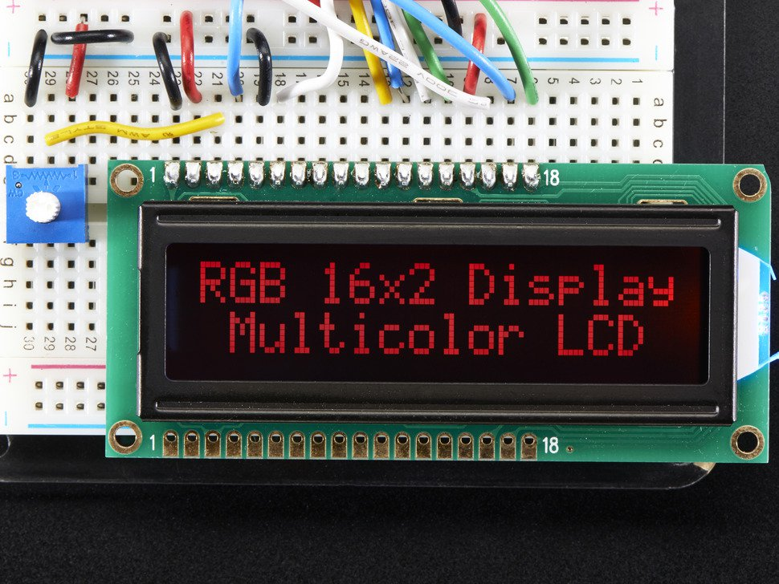 | + Style  + tutorial | - Lots of pins needed (understandable) | $13.95

RFID Card Reader (cards need 682 byte)
Component | Pros | Cons | Price
MF522-AN Neuftech® Lecteur RFID  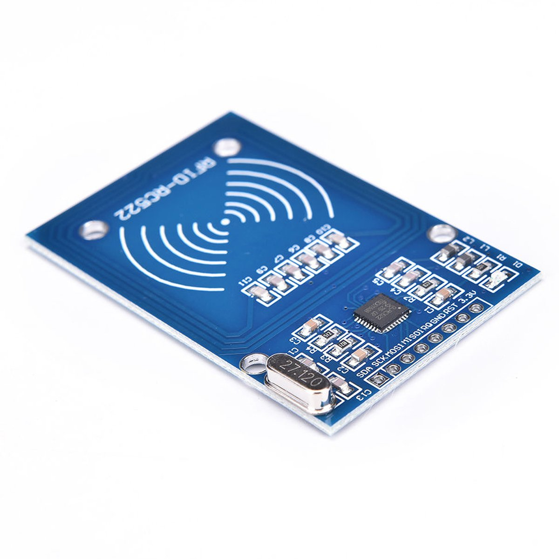 | + S50 will have extra memory |  | Euro 7 (1 key included)
RC522 RF IC  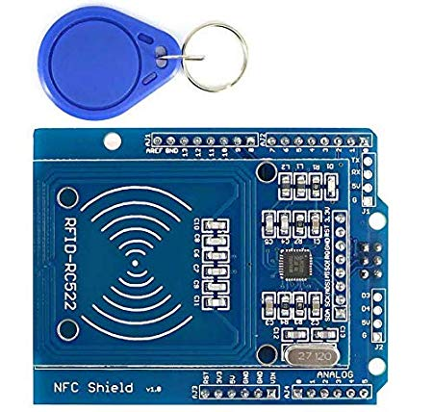 |  | - Looks like the previous one, with extra things | Euro 12

Chips
Chip | Pros/Uses | Cons | Price
ATmega328P  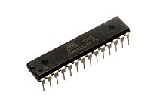 | + Many Pins |  | < euro 2

SD Card reader

