

Deccan Education Society's

NAVINCHANDRA MEHTA INSTITUTE OF TECHNOLOGY AND DEVELOPMENT

# NAAC Accredited “B++”

Garbage Management System

SUBMITTED BY

**Jay Suresh Adavade (C22002)**

**Mentor: Mrs. Lavina Mistry**

**ACADEMIC YEAR 2022-2024**

Submitted to University of Mumbai

in partial fulfillment of the requirements for qualifying

MASTER OF COMPUTER APPLICATION

Examination

## **Deccan Education Society’s**

NAVINCHANDRA MEHTA INSTITUTE OF TECHNOLOGY AND DEVELOPMENT

**PROJECT CERTIFICATE**

This is to certify that the Project done at **Deccan Education Society** by **Mr. Jay Suresh Adavade** (Seat No. **C22002**) in partial fulfillment for MCA Degree Examination has been found satisfactory. This report had not been submitted for any other examination and does not form part of any other course undergone by the candidate.

**Internal Guide Director**

EXAMINED BY

EXTERNAL EXAMINER …………………………

DATE:

College Stamp

**ACKNOWLEDGEMENT**

Achievement is finding out what you would be doing rather than what you have to do. It is not until you undertake such a project that you realize how much effort and hard work it really is, what are your capabilities and how well you can present yourself or other things. It tells us how much we rely on the efforts and goodwill of others. It gives me immense pleasure to present this report towards the fulfilment of my project. It has been rightly said that we are built on the shoulder of others. For everything I have achieved, the credit goes to all those who had helped me to complete this project successfully.

We take this opportunity to express my profound gratitude to management of **Deccan Education Society's Navinchandra Mehta Institute Of Technology & Development** for giving me thisopportunity to accomplish this project work.

We are very much thankful to **Dr. Anita Bobade** - Director of DES for their kind co-operation in the completion of my project. A special vote of thanks to our guides **Mrs. Lavina Mistry** for their sincere, useful andencouraging throughout the project span, without them we couldn’t start and complete project on time.

**ABSTRACT**

Smart cities integrate multiple mobile or websolutions to build a comfortable human habitation. One of these solutions is to provide an environmentally friendly, efficient and effective garbage management system. The current garbage collection system includes routine garbage trucks doing roundsdaily or weekly, which not only doesn't cover every zone of the city but its completely inefficient use of government resources. The proposed system, where admin manage the garbage app for full online based mointoring and analyze the system. Here admin handle bins, driver, complaints from user and work report from driver. This project proposes a cost-effective mobile or web based system for the government to utilize available resources to efficiently manage the over whelming amounts of garbage collected each day, while also providing a better solution for the inconvenience of garbage disposal for the citizens. This is done by a driver, app will provide predictive and guide routes generated through for garbage trucks. Then driver update the status of work done will be data collected. An web app is developed for the work force and the citizens, which primarily provides the user create complatints available smart bin.

**INDEX**

|  |  |  |  |
| --- | --- | --- | --- |
| **Chapter** |  | **Contents** | **Page No.** |
| **I** |  | **Introduction** | 6 |
|  |  |  |  |
| **II** |  | **System Design** | 7-9 |
|  | 2.1 | Existing System |  |
|  | 2.2 | Proposed System |  |
|  | 2.3 | Software Requirements |  |
|  | 2.4 | Hardware Requirements |  |
|  |  |  |  |
| **III** |  | **Overall Description of the proposed system** | 10-12 |
|  | 3.1 | Module Description |  |
|  | 3.2 | System Features |  |
|  | 3.3 | Gantt Chart |  |
|  |  |  |  |
| **IV** |  | **Design** | 13-23 |
|  | 4.1 | UML Diagram |  |
|  | 4.1.1 | UseCase Diagram |  |
|  | 4.1.2 | Sequence Diagram |  |
|  | 4.1.3 | Data Flow Design |  |
|  | 4.1.4 | Flow Diagram |  |
|  | 4.1.5 | Architecture Design |  |
|  | 4.1.6 | ER Design |  |
|  | 4.1.7 | Table Design |  |
|  |  |  |  |
| **V** |  | **Output Screenshots and Code** | 24-27 |
|  |  |  |  |
| **VI** |  | **System Testing** | 28-32 |
|  |  | Test Cases |  |
|  |  |  |  |
| **VII** |  | **Conclusions** | 33 |
|  |  |  |  |
| **VIII** |  | **Bibliography** | 34 |

# CHAPTER 1 – INTRODUCTION

Proper waste management is a basic requirement in any kind of an environment. Usually cleaning in these environments are done in the morning and the afternoon. If you take an urban city like Mumbai usually there are about 1,200,000 to 1,500,000 employees heading for their workstations every morning. For all those people, there are just not enough garbage bins available. On the streets of urban cities, hundreds of people are passing the same location around one minute. Around 95% of people are carrying food covers, polythene bags, and plastic bottles. If they dispose all them at once, the bins will be filled in several minutes. When they fill up people just litter their trash around the garbage bins because there is nowhere else to put them. The obvious solution to this is for the cleaning staff to stay near garbage bins every day till they fill up to clean them. This is not a real solution. It takes way more cleaning staff and costs a lot of money. So, it is impractical. The same scenario is happening in workstations. For instance, a bank or a government office cafeteria usually has about five to six garbage bins to serve hundreds of employees. This is simply not enough. There are some notable negative effects when considering the garbage bins always being full. One of the main effects is the surrounding area starting to smell and be very unpleasant. When the garbage bins are full people put their trash on sides of the garbage bins. When this is done for some time, first it starts to smell bad. So, others who come later tend not to go close and throw their trash in the direction of the garbage bins. If there are any leftover food items, throwing it causes them to spill. This attracts animals like cats, dogs, and flies. And these animals spill them even more. Another negative effect is the diseases that spread. It's not just the garbage that spread them, but the animals also can be a source.

# CHAPTER 2 – SYSTEM DESIGN

The concept of Smart City, brings new possibilities for the city management. In this project, we are discussing one of the most challenging issues - municipal waste-collection within the Smart City. To optimize the logistic procedure of waste collection, we use own genetic algorithm implementation. The presented solution provides calculation of more efficient garbage-truck routes. As an output, we provide a set of simulations focused on mentioned area. All our algorithms are implemented within the integrated simulation framework which is developed as an open source solution with respect to future modifications.

## **2.1 Existing System**

Employees heading for their workstations every morning. For all those people, there are just not enough garbage bins available. On the streets of urban cities, hundreds of people are

passing the same location around one minute.

The obvious solution to this is for the cleaning staff to stay near garbage bins every day till they fill up to clean them. This is not a real solution. There are some notable negative effects when considering the garbage bins always being full. One of the main effects is the surrounding area starting to smell and be very unpleasant. When the garbage bins are full people put their trash on sides of the garbage bins.

**Disadvantages:**

On the streets of urban cities, hundreds of people are passing the same location around one minute. Around 95% of people are carrying food covers, polythene bags, and plastic bottles. If they dispose all them at once, the bins will be filled in several minutes. When they fill up people just litter their trash around the garbage bins because there is nowhere else to put them. The obvious solution to this is for the cleaning staff to stay near garbage bins every day till they fill up to clean them.

This is not a real solution. It takes way more cleaning staff and costs a lot of money. So, it is impractical. The same scenario is happening in workstations. For instance, a bank or a government office cafeteria usually has about five to six garbage bins to serve hundreds of employees. This is simply not enough.

## **2.2 PROPOSED SYSTEM**

* The proposed system overview for this system. Solid waste management can be broadly categorized as segregation, collection, and transportation.
* The server will collect the data and store them only a database. This data will be analyzed and displayed on two different dashboards that can be accessed by the workforce and clients.
* Using data analytics, reports will be generated which can be monitored by the admins through the admin dashboard.
* Based on the data collected, garbage trucks can be given routes generated through various algorithms and google maps API to efficiently route through all necessary garbage bins and finally reach the dumping site

**Advantages**

* The application has a map that shows the current levels of all the bins. This receives the calculated route (mentioned in the route calculation) at the designated time slots and when there is special bin to be cleaned.
* The government to utilize available resources to efficiently manage the overwhelming amounts of garbage collected each day, while also providing a better solution for the inconvenience of garbage disposal for the citizens.

# 2.3 Software Requirements: -

Front End: HTML5, CSS3, Bootstrap

Back End: PHP, MYSQL

Control End: Angular Java Script

**Tools:-**

xampp-win64-7.4

# 2.4 Hardware Requirements:-

Processor : Intel(R) 2.10GHz

Installed memory (RAM) : 4 GB

Hard Disk : 160 GB

Operating System : Windows (7)

# CHAPTER 3 OVERALL DESCRIPTION OF THE PROPOSED SYSTEM

## **3.1 Module Description**

By using garbage update information of worker, general public can communicate with adminstrate. Communication is possible among the workers, general public and administrator.

**3.2 System Features**

In the life of the software development, problem analysis provides a base for design and development phase. The problem is analyzed so that sufficient matter is provided to design a new system. Large problems are sub-divided into smaller once to make them understandable and easy for finding solutions. Same in this project all the task are sub-divided and categorized.

**System Modules:**

* **Administrator**
  1. Login
  2. Create Garbage bin
  3. Update/Delete garbage bin
  4. Assign best route for drivers
  5. Manage driver
  6. View Garbage Report
  7. View complaints from public
* **General Public**
  1. Register
  2. Login
  3. Register complaint
  4. My complaint & status
* **Driver**
  1. Login
  2. Check daily work updates
  3. Choose best route
  4. Update garbage load

**Modules Description:**

* **Administrator**
  1. Login
     1. In log in page, admin can manage all information. They can update or edit any information.
  2. Create Garbage bin
     1. Admin can create the grabage avaible in the city with details and location
  3. Update/Delete garbage bin
     1. Admin can View and update the grabage avaible in the city with details and location
  4. Assign best route for drivers
     1. Admin can update the grabage best route to reatch the bin of the city quickly
  5. Manage driver
     1. Admin can Create & View and update the driver login details
  6. View Garbage Report
     1. Admin can View work report of grabage all updates from the driver
  7. View complaints from public
     1. Admin can View the complaint and update status of the complaints
* **General Public**
  1. Register
     1. User can register to grabage application
  2. Login
     1. User can login to grabage application
  3. Register complaint
     1. User can register to complaints about the cleaning of the garbage
  4. My complaint & status
     1. User can view the status of the complaints about the cleaning of the garbage
* **Driver**
  1. Login
     1. Drive can login to grabage application
  2. Check daily work updates
     1. Drive can update the daily work status
  3. Choose best route
     1. Drive can view the route for the garbage bins
  4. Update garbase load
     1. Drive can update the load for the garbage bins

**3.3 Gantt Chart**



# CHAPTER 4 – DESIGN

Design is the first step in the development phase for any techniques and principles for the purpose of defining a device, a process or system in sufficient detail to permit its physical realization.

Once the software requirements have been analyzed and specified the software design involves three technical activities - design, coding, implementation and testing that are required to build and verify the software.

The design activities are of main importance in this phase, because in this activity, decisions ultimately affecting the success of the software implementation and its ease of maintenance are made. These decisions have the final bearing upon reliability and maintainability of the system. Design is the only way to accurately translate the customer’s requirements into finished software or a system.

Design is the place where quality is fostered in development. Software design is a process through which requirements are translated into a representation of software. Software design is conducted in two steps. Preliminary design is concerned with the transformation of requirements into data.

## **4.1UML Diagrams:**

UML stands for Unified Modeling Language. UML is a language for specifying, visualizing and documenting the system. This is the step while developing any product after analysis. The goal from this is to produce a model of the entities involved in the project which later need to be built. The representation of the entities that are to be used in the product being developed need to be designed.

There are various kinds of methods in software design:

* Use case Diagram
* Sequence Diagram
* Collaboration Diagram

**4.1.1Usecase Diagrams**:

Use case diagrams model behavior within a system and helps the developers understand of what the user require. The stick man represents what’s called an actor. Use case diagram can be useful for getting an overall view of the system and clarifying that can do and more importantly what they can’t do.

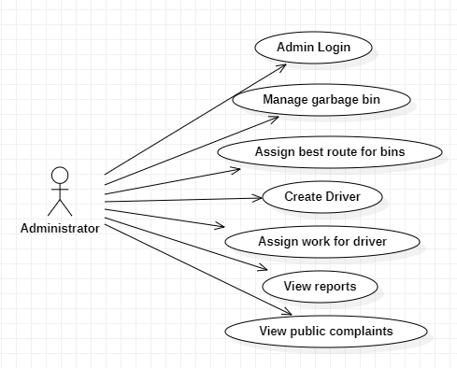

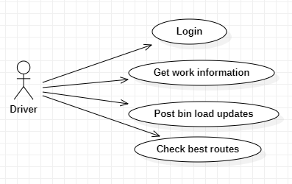­­

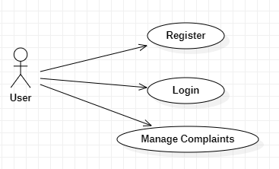

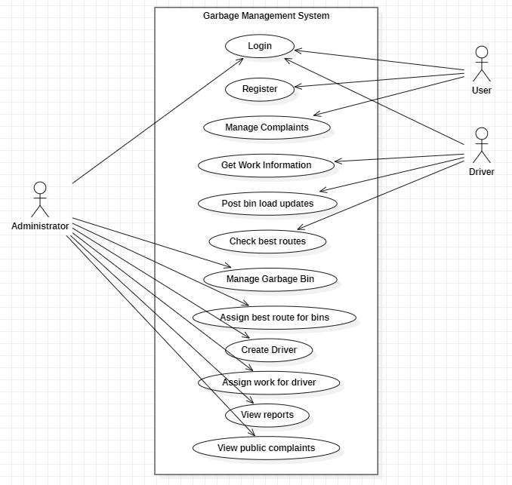

**4.1.2 Sequence Diagram:**

Sequence diagram and collaboration diagram are called INTERACTION DIAGRAMS. An interaction diagram shows an interaction, consisting of set of objects and their relationship including the messages that may be dispatched among them.

A sequence diagram is an introduction that empathizes the time ordering of messages. Graphically a sequence diagram is a table that shows objects arranged along the X-axis and messages ordered in increasing time along the Y-axis.



**4.1.3 Data Flow Design:**

**0-Level DFD**

Create Complaint

Use

**Manage Bin Details**

**App User**

**1-LEVEL DFD**

**App User**

All database

**2-Level Admin DFD**

Admin Login

Manage Bin/driver

Update Complaint Status

2 **Level User DFD**

Logout

View User Details

View Work Status

User Register/ Login

Create Complaints

View Complaint Status

Logout

My Profile

### **4.1.4 FLOW DIAGRAM**

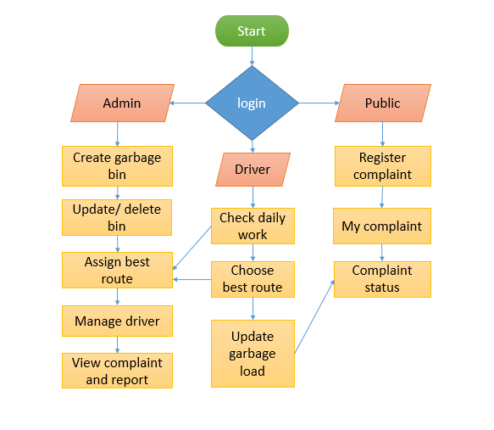

**4.1.5 Architecture Design:**

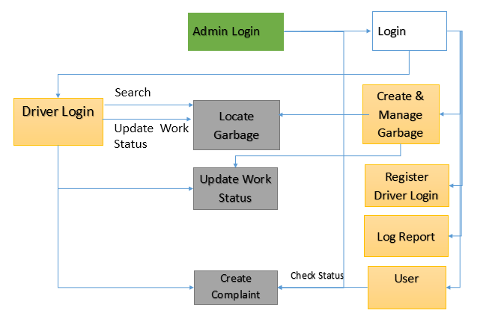

**4.1.6 ER Design:**

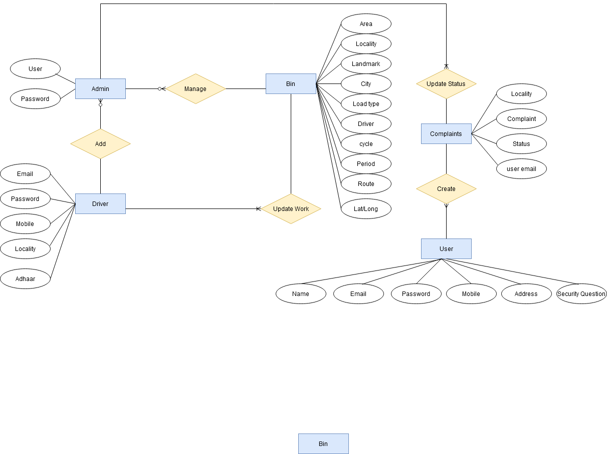

**4.1.7 Table Design:**

User & Admin & Worker Login

|  |  |  |
| --- | --- | --- |
| Id | Username | Password |
| Int | Varchar | Varchar |
| 100 | 100 | 100 |
| Primary key |  |  |

**User Register**

|  |  |  |  |  |  |  |  |  |
| --- | --- | --- | --- | --- | --- | --- | --- | --- |
| User ID | Name | Email Id | Password | Mobile | Address | City | Question 1 | Question 2 |
| Int | Varchar | Varchar | Varchar | Varchar | Varchar | Varchar | Varchar | Varchar |
| 100 | 100 | 100 | 100 | 100 | 100 | 100 | 100 | 100 |
| Primary key |  |  |  |  |  |  |  |  |

**Garbage**

|  |  |  |  |  |  |  |  |  |
| --- | --- | --- | --- | --- | --- | --- | --- | --- |
| ID | Place | Locality | Landmark | Driver ID | Address 1 | Address 2 | Lat | Long |
| Int | Varchar | Varchar | Varchar | Varchar | Varchar | Varchar | Varchar | Varchar |
| 100 | 100 | 100 | 100 | 100 | 100 | 100 | 100 | 100 |
| Primary key |  |  |  |  |  |  |  |  |

**Worker Status**

|  |  |  |  |  |
| --- | --- | --- | --- | --- |
| ID | Name | Email Id | Address | Status |
| Int | Varchar | Varchar | Varchar | Varchar |
| 100 | 100 | 100 | 100 | 100 |
| Primary key |  |  |  |  |

**User Complaints**

|  |  |  |  |  |
| --- | --- | --- | --- | --- |
| ID | Name | Email Id | Address | Status |
| Int | Varchar | Varchar | Varchar | Varchar |
| 100 | 100 | 100 | 100 | 100 |
| Primary key |  |  |  |  |

# CHAPTER 5 - OUTPUT SCREENSHOTS

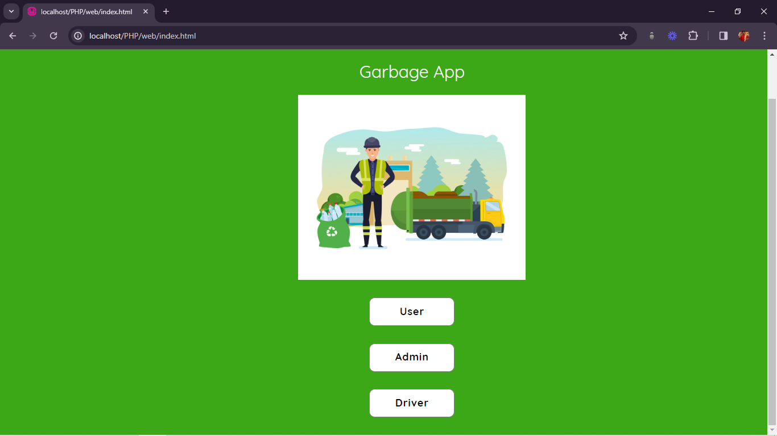

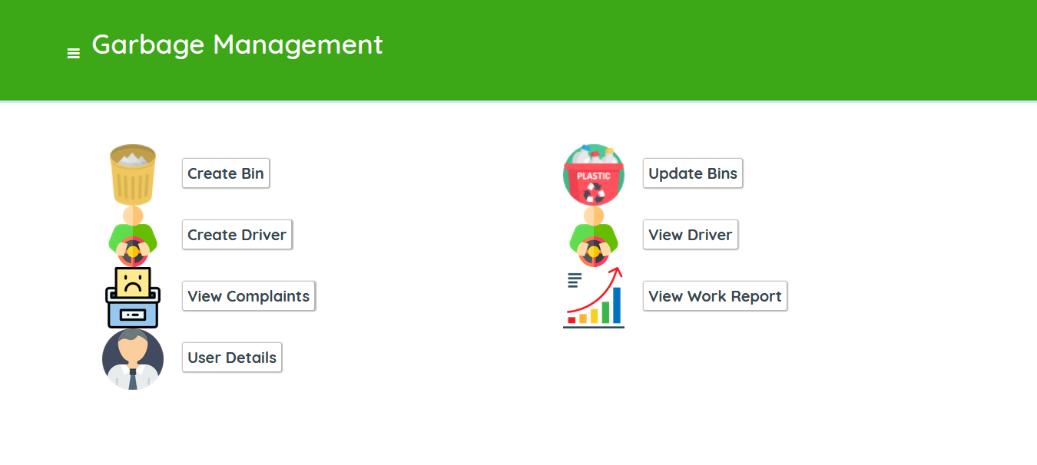

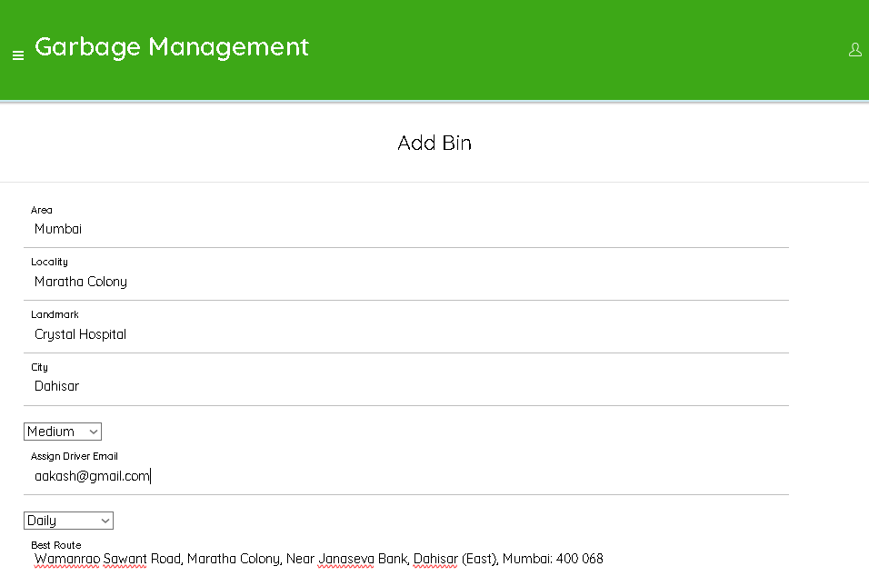

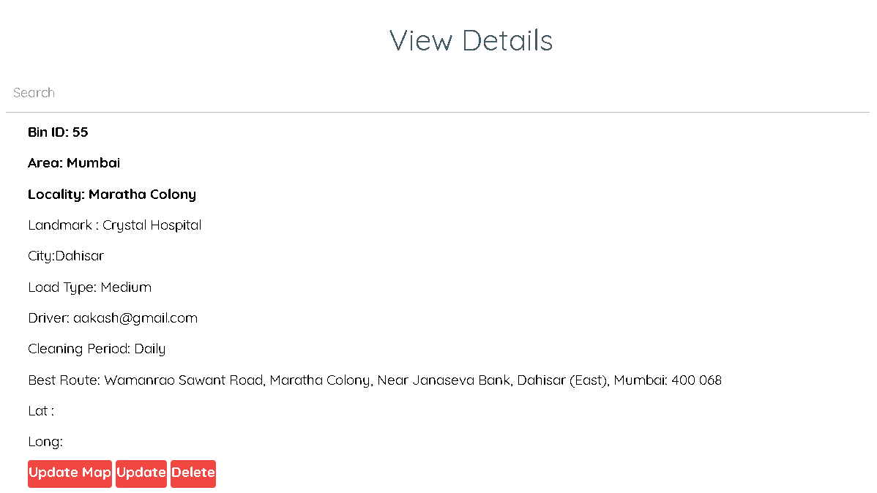

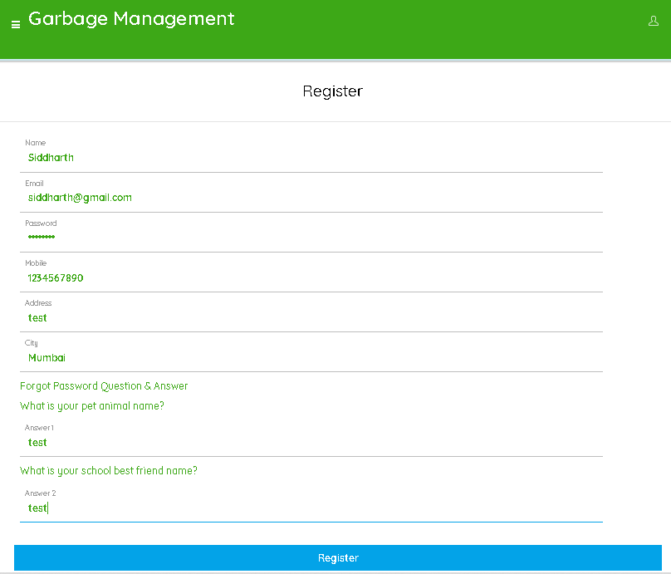

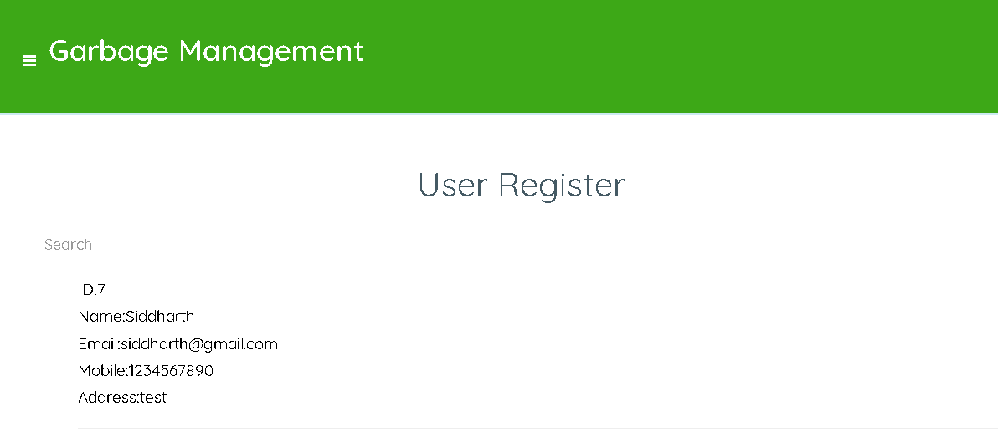

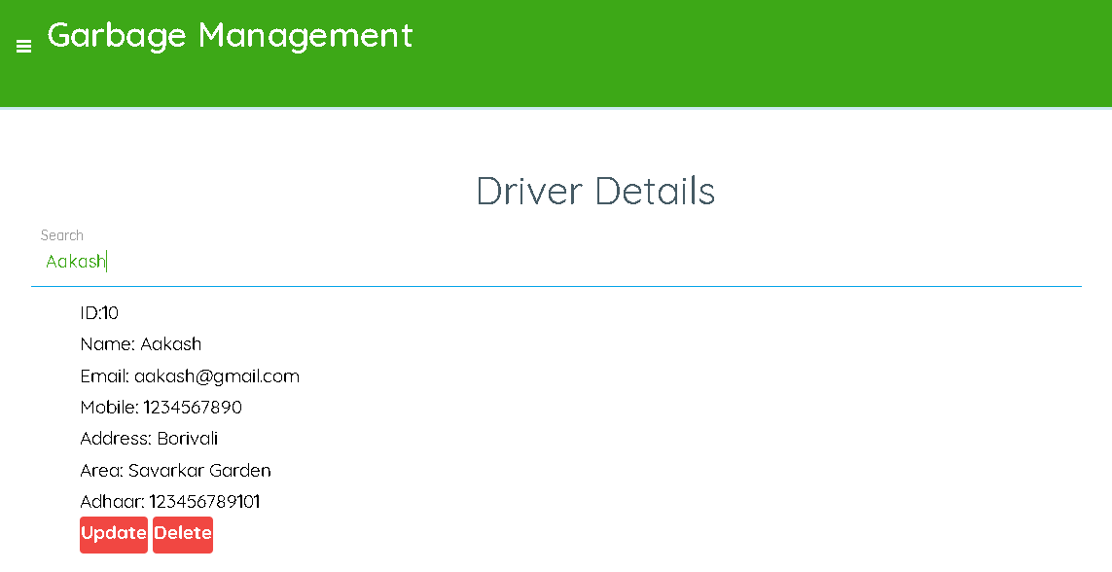

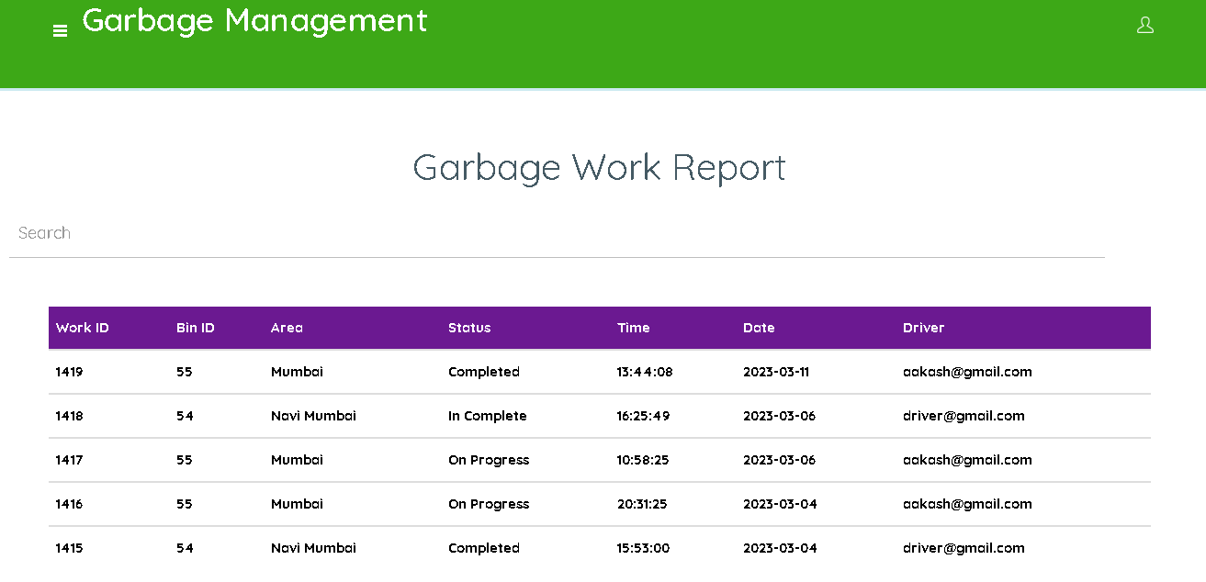

# CHAPTER 6-SYSTEM TESTING

The purpose of testing is to discover errors. Testing is the process of trying to discover every conceivable fault or weakness in a work product. It provides a way to check the functionality of components, sub-assemblies, assemblies and/or a finished product It is the process of exercising software with the intent of ensuring that the

Software system meets its requirements and user expectations and does not fail in an unacceptable manner. There are various types of test. Each test type addresses a specific testing requirement.

## 

## **TEST CASES**

A test case has components that describe input, action and an expected response, in order to determine if a feature of an application is working correctly. A test case is a set of instructions on “HOW” to validate a particular test objective/target, which when followed will tell us if the expected behavior of the system is satisfied or not.

|  |  |  |  |  |
| --- | --- | --- | --- | --- |
| **S.NO** | **SCENARIO** | **INPUT** | **EXPECTED**  **OUTPUT** | **ACTUAL OUTPUT** |
| 1 | Admin login Details | Admin will enter email and password | Login successfully or if incorrect login details  “Login unsuccessfully” | Login successfully or  Login unsuccessfully |
| 2 | Add Garbage Bin Details | Admin will enter all garbage details | If all the garbage bin  “Created Successfully” | Created successfully or created unsuccessfully |
| 3 | Edit and delete Garbage | Admin can edit and delete the garbage details | If any changes edit updated successfullly or delete successfullly | Updated successfully or unsuccessfully  Delete successfully or unsuccessfully |
| 3 | Driver Login | Admin will create login id for drivers | Driver login id will be  “Created Successfully” | Created successfully or created unsuccessfully |
| 4 | View Work Report | Admin will check the garbage work report | Admin view garbage details | View all garbage details |
| 5 | View Complaint | Admin will check the Complaint details | Admin will update Complaint Status | Updated successfully or unsuccessfully |
| 6 | Driver login | Driver will enter email and password | Login successfully or if incorrect login details  “Login unsuccessfully” | Login successfully or  Login unsuccessfully |
| 7 | daily work updates | Driver will check the garbage details | Driver will update work Status | Updated successfully or unsuccessfully |
| 8 | Create Business | Business created by all details like name,address, phone etc | All the details Create successfully | Created successfully or created unsuccessfully |
| 9 | View my Business | Mechanic check and view all business details | Mechanic view business details | View all business details |
| 10 | Update Geo Location | Mechanic update location of shop in google map | Drap and drop the locaiton | Updated successfully or unsuccessfully |
| 11 | Edit and delete product | Mechanic can edit and delete the details | If any changes or non available details can edit or delete | Updated successfully or unsuccessfully  Delete successfully or unsuccessfully |
| 12 | User Login | Email and Password | If correct directed to home page otherwise show “Invalid Login” | Login successfully or  Login unsuccessfully |
| 13 | User register | Email and Password | All the user details register successfully | Register successfully  Or  Register unsuccessfully |
| 14 | Create Complaint | Complaint created by all details like area, locality | All the details Create successfully | Created successfully or created unsuccessfully |
| 15 | View my Complaint | user check and view all complaint details | User view Complaint details | View my Complaint details |
| 16 | Edit My Profile | User can edit and profile | If any changes or user can edit profile | Updated successfully or unsuccessfully |

**TYPES OF TEST**

**Unit testing**

Unit testing involves the design of test cases that validate that the internal program logic is functioning properly, and that program inputs produce valid outputs. All decision branches and internal code flow should be validated. It is the testing of individual software units of the application .it is done after the completion of an individual unit before integration. This is a structural testing, that relies on knowledge of its construction and is invasive. Unit tests perform basic tests at component level and test a specific business process, application, and/or system configuration. Unit tests ensure that each unique path of a business process performs accurately to the documented specifications and contains clearly defined inputs and expected results. Unit testing is usually conducted as part of a combined code and unit test phase of the software lifecycle, although it is not uncommon for coding and unit testing to be conducted as two distinct phases.

**Test strategy and approach**

Field testing will be performed manually and functional tests will be written in detail.

**Test objectives**

* All field entries must work properly.
* Pages must be activated from the identified link.
* The entry screen, messages and responses must not be delayed.

**Features to be tested**

* Verify that the entries are of the correct format
* No duplicate entries should be allowed
* All links should take the user to the correct page

# CHAPTER 7– CONCLUSIONS AND FUTURE ENHANCEMENT

Future work can include many areas. One area that can be improved on, but limited at this time due to trying to making this project low cost, is identifying types of garbage from the bin itself, thus removing human segregation. If this is mplemented, in a single location instead of four bins for the four different types of garbage, one large bin can be placed which segments the garbage by itself. Another area which can be improved is instead of each bin connecting to an access point to communicate with the server, bins can communicate with each other and connect to an access point through the main hub. This method may reduce network costs and make the network process more efficient.

# CHAPTER 8- BIBLIOGRAPHY

http://www.statistics.gov.lk/page.asp?page=Population%20and%20Housing/.

http://www.lgpc.gov.lk/eng/?page_id=1118/.

http://logicify.github.io/jquery-locationpicker-plugin/

https://developers.google.com/maps/documentation/javascript/examples/directionswaypoints/.