* Open the folder “ sonichealth-vendingmachine-app” in vscode and run “ng serve” in nodejs or powershell terminal
* Open the folder “SonicHealthVendingMachineService” in vscode and run “dotnet run”
* Go to browser and run <http://localhost:4200/> to start the app

Step 1:

Click on a can # and press enter

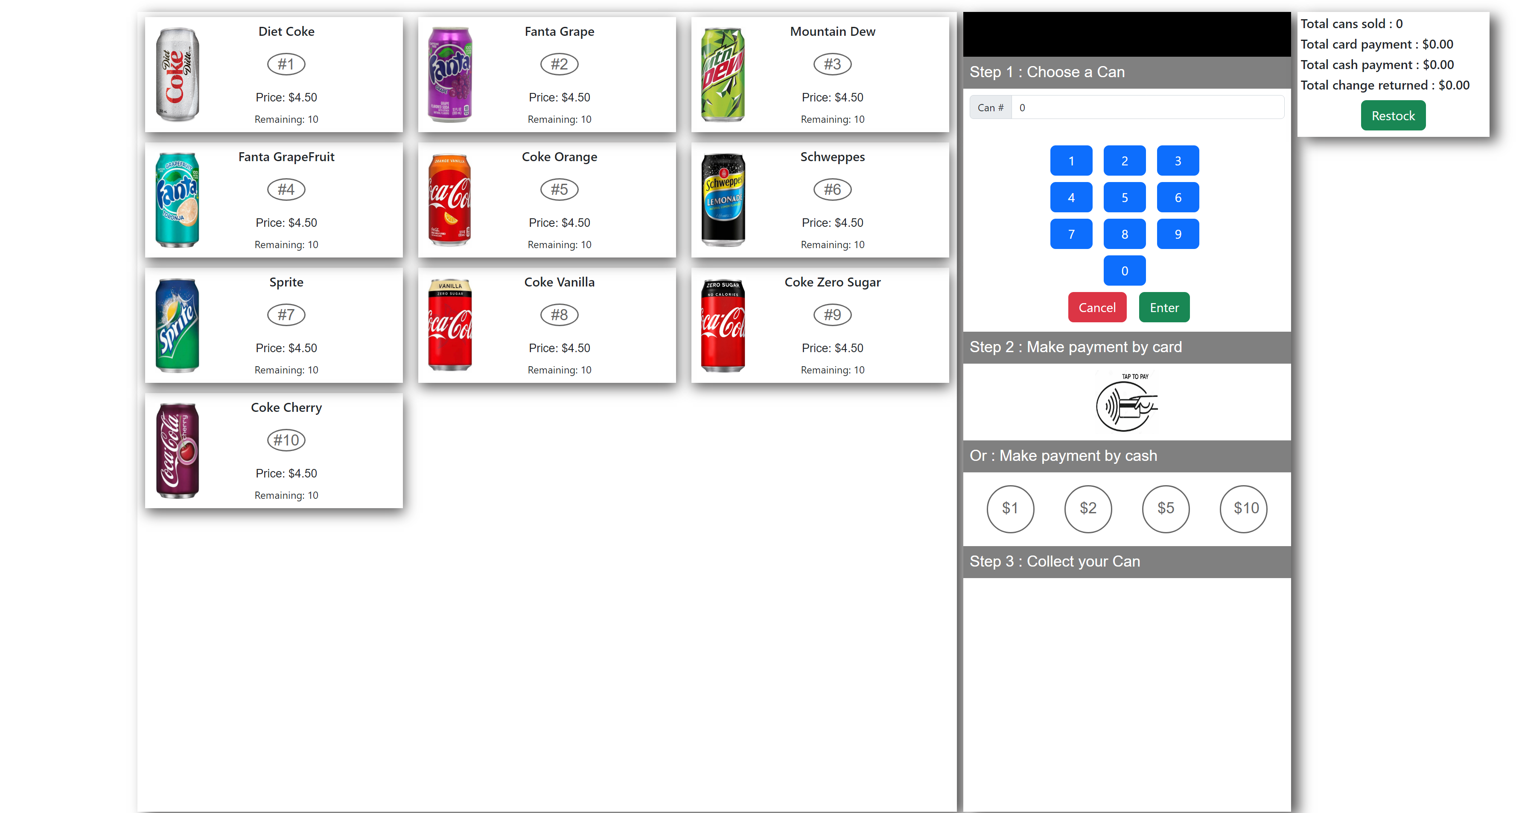

Step 2

Choose a payment by click the card or choose coins to insert

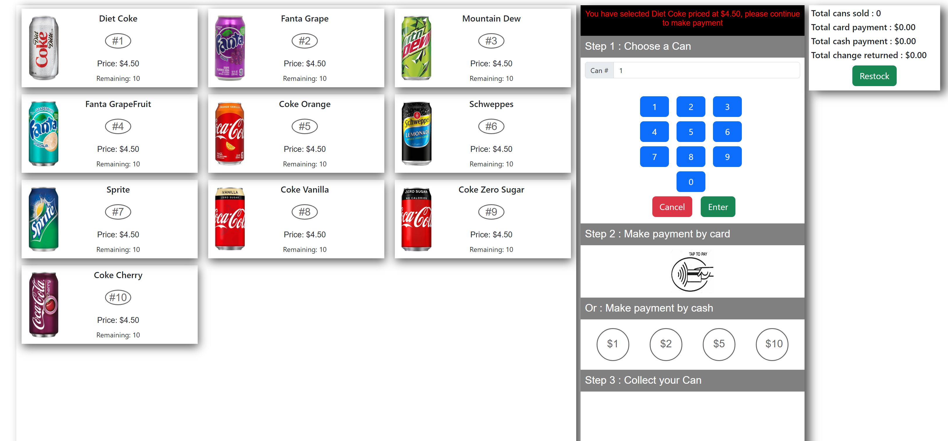

Step 3:

Once paid the message to collect the can and change will be shown, try with multiple options and see the remaining quantity adjusted automatically.

The summary section will show all the payment transaction details.

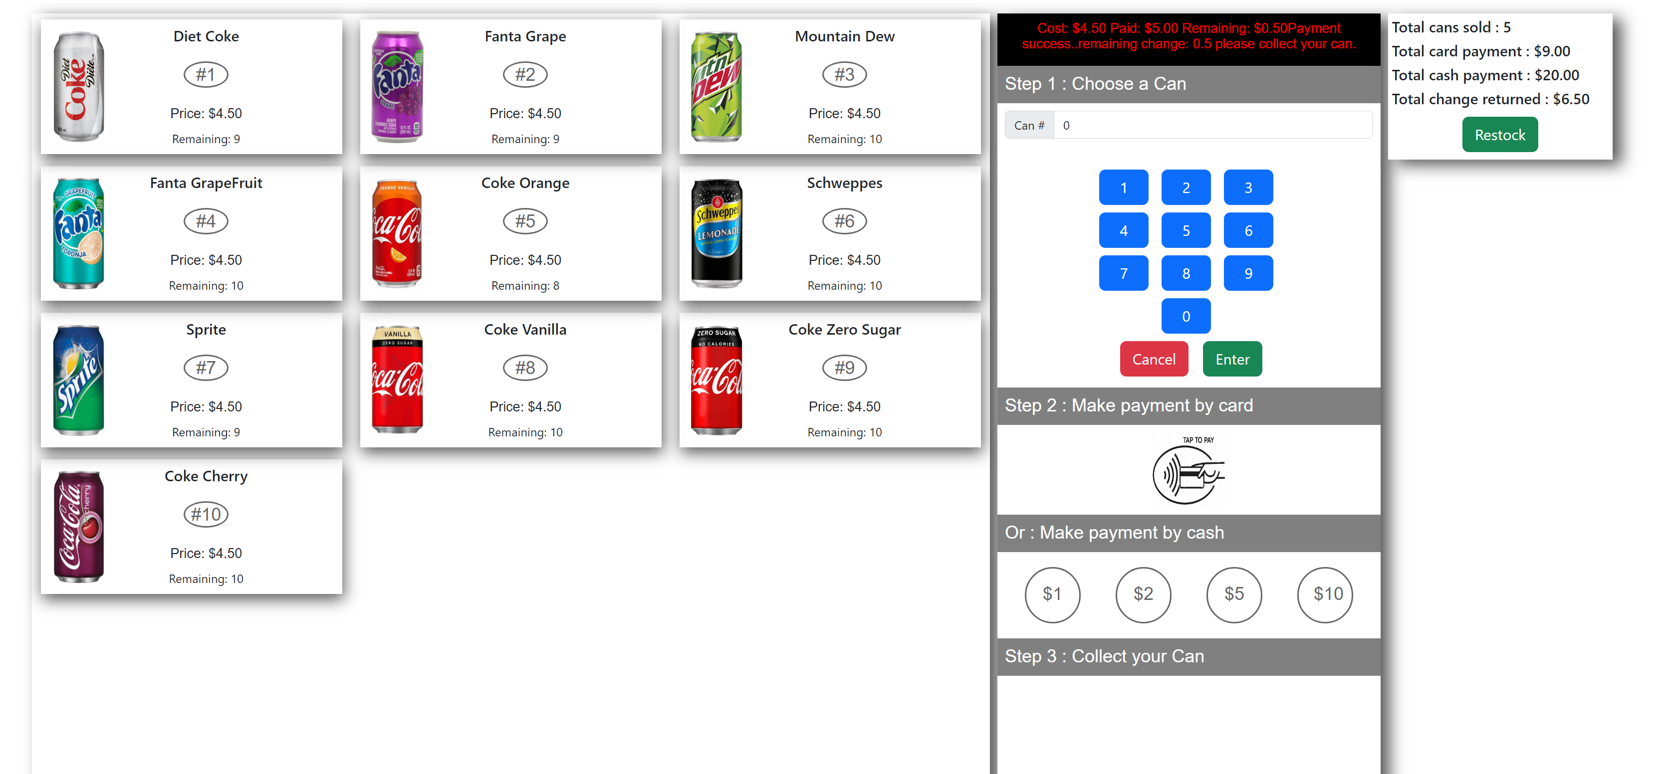

Step 4

Click on restock and all the data would restore a fresh filled vending machine.

