|  |  |
| --- | --- |
| Ex-5 | Variable types & Parallel Prefix sum |
| 12/08/2025 |  |

Aim:

To

1. Write a C++ program in which, inside the parallel region, change the datatype of variables private, firstprivate, lastprivate, shared. Explore the default behaviour inside a parallel

region.

1. Write a C++ program with OpenMP directives to find the parallel prefix sum. Compare with the serial version of the code for array sizes changing from

{10,100,1000,10000,100000,1000000}.

1. Find an application with a while loop which can be parallelised using the slave model. Compare the speedup you achieve post-parallelisation.

Algorithm:

1)

1. start
2. declare variables for shared,private,firstprivate and last private
3. open openmp section and modify and access the variables
4. print the changes in the variables 5)stop

2)

1. start
2. implement functions for prefix sum in parallel and prefix sum in serial
3. In main function call both function and measure time 4)stop

3)

1. start
2. implement functions for performing monte carlo estimation of pi using serial and parallel methods
3. In main functions call the functions and compare by measuring time
4. stop

CODE:

1)

#include <iostream> #include <omp.h>

int main() {

int shared_var=10; int private_var=20;

int firstprivate_var=30; int lastprivate_var=40;

std::cout<<"Before parallel region:"<<std::endl; std::cout<<"shared_var = "<<shared_var<<std::endl; std::cout<<"private_var = "<<private_var<<std::endl; std::cout<<"firstprivate_var = "<<firstprivate_var<<std::endl; std::cout<<"lastprivate_var = "<<lastprivate_var<<std::endl;

#pragma omp parallel for \ shared(shared_var) \ private(private_var) \ firstprivate(firstprivate_var) \ lastprivate(lastprivate_var)

for(int i=0;i<omp_get_max_threads();i++){ int default_var=100;

shared_var+=i; private_var+=i; firstprivate_var+=i; lastprivate_var=i; default_var+=i;

#pragma omp critical

{

std::cout<<"Thread "<<omp_get_thread_num()<<": "

<<"shared_var = "<<shared_var<<", "

<<"private_var = "<<private_var<<", "

<<"firstprivate_var = "<<firstprivate_var<<", "

<<"lastprivate_var = "<<lastprivate_var<<", "

<<"default_var = "<<default_var<<std::endl;

}

}

std::cout << "\nAfter parallel region:" << std::endl; std::cout << "shared_var = " << shared_var << std::endl;

std::cout << "private_var = " << private_var << " (unchanged in master thread)" << std::endl; std::cout << "firstprivate_var = " << firstprivate_var << " (unchanged in master thread)" <<

std::endl;

std::cout << "lastprivate_var = " << lastprivate_var << " (value from last iteration/thread)" <<

std::endl;

return 0;

}

2)

#include <iostream> #include <vector> #include <chrono> #include <omp.h> #include <cassert>

void prefix_sum_serial(const std::vector<int>& input, std::vector<int>& output) { output[0]=input[0];

for (size_t i=1;i<input.size();i++) { output[i]=output[i-1]+input[i];

}

}

void prefix_sum_parallel(const std::vector<int>& input, std::vector<int>& output) { int n=input.size();

int num_threads=1;

#pragma omp parallel

{

#pragma omp single num_threads=omp_get_num_threads();

}

std::vector<int> partial_sums(num_threads+1,0); #pragma omp parallel

{

int tid=omp_get_thread_num();

int chunk_size=(n+num_threads-1)/num_threads; int start=tid*chunk_size;

int end=std::min(start+chunk_size,n);

if(start<n){ output[start]=input[start];

for (int i=start+1;i<end;i++) { output[i]=output[i-1]+input[i];

}

partial_sums[tid+1]=output[end-1]; // store sum of this chunk

}

}

for (int i=1;i<num_threads+1;i++){ partial_sums[i]+=partial_sums[i - 1];

}

#pragma omp parallel

{

int tid=omp_get_thread_num();

int chunk_size=(n+num_threads-1)/num_threads; int start=tid*chunk_size;

int end=std::min(start+chunk_size,n);

if(tid>0&&start<n){

int add_value=partial_sums[tid]; for(int i=start;i<end;i++){

output[i]+=add_value;

}

}

}

}

int main() {

std::vector<int> sizes={10,100,1000,10000,100000,1000000};

for (int n : sizes){ std::vector<int> input(n);

std::vector<int> output_serial(n); std::vector<int> output_parallel(n);

for (int i=0;i<n;i++) { input[i] = i+1;

}

auto start_serial=std::chrono::high_resolution_clock::now(); prefix_sum_serial(input, output_serial);

auto end_serial=std::chrono::high_resolution_clock::now();

auto start_parallel=std::chrono::high_resolution_clock::now(); prefix_sum_parallel(input, output_parallel);

auto end_parallel=std::chrono::high_resolution_clock::now();

bool correct=true;

for (int i=0;i<n;i++) { if(output_serial[i]!=output_parallel[i]) {

correct=false; break;

}

}

auto serial_time=std::chrono::duration<double, std::milli>(end_serial - start_serial).count(); auto parallel_time=std::chrono::duration<double, std::milli>(end_parallel -

start_parallel).count();

std::cout<<"Array size: "<<n<<"\n"; std::cout<<"Serial time: "<<serial_time<<" ms\n"; std::cout<<"Parallel time: "<<parallel_time<<" ms\n";

std::cout<<"Results match? "<<(correct ? "Yes" : "No")<<"\n\n";

}

return 0;

}

3)

#include <iostream> #include <random> #include <chrono> #include <omp.h>

double monte_carlo_serial(long long num_points) { std::mt19937_64 rng(42); std::uniform_real_distribution<double> dist(0.0, 1.0); long long inside_circle=0;

long long i=0;

while(i<num_points){ double x=dist(rng); double y=dist(rng);

if(x*x+y*y<=1.0) inside_circle++;

i++;

}

return 4.0*inside_circle/num_points;

}

double monte_carlo_parallel(long long num_points, int num_threads) { long long inside_circle = 0;

#pragma omp parallel num_threads(num_threads)

{

std::mt19937_64 rng(42 + omp_get_thread_num()); std::uniform_real_distribution<double> dist(0.0, 1.0); long long local_count=0;

#pragma omp for

for (long long i=0;i<num_points;i++) { double x=dist(rng);

double y=dist(rng);

if (x*x+y*y<=1.0) local_count++;

}

#pragma omp atomic inside_circle+=local_count;

}

return 4.0*inside_circle/num_points;

}

int main(){

long long num_points=1e8; int num_threads=4;

std::cout<<"Estimating pi using "<<num_points<<" points\n"; std::cout<<"Using "<<num_threads<<" threads for parallel version\n\n";

auto start_serial=std::chrono::high_resolution_clock::now(); double pi_serial=monte_carlo_serial(num_points);

auto end_serial=std::chrono::high_resolution_clock::now(); std::chrono::duration<double> time_serial=end_serial-start_serial;

std::cout<<"Serial pi ≈ "<<pi_serial<<"\n";

std::cout<<"Serial Time: "<<time_serial.count()<<" seconds\n\n";

auto start_parallel=std::chrono::high_resolution_clock::now(); double pi_parallel=monte_carlo_parallel(num_points, num_threads); auto end_parallel=std::chrono::high_resolution_clock::now();

std::chrono::duration<double> time_parallel=end_parallel-start_parallel;

std::cout<<"Parallel pi ≈ "<<pi_parallel<<"\n";

std::cout<<"Parallel Time: "<<time_parallel.count()<<" seconds\n";

double speedup=time_serial.count()/time_parallel.count(); std::cout<<"\nSpeedup: "<<speedup<<"×\n";

return 0;

}

OUTPUT: 1)

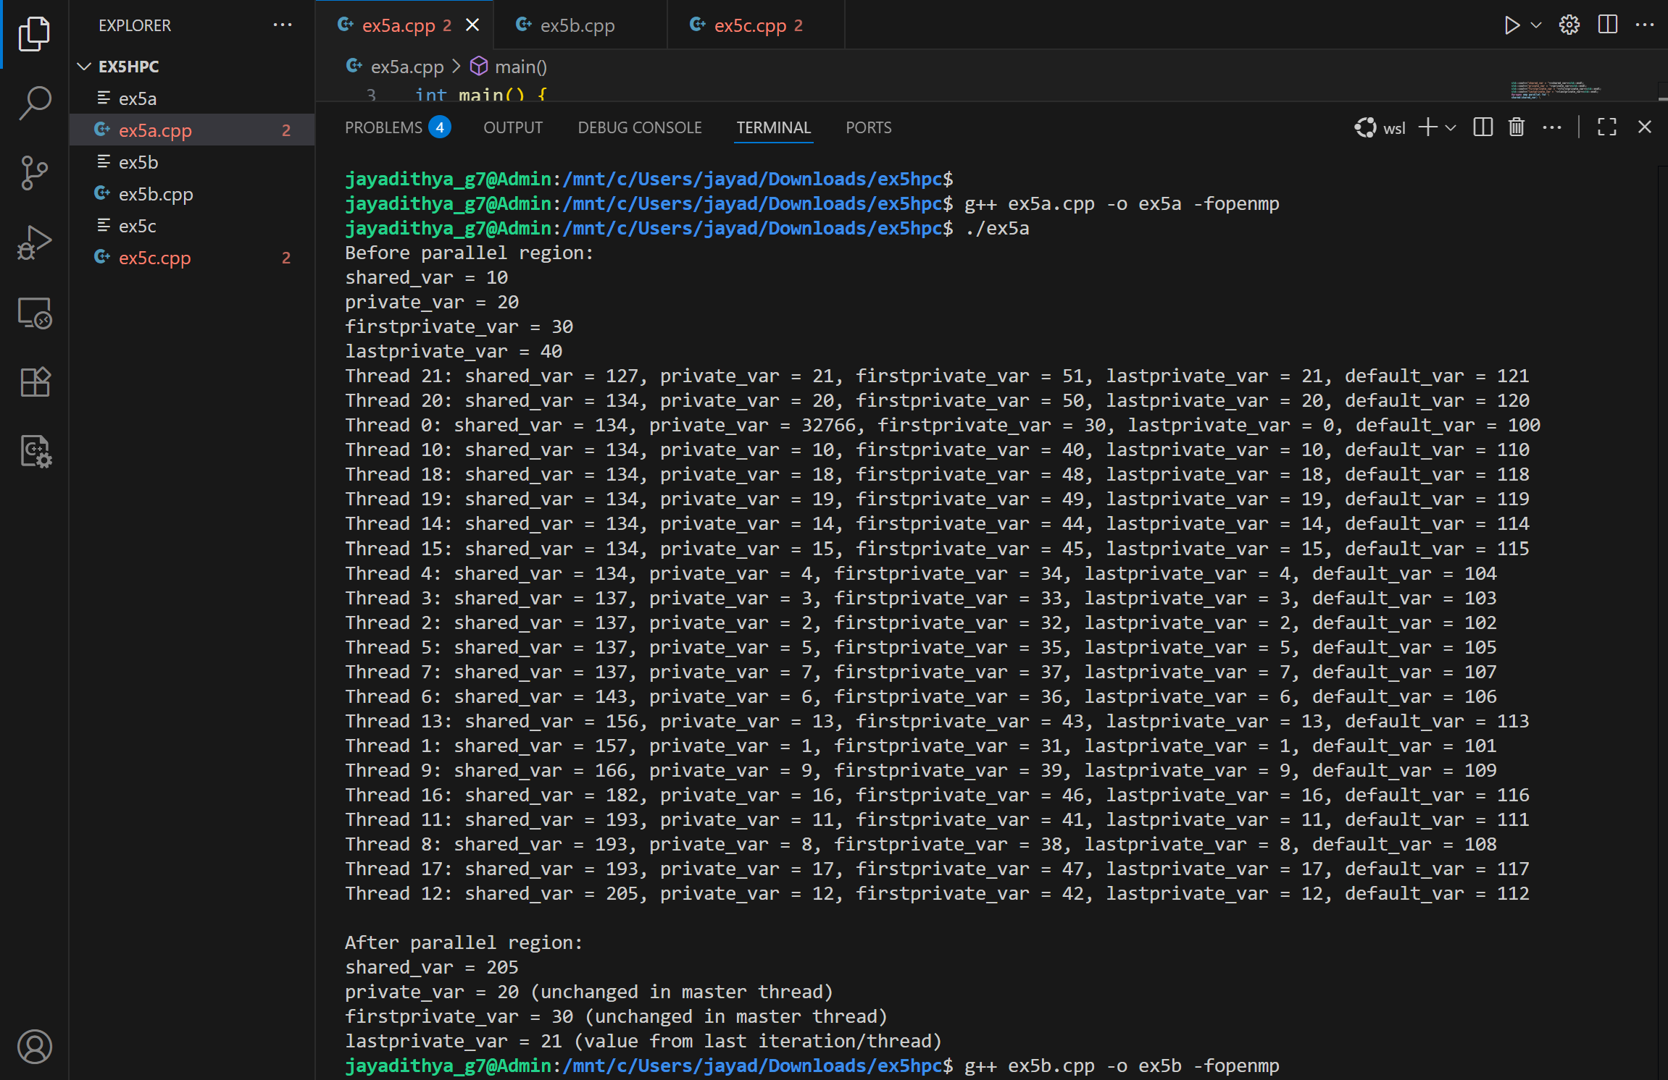

2)

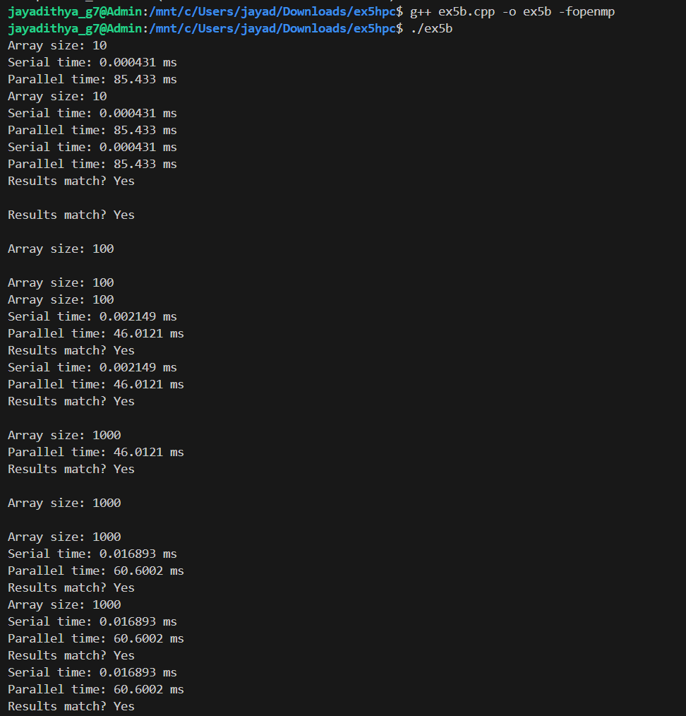

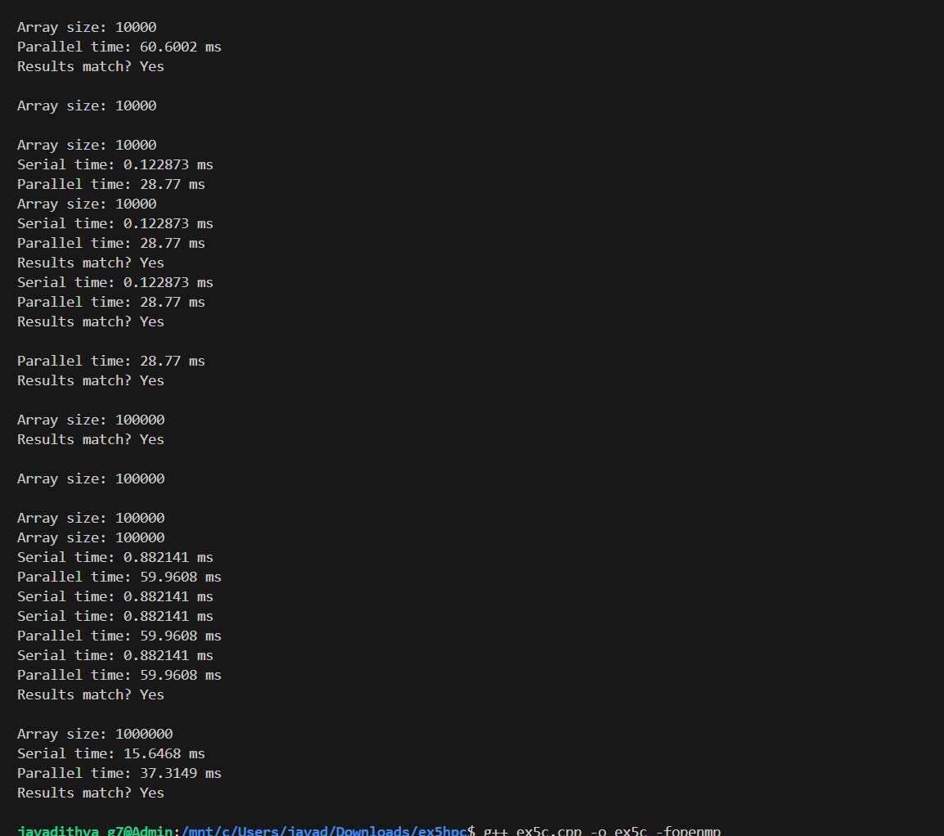

3)

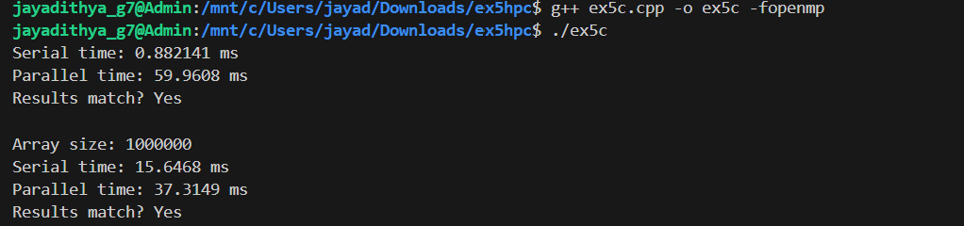

Result:-

Hence the c++ programs are executed successfully and output has been verified.