|  |  |
| --- | --- |
| Ex-6 | **Parallelizing recursive functions** |
| 19/8/25 |  |

**AIM:**

To

1.Write a C++ recursive function for the flood fill algorithm. Compare the OpenMP and serial

versions of the code for different values of N.

2.Write a C++ program for merge sort with a cutoff array size for a serial nature. Experiment

with different cutoff values and observe the corresponding running times.

**CODE:**

a)

#include<iostream>

#include<ctime>

#include<cstdlib>

#include<omp.h>

using namespace std;

const int MAXN=1000;

int image[MAXN][MAXN];

int backup[MAXN][MAXN];

void generateImage(int n){

for(int i=0;i<n;i++){

for(int j=0;j<n;j++){

image[i][j]=rand()%2;

}

}

}

void copyImage(int src[MAXN][MAXN],int dest[MAXN][MAXN],int n){

for(int i=0;i<n;i++){

for(int j=0;j<n;j++){

dest[i][j]=src[i][j];

}

}

}

void floodFill(int x,int y,int targetColor,int replacementColor){

if(x<0||x>=MAXN||y<0||y>=MAXN){

return;

}

if(image[x][y]!=targetColor){

return;

}

image[x][y]=replacementColor;

floodFill(x+1,y,targetColor,replacementColor);

floodFill(x-1,y,targetColor,replacementColor);

floodFill(x,y+1,targetColor,replacementColor);

floodFill(x,y-1,targetColor,replacementColor);

}

void parallelFloodFill(int x,int y,int targetColor,int replacementColor){

#pragma omp parallel

{

#pragma omp single

{

floodFill(x,y,targetColor,replacementColor);

}

}

}

int main(){

int sizes[]={100,200,300,400,500};

for(int k=0;k<5;k++){

int n=sizes[k];

generateImage(n);

copyImage(image,backup,n);

double start=omp_get_wtime();

floodFill(0,0,image[0][0],3);

double stop=omp_get_wtime();

cout<<"serial n="<<n<<",time:"<<stop-start<<"s"<<endl;

copyImage(backup,image,n);

start=omp_get_wtime();

parallelFloodFill(0,0,image[0][0],3);

stop=omp_get_wtime();

cout<<"parallel n="<<n<<",time:"<<stop-start<<"s"<<endl;

}

return 0;

}

b)

#include <iostream>

#include <vector>

#include <cstdlib>

#include <ctime>

#include <chrono>

using namespace std;

using namespace chrono;

const int MAXN=100000;

int cutoff=10;

void insertionSort(vector<int>& arr,int left,int right) {

for (int i=left+1;i<=right;i++) {

int key=arr[i];

int j=i-1;

while(j>=left && arr[j]>key) {

arr[j+1]=arr[j];

j--;

}

arr[j+1]=key;

}

}

void merge(vector<int>& arr,int left,int mid,int right) {

int n1=mid-left+1;

int n2=right-mid;

vector<int> L(n1),R(n2);

for(int i=0;i<n1;i++){

L[i]=arr[left+i];

}

for(int j=0;j<n2;j++){

R[j]=arr[mid+1+j];

}

int i=0,j=0,k=left;

while(i<n1 && j<n2){

if(L[i]<=R[j]){

arr[k++]=L[i++];

}

else{

arr[k++]=R[j++];

}

}

while(i<n1){

arr[k++]=L[i++];

}

while(j<n2){

arr[k++]=R[j++];

}

}

void mergeSort(vector<int>& arr,int left,int right) {

if(right-left+1<=cutoff){

insertionSort(arr,left,right);

return;

}

if(left<right){

int mid=left+(right-left)/2;

mergeSort(arr,left,mid);

mergeSort(arr,mid+1,right);

merge(arr,left,mid,right);

}

}

void generateRandomArray(vector<int>& arr,int n) {

arr.clear();

arr.resize(n);

for(int i=0;i<n;i++){

arr[i]=rand()%100000;

}

}

int main(){

srand(time(0));

int n=50000;

vector<int> arr,temp;

int cutoffs[]={0,5,10,20,50,100};

for (int i=0;i<6;i++) {

cutoff=cutoffs[i];

generateRandomArray(arr,n);

temp=arr;

auto start=high_resolution_clock::now();

mergeSort(arr,0,n-1);

auto stop=high_resolution_clock::now();

auto duration=duration_cast<milliseconds>(stop-start);

cout<<"cutoff = "<<cutoff<<",time: "<<duration.count()<<"ms"<<endl;

}

return 0;

}

**INPUT/OUTPUT:**

a)

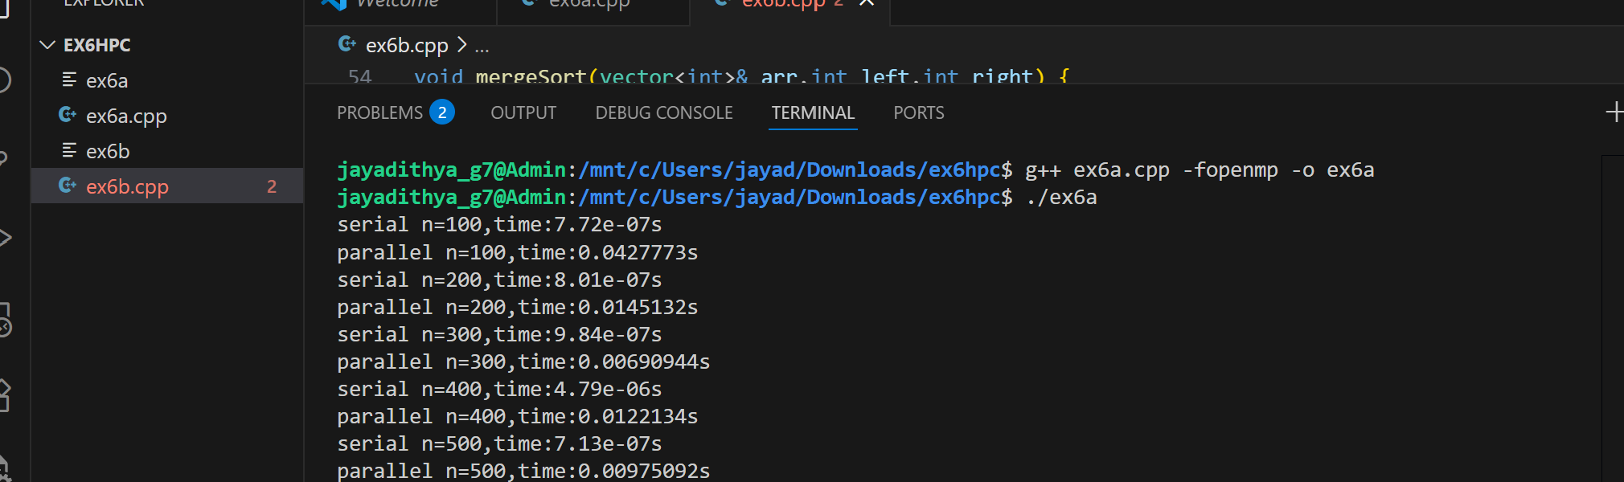

b)

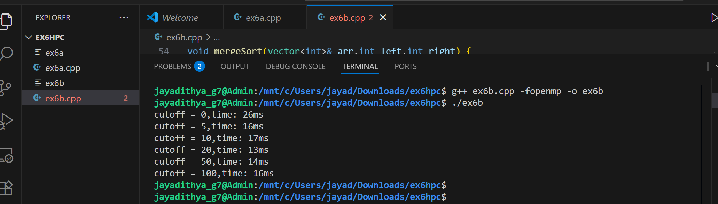

**RESULT:**

Hence the code has been executed successfully and output has been verified.