**OOPS Assignment – JAVA Tutorials2**

Assignment-1 (OOPs (CS2003)) Unit-1

**Q-1] Explain the concept of Object-Oriented Programming (OOP) and its benefits. What is inheritance? Provide a code example in Java­­**

**What is Object-Oriented Programming (OOP)?**

* Object-Oriented Programming (OOP) is a programming standard that revolves around the concept of objects and classes.
* It's a way of designing and organizing code that simulates real-world objects and systems.
* OOP provides a framework for creating reusable, modular, and maintainable software systems.
* So in a nutshell, OOP is a way of writing code that helps us organize and structure our programs in a more logical and efficient way.

**Key Concepts:-**

1. **Classes and Objects:**
   * A class is a blueprint or template that defines the properties and behaviors of an object.
   * An object is an instance of a class, with its own set of attributes (data) and methods (functions).
2. **Inheritance: (what is inheritance? – asked in quest.)**
   * Inheritance is the mechanism by which one class can inherit the properties and behaviors of another class.
   * The child class inherits all the fields and methods of the parent class and can also add new fields and methods or override the ones inherited from the parent class.
3. **Polymorphism:**
   * Polymorphism is the ability of an object to take on multiple forms.
   * This can be achieved through method overriding (where a subclass provides a different implementation of a method already defined in its superclass) or method overloading (where multiple methods with the same name can be defined, but with different parameters).
4. **Encapsulation:**
   * Encapsulation is the concept of bundling data and methods that operate on that data within a single unit (the class).
   * This helps to hide the implementation details of an object from the outside world and provides a way to control access to the object's state.
5. **Abstraction:**
   * Abstraction is the process of exposing only the necessary information to the outside world while hiding the implementation details.
   * Abstraction helps to reduce complexity and improve modularity by providing a simplified interface to an object's functionality.

**Benefits of OOP:-**

1. **Modularity:**

OOP promotes modular code, making it easier to develop, test, and maintain large software systems.

1. **Reusability:**

OOP enables code reuse through inheritance and polymorphism, reducing the amount of code that needs to be written and maintained.

1. **Easier Maintenance:**

OOP's modular and reusable nature makes it easier to modify and extend existing code without affecting other parts of the system.

1. **Improved Readability:**

OOP's focus on objects and classes makes it easier to understand and visualize the relationships between different components of a system.

**Q) What is Inheritance?**

A child class can inherit properties and behaviors from a parent class.

**Code Example in Java**:-

In this example, the **Dog** class inherits the **sound()** method from the **Animal** class and provides its own implementation. This demonstrates the concept of inheritance in OOP.

**Hello world in java:- (Another Sample Java program)**

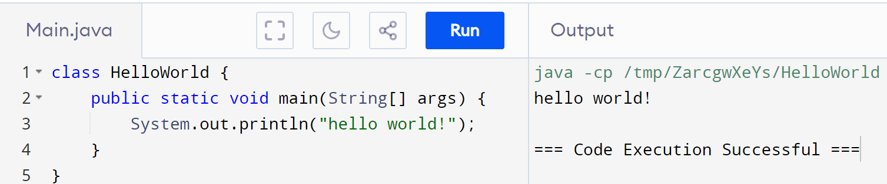

**Looping statements – An example:-**

**Q-2] Write a Java program to calculate the factorial of a number.**

**AIM:-**

To write a program in Java to calculate factorial of a number

**Algorithm: Factorial**

Input: n, a positive integer using Scanner, a class in java.util package used for obtaining the input of the primitive types like int, double, etc. and strings

Output: factorial, the factorial of n

Steps:

* Initialize factorial to 1.
* For each integer i from 1 to n:
* Multiply factorial by i.
* Return factorial.

**Program**:-

import java.util.Scanner;

public class Factorial {

public static void main(String[] args) {

Scanner scanner = new Scanner(System.in);

System.out.print("Enter a number: ");

int num = scanner.nextInt();

long factorial = 1;

for(int i = 1; i <= num; ++i)

{

factorial *= i;

}

System.out.printf("Factorial of %d = %d", num, factorial);

}

}

**Output**:-

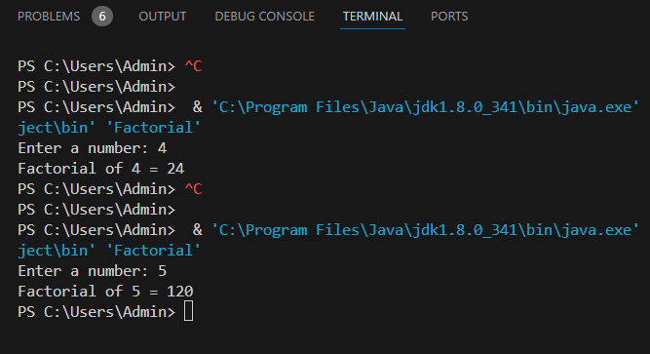

**Result:-**

Thus a Java program to find factorial of a number is executed and the output is verified successfully.

**Q-3] Write a Java program to implement a simple calculator.**

**Aim:-**

To write a Java program to implement a simple calculator

**Algorithm:-**

* Ask user to choose an operation (addition, subtraction, multiplication, or division)
* Get two numbers from the user
* Perform the chosen operation on the two numbers
* Use a while loop or implement a switch case condition to demonstate the arithmetic operation and calculation in a menu driven interface
* Display the result
* Handle errors (e.g. division by zero)

**Pseudocode:**

**­­Program:-**

import java.util.Scanner;

public class Calculator {

public static void main(String[] args) {

Scanner scanner = new Scanner(System.in);

System.out.println("Simple Calculator");

System.out.println("1. Addition");

System.out.println("2. Subtraction");

System.out.println("3. Multiplication");

System.out.println("4. Division");

System.out.println("Choose an operation (1-4): ");

int choice = scanner.nextInt();

System.out.print("Enter first number: ");

double num1 = scanner.nextDouble();

System.out.print("Enter second number: ");

double num2 = scanner.nextDouble();

double result = 0;

switch (choice) {

case 1:

result = num1 + num2;

break;

case 2:

result = num1 - num2;

break;

case 3:

result = num1 * num2;

break;

case 4:

if (num2 != 0) {

result = num1 / num2;

} else {

System.out.println("Error: Division by zero!");

return;

}

break;

default:

System.out.println("Invalid choice!");

return;

}

System.out.println("Result: " + result);

}

}

**Output**:-

**Result**:-

Thus a Java Program to implement a Simple Calculator is executed and the output is verified successfully.

**Q-4] Write a Java program to perform the multiplication of two matrices.**

**Aim:-**

**To write a Java program to perform the multiplication of two matrices**

**Sample example “JUST FOR LEARNING PURPOSES”**

**(case-1 : the inputs are passed as parameters)**

public class MatrixMultiplication {

public static void main(String[] args) {

int[][] matrixA = {{1, 2, 3}, {4, 5, 6}};

int[][] matrixB = {{7, 8}, {9, 10}, {11, 12}};

int[][] result = multiplyMatrices(matrixA, matrixB);

System.out.println("Matrix A:");

printMatrix(matrixA);

System.out.println("Matrix B:");

printMatrix(matrixB);

System.out.println("Result:");

printMatrix(result);

}

public static int[][] multiplyMatrices(int[][] matrixA, int[][] matrixB) {

int rowsA = matrixA.length;

int colsA = matrixA[0].length;

int rowsB = matrixB.length;

int colsB = matrixB[0].length;

if (colsA!= rowsB) {

System.out.println("Matrices cannot be multiplied!");

return null;

}

int[][] result = new int[rowsA][colsB];

for (int i = 0; i < rowsA; i++) {

for (int j = 0; j < colsB; j++) {

for (int k = 0; k < colsA; k++) {

result[i][j] += matrixA[i][k] * matrixB[k][j];

}

}

}

return result;

}

public static void printMatrix(int[][] matrix) {

for (int i = 0; i < matrix.length; i++) {

for (int j = 0; j < matrix[0].length; j++) {

System.out.print(matrix[i][j] + " ");

}

System.out.println();

}

}

}

**case-1 output**:-

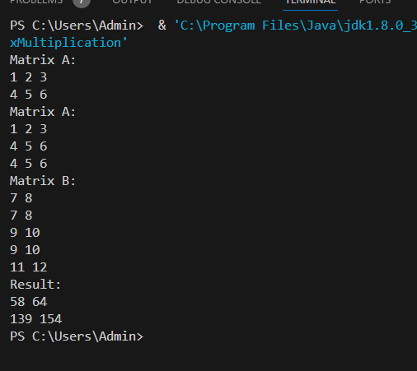

**Case-2: Taking user-defined inputs**

**Aim:-**

To write a Java program to perform the multiplication of two matrices.

**Algorithm: Matrix Multiplication**:-

**Get Matrix A**:

* Ask user for number of rows and columns
* Ask user to input each element of Matrix A

**Get Matrix B**:

* Ask user for number of rows and columns
* Ask user to input each element of Matrix B

**Check if matrices can be multiplied: (put a condition) m*n ** n*q**

If number of columns in Matrix A is not equal to number of rows in Matrix B, stop

**Multiply Matrices:**

* Create a result matrix with same number of rows as Matrix A and same number of columns as Matrix B
* For each element in result matrix, multiply corresponding elements of Matrix A and Matrix B and add them up

**Print Results** (Display): Print Matrix A, Matrix B, and result matrix

**Program**:-

import java.util.Scanner;

public class MatrixMultiplication {

public static void main(String[] args) {

Scanner scanner = new Scanner(System.in);

System.out.println("Enter the number of rows for Matrix A:");

int rowsA = scanner.nextInt();

System.out.println("Enter the number of columns for Matrix A:");

int colsA = scanner.nextInt();

int[][] matrixA = new int[rowsA][colsA];

System.out.println("Enter the elements of Matrix A:");

for (int i = 0; i < rowsA; i++) {

for (int j = 0; j < colsA; j++) {

System.out.print("Enter element [" + i + "][" + j + "]: ");

matrixA[i][j] = scanner.nextInt();

}

}

System.out.println("Enter the number of rows for Matrix B:");

int rowsB = scanner.nextInt();

System.out.println("Enter the number of columns for Matrix B:");

int colsB = scanner.nextInt();

int[][] matrixB = new int[rowsB][colsB];

System.out.println("Enter the elements of Matrix B:");

for (int i = 0; i < rowsB; i++) {

for (int j = 0; j < colsB; j++) {

System.out.print("Enter element [" + i + "][" + j + "]: ");

matrixB[i][j] = scanner.nextInt();

}

}

int[][] result = multiplyMatrices(matrixA, matrixB);

System.out.println("Matrix A:");

printMatrix(matrixA);

System.out.println("Matrix B:");

printMatrix(matrixB);

System.out.println("Result:");

printMatrix(result);

}

public static int[][] multiplyMatrices(int[][] matrixA, int[][] matrixB) {

int rowsA = matrixA.length;

int colsA = matrixA[0].length;

int rowsB = matrixB.length;

int colsB = matrixB[0].length;

if (colsA != rowsB) {

System.out.println("Matrices cannot be multiplied!");

return null;

}

int[][] result = new int[rowsA][colsB];

for (int i = 0; i < rowsA; i++) {

for (int j = 0; j < colsB; j++) {

for (int k = 0; k < colsA; k++) {

result[i][j] += matrixA[i][k] * matrixB[k][j];

}

}

}

return result;

}

public static void printMatrix(int[][] matrix) {

for (int i = 0; i < matrix.length; i++) {

for (int j = 0; j < matrix[0].length; j++) {

System.out.print(matrix[i][j] + " ");

}

System.out.println();

}

}

}

**Output**:-

**Result**:- Thus a Java program to implement multiplication of 2 matrices is executed and the output is verified successfully.

**Q-5] Write a Java method to compute the determinant of an 𝑁 × 𝑁 matrix using recursion.**

**AIM:-**

**To write a Program in Java to compute the determinant of a N*N matrix using recursion.**

**Algorithm:-**

1. Get Matrix Size: Ask user for the size of the matrix (N).
2. Get Matrix Elements: Ask user to input elements of the matrix.
3. Calculate Determinant:
   * If matrix size is 1, return the single element.
   * If matrix size is 2, calculate determinant using the formula: a*b - c*d.
   * For larger matrices:
     + For each element in the first row:
       - Create a smaller sub-matrix by removing the current row and column.
       - Calculate the determinant of the sub-matrix recursively.
       - Multiply the result by the current element and a sign factor (-1)^i.
     + Add up all the results to get the final determinant.
4. Print Result: Display the calculated determinant to the user.

**Program** :-

import java.util.Scanner;

public class MatrixDeterminant {

public static void main(String[] args) {

Scanner scanner = new Scanner(System.in);

System.out.println("Enter the dimension of the matrix (N): ");

int n = scanner.nextInt();

int[][] matrix = new int[n][n];

System.out.println("Enter the elements of the matrix: ");

for (int i = 0; i < n; i++) {

for (int j = 0; j < n; j++) {

matrix[i][j] = scanner.nextInt();

}

}

int determinant = findDeterminant(matrix, n);

System.out.println("The determinant of the matrix is: " + determinant);

}

public static int findDeterminant(int[][] matrix, int n) {

if (n == 1) {

return matrix[0][0];

}

if (n == 2) {

return matrix[0][0] * matrix[1][1] - matrix[0][1] * matrix[1][0];

}

int determinant = 0;

for (int i = 0; i < n; i++) {

int[][] subMatrix = new int[n - 1][n - 1];

for (int j = 1; j < n; j++) {

for (int k = 0, col = 0; k < n; k++) {

if (k != i) {

subMatrix[j - 1][col++] = matrix[j][k];

}

}

}

determinant += Math.pow(-1, i) * matrix[0][i] * findDeterminant(subMatrix, n - 1);

}

return determinant;

}

}

**Output**:-

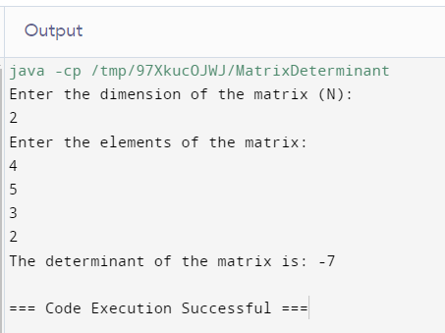

**Result**:-

Thus a Java program to compute the determinant of a N*N matrix using recursion is executed and the output is verified successfully.

**Q-6] Write a Java program to solve a system of linear equations using Cramer's rule.**

**Aim:-**

To Write a program in Java to solve a system of linear equations using Cramer's rule**.**

**Algorithm:-**

Cramer's Rule Algorithm

1. Get Number of Variables: Ask user for the number of variables (n).
2. Get Coefficients and Constants: Ask user to input coefficients of the matrix and constants.
3. Calculate Determinant: Calculate the determinant of the coefficient matrix using recursion.
4. Check for Unique Solution: If the determinant is 0, print "The system has no unique solution." and exit.
5. Calculate Solutions: For each variable, create a modified matrix by replacing the coefficients of the current variable with the constants, and calculate its determinant.
6. Calculate Solution Values: Calculate the solution value for each variable by dividing the determinant of the modified matrix by the determinant of the coefficient matrix.
7. Print Solutions: Print the solution values for each variable.

Note: This algorithm assumes that the input is a system of linear equations, and Cramer's Rule is used to solve it**.**

**Program:-**

import java.util.Scanner;

public class CramersRule {

public static void main(String[] args) {

Scanner scanner = new Scanner(System.in);

System.out.println("Enter the number of variables: ");

int n = scanner.nextInt();

int[][] matrix = new int[n][n];

int[] constants = new int[n];

System.out.println("Enter the coefficients of the matrix: ");

for (int i = 0; i < n; i++) {

for (int j = 0; j < n; j++) {

matrix[i][j] = scanner.nextInt();

}

}

System.out.println("Enter the constants: ");

for (int i = 0; i < n; i++) {

constants[i] = scanner.nextInt();

}

int determinant = findDeterminant(matrix, n);

if (determinant == 0) {

System.out.println("The system has no unique solution.");

return;

}

int[] solutions = new int[n];

for (int i = 0; i < n; i++) {

int[][] modifiedMatrix = new int[n][n];

for (int j = 0; j < n; j++) {

for (int k = 0; k < n; k++) {

if (k == i) {

modifiedMatrix[j][k] = constants[j];

} else {

modifiedMatrix[j][k] = matrix[j][k];

}

}

}

solutions[i] = findDeterminant(modifiedMatrix, n) / determinant;

}

System.out.println("The solutions are: ");

for (int i = 0; i < n; i++) {

System.out.println("x" + (i + 1) + " = " + solutions[i]);

}

}

public static int findDeterminant(int[][] matrix, int n) {

if (n == 1) {

return matrix[0][0];

}

if (n == 2) {

return matrix[0][0] * matrix[1][1] - matrix[0][1] * matrix[1][0];

}

int determinant = 0;

for (int i = 0; i < n; i++) {

int[][] subMatrix = new int[n - 1][n - 1];

for (int j = 1; j < n; j++) {

for (int k = 0, col = 0; k < n; k++) {

if (k != i) {

subMatrix[j - 1][col++] = matrix[j][k];

}

}

}

determinant += Math.pow(-1, i) * matrix[0][i] * findDeterminant(subMatrix, n - 1);

}

return determinant;

}

}

**Output**:-

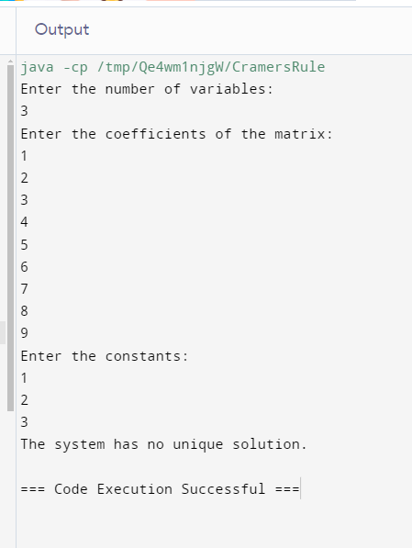

**Result**:-

Thus a Java program to solve a system of linear equations using Cramer's rule is executed and the output is verified successfully.

**Q-7] Write a Java program to find the eigenvalues of a 2x2 matrix and verify the determinant as the product of eigenvalues.**

**Aim:-**

To Write a Java program to find the eigenvalues of a 2x2 matrix and verify the determinant as the product of eigenvalues.

**Algorithm**:-

**Eigenvalues Algorithm**

1. **Get Matrix Elements**: Ask user to input elements of a 2x2 matrix.
2. **Calculate Coefficients**: Calculate coefficients**a**,**b**, and**c**for the quadratic equation.
3. **Check for Complex Eigenvalues**: If the discriminant (**b^2 - 4ac**) is negative, print "The matrix has complex eigenvalues." and exit.
4. **Calculate Eigenvalues**: Calculate two eigenvalues using the quadratic formula.
5. **Calculate Determinant**: Calculate the determinant of the matrix.
6. **Verify Determinant**: Verify that the determinant is equal to the product of the eigenvalues.
7. **Print Results**: Print the eigenvalues, determinant, and verification result.

Note: This algorithm assumes that the input is a 2x2 matrix, and it calculates the eigenvalues and determinant using the quadratic formula and matrix operations.

**Program**:-

import java.util.Scanner;

public class Eigenvalues {

public static void main(String[] args) {

Scanner scanner = new Scanner(System.in);

double[][] matrix = new double[2][2];

System.out.println("Enter the elements of the 2x2 matrix: ");

for (int i = 0; i < 2; i++) {

for (int j = 0; j < 2; j++) {

matrix[i][j] = scanner.nextDouble();

}

}

double a = 1;

double b = -(matrix[0][0] + matrix[1][1]);

double c = matrix[0][0] * matrix[1][1] - matrix[0][1] * matrix[1][0];

double discriminant = b * b - 4 * a * c;

if (discriminant < 0) {

System.out.println("The matrix has complex eigenvalues.");

return;

}

double eigenvalue1 = (-b + Math.sqrt(discriminant)) / (2 * a);

double eigenvalue2 = (-b - Math.sqrt(discriminant)) / (2 * a);

double determinant = matrix[0][0] * matrix[1][1] - matrix[0][1] * matrix[1][0];

double productOfEigenvalues = eigenvalue1 * eigenvalue2;

System.out.println("Eigenvalue 1: " + eigenvalue1);

System.out.println("Eigenvalue 2: " + eigenvalue2);

System.out.println("Determinant: " + determinant);

System.out.println("Product of Eigenvalues: " + productOfEigenvalues);

if (Math.abs(determinant - productOfEigenvalues) < 1e-9) {

System.out.println("The determinant is verified to be the product of the eigenvalues.");

} else {

System.out.println("The determinant does not match the product of the eigenvalues.");

}

}

}

**Output:**-

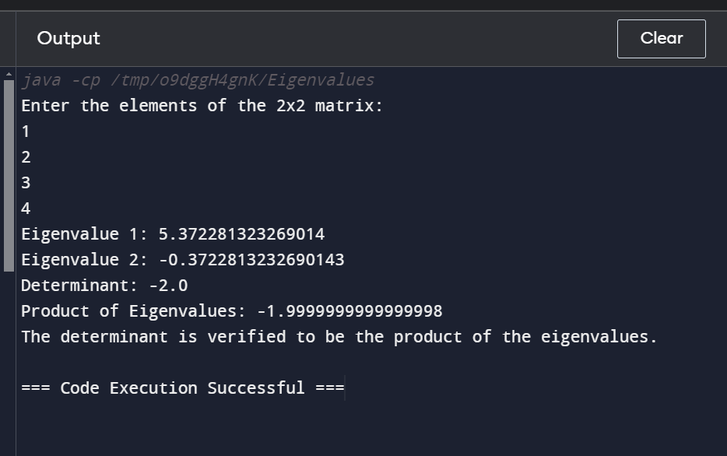

**Result**:-

Thus a Java program to find the eigenvalues of a 2x2 matrix and verify the determinant as the product of eigenvalues is executed and the output is verified successfully.

**Note:-**

* All the program codes and outputs of the assignment questions are pushed into the following repository of mine for reference, which I have given below.

<https://github.com/jayadithya-g7/OOPS-Assignment-Programs-UNIT-1-/tree/main>