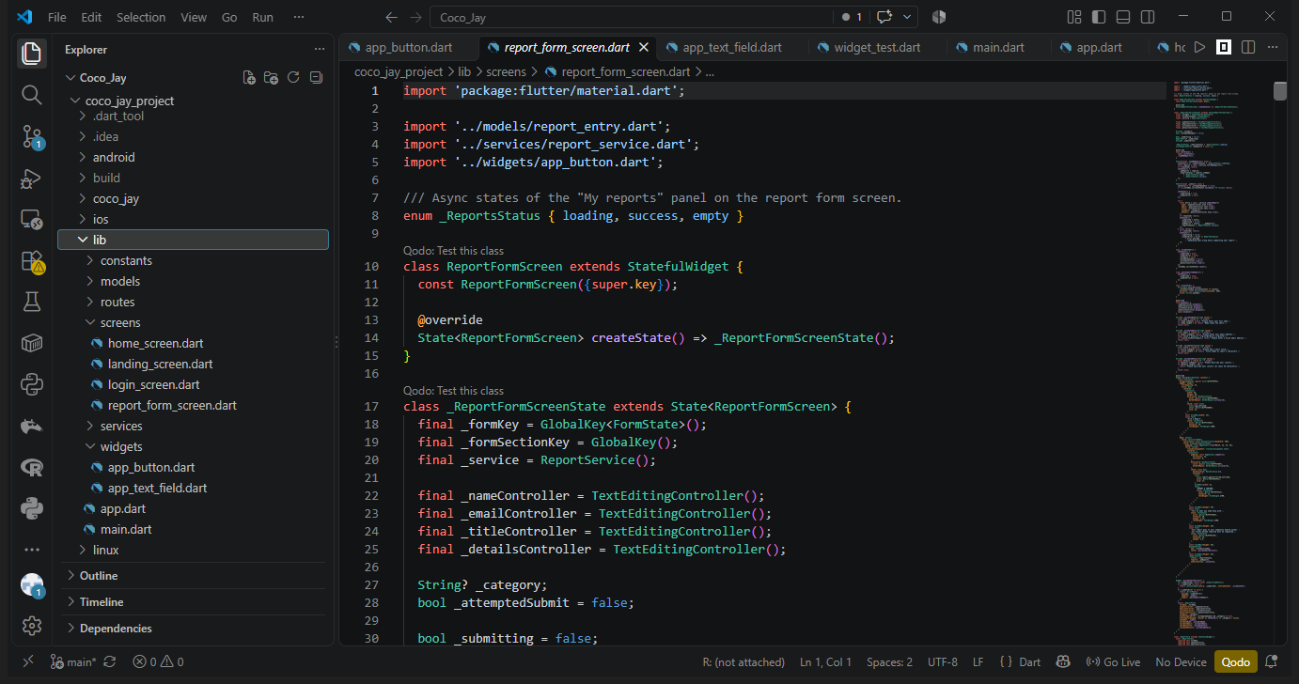Opened the project in Visual Studio Code and expanded the Explorer so the new files under lib/ (models, services, screens including report_form_screen.dart, routes, widgets) are visible.
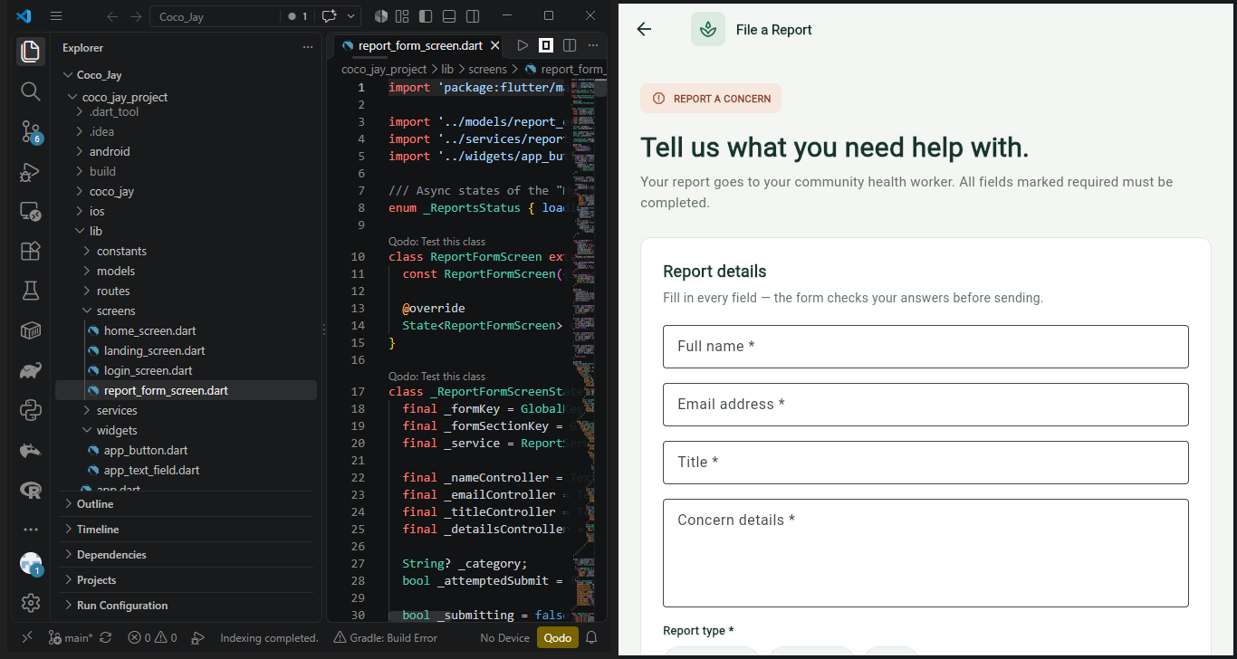Side-by-side view: the code of report_form_screen.dart in VS Code on the left, and the same report screen running in the browser on the right.
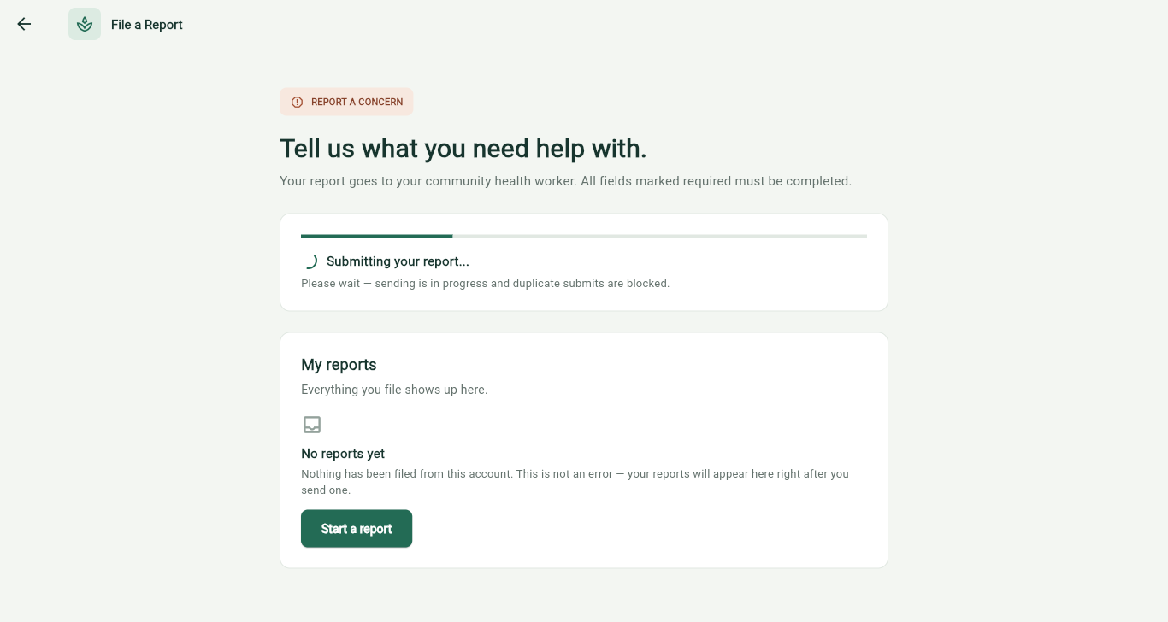Filled in every field, chose Appointment, and clicked Submit report; the form area switched to the loading panel "Submitting your report..." with a progress bar and spinner while the request was in flight.
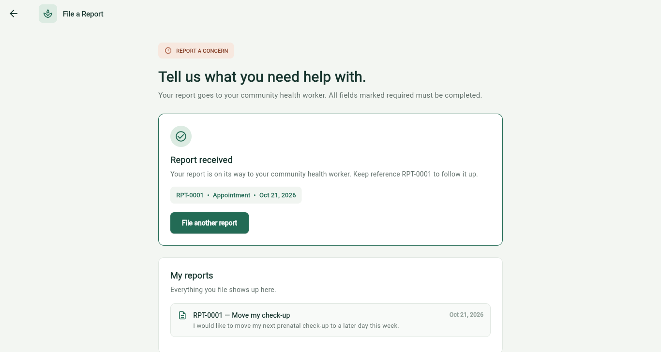After the simulated request finished, the success panel showed "Report received" with reference RPT-0001 · Appointment, and the new report appeared at the top of the My reports list.
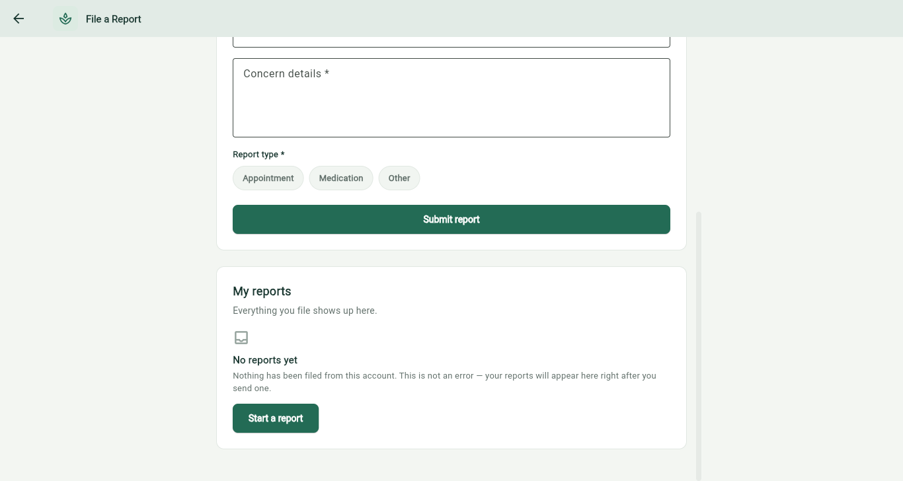On first visit the My reports panel finished loading and showed the empty state "No reports yet", explaining that this is not an error and offering a Start a report button.
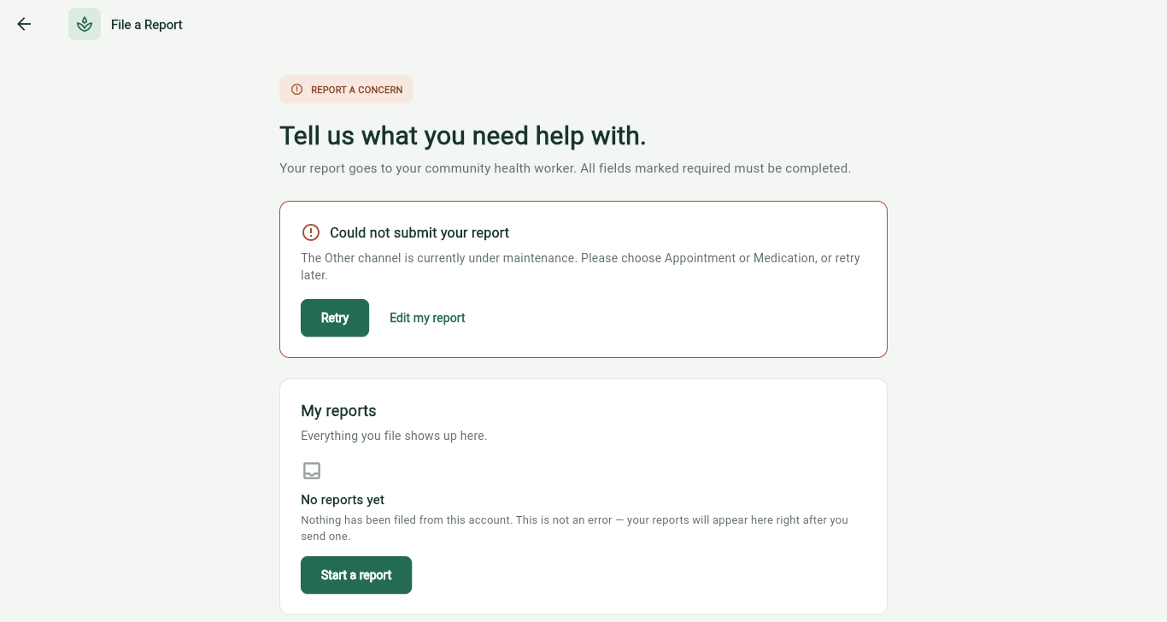Submitted a second report with the Other category, which the service rejects on purpose; the error panel appeared with the maintenance message and Retry / Edit my report actions.

