MINI PROJECT REPORT ON

( **NOVA: DESKTOP ASSISTANT)**

(KCA-353)

Session-2024-2025

Department of Master of Computer Applications (MCA)



**Submitted to: Submitted By:**

Ms. Shanta Satyapati

Name: JAYA GUPTA

Roll no:2301920140073

Class & Semester: MCA 3rd Sem

Section: A2

**GL Bajaj Institute of Technology & Management**

Plot No 2, APJ Abdul Kalam Rd, Knowledge Park III,

Greater Noida, Uttar Pradesh

# ACKNOWLEDGEMENT

I feel a great pleasure to express my deep sense of gratitude to all those who has helped us directly or indirectly in preparation of this project designing part. It is very exciting for me to work on designing part of the project “**NOVA: DESKTOP ASSISTANT** ”. During this work I have gained both practical as well as theoretical knowledge of great significance and important. This satisfaction that accompanies that the successful completion of any Task would be incomplete without the mention of people whole cooperation made it possible whose constant Guidance and Encouragement Crown all efforts with success. I would like to express my deep gratitude to my project guide, **Ms. Shanta Satyapati**, Assistant Professor (Department of Master of Computer Application), GL Bajaj Institute of Technology & Management, Greater Noida for her guidance with unsurpassed knowledge and immense encouragement. I am also grateful to **Dr. Madhu S.Gaur**, Head of the Department, Department of Master of Computer Application, for providing me with the required facilities for the completion of the project work.

I express my thanks to all teaching faculty of the Department of MCA, whose suggestions during reviews helped me in the accomplishment of my project. I would like to thank all non-teaching staff of the Department of MCA, for providing great assistance in the accomplishment of my project.

I would like to thank my parents, friends, and classmates for their encouragement throughout my project period. Last, but not least, I thank everyone for supporting me directly or indirectly in completing this project successfully.

Name of the Student: Jaya Gupta (2301920140073)

Place: Greater Noida

Date:

# CERTIFICATE OF ORIGINALITY

I hereby declare that my Project titled “**NOVA: DESKTOP ASSISTANT** ” submitted to **Dr. APJ ABDUL KALAM TECHNICAL UNIVERSITY, Lucknow** for the partial fulfillment of the degree of Master of Computer Application Session 2024-2025 from **GL Bajaj Institute of Technology and Management, Greater Noida** has not previously formed the basis for the award of any other degree, diploma or other title.

**Place: Greater Noida Signature**

**Date: Jaya Gupta**

# CERTIFICATE OF ACCEPTANCE

This is to certify that the project entitled, “**NOVA: DESKTOP ASSISTANT”** submitted by **JAYA GUPTA** a Bonafide student of **GL Bajaj Institute of Technology and Management, Greater Noida** in partial fulfillment for the award of **Master of Computer Applications** affiliated to **Dr. APJ ABDUL KALAM TECHNICAL UNIVERSITY, LUCKNOW** during the year 2024-25. It is certified that all corrections, suggestions indicated as per Internal Assessment have been incorporated in the project.

To the best of our knowledge, the work embodied in this report is original and has not been submitted to any other degree of discipline. The project report has been approved as it satisfies the academic requirements in respect of Project work prescribed for the said degree.

**[Sign and Name of Internal Guide] [Sign of External Examiner]**

**HOD**

**Department of Master of Computer Applications**

# Executive Summary

A Voice Assistant is one of the hot topics in the current world that are programs that listens to human’s verbal command and respond to them which makes it a human- computer/device interaction. In the current days, a voice assistant is everywhere which is a lot useful in these busy days. Now a days, almost everyone in the current world is using voice assistant because it’s everywhere starting from Google smartphone assistant which even 5 years old kids will know how to use because of the current world pandemic which makes them use smartphones till Amazon's Alexa which will be very useful to do works starting from entertaining the users till turning on and off the household products (Internet of Things). One of the greatest features is that it will be very useful to even physically challenged people, for example, people who aren't able to walk use the Internet of Things (IoT) feature to operate the household products and maintain them. So, we tend to develop a voice assistant which will be very useful to the users same as the other voice assistants which are currently in the world.

# TABLE OF CONTENTS

|  |  |  |
| --- | --- | --- |
| S.No | Title | Page No. |
| 1. | Introduction and Objective | *2-5* |
| 2. | Related Background Study | 5-9 |
| 3. | Requirement Analysis and Specification | 10-13 |
| 4. | Design and Development | 14-26 |
| 5. | Testing and Implementation | 27-28 |
| 6. | Result and Discussion | 29-31 |
| 7. | Conclusion | 32 |
| 8. | Future Scope | 32 |
| 9. | List of Figures | 33 |
| 10. | List of Abbreviations | 33 |
| 11. | References | 34 |

**CHAPTER 1**

**INTRODUCTION**

The very first voice activated product was released in 1922 as Radio Rex. This toy was very simple, wherein a toy dog would stay inside a dog house until the user exclaimed its name, “Rex” at which point it would jump out of the house. This was all done by an electromagnet tuned to the frequency similar to the vowel found in the word Rex, and predated modern computers by over 20 years.

In the 21st century, human interaction is being replaced by automation very quickly. One of the main reasons for this change is performance. There’s a drastic change in technology rather than advancement. In today’s world, we train our machines to do their tasks by themselves or to think like humans using technologies like Machine Learning, Neural Networks, etc. Now in the current era, we can talk to our machines with the help of virtual assistants.

Virtual assistants are software programs that help you ease your day to day tasks, such as showing weather reports, giving daily news, searching the internet etc. They can take commands by voice. Voice-based intelligent assistants need an invoking word or wake word to activate the listener, followed by the command. We have so many virtual assistants, such as Apple’s Siri, Amazon’s Alexa and Microsoft’s Cortana and Amazon's Alexa and this has been an inspiration for us to do this as a project. This system is designed to be used efficiently on desktops. Voice assistants are programs on digital devices that listen and respond to verbal commands. A user can say, “What's the weather?” and the voice assistant will answer with the weather report for that day and location.

* 1. **OVERVIEW**

A disease is a condition that affects the individual functioning of body totally. Diseases if neglected will lead to the death of an individual. Diseases can be identified by the symptoms of the body of an individual. Health is the most important in every human’s life. Weekly or monthly check up of one’s health is most important for the prevention and also to stay healthy.

Healthcare is the most crucial parts of the human life. Nowadays, so many are not willing to go to hospital, due to work overload and negligence of their health. The doctors and nurses are putting up maximum efforts to save people’s lives without even considering their own loves. There are also some villages which lack medical facilities.

Accurate and on-time analysis of any health-related problem is important for the prevention and treatment of the illness. The traditional way of diagnosis may not be sufficient in the case of a serious ailment. In this situation, where everything has turned virtual, the doctors and nurses are putting up maximum efforts to save people’s lives even if they have to danger their own.

## DESIGN

* + 1. The voice assistant takes an input word which is called as "signal word" to be activated. so, it takes in the signal word and starts operating for the user commands.
    2. Converting the speech into text will be processed by the assistant.
    3. The converted text is now processed to get the required results.
    4. The text given by the user should contain one or two keywords that determine what query is to be executed. If the keyword doesn’t match any of the queries in the code then the assistant asks the user to speak again.
    5. Finally, the output to the user's query will be given by converting speech to text.

## VOICE ASSISTANT

Our assistant “NOVA” extends to helps us when working on a system in which it is installed. We can access by calling the wake word "Hello NOVA".

### WHAT IS VOICE ASSISTANT

A voice assistant, also known as an intelligent personal assistant or a connected speaker, is a new type of device that is based on natural language speech recognition and is offered by popular companies like Apple, Amazon, and Google. We got inspired by that and created one our self.

### WHY DO WE NEED IT

Usually, typing out and searching or doing day-to-day tasks becomes hectic. But our life doesn’t need to be like that. One can ask for help to voice assistants. They let the users to perform a task using a speech command, as well as retrieve information via voice synthesis.

Following are the reasons to have a voice assistant.

* + - * **Minimal Effort**
* It’s easier to say a few words than type them on a small smartphone screen.
  + **Eyes Free**
* One can be as blind as a bat, but a voice assistant will always help you. Our ears are enough. One can also ask the bot about something while cooking at the same time.
  + **Fast response**
* Imagine how much time you have to spend to find some information on a website? Or how many clicks do you need to make before you find the thing you need in a mobile application? Voice assistants don’t generate such difficulties. One can ask a question and you have the answer.

### WHERE TO USE IT

Voice search has been a hot topic of discussion. Voice visibility will undoubtedly be a challenge. This is due to the lack of a visual interface for voice assistants. Users cannot see or interact with a voice interface unless it is linked to the Alexa or Google Assistant app. Search behavior patterns will change dramatically as a result.

Advertising agencies are becoming more popular as voice search grows in popularity. Voice assistants will also continue to offer more individualized experiences as they get better at differentiating between voices. According to the Voice bot Smart Speaker Consumer Adoption Report 2018, almost ten percent of people who do not own a smart speaker plan to purchase one. If this holds true, the user base of smart speaker users will grow 50 percent, meaning a quarter of adults in the United States will own a smart speaker.

## OBJECTIVE OF PROJECT

Main objective of building personal assistant software (a virtual assistant) is using semantic data sources available on the web, user generated content and providing knowledge from knowledge databases. The main purpose of an intelligent virtual assistant is to answer questions that users may have. This may be done in a business environment, for example, on the business website, with a chat interface. On the mobile platform, the intelligent virtual assistant is available as a call-button operated service where a voice asks the user “What can I do for you?” and then responds to verbal input. Virtual assistants can tremendously save you time. We spend hours in online research and then making the report in our terms of understanding.

Provide a topic for research and continue with your tasks while the assistant does the research.

Another difficult task is to remember test dates, birthdates or anniversaries. It comes with a surprise when you enter the class and realize it is class test today. Just tell assistant in advance about your tests and she reminds you well in advance so you can prepare for the test. One of the main advantages of voice searches is their rapidity**.** In fact, voice is reputed to be four times faster than a written search: whereas we can write about 40 words per minute, we are capable of speaking around 150 during the same period of time. In this respect, the ability of personal assistants to accurately recognize spoken words is a prerequisite for them to be adopted by consumers

# CHAPTER 2

# RELATED BACKGROUND STUDY

## 2.1 RELATED WORK

This field of virtual assistants having speech recognition has seen some major advancements or innovations. This is mainly because of its demand in devices like smartwatches or fitness bands, speakers, Bluetooth earphones, mobile phones, laptop or desktop, television, etc. Almost all the digital devices which are coming nowadays are coming with voice assistants which help to control the device with speech recognition only. A new set of techniques is being developed constantly to improve the performance of voice automated search.

As the amount of data is increasing exponentially now known as Big Data the best way to improve the results of virtual assistants is to incorporate our assistants with machine learning and train our devices according to their uses. Other major techniques that are equally important are Artificial Intelligence, Internet of Things, Big Data access and management, etc. With the use of voice assistants, we can automate the task easily, just give the input to the machine in the speech form and all the tasks will be done by it from converting your speech into text form to taking out keywords from that text and execute the query to give results to the user.

Machine Learning is just a subset of Artificial Intelligence. This has been one of the most helpful advancements in technology. Before AI we were the ones who were upgrading technology to do a task but now the machine is itself able to counter new tasks and solve it without need to involve the humans to evolve it.

This has been helpful in day-to-day lifestyle. From mobile phones to personal desktops to mechanical industries these assistants are in very much demand for automating tasks and increasing efficiency.

* **Nivedita Singh** (2021) et al. proposed a voice assistant using python speech to text (STT) module and had performed some api calls and system calls which has led to developing a voice assistant using python which allows the user to run any type of command through voice without interaction of keyboard. This can also run on hybrid platforms. Therefore, this paper lacks in some parts like the system calls that aren’t much supported.
* **Abeed Sayyed** (2021) et al. presented a paper on Desktop Assistant AI using python with IOT features and also used Artificial Intelligence (AI) features along with a SQLite DB with the use of Python. This Project has a Database connection and a query framework but lacks API call and System calls features.
* **P.Krishnaraj** (2021) et al. presented a project on Portable Voice Recognition with GUI Automation, This system uses Google’s online speech recognition system for converting speech input to text along with Python. Therefore, this project has a GUI and is also has a portable framework. Accuracy of this text to speech (TTS) engine is comparatively less and also lacks IoT.
* **Rajdip Paul** (2021) et al. presented a project named A Novel Python-based Voice Assistance System for reducing the Hardware Dependency of Modern Age Physical Servers. This Author has proposed assistant project with python as a backend supporting system calls, api calls and various features. This Project is quite well responsive with api calls, also needs improvement in understanding and reliability.
* **V. Geetha** (2021) et al. presented a project named The Voice Enabled Personal Assistant for Pc using Python. This Author has proposed assistant project with python as a backend and features like turning our PC off, or restarting it, or reciting some latest news, are just one voice command away. Also, this project has well supported library not every API will have the capability to convert the raw JSON data into text. And there is a delay in processing request calls.
* **Rahul Kumar** (2020) et al. has proposed Power Efficient Smart Home with voice assistant by which we can say that a Voice Assistant is one of the important part of the Smart home which is becoming one of the major things in the current world as it can operate the Home Appliances just with voice which also increase the home security because of the smart locks but it requires a reliable internet connection which is crucial and sometimes, the user might lock themselves out of their own house.

## EXISTING SYSTEM

From the above literature survey, we have inferred that all the systems existing predict only particular diseases namely lung disease, breast cancer, heart disease, diabetes by implementing various algorithms on the particular datasets.

After implementing various algorithms, the most accurate one is selected and it is used for prediction of disease. Sometimes, we may get confused of what algorithm to use. Also, all the systems find only the particular disease and not the disease based on the symptoms.

## PROPOSED SYSTEM

We are proposing a system in an efficient way of implementing a Personal voice assistant, Speech Recognition library has many in-built functions, that will let the assistant understand the command given by user and the response will be sent back to user in voice, with Text to Speech functions. When assistant captures the voice command given by user, the under lying algorithms will convert the voice into text. And according to the keywords present in the text (command given by user), respective action will be performed by the assistant.

This is made possible with the functions present in different libraries. Also, the assistant was able to achieve all the functionalities with help of some API’s. We had used these APIs for functionalities like performing calculations, extracting news from web sources, and for telling the weather. We will be sending a request, and through the API, we’re getting the respective output. API’s like WOLFRAMALPHA, are very helpful in performing things like calculations, making small web searches. And for getting the data from web. In this way, we are able to extract news from the web sources, and send them as input to a function for further purposes. Also, we have libraries like Random and many other libraries, each corresponding to a different technology. We used the library OS to implement Operating System related functionalities like Shutting down a system, or restarting a system.

At the outset we make our program capable of using system voice with the help of sapi5 and pyttsx3. pyttsx3 is a text-to-speech conversion library in Python. Unlike alternative libraries, it works offline, and is compatible with both Python 2 and 3. The Speech Application Programming Interface or SAPI is an API developed by Microsoft to allow the use of speech recognition and speech synthesis within Windows applications. Then we define the speak function to enable the program to speak the outputs.

After that we will define a function to take voice commands using the system microphone. The main function is then defined where all the capabilities of the program are defined.

* + The proposed system will have the following functionality:
    1. The system will keep listening for commands and the time for listening is variable which can be changed according to user requirements.
    2. If the system is not able to gather information from the user input it will keep asking again to repeat till the desired number of times.
    3. The system can have both male and female voices according to user requirements.
    4. Features supported in the current version include playing music, texts, search on Wikipedia, or opening system installed applications, opening anything on the web browser, etc.

# CHAPTER 3

# REQUIREMENT ANALYSIS

# AND SPECIFICATION

## SOFTWARE AND HARDWARE REQUIREMENTS

### Software Requirements:

* Python 3.5 & Above
* Windows 7 And Above

### Hardware Requirements:

* Processor: Intel Core i5
* RAM: 4GB
* OS: Windows / Mac
* Microphone
* ARDUINO UNO board
* Relay
* A Light Bulb
* USB Cable
* Electronics Wires
* Plug Point & a Plug.

### Libraries:

* **Pyttsx3-** It is a text to speech conversion library in python which is used to convert the text given in the parenthesis to speech. It is compatible with python 2 and 3. An application invokes the pyttsx3.init() factory function to get a reference to a pyttsx3. it is a very easy to use tool which converts the entered text into speech. The pyttsx3 module supports two voices first is female and the second is male which is provided by “sapi5” for windows. Command to install: - pip install pyttsx3

It supports three TTS engines:- sapi5- To run on windows

nsss – NS Speech Synthesizer on Mac OS X e speak – e Speak on every other platform

**Speech_Recognition-** It allows computers to understand human language. Speech recognition is a machine's ability to listen to spoken words and identify them. We can then use speech recognition in Python to convert the spoken words into text, make a query or give a reply. Python supports many speech recognition engines and APIs, including Google Speech Engine, Google Cloud Speech API.

Command to install :- pip install Speech Recognition

* **Wol farm Alpha-** Wolfram Alpha is an API which can compute expert-level answers using Wolfram's algorithms, knowledgebase and AI technology. It is made possible by the Wolfram Language. The Wol farm Alpha API provide a web-based API allowing the computational and presentation capabilities of Wolfram Alpha to be integrated into web, mobile and desktop applications.

Command to install :- pip install wolfram alpha

* + **Rand facts**- Rand facts is a python library that generates random facts. We can use rand facts get fact() to return a random fun fact.

Command to install :- pip install rand facts

* + **Pyjokes**- Pyjokes is a python library that is used to create one-line jokes for the users. Informally, it can also be referred as a fun python library which is pretty simple to use . Command to install :- pip install pyjokes
  + **Datetime**- This module is used to get the date and time for the user. This is a built-in module so there is no need to install this module externally. Python Datetime module supplies classes to work with date and time. Date and datetime are an object in Python, so when we manipulate them, we are actually manipulating objects and not string or timestamps.
  + **Random2**- Python version 2 has a module named "random". This module provides a Python 3 ported version of Python 2.7's random module. It has also been back-ported to work in Python 2.6. In Python 3, the implementation of randrange() was changed, so that even with the same seed you get different sequences in Python 2 and 3.
  + **Math**- This is a built-in module which is used to perform mathematical tasks. For example, math.cos() which returns the cosine of a number or math.log() returns the natural logarithm of a number, or the logarithm of number to base.
  + **Warnings**- The warning module is actually a subclass of Exception which is a built-in class in Python. A warning in a program is distinct from an error. Conversely, a warning is not critical. It shows some message, but the program runs.
  + **OS**- The OS module is a built-in module which provides functions with which the user can interact with the OS when they are running the program. This module provides a portable way of using operating system-dependent functionality. This module has functions with which the user can open the file which is mentioned in the program.
  + **Serial**- This module encapsulates the access for the serial port. It provides backends for Python running on Windows, OSX, Linux, BSD and Iron Python. The module named “serial” automatically selects the appropriate backend.

Command to install :- pip install pyserial

* + **Time**- This module provides many ways of representing time in code, such as objects, numbers, and strings. It also provides functionality other than representing time, like waiting during code execution and measuring the efficiency of our code. This is a built-in module so the installation is not necessary.
  + **Wikipedia** :-This is a Python library that makes it easy to access and parse data from Wikipedia. Search Wikipedia, get article summaries, get data like links and images from a page, and more. Wikipedia is a multilingual online encyclopedia.

Command to install :- pip install Wikipedia

* + **Selenium Web drive**- The selenium module is used to automate web browser interaction from Python. Several browsers/drivers are supported (Firefox, Chrome, Internet Explorer), as well as the Remote protocol. The supported python versions are python 3.5 and above.

Command to install :- pip install selenium

* + **Requests**- The requests module allows you to send HTTP requests using Python. The HTTP request returns a Response Object with all the response data. With it, we can add content like headers, form data, multipart files, and parameters via simple Python libraries. It also allows you to access the response data of Python in the same way.

Command to install :- pip install requests

* + **Web browser-** Web browser module is a convenient web browser controller. It provides a high-level interface that allows displaying Web-based documents to users. Web browser can also be used as a CLI tool. It accepts a URL as the argument with the following optional parameters: -n opens the URL in a new browser window, if possible, and -t opens the URL in a new browser tab. This is a built-in module so installation is not required.

### DOMAIN

The internet of things, or IoT, is a system of interrelated computing devices, mechanical and digital machines, objects, animals or people that are provided with unique identifiers (UIDs) and the ability to transfer data over a network without requiring human-to-human or human-to-computer interaction.

A *thing* in the internet of things can be a person with a heart monitor implant, a farm animal with a biochip transponder, an automobile that has built- in sensors to alert the driver when tire pressure is low or any other natural or man-made object that can be assigned an Internet Protocol (IP) address and is able to transfer data over a network.

Increasingly, organizations in a variety of industries are using IoT to operate more efficiently, better understand customers to deliver enhanced customer service, improve decision-making and increase the value of the business. An IoT ecosystem consists of web-enabled smart devices that use embedded systems, such as processors, sensors and communication hardware, to collect, send and act on data they acquire from their environments.

# CHAPTER 4

# PROJECT DESIGN

## ALGORITHMS USED

### SPEECH RECOGNITION MODULE

* + - * The class which we are using is called Recognizer.
      * It converts the audio files into text and module is used to give the output in speech.
      * **Energy threshold** function represents the energy level threshold for sounds. Values below this threshold are considered silence, and values above this threshold are considered speech.

Recognizer instance adjust or ambient noise(source, duration = 1), adjusts the energy threshold dynamically using audio from source (an Audio Source instance) to account for ambient noise.

### SPEECH TO TEXT & TEXT TO SPEECH CONVERSION

* + - * Pyttsx3 is a text-to-speech conversion library in Python. And can change the Voice, Rate and Volume by specific commands.
      * Python provides an API called Speech Recognition to allow us to convert audio into text for further processing converting large or long audio files into text using the Speech Recognition API in python.
      * We have Included sapi5 and e speak TTS Engines which can process the same.

### PROCESS & EXECUTES THE REQUIRED COMMAND

* + - * The said command is converted into text via speech recognition module and further stored in a temp.
      * Then, Analyze the user’s text via temp and decide what the user needs based on input provided and runs the while loop.
      * Then, Commands are executed.

**SYSTEM ARCHITECTURE**

### DATA FLOW DIAGRAM

###### DFD Level 0

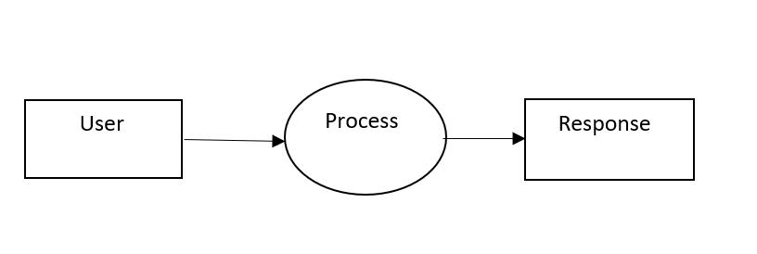

###### DFD Level 1

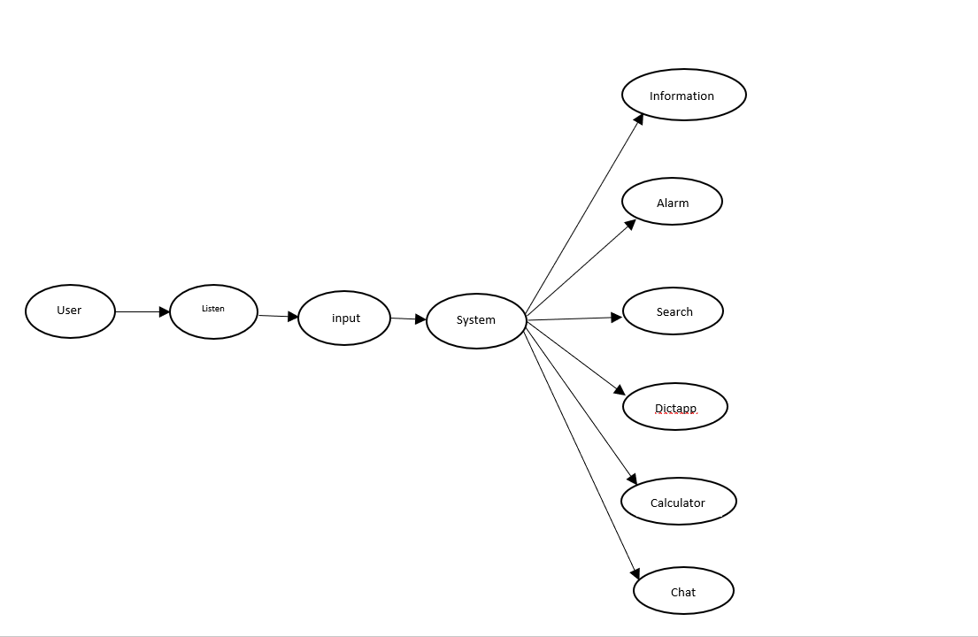

###### DFD Level 2

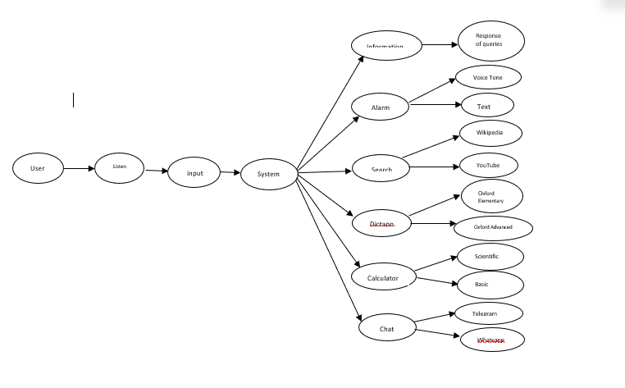

**COMPONENT DIAGRAM:**

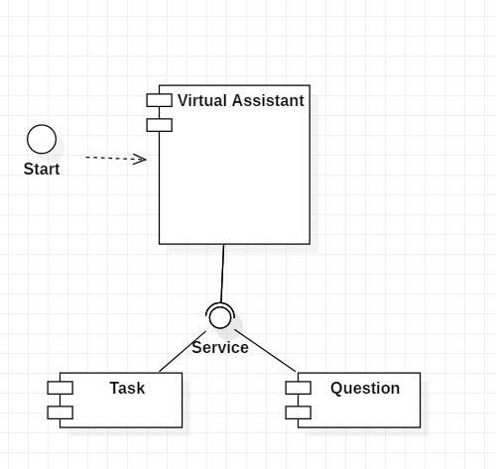

The main component here is the Virtual Assistant. It provides two specific service, executing Task or Answering your question.

### ER DIAGRAM

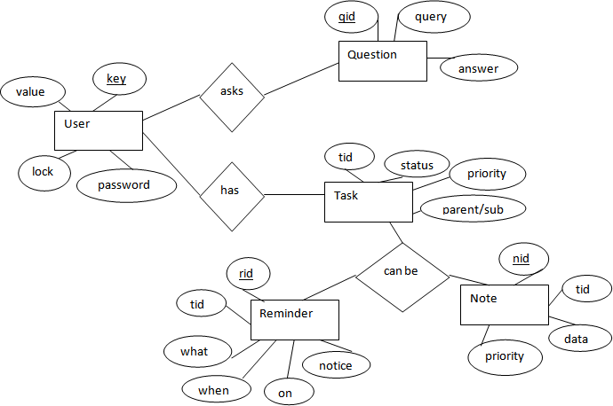

The above diagram shows entities and their relationship for a virtual assistant system. We have a

user of a system who can have their keys and values. It can be used to store any information

about the user. Say, for key “name” value can be “Jim”. For some keys user might like to keep

secure. There he can enable lock and set a password (voice clip).

Single user can ask multiple questions. Each question will be given ID to get recognized along

with the query and its corresponding answer. User can also be having n number of tasks.

These should have their own unique id and status i.e. their current state. A task should also have

a priority value and its category whether it is a parent task or child task of an older task.

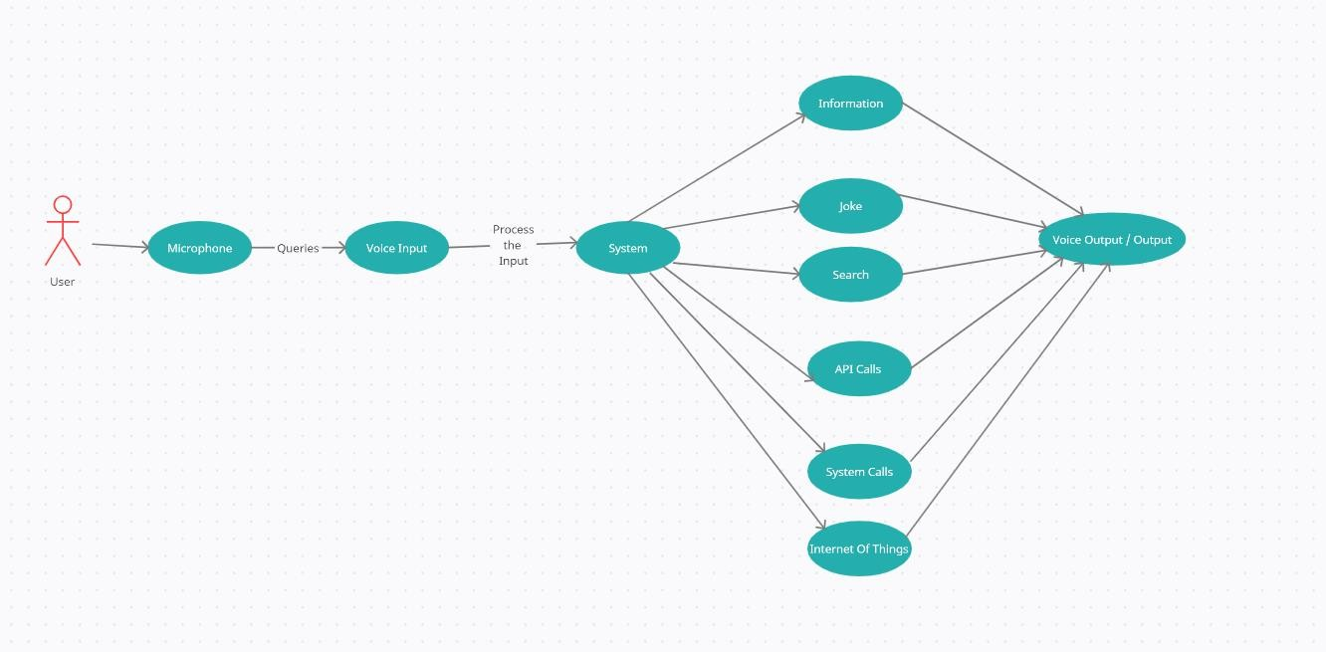**USE CASE DIAGRAM:**

In this project there is only one user. The user queries command to the system. System then interprets it and fetches answer. The response is sent back to the user.

### SEQUENCE DIAGRAM

The above sequence diagram shows how an answer asked by the user is being fetched from

internet. The audio query is interpreted and sent to Web scraper. The web scraper searches and

finds the answer. It is then sent back to speaker, where it speaks the answer to user.

The user sends command to virtual assistant in audio form. The command is passed to the interpreter. It identifies what the user has asked and directs it to task executer. If the task is missing some info, the virtual assistant asks user back about it. The received information is sent back to task and it is accomplished. After execution feedback is sent back to user.

**ACTIVITY DIAGRAM**

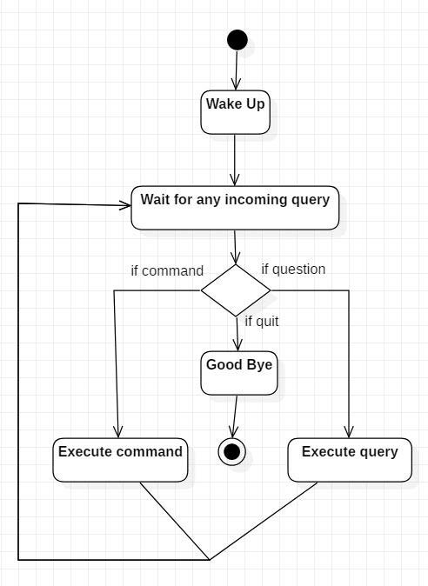

Initially, the system is in idle mode. As it receives any wake up cal it begins execution.

The received command is identified whether it is a questionnaire or a task to be performed. Specific action is taken accordingly. After the Question is being answered or the task is being performed, the system waits for another command. This loop continues unless it receives quit command. At that moment, it goes back to sleep.

**Feasibility Study:-**

Feasibility study can help you determine whether or not you should proceed with your project. It is essential to evaluate cost and benefit. It is essential to evaluate cost and benefit of the proposed system. Five types of feasibility study are taken into consideration.

1. **Technical feasibility:** It includes finding out technologies for the project, both hardware and software. For virtual assistant, user must have microphone to convey

their message and a speaker to listen when system speaks. These are very cheap now a days and everyone generally possess them. Besides, system needs internet connection.

While using, make sure you have a steady internet connection. It is also not an issue in this era where almost every home or office has Wi-Fi.

1. **Operational feasibility:** It is the ease and simplicity of operation of proposed system. System does not require any special skill set for users to operate it. In fact, it is designed to be used by almost everyone. Kids who still don’t know to write can read

out problems for system and get answers.

1. **Economic feasibility:** Here, we find the total cost and benefit of the proposed system over current system. For this project, the main cost is documentation cost. User also, would have to pay for microphone and speakers. Again, they are cheap and available. As far as maintenance is concerned, it won’t cost too much.
2. **Organizational feasibility:** This shows the management and organizational structure of the project. This project is not built by a team. The management tasks are all to be carried out by a single person. That won’t create any management issues and will increase the feasibility of the project.
3. **Cultural feasibility:** It deals with compatibility of the project with cultural environment. Virtual assistant is built in accordance with the general culture. This project is technically feasible with no external hardware requirements. Also, it is simple in operation and does not cost training or repairs. Overall feasibility study of the project reveals that the goals of the proposed system are achievable. Decision is taken to proceed with the project.

**SOURCE CODE**

* + - 1. **SOURCE CODE**

import pyttsx3

import speech_recognition

import requests

from bs4 import BeautifulSoup

import datetime

import os

import pyautogui

import random

import webbrowser

import speedtest

for i in range(3):

a = input("Enter Password to open NOVA :- ")

pw_file = open("password.txt","r")

pw = pw_file.read()

pw_file.close()

if (a==pw):

print("WELCOME SIR ! PLZ SPEAK [WAKE UP] TO LOAD ME UP")

break

elif (i==2 and a!=pw):

exit()

elif (a!=pw):

print("Try Again")

engine = pyttsx3.init("sapi5")

voices = engine.getProperty("voices")

engine.setProperty("voice",voices[1].id)

def speak(audio):

engine.say(audio)

engine.runAndWait()

def takeCommand():

r = speech_recognition.Recognizer()

with speech_recognition.Microphone() as source:

print("Listening....")

r.pause_threshold = 1

r.energy_threshold = 300

audio = r.listen(source,0,4)

try:

print("Understanding...")

query = r.recognize_google(audio,language='en-in')

print(f"You Said: {query}\n")

except Exception as e:

print("Say that again")

return "None"

return query

def alarm(query):

timehere = open("Alarmtext.txt","a")

timehere.write(query)

timehere.close()

os.startfile("Alarm.py")

if __name__ == "__main__" :

while True:

query = takeCommand().lower()

if "wake up" in query:

from GreetMe import greetMe

greetMe()

while True:

query = takeCommand().lower()

if "go to sleep" in query:

speak("Ok sir,You can call me anytime")

break

elif "change password" in query:

speak("What's the new password")

new_pw = input("Enter the new password\n")

new_password = open("password.txt","w")

new_password.write(new_pw)

new_password.close()

speak("Done sir")

speak(f"Your new password is{new_pw}")

elif "open" in query: #EASY METHOD

query = query.replace("open","")

query = query.replace("jarvis","")

pyautogui.press("super")

pyautogui.typewrite(query)

pyautogui.sleep(2)

pyautogui.press("enter")

elif "internet speed" in query:

wifi = speedtest.Speedtest()

upload_net = wifi.upload()/1048576 #Megabyte = 1024*1024 Bytes

download_net = wifi.download()/1048576

print("Wifi Upload Speed is", upload_net)

print("Wifi download speed is ",download_net)

speak(f"Wifi download speed is {download_net}")

speak(f"Wifi Upload speed is {upload_net}")

elif "hello" in query :

speak("Hello sir. How are you?")

elif "i am fine" in query:

speak("that's great, sir")

elif "how are you" in query:

speak("Perfect, sir")

elif "thank you" in query:

speak("you are welcome, sir")

elif "excellent" in query:

speak("Thank You, sir")

elif "your name" in query:

speak("My name is Nova, New Generation Optimal Virtual Assistant.")

elif "tired" in query:

speak("Playing your favourite songs, sir")

a = (1,2,3) # You can choose any number of songs (I have only choosen 3)

b = random.choice(a)

if b==1:

webbrowser.open("https://www.youtube.com/watch?v=qgN1L95njA8")

elif "pause" in query:

pyautogui.press("k")

speak("video paused")

elif "play" in query:

pyautogui.press("k")

speak("video played")

elif "mute" in query:

pyautogui.press("m")

speak("video muted")

elif "volume up" in query:

from keyboard import volumeup

speak("Turning volume up,sir")

volumeup()

elif "volume down" in query:

from keyboard import volumedown

speak("Turning volume down, sir")

volumedown()

elif "open" in query:

from Dictapp import openappweb

openappweb(query)

elif "close" in query:

from Dictapp import closeappweb

closeappweb(query)

elif "google" in query:

from SearchNow import searchGoogle

searchGoogle(query)

elif "youtube" in query:

from SearchNow import searchYoutube

searchYoutube(query)

elif "wikipedia" in query:

from SearchNow import searchWikipedia

searchWikipedia(query)

elif "news" in query:

from NewsRead import latestnews

latestnews()

elif "calculate" in query:

from Calculatenumbers import WolfRamAlpha

from Calculatenumbers import Calc

query = query.replace("calculate","")

query = query.replace("jarvis","")

Calc(query)

elif "whatsapp" in query:

from Whatsapp import sendMessage

sendMessage()

elif "temperature" in query:

search = "temperature in delhi"

url = f"https://www.google.com/search?q={search}"

r = requests.get(url)

data = BeautifulSoup(r.text,"html.parser")

temp = data.find("div", class_ = "BNeawe").text

speak(f"current{search} is {temp}")

elif "weather" in query:

search = "temperature in delhi"

url = f"https://www.google.com/search?q={search}"

r = requests.get(url)

data = BeautifulSoup(r.text,"html.parser")

temp = data.find("div", class_ = "BNeawe").text

speak(f"current{search} is {temp}")

elif "set an alarm" in query:

print("input time example:- 10 and 10 and 10")

speak("Set the time")

a = input("Please tell the time :- ")

alarm(a)

speak("Done,sir")

elif "the time" in query:

strTime = datetime.datetime.now().strftime("%H:%M")

speak(f"Sir, the time is {strTime}")

elif "finally sleep" in query:

speak("Going to sleep,sir")

exit()

elif "remember that" in query:

rememberMessage = query.replace("remember that","")

rememberMessage = query.replace("jarvis","")

speak("You told me "+rememberMessage)

remember = open("Remember.txt","a")

remember.write(rememberMessage)

remember.close()

elif "what do you remember" in query:

remember = open("Remember.txt","r")

speak("You told me " + remember.read())

# CHAPTER-5

# PROJECT TESTING AND IMPLEMENTATION

### TEST CASE DESIGN

##### **Test Case 1**

**Test Title:** Response Time

**Test ID**: T1

**Test Priority:** High

**Test Objective:** To make sure that the system respond back time is efficient.

Description:

Time is very critical in a voice based system. As we are not typing inputs, we are speaking them. The system must also reply in a moment. User must get instant response of the query made.

* **Test Case 2**

**Test Title:** Response Time

**Test ID:** T2

**Test Priority:** High

**Test Objective:** To assure that answers retrieved by system are accurate as per gathered data.

Description:

A virtual assistant system is mainly used to get precise answers to any question asked. Getting answer in a moment is of no use if the answer is not correct. Accuracy is of utmost importance in a virtual assistant system.

##### **Test Case 3**

**Test Title:** Approximation

**Test ID: t3**

**Test priority:** Moderate

**Test Objective:** To check approximate answers about calculations.

Description:

There are times when mathematical calculation requires approximate value. For example, if someone asks for value of PI the system must respond with approximate value and not the accurate value. Getting exact value in such cases is undesirable.

Note: There might include a few more test cases and these test cases are also subject to change with the final software development

# CHAPTER 6

**RESULTS AND DISCUSSION**

The project work of the voice assistant has been clearly explained in this report, how useful it is and how we can rely on a voice assistant for performing any/every task which the user needs to complete and how the assistant is developing everyday which we can hope that it'll be one of the biggest technology in the current technological world. Development of the software is almost completed form our side and it's working fine as expected which was discussed for some extra development. So, maybe some advancement might come in the near future where the assistant which we developed will be even more useful than it is now.

## 5.1. WORKING

It starts with a signal word. Users say the names of their voice assistants for the same reason. They might say, “Hey Siri!” or simply, “Alexa!” Whatever the signal word is, it wakes up the device. It signals to the voice assistant that it should begin paying attention. After the voice assistant hears its signal word, it starts to listen. The source code then sends these commands back to the voice assistant. Once it receives the commands, the voice assistant knows what to do next. If it understands, the voice assistant will carry out the task we asked for. For example, “Hey NOVA! What’s the weather?” NOVA reports back to us in seconds. The more directions the devices receive, the better and faster they get at fulfilling our requests. The user gives the voice input through microphone and the assistant is triggered by the wake up word and performs the STT (Speech to Text) and converts it into a text and understands the Voice input and further performs the task said by the user repeatedly and delivers it via TTS (Text to Speech) module via AI Voice.

These are the important features of the voice assistant but other than this, we can do an plenty of things with the assistant.

List of features that can be done with the assistant:

* Playing some video which, the user wants to see.
* Telling some random fact at the start of the day with which the user can do their work in an informative way and the user will also learn something new.
* One of the features which will be there in every assistant is playing some game so that the user can spend their free time in a fun way.
* Users might forget to turn off the system which might contain some useful data but with a voice assistant, we can do that even after leaving the place where the system is just by commanding the assistant to turn the system off.

As discussed about the mandatory features to be listed in voice assistant are implemented in this work, brief explanation is given below.

1. **Must provide the user any information which they ask for:** -

The user might need any information which will be available on the internet but searching for that information and reading that takes a lot of time but with the help of a voice assistant, we can complete that task of getting the information sooner than searching and reading it. So, this is a small proof that a voice assistant helps the user to save time.

1. **Telling the day's hot news in the user's location:** -

In Common, watching a news channel just to know the important news in one’s location takes a lot of time and the user might even want to listen to some news which is unnecessary to them or a news of some different location before getting to know the news which they want needs a lot of patience to the user but having a voice assistant makes all that nothing, it'll give the news of the location which the user wants to now or the news which they want to know.

1. **Telling some joke to chill up the moment:** -

Now let's be honest, everyone would have had at least one moment in their life where they were so tensed up or had an argument with their close people. So, these moments can be chilled up at least ten percentage with some random joke which might cool us that moment or stop that fight. We even have a quote stating "Laughter is the best medicine" which is relatable to the words mentioned here in this paragraph.

1. **Opening the file/folder which the user wants: -**

In the busy world, everything should do quick else, our schedule will get changed and sometimes we need assistance of someone to complete that task quickly but, if we have a voice assistant, we can complete that task in right away in a hustle freeway. For example, let's say the user is doing some documentation but after a while, he needs some file for reference and he goes searching for that file which wastes a lot of time and he ends up missing the deadline but, with a voice assistant we can do the searching part in a quick way by commanding the assistant to open the folder. So, by this we can say that it is one of the important features of a voice assistant.

1. **Telling the temperature/weather at the user's location: -**

Let's start this with a question, why is it important for us to know the weather of the day? or why is it important for us to monitor the weather every day? The answer is pretty simple it forewarns the users asking about the weather telling that "it might rain today so carry an umbrella if you go out" or "It will be a sunny day so wear a sun glass". So, by this we can say that this is also a must have feature.

1. **Searching for what the user asks:**

Today in the 20th century, we people often get doubts and we need to clear that doubt as soon as possible else that one doubt will be multiplied and at the end, we'd have n doubts and to clear the doubts searching the question in the internet will give us an answer and clear our doubts and asking that to the assistant will save a lot of time. Other than clearing the doubts, we need to search a lot of questions or topics in the internet to keep up with the trend and we can do this searching just by giving command to our assistant, asking it to search a specific topic/question.

1. **Internet of Things:**

The final important feature which is the most important feature and that is Internet of Things which is a lot useful because, it'll save a lot of time. Let's take an example, let's say that there is a person with a walking disability and he has to turn on the fan but the switch is a bit far and he can't walk but what he can do is that, he can tell the assistant to turn on the fan and that will turn it on. This is just one example but with the help of IoT, we can do a lot of helpful stuffs like this. These are the important features of the voice assistant but other than this, we can do an ample of stuffs with the assistant.

# CHAPTER 7 CONCLUSION

As stated before, "voice assistant is one of the biggest problem solver" and you can see that in the proposals with the examples that it is in fact one of the biggest problem solver of the current world. We can see that voice assistant is one of the major evolving artificial intelligence in the current world once again on seeing the proposal examples because at the past, the best feature which a voice assistant had was telling the date and searching the web and giving the results but now look at the functions that it can do so with this, we can say that it is a evolving software in the current world. The main idea is to develop the assistant even more advanced than it is now and make it the best ai in the world which will save an ample of time for its users. I would like to conclude with the statement that we will try our best and give one of the best voice assistants which we are able to.

**FUTURE SCOPE**

We are entering the era of implementing voice-activated technologies to remain relevant and competitive. Voice-activation technology is vital not only for businesses to stay relevant with their target customers, but also for internal operations. Technology may be utilized to automate human operations, saving time for everyone. Routine operations, such as sending basic emails or scheduling appointments, can be completed more quickly, with less effort, and without the use of a computer, just by employing a simple voice command. People can multitask as a result, enhancing their productivity. Furthermore, relieving employees from hours of tedious administrative tasks allows them to devote more time to strategy meetings, brainstorming sessions, and other jobs that need creativity and human interaction.

1. Sending Emails with a voice assistant:

Emails, as we all know, are very crucial for communication because they can be used for any professional contact, and the finest service for sending and receiving emails is, as we all know, GMAIL. Gmail is a Google-created free email service. Gmail can be accessed over the web or using third-party apps that use the POP or IMAP protocols to synchronize email content.

To integrate Gmail with Voice Assistant we have to utilize Gmail API. The Gmail API allows you to access and control threads, messages, and labels in your Gmail mailbox.

1. Scheduling appointments using a voice assistant

The demands on our time increase as our company grows. A growing number of people want to meet with us. We have a growing number of people who rely on us. We must check in on certain projects or set aside time to chat with possible business leads. There won't be enough hours in the day if we keep doing things the old way.

**LIST OF FIGURES**

|  |  |  |
| --- | --- | --- |
| **c** | **Figure Name** | **Page No.** |
| 3.1 | SYSTEM ARCHITECTURE | 16 |
| 3.2 | USE CASE DIAGRAM | 18 |
| 3.3 | COMPONENT DIAGRAM | 19 |
| 3.4 | SEQUENCE DIAGRAM | 19 |
| 3.5 | SEQUENCE DIAGRAM (Answering the user) | 20 |
| 5.1 | FLOWCHART | 24 |

# LIST OF ABBREVIATIONS

|  |  |
| --- | --- |
| **ABBREVIATIONS** | **EXPANSION** |
| IOT | Internet of Things |
| AI | Artificial Intelligence |
| COM | Communication Port |
| OOPs | Object Oriented Programming |
| API | Application Programming Interface |
| TTS | Text to Speech |
| STT | Speech to Text |
| RAD | Rapid Application Development |
| UIDs | Unique Identifiers |
| NOVA | Next-Gen Optimal Voice Assistant |
| IP | Internet Protocol |

# REFERENCES

1. K. Noda, H. Arie, Y. Suga, T. Ogata, Multimodal integration learning of robot behavior using deep neural networks, Elsevier: Robotics and Autonomous Systems, 2014.
2. Artificial intelligence (AI), sometimes called machine intelligence. <https://en.wikipedia.org/wiki/Artificial_intelligence>.
3. Deepak Shende, RiaUmahiya, Monika Raghorte, AishwaryaBhisikar, AnupBhange, “AI Based Voice Assistant Using Python”, Journal of Emerging Technologies and Innovative Research (JETIR), February 2019, Volume 6, Issue 2.
4. J. B. Allen, “From lord rayleigh to shannon: How do humans decode speech,” in International Conference on Acoustics, Speech and Signal Processing, 2002.
5. John Levis and Ruslan Suvorov, “Automatic Speech Recognition”.
6. B.H. Juang and Lawrence R. Rabiner, “Automatic Speech Recognition - A Brief History of the Technology Development”.
7. AbhayDekate, ChaitanyaKulkarni, RohanKilledar, “Study of Voice Controlled Personal Assistant Device”, International Journal of Computer
   1. Trends and Technology (IJCTT) – Volume 42 Number 1 – December 2016