Required Capstone Checkpoint 3.1: Evaluation Infrastructure and Baseline Diagnosis

Directions
Download this worksheet and save a copy to your device before you begin working. Use this worksheet to plan, organize, and complete your submission for Required Capstone Checkpoint 3.1. Type your responses directly into the document, save your completed work, and upload the finished file when you are ready to submit.

Completion Checklist
☐ A clear description of the retrieval system and intended user tasks
☐ Defined and justified evaluation criteria, metrics, and testing approach
☐ Baseline evaluation results supported by relevant examples or evidence
☐ Identification of meaningful system strengths, weaknesses, and likely failure modes
☐ Evidence that the evaluation framework can detect degraded, manipulated, or otherwise problematic outputs
☐ Reflection on potential blind spots or limitations in the evaluation framework

Step 1. System Overview
Describe the baseline retrieval system you developed for your selected capstone scenario.
- Briefly explain what the system retrieves or answers.
- Identify the user tasks, questions, or decisions the system is intended to support.
Brief description of your retrieval system
Response:
I continued using the Research Paper Navigator and the corpus of 153 research paper PDF provided for the project.
My baseline retrieval system used hybrid retrieval approach, so that it can combine BM25 keyword retrieval along with semantic vector retrieval using embedding and a Chroma vector db.
I used the same queries used in the previous models. The keyword retrieval performs better for paper titles, author names and extract term matching and the semantic retrieval will support conceptual queries. This will provide the balance between precision and flexibility.
In this checkpoint the system will use the evaluation framework established to measure behavior consistently.

Intended user tasks or questions
Response:
The system is intended to help answer questions about a large collection of research papers like finding information from a specific paper, listing papers written by a particular author, identifying authors research focuses based on multiple papers, comparing concepts discussed across different papers etc.
Further the system uses the implemented evaluation framework to measure the responses.

Step 2. Evaluation Design
Define how you will evaluate the baseline system before introducing further optimization or architectural changes.
- Identify the criteria you will use to judge system performance.
- Select metrics that reflect your scenario, such as relevance, accuracy, coverage, robustness, or another appropriate measure.
- Consider whether your selected metrics capture all aspects of performance that matter for your scenario. What important behaviors might not be fully measured?
- Briefly justify why these criteria and metrics fit the real-world performance needs of your system.
Evaluation criteria
Response:
To judge the performance, the LLM as judge model is used. Each evaluation item contains a user query, grading notes describing what a correct answer must contain.
The retrieval LLM generates answer from research papers collection and a separate judge LLM evaluates whether the responses meet the grading criteria.

Selected metrics
Response:
The evaluation metric was simple Pass/Fail judgement.
It was designed to measure:
- Answer correctness,
- Retrieval relevance,
- Grounding of the responses in retrieve documents,
- Coverage of the required concepts and ability to answer both factual and conceptual questions.

Potential metric limitations
Response:
I observed that the evaluation results are highly depending on how grading notes are written. Some of my grading notes were broad and generic and that resulting in a higher pass rate. After revising the grading notes to include specific requirements, the answers that previously passed were scored as a failure. Hence the evaluation metrics and scoring criteria directly influence observed system performance.

Brief justification for your criteria and metrics
Response:
The research paper navigator’s goal is to retrieve relevant, accurate and supported by evidence hence the simple Pass/Fail evaluation provides a clear baseline evaluation metric before we learn making further improvements.

Step 3. Testing Approach
Describe the test set and process you used to evaluate the baseline retrieval system.
- Include the number and types of queries or cases used.
- Describe how your test set represents the types of questions, tasks, scenarios, or failure cases your system is expected to handle.
- Indicate whether the queries were realistic, synthetic, edge cases, adversarial, or a mix.
- Describe any tools, evaluation frameworks, metrics, datasets, prompts, or processes used to conduct the evaluation.
Description of your test set
Response:
I used 5 queries, based on the same types of retrieval scenarios used in previous checkpoint:
- Exact paper lookup
- Author identification
- Research focus analysis
- Conceptual question
- Cross document reference
These queries represent realistic user behaviors using different patterns keyword search, multi document search and broader research topic questions related to the corpus.

How the evaluation was conducted
Response:
I ran the evaluation system several times while making some changes to the framework.
I made changes to grading criteria, temperature settings and judge model to observe its effects to the evaluation results.
It provided more systematic testing compared to manual testing we were performing in the previous checkpoint.

Step 4. Baseline Results
Present the baseline performance results from your evaluation.
- Include scores or findings across your selected metrics. Note any surprising, inconsistent, or difficult-to-interpret results.
- Provide at least two concrete examples of system outputs.
- Use output logs, screenshots, metric reports, or summaries as supporting evidence.
Summary of baseline evaluation results
Response:
The baseline evaluation generated different results as I changed the evaluation framework for testing.

Example 1: Query, system output, and result
Response:
When I made the grading notes more specific and required certain concepts in the answers, some questions that previously passed began failing.
In some evaluation runs, only two or three questions passed even though the answers contained information that was relevant to the query.
The failures were in the author identification, research focus, and conceptual questions.
I noticed that stricter grading notes resulted in 2/5 pass. Whereas more generic grading resulted in different evaluation score.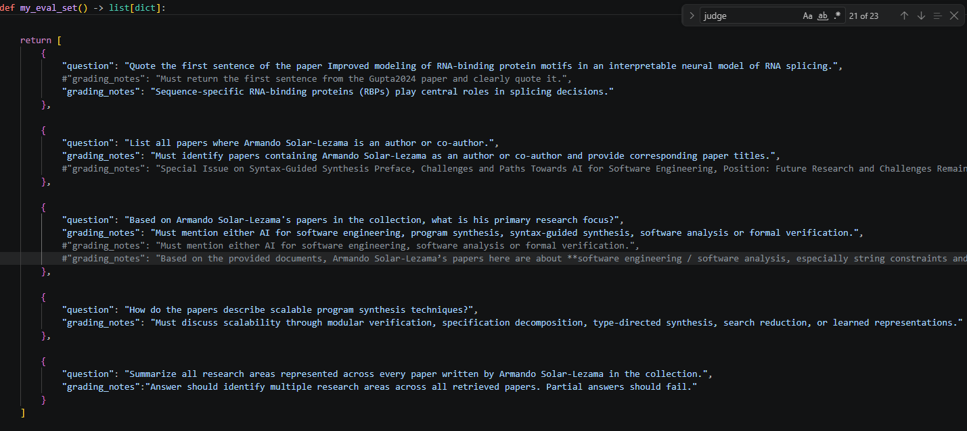

This shows that evaluation results were highly sensitive to the wording of grading criteria. More detailed grading notes improved evaluation rigor but also made the evaluation framework more difficult to satisfy consistently.

Example 2: Query, system output, and result
Response:
Changed the Judge model to a stronger one “openai/gpt-oss-120b”. With the same evaluation set and grading criteria, by just changing the judge model the system produced 5/5 pass rate. This suggests that the stronger evaluation model interprets grading requirements more reliably and reduced some of the variability observed in earlier runs.

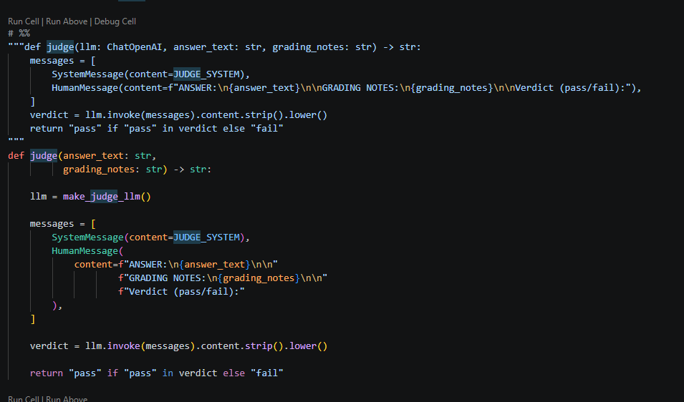

Example 3: Query, system output, and result, if applicable
Response:
Changed temperature from 0.2 to 0
Observed that answers changed and pass rates changed despite using the same overall grading. The run that was previously passed became a failure because the generated response wording changed.
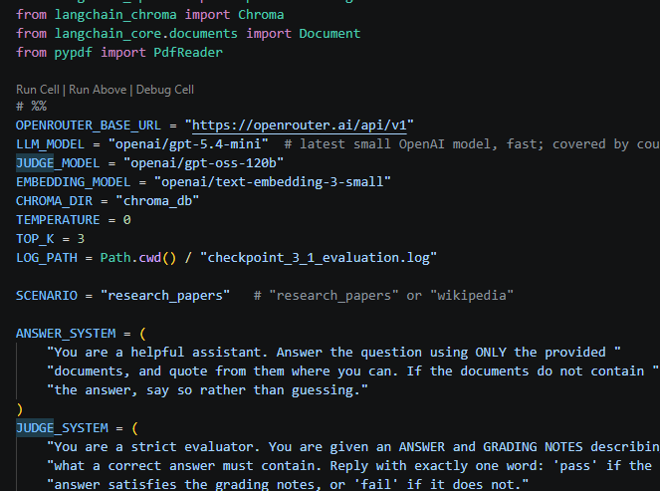

Step 5. Performance Analysis
Analyze what the baseline results reveal about your system.
- Identify meaningful strengths and weaknesses.
- Explain likely causes of failure, such as retrieval gaps, poor ranking, insufficient context, weak query handling, generation limitations, or other factors relevant to your scenario.
- Connect your analysis to the evidence presented in Step 4.
Key system strengths
Response:
The evaluation results have several strengths and weaknesses in both the retrieval system and the evaluation framework.
The hybrid retrieval approach performs well. For the type of questions included system retrieved relevant documents, mostly accurate responses.

Key system weaknesses
Response:
However, I noticed that multi-document questions were more difficult. In some cases the retrieved paper contained relevant information, but the generate answer did not include all of the concepts required by the grading notes.
A system can retrieve relevant information but still fail if the generated answer is incomplete, lacks details/coverage, or does not clearly provide all the required information.
Another thing is the evaluation results changed significantly when I modified the grading notes. More general grading notes produced higher pass results, while more specific grading notes caused additional failures. Hence the evaluation should be used as a diagnostic tool rather than relying on the on the final score

Likely failure modes and causes
Response:
The pass/fail metric provides a useful quantitative performance of the system, however qualitative analysis like the completeness of the explanations, usefulness of the the retrieved evidence and clarify and trustworhhiness is often necessary to understand how systems actually fail.

Step 6. Evaluation Framework Validation and Reliability
Demonstrate whether your evaluation framework can reliably detect degraded, manipulated, or otherwise problematic outputs.

- Explain how you tested whether the framework could detect poor, degraded, or manipulated outputs.
- Provide evidence from the validation test.
- Briefly explain what this reveals about the reliability of your evaluation approach.
- Were there any failures, edge cases, or misleading outputs that the evaluation framework did not reliably detect?
How you tested the evaluation framework
Response:
I tested the evaluation framework by following the steps provided in the starter code and performing experiments on the evaluation settings.
Example experimenting by changing grading notes, temperature notes, replacing judge model. These tests helped me evaluate how the framework behaved across different configurations.

Evidence that the framework detected poor, degraded, or manipulated outputs
Response:
The framework responded differently when I changed key evaluation settings.
After reducing the temperature from 0.2 to 0, the overall pass rate changed from 5/5 to 4/5.
After replacing the judge model to openai/gpt-oss-120b, the evaluation returned 5/5 passes using the same evaluation questions and grading notes.
These results showcased that the framework was sensitive to changes in answer quality and evaluation behavior.

Brief interpretation of the validation results
Response:
The validation results showed that the framework was capable of detecting incorrect, incomplete, or degraded responses, but it was not perfectly consistent under all conditions.
Overall, the evaluation framework is a useful diagnostic tool as it helped identify retrieval quality, answer completeness, and evaluation design.
However, it should be used together with qualitative review of the generated answers rather than relying solely on pass/fail scores.

Potential blind spots in the evaluation framework
Response:
One potential blind spot is that the framework relies heavily on the grading notes provided to the judge model. If the grading notes are too broad, weak answers may receive passing scores. If the grading notes are too specific, otherwise reasonable answers may fail because they do not use the expected wording or concepts.
Another limitation is the use of an LLM-as-Judge approach can introduce bias, inconsistent judgments, and differences in scoring depending on the model being used.
In my testing changing from gpt-5.4-mini to gpt-oss-120b changed evaluation outcomes without changing the underlying system.
The evaluation framework also focuses primarily on pass/fail scores. While this quantitative metric it may not fully capture qualitative factors such as reasoning quality, answer usefulness, completeness, or user satisfaction.
I believe the framework provides a useful baseline evaluation, but additional evaluation methods and larger test sets would help improve reliability and better capture real world system behavior.

Step 7. Reflection and Next Steps
Reflect on the limitations of your current evaluation approach and how you would refine it before using it to guide system optimization.
- Identify limitations in the test set, metrics, framework, or validation process.
- Propose specific improvements you would make next.
- Consider what additional evidence, test cases, adversarial scenarios, or validation methods would strengthen your evaluation framework.
Limitations of your current evaluation approach
Response:
One of the lessons learned is that evaluation is not neutral. Changes in grading criteria, temperature settings, retrieval results, and judge models all affect observed performance.
The same retrieval system could appear stronger or weaker depending on how the evaluation framework is configured.
This provides a practical example of Goodhart's Law. If evaluation criteria are too broad, the system can receive passing scores without demonstrating all of the intended capabilities. However, if evaluation criteria become too strict, correct answers may fail because of missing wording or typo or grammar rather than an actual retrieval failure.

Specific improvements or next steps
Response:
If I continue improving this baseline evaluation system, I would keep the hybrid retrieval approach because it provides the best balance between keyword and semantic retrieval.
I would consider expanding the evaluation dataset, test some adversarial and edge case queries, and continue refining the evaluation framework to increase consistency.

Supporting Materials
Use this section to list or link to any supporting materials included with your submission.
Supporting material | Location, link, or note
Sample test queries

Output logs, screenshots, or metric reports

Code, notebook, repository link, or screenshots of setup

Other supporting evidence

Validation evidence (optional)

End of Required Capstone Checkpoint 3.1
Return to the assignment page in the learning platform to upload and submit your completed capstone checkpoint and complete any remaining items in this module.

