Required Capstone Checkpoint 2.1: Retrieval Strategy Design and Baseline Implementation

Directions

You will continue working with the same dataset and scenario you selected for your capstone checkpoint in Module 1. In this activity, you will design and implement a baseline retrieval system that supports the types of queries required for your scenario.

Download this worksheet and save a copy to your device before you begin working. Type your responses directly into the document, save your completed work, and upload the finished file when you are ready to submit.

Use this worksheet to:
- Document your retrieval approach
- Capture representative retrieval queries and results
- Provide evidence that your retrieval system is functioning
- Observe how retrieval performance changes across different query types
- Reflect on where the retrieval approach performs well and where it struggles

1. Selected Scenario and Retrieval Approach
- Identify your chosen capstone scenario.
- Describe the retrieval approach you implemented (keyword-based, semantic, or hybrid).
- Briefly explain why this retrieval approach is appropriate for your dataset and query types.
- Describe any trade-offs you considered when selecting this approach
Scenario
☐ Research Paper Navigator
☐ Wikipedia Retrieval Engine
Retrieval approach used, brief explanation, and description of trade-offs considered
Response:
For this capstone checkpoint I have implemented hybrid retrieval approach that combines BM25 keyword retrieval and semantic vector retrieval using embedding and a chroma vector db.
I chose this approach so that BM25 can retrieve the papers containing exact keywords, titles and author names. Whereas semantic retrieval can identify papers that were conceptually related to the queries.
Some queries require exact keyword matching while others require understanding meaning and context.
The trade-off considered was the precision and flexibility. Keyword retrieval would provide high precision but mya miss relative peppers that use different wording. Whereas Semantic retrieval handles conceptual queries better but it can sometimes return loosely related results. The hybrid approach balances these strengths but it introduced implementation complexity and some retrieval noise.

2. Baseline Retrieval System Evidence
- Provide evidence that your retrieval system was implemented and tested.
- Evidence may include screenshots, logs, outputs, notebook examples, code snippets, or brief descriptions showing that retrieval queries were executed successfully.
Evidence of retrieval system implementation and testing
Response:
I was able to successfully implement and test the hybrid retrieval system (using combination of BM25 keyword and semantic retrieval) and point the code to the corpus of 153 research papers PDF’s provided by the course for the capstone project.

The following output shows that the 4 queries returned ranked results with retrieval scores.
For e.g. The query asking for first sentence of “Improved modeling of RNA-binding protein motifs in an interpretable neural model of RNA splicing” retrieved Gupta2024.pdf as the top result with a score of 1.
Output Screenshot:
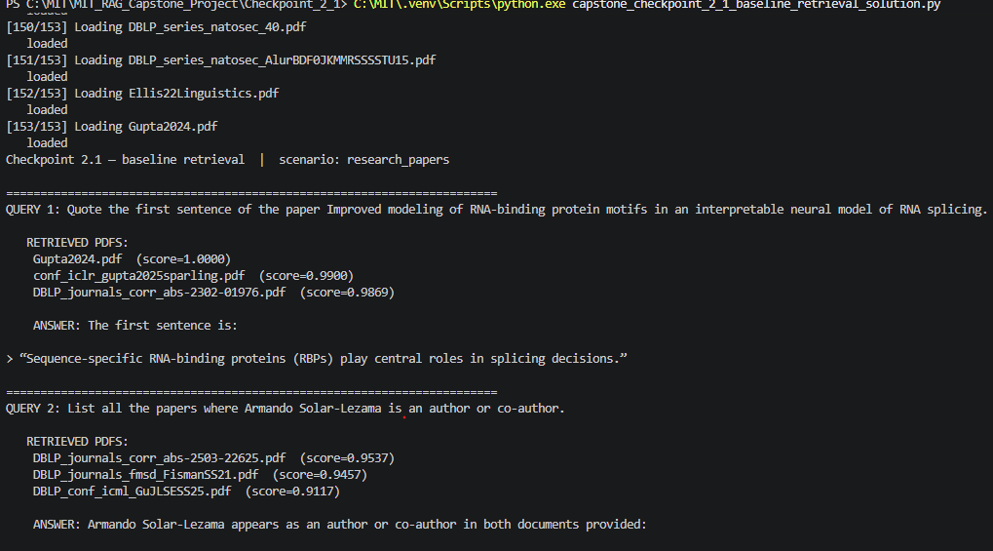

My additional queries included author-based search and cross reference across papers. Each query retuned multiple relevant PDFs with associated scores. I updated the code to include the scores in the output so I can see the grounded answers and its source.

Evidence of log also contains the output of the 4 queries:

3. Representative Queries and Retrieved Results
- Provide three to five representative queries relevant to your scenario.
- Include the retrieved results for each query.
- Focus on showing how the retrieval system behaves across different types of information needs. Where possible, include a mix of precise, conceptual, or broader exploratory queries.
Query 1
Query:
QUERY 1: Quote the first sentence of the paper Improved modeling of RNA‑binding protein motifs in an interpretable neural model of RNA splicing.
Retrieved results:
RETRIEVED PDFS:
Gupta2024.pdf (score=1.0000)
conf_iclr_gupta2025sparling.pdf (score=0.9900)
DBLP_journals_corr_abs-2302-01976.pdf (score=0.9869)

ANSWER: “Sequence‑specific RNA‑binding proteins (RBPs) play central roles in splicing decisions.”
Observations:
What worked well? What limitations, challenges, or unexpected retrieval behaviors did you observe?

The retrieval system successfully identified the exact paper and returned the first sentence.
The query relied on exact identification of the document, so keyword retrieval contributed to generating useful results. Semantic search was not used in this query.

Query 2
Query:
QUERY 2: List all the papers where Armando Solar-Lezama is an author or co-author.
Retrieved results:
RETRIEVED PDFS:
DBLP_journals_corr_abs-2503-22625.pdf (score=0.9537)
DBLP_journals_fmsd_FismanSS21.pdf (score=0.9457)
DBLP_conf_icml_GuJLSESS25.pdf (score=0.9117)

ANSWER: Armando Solar-Lezama appears as an author or co-author in the provided documents on these papers:

1. **Challenges and Paths Towards AI for Software Engineering**
- Listed authors include: “Armando Solar-Lezama asolar@csail.mit.edu”

2. **Special Issue on Syntax-Guided Synthesis Preface**
- Listed authors include: “Dana Fisman 1 · Rishabh Singh 1 · Armando Solar-Lezama 1”

3. **Position: Future Research and Challenges Remain Towards AI for Software Engineering**
- Listed authors include: “Alex Gu 1 Naman Jain 2 * Wen-Ding Li 3 * Manish Shetty 2 * Kevin Ellis 3 Koushik Sen 2 Armando Solar-Lezama 1”

Observations:
What worked well? What limitations, challenges, or unexpected retrieval behaviors did you observe?
The retrieval system successfully returned multiple papers containing Armando Solar-Lezama as the author or co-author. I did notice some inconsistency in output level of details provided varied with multiple runs. Initially it stated that only 2 papers were found even though the following run contained 3 relevant documents. This suggests that the retravel a system not always generates all the retrieved evidence completely. Adding result validation could improve completeness.

Query 3
Query:
QUERY 3: Based on Armando Solar-Lezama's papers in the collection, what is his main research focus? Quote the relevant sentences.
Retrieved results:
RETRIEVED PDFS:
DBLP_conf_hvc_GaneshMSR12.pdf (score=0.9548)
DBLP_conf_icml_GuJLSESS25.pdf (score=0.8987)
DBLP_journals_corr_abs-2503-22625.pdf (score=0.8844)

ANSWER: Based on the provided documents, Armando Solar-Lezama’s papers here are about **AI for software engineering** and **formal methods / string constraint solving**.

Relevant quotes:

- From the 2012 paper:
- “**We prove several decidability and undecidability results for the satisfiability and validity problems for languages that can express solutions to word equations with length constraints.**”
- “These questions are important in **logic, program analysis, and formal verification**.”
- “In practice, formulas of this form have been solved by off-the-shelf satisfiability procedures … in the context of **security analysis for string-manipulating programs**”

- From the 2025 AI-for-SE paper:
- “**AI for software engineering has made remarkable progress, becoming a notable success within generative AI.**”
- “In this paper, our goal is threefold. First, we provide a taxonomy of measures and tasks to categorize work towards **AI software engineering**.”
- “Finally, we call for large open-source community efforts and lay out a collection of promising research directions to address these challenges, hoping that we can all come together to advance and shape the future of **AI for code**.”

So, based on these documents, his main research focus appears to be **software engineering, especially AI for software engineering, with related work in formal verification and string/word-equation decision problems**.
Observations:
What worked well? What limitations, challenges, or unexpected retrieval behaviors did you observe?
In this query semantic search performed better than keyword search because the query was about a broader concept rather than a specific paper.
Again, in this case while the retrieved main research focus stated consistent, different aspects of the authors work was retrieved, so the final output depends of how the retrieved information is aggregated rather than on a single definitive source.

Optional Additional Queries
Query:
QUERY 4: How do the papers describe scalable program synthesis techniques?
Retrieved results:
RETRIEVED PDFS:
DBLP_conf_pldi_PolikarpovaKS16.pdf (score=0.8920)
DBLP_journals_corr_PolikarpovaS15.pdf (score=0.8920)
DBLP_conf_iclr_NyePBATS21.pdf (score=0.8540)

ANSWER: The papers describe scalable program synthesis in two main ways:

1. **Modular, type-directed synthesis with reﬁnement types**
- The PLDI paper says, “**The key to scalable program synthesis is modular verification**.”
- It explains that modularity lets the synthesizer “**prune candidates for different subprograms independently**,” which “**combinatorially reduc[es] the size of the search space**.”
- It also argues that reﬁnement types are well suited because they combine “**expressive power and decidability**,” and because a specification “**can often be effectively decomposed into independent specifications for its components**.”
- Their approach uses “**local liquid type checking**” and “**round-trip type checking**” to propagate constraints both top-down and bottom-up, enabling more scalable synthesis.

2. **Search guided by learned representations of partial programs**
- The ICLR paper says synthesis requires searching “**over a vast, combinatorial space of possible programs**,” and that a key challenge is representing “**the behavior of a partially written program**.”
- To scale this search, it introduces “**blended abstract semantics**,” combining “**concrete execution state and learned neural representations**.”
- The goal is to help a search procedure decide whether a partial program is “**on the right track**” and where to search next.

In short, one paper emphasizes **modular verification and type-based decomposition**, while the other emphasizes **learned semantic representations to guide search through large program spaces**.
Observations:
What worked well? What limitations, challenges, or unexpected retrieval behaviors did you observe?
The semantic retrieval was able to retrieve connected papers that discuss similar concepts even when different terminologies are used.
Again, the definition and explained was not consistence and it produced different approaches; overgeneralization.

4. Retrieval Performance Reflection
- Reflect on where your retrieval approach performs well and where it struggles.
- Consider how different query types affect retrieval quality, relevance, flexibility, or precision.
Retrieval strengths
Which types of queries did your retrieval strategy handle most effectively? What aspects of the approach contributed to these results?

The hybrid retrieval strategy performed best on queries involving specific papers, author name, and research topics. BM25 provided better precision on exact term queries, while semantic retrieval improved performance for conceptual matching questions. Combining the two approaches increased relevance of retrieved information.

Retrieval limitations or challenges
Which queries were more difficult for the retrieval system? What limitations or trade-offs became apparent?
Borad concept queries were more difficult because semantic search because it sometimes returned related but not relevant results. Keyword search also has limitations of because vector search also does not guarantee precise retrieval. Hence the hybrid search is better but sometimes introduces noise.

Patterns observed across different query types
What patterns did you observe when comparing retrieval performance across different query types? How did these observations influence your understanding of the strengths and limitations of your chosen retrieval strategy?

The patterns I noticed that the author and cross paper-based queries sometimes may require more than top three results and ranking to guarantee complete coverage.
Overall, there is no single retrieval strategy performs best in all cases. Hybrid retrieval provides a balance between accuracy and flexibility.

5. Retrieval Strategy Reflection
If you were continuing to improve this system, would you keep the same retrieval approach or make changes? Explain your reasoning.
Reflection
Response:

If I continued improving the system I would keep the hybrid retrieval approach. But I would experiment with chunk sizes and be able to chunk whole documents by section or page metadata and retrieve more results before ranking them.

Up until this checkpoint we learned that hybrid retrieval provides the balanced performance. Hence, I chose that for the research paper scenario. Keyword retrieval supports exact lookup while Semantic retrieval supports broader conceptual understanding, together it improves reliability, grounding, and user trust compared to either approach used individually.

Supporting Materials
Additional Evidence (Optional):
If needed, include any additional screenshots, output excerpts, or code snippets that support your responses above. No additional files or repository link are required for this checkpoint.

End of Required Capstone Checkpoint 2.1
Return to the assignment page in the learning platform to upload and submit your completed capstone checkpoint and complete any remaining items in this module.

