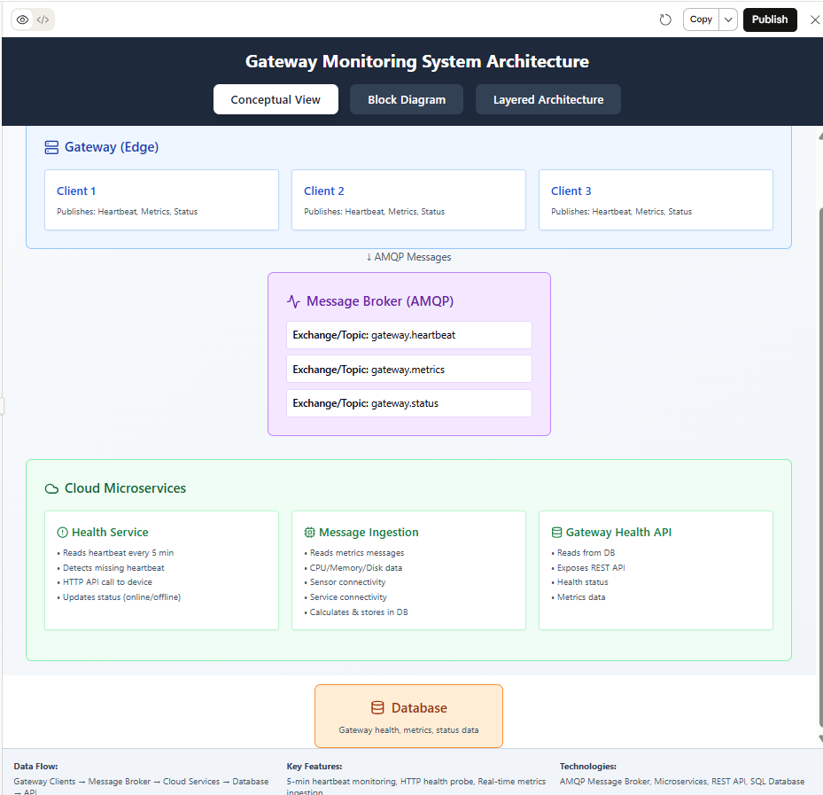

I've fixed the error and created a complete, working Gateway Monitoring System architecture with three comprehensive views:
1. System Overview
- Complete architecture layers from Gateway to Database
- Visual representation of all components
- Clear data flow paths (HTTP and AMQP)
2. Detailed Flow Diagrams
- Gateway Client Process: Step-by-step health check flow
- Cloud HTTP Endpoint: How health data is received and processed
- Background Monitor: Decision logic with 3 scenarios:
  - HTTP recent → ONLINE
  - HTTP stale but AMQP recent → ONLINE (messaging works)
  - Both stale → OFFLINE
3. Recommended Approach
- Why Reverse Approach: Security, network simplicity, scalability
- Technology Stack: Specific recommendations for gateway and cloud
- Implementation Guidelines: Timing, error handling, security
- Key Benefits: Dual path redundancy, network friendly, scalable
Core Recommendation:
Use the reverse approach where gateways make HTTP POST calls to cloud every 5 minutes. Cloud monitors DB timestamps and uses AMQP as fallback verification. This provides:
- Better security (no inbound connections to gateways)
- Works behind NAT/firewalls
- Dual verification path for accuracy
- Standard REST API pattern
The artifact is now error-free and fully interactive!
Claude is AI and can make mistakes.
Please double-check responses.
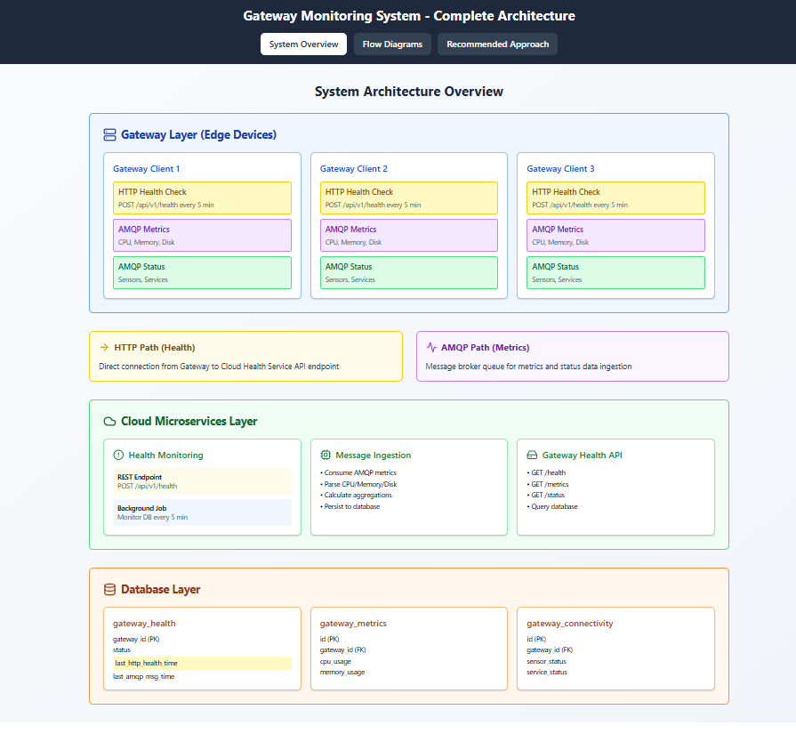
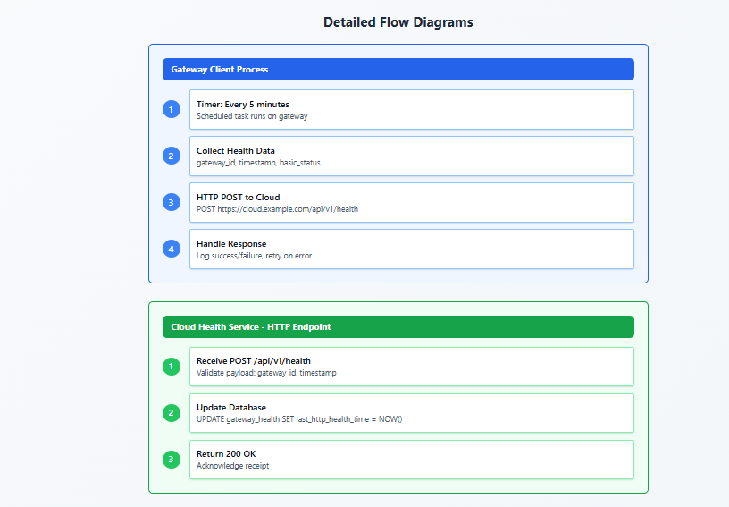
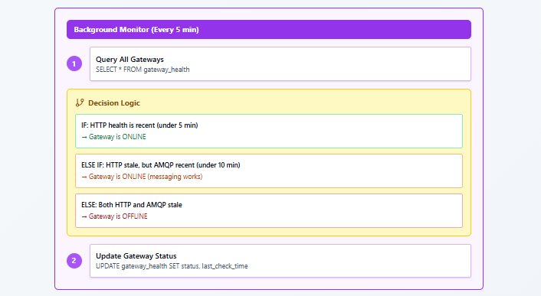

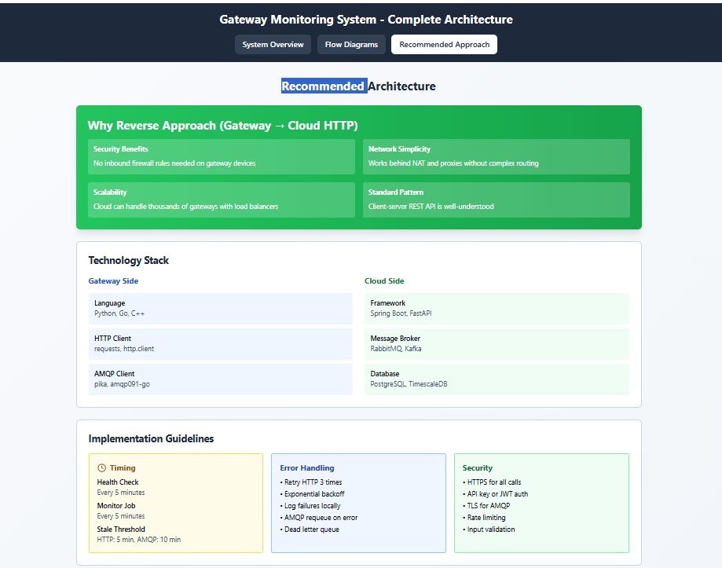

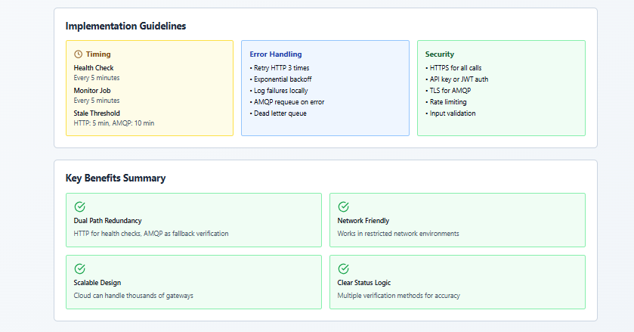
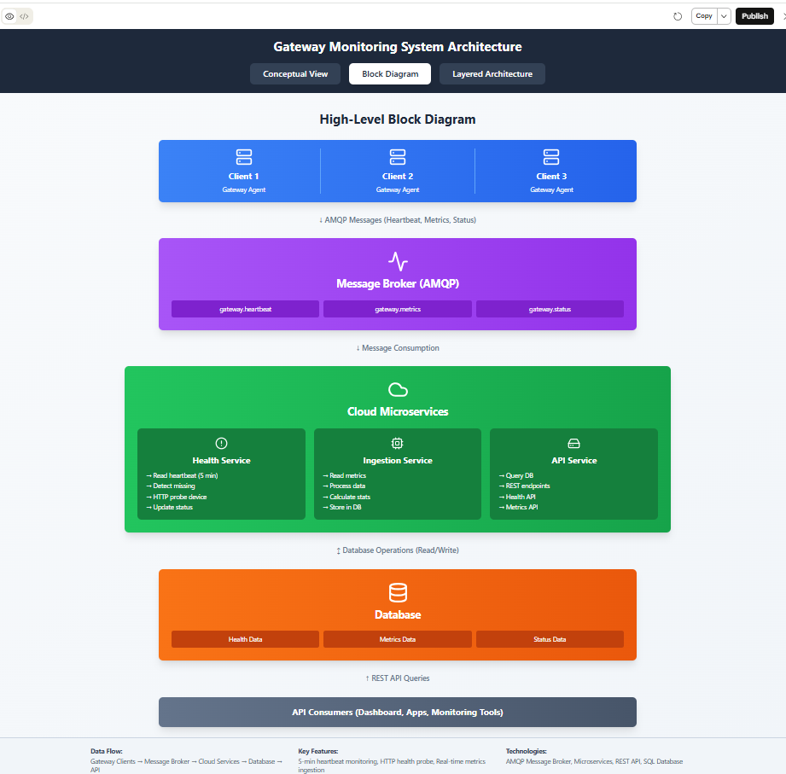

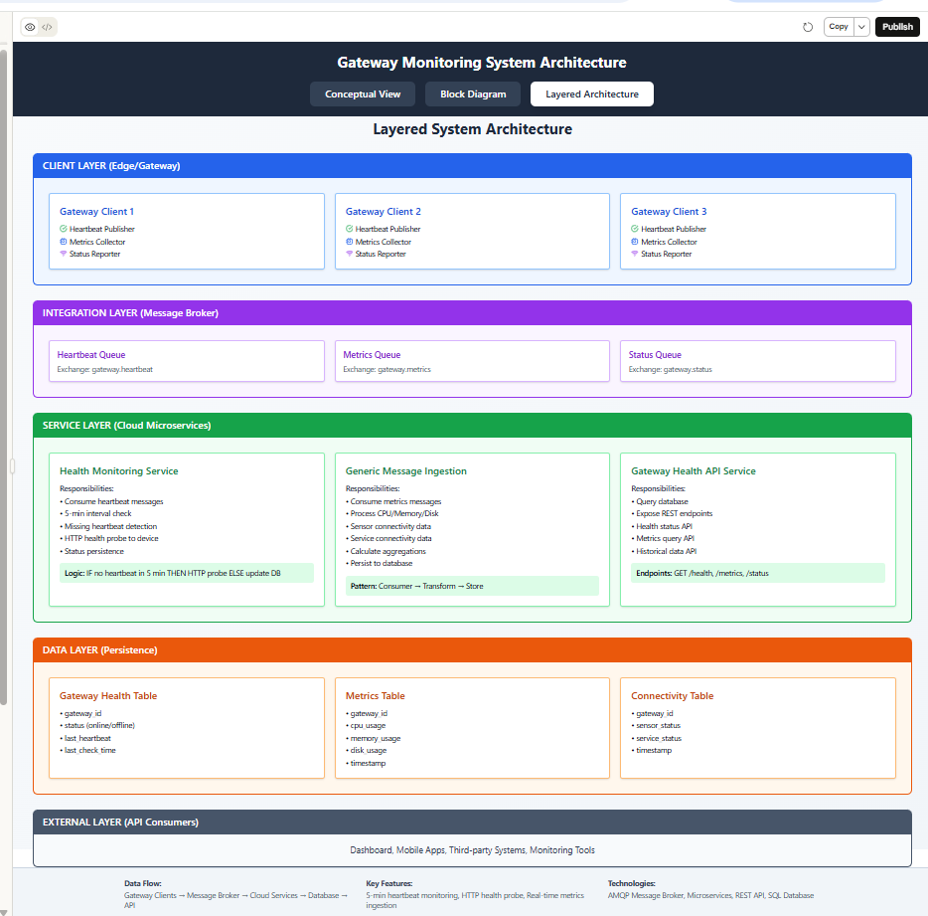

I've created comprehensive architecture diagrams for your gateway monitoring system with three different views:
1. Conceptual View
Shows the logical flow from gateway clients through the message broker to cloud microservices and database.
2. Block Diagram
Presents a high-level visual representation of system components and their relationships with clear data flow arrows.
3. Layered Architecture
Breaks down the system into five distinct layers:
Client Layer (Edge/Gateway)
- 3 Gateway clients that publish heartbeat, metrics, and status data
Integration Layer (Message Broker)
- AMQP-based message broker with separate queues for heartbeat, metrics, and status
Service Layer (Cloud Microservices)
- Health Monitoring Service: Consumes heartbeat messages every 5 minutes, detects missing heartbeats, performs HTTP health probes, and updates online/offline status
- Generic Message Ingestion Service: Processes CPU/memory/disk metrics, sensor connectivity, and service connectivity data, then stores calculations in the database
- Gateway Health API Service: Queries the database and exposes REST endpoints for health status and metrics
Data Layer (Persistence)
- Three main tables: Gateway Health, Metrics, and Connectivity
External Layer (API Consumers)
- Dashboards, mobile apps, and monitoring tools that consume the REST APIs
The diagrams include the complete data flow, responsibilities of each component, and the critical 5-minute heartbeat monitoring logic with automatic HTTP fallback for device reachability checks.
Claude is AI and can make mistakes.
Please double-check responses.
Yes, exactly! The HTTP health probe API call is initiated FROM the cloud microservice TO the gateway device. Here's the clarification:
Flow of HTTP Health Probe:
- Normal Operation: Gateway clients → AMQP messages → Cloud microservice
- Missing Heartbeat Scenario:
  - Cloud Health Service detects no heartbeat for 5 minutes
  - Cloud Health Service initiates HTTP API call FROM Cloud → TO Gateway
  - Gateway device must expose an HTTP endpoint (e.g., GET /health or /ping)
  - Cloud receives response:
    - 200 OK → Device is reachable → Mark as ONLINE (messaging issue)
    - Timeout/Error → Device is unreachable → Mark as OFFLINE (device down)
Gateway Requirements:
For this to work, each gateway device needs to:
- Expose an HTTP health endpoint (REST API)
- Be reachable from the cloud (proper network configuration, firewall rules)
- Respond quickly to health check requests
Architecture Implication:
This creates a bidirectional communication pattern:
- Primary: Gateway → Cloud (via AMQP message broker)
- Fallback: Cloud → Gateway (via HTTP health probe)
This design provides redundancy and helps distinguish between:
- Messaging infrastructure issues (device is up but not sending messages)
- Actual device failures (device is completely unreachable)
I've updated the diagrams to highlight this cloud-to-gateway HTTP probe direction!
Claude is AI and can make mistakes.
Please double-check responses.

