Koneru Lakshmaiah Education Foundation (KL University)
Department of Computer Science & Information Technology
QueryGenie
A Self-Correcting Natural Language to SQL Interface
Final Report — Engineering Capstone Project (Phase I)
DRAFT — Week 14
Team 21
2320090050 — N V V S S Jayakanth Kamisetti
2320090009 — Boddupally Narendar
2320090018 — M Praneeth Reddy
Supervisor: M Parameswar
Anchor paper: CodeS — Towards Building Open-source Language Models for Text-to-SQL (SIGMOD 2024), arXiv:2402.16347
September 2026

Abstract
Natural-language interfaces to databases let people who do not know SQL query data directly, but current models answer every question with the same apparent confidence, so a wrong answer looks exactly like a right one. This project reproduces CodeS, an open-source text-to-SQL language model (SIGMOD 2024), and extends it with confidence-aware abstention.
Reproduction. Using the released fine-tuned CodeS-1B checkpoint and the authors’ database prompt and inference procedure, we obtain 77.8% Execution Accuracy on the 1,034-question Spider development set, scored with the official evaluator, against 77.9% reported in the paper — a difference of 0.1 points. A line-by-line audit of our evaluation harness against the authors’ code was essential: earlier runs had reported 71.7–73.8% because of a simplified scoring metric and a value-retriever bug, both found and fixed. An ablation study shows that every component of the CodeS prompt contributes 0.9 to 1.9 points.
Enhancement. The system executes the four candidate queries produced by beam search and measures how many return the same result. When agreement is low it declines to answer and asks the user to choose between interpretations. At a pre-registered operating point it answers 90.4% of questions and is correct on 83.3% of them, against 77.8% when answering everything; wrong answers fall from 230 to 156 (−32%). The gain is significant under a paired t-test (p = 7.7 × 10⁻¹⁰), a Wilcoxon signed-rank test (p = 9.8 × 10⁻⁴) and a question-level bootstrap (95% CI +4.5 to +6.7 points). The enhancement is built into a desktop application for macOS and Windows that shows a confidence estimate, the SQL behind every answer and, when unsure, a “Did you mean…?” choice.
Keywords: text-to-SQL, natural language interfaces to databases, reproducibility, large language models, selective prediction, abstention.

Contents

1. Introduction

1.1 Problem
Much of an organisation’s data sits in relational databases, and getting answers out of them normally requires writing SQL. Text-to-SQL systems translate a plain-English question into a query, and recent language models do this well on benchmarks. But they answer every question, including the ones they get wrong, and a wrong table looks just as authoritative as a correct one. For a user who cannot read SQL, that is the central risk: silently wrong answers.

1.2 Objectives
- Reproduce the published results of CodeS, an open-source text-to-SQL model, within the department’s tolerance of ±5–10%, and document every deviation.
- Establish which parts of the CodeS pipeline matter, through an ablation study.
- Propose, implement and statistically test one enhancement: confidence-aware abstention.
- Deliver the system as a working local application rather than a notebook.

1.3 Contributions
- A faithful reproduction of SFT CodeS-1B on Spider: 77.8% Execution Accuracy against the reported 77.9%, with an audited evaluation harness and a documented list of remaining deviations.
- An ablation study of the CodeS database prompt and inference procedure, scored with the official evaluator.
- Confidence-aware abstention based on execution agreement between beam candidates, with a pre-registered hypothesis, significance tests and a measured accuracy–coverage trade-off.
- QueryGenie, a desktop application for macOS and Windows that runs the evaluated pipeline, reports confidence and asks for clarification when unsure.

1.4 Structure of this report
Following the department guidelines, Section 2 gives background, Section 3 the reproduction methodology, Section 4 the reproducibility results, Section 5 the enhancement, Section 6 a discussion of the differences, and Section 7 the conclusion. Appendices give the full run log and instructions for reproducing every result.

2. Background

2.1 Text-to-SQL and the Spider benchmark
Given a question Q and a database D, a text-to-SQL system produces a query S whose result answers Q. Spider (Yu et al., 2018) is the standard cross-domain benchmark: its development set has 1,034 questions over 20 databases that do not appear in training. Two metrics are used for CodeS. Execution Accuracy (EX) counts a prediction as correct when it returns the same result as the gold query. Test-suite accuracy (TS) (Zhong et al., 2020) runs both queries on many generated variants of each database and is stricter. Both are computed by the official test-suite evaluator, which treats row order as significant only when the gold query sorts, tolerates reordered columns, and ignores DISTINCT by default.

2.2 CodeS
CodeS (Li et al., 2024) is a family of open-source models (1B, 3B, 7B and 15B parameters) obtained by incrementally pre-training StarCoder on SQL-centric data and then fine-tuning on Spider. At inference time it builds a database prompt with two parts: the schema (tables, columns, types, primary keys, a few representative values per column, and the foreign keys), and the cell values that match words in the question, found by a value retriever. A schema item classifier can prune the schema to the most relevant tables and columns. The model generates four candidates with beam search and the first one that SQLite accepts is returned. The paper reports the results in Table 1 for the fine-tuned models on the Spider development set.
Model (fine-tuned on Spider) | EX (%) | TS (%)
CodeS-1B — reproduced in this project | 77.9 | 72.2
CodeS-3B | 83.4 | 78.1
CodeS-7B | 85.4 | 80.3
CodeS-15B | 84.9 | 79.4
Table 1 — Results reported in the CodeS paper (Table 5), Spider development set.

2.3 Related ideas used in the enhancement
DIN-SQL (Pourreza and Rafiei, 2023) repairs SQL that fails to execute by feeding the error back to the model; this execution-guided self-correction is kept in QueryGenie as an application feature. Self-consistency (Wang et al., 2022) samples several reasoning paths and trusts the answer they agree on. Selective classification (Geifman and El-Yaniv, 2017) lets a model decline inputs on which it is not confident and evaluates the trade-off between the share of inputs answered (coverage) and the accuracy on them. Our enhancement combines the last two ideas with the candidates CodeS already produces.

3. Reproduction Methodology

3.1 Scope
CodeS is obtained through an incremental pre-training run on eight A800 80 GB GPUs, which is far beyond a student budget. We therefore reproduce the published inference-time results using the released fine-tuned checkpoint seeklhy/codes-1b-spider, the configuration behind the 77.9% figure. The Week-4 gate (Tier 1) first confirmed that the released model loads, generates SQL and executes it; the faithful evaluation (Tier 2) followed.

3.2 Environment
 | Authors (official repository) | This project
GPU | 8 × NVIDIA A800, 80 GB | NVIDIA Tesla T4, 16 GB (Google Colab); Apple M4 16 GB for development
Precision / batch | fp16, batch size 1 at inference | fp16, batch size 1
Python | 3.8.5 | Colab default (3.12.13 at the gate run)
PyTorch | 1.13.1 | 2.11.0+cu128
transformers | 4.28.1 | 5.15.0 (gate run), 5.16.1 (reported runs)
Dataset | Spider (Google Drive bundle) | Spider from Hugging Face (xlangai/spider); databases from HAL-9001/spider-databases
Table 2 — Authors’ environment and ours.

3.3 The reproduced pipeline
The evaluation harness (research/colab_eval_tier2.py; the same logic is shared with the application in querygenie/pipeline.py) reproduces the authors’ inference code. The authors’ database utilities are vendored unmodified (Apache-2.0).
- Prompt: schema sequence + matched contents + question, with the beginning-of-sequence token prepended and the authors’ left-truncation, exactly as in their prepare_text2sql_prefix_sequence.
- Value retriever: the authors’ fine matcher (difflib and rapidfuzz, score ≥ 0.9, at most 25 values per column) applied to every column’s distinct values. The authors first narrow the candidates with a Lucene BM25 index; we scan all values instead (a documented deviation).
- Decoding and selection: beam search with four beams, all four returned and post-processed; the first candidate that passes SQLite’s EXPLAIN QUERY PLAN is kept, otherwise the first beam — the rule in the authors’ text2sql_zero_shot.py.
- Scoring: the official Spider test-suite evaluator (evaluation.py --etype exec), which is what the authors call. Every prediction is saved so that any run can be re-scored.

3.4 Audit of the evaluation harness
After three runs gave 64.8%, 71.7% and 73.8%, the harness was compared line by line with the authors’ code (load_sft_dataset.py, prepare_sft_datasets.py, build_contents_index.py, text2sql_zero_shot.py and db_utils.py), and every effect was measured on the full development set. Prompt assembly, decoding, candidate selection and post-processing matched, and the vendored code was identical to the authors’. Four discrepancies were found and fixed:
- Value-retriever bug. The authors index every value as text, numbers included; our port kept only text values, so numbers in questions (“older than 20”) were never matched. This changed the prompt for 128 of the 1,034 questions (12.4%).
- Scoring metric. Our early metric compared sorted rows as strings: it ignored row order and did not accept reordered columns. On the same predictions it gives 73.4% where the official evaluator gives 77.8%, so the earlier runs were not on the paper’s scale.
- Column descriptions. The authors add human-readable column names from Spider’s tables.json; 12 of the 439 development-set columns are affected.
- Saved predictions. Earlier runs did not save their SQL and could not be re-scored.
The official evaluator was checked by scoring the gold queries against themselves (1.000). Prompt truncation never occurs on this data set: the longest prompt is 1,717 tokens against a limit of 3,840.

3.5 Run logging and determinism
Every run is logged with its seed, hardware, runtime and library versions in results/reproduction_log.csv and results/Reproduction_Log.xlsx, including runs that were later superseded. Beam search is deterministic: repeating a run returned exactly the same predictions (763 of 1,034 correct in T2-003 and its repeat; 759 of 1,034 on the simple metric in T2-005 and T2-006). Differences between runs therefore come from configuration changes, not chance.

4. Reproducibility Results

4.1 Run history
Run | Configuration | Metric | EX | vs 77.9%
T1-001 | Week-4 gate: codes-1b loads, generates and executes SQL (Colab T4) | liveness | passed | —
T2-001 | schema + foreign keys only; first beam; Apple M4 | simple | 64.8% | not comparable
T2-002 | full CodeS prompt; first beam; Colab T4 | simple | 71.7% | not comparable
T2-003 | + authors’ candidate selection; Colab T4 (repeated identically) | simple | 73.8% | not comparable
T2-005 | audited harness (v2); Colab T4 | official | 77.8% | −0.1 pts
T2-006 | fresh re-run of T2-005 (Week 10 baseline) | official | 77.76% (804/1034) | −0.14 pts
Table 3 — Tier-2 runs on the Spider development set (1,034 questions). “Simple” is the early sorted-rows metric; only “official” matches the paper.

4.2 Headline comparison
Scored with the paper’s own evaluator, the reproduced CodeS-1B reaches 77.8% Execution Accuracy against the reported 77.9%: a difference of 0.1 points (0.1% relative), well inside the department’s ±5% band. The fresh Week-10 re-run gave the identical result (804 of 1,034 correct; the evaluator prints 0.778). 97.3% of the predictions execute.
The reproduction reached this point in steps, and each step isolates a real effect: moving from a schema-only prompt to the authors’ full database prompt (column types, keys, representative values and matched cell values) raised the simple-metric score from 64.8% to 71.7%, the authors’ candidate-selection rule raised it to 73.8%, and the audit showed that most of the remaining gap was the scoring metric rather than the model.
Test-suite accuracy (paper: 72.2%) requires the distilled test-suite databases, which are distributed on Google Drive and were not obtained; our TS is TBD. The saved predictions of T2-006 can be scored for TS without re-running the model.

4.3 Ablation study
Each component of the pipeline was disabled in turn and the full development set re-evaluated with the official evaluator (runs AB-103 to AB-106, Colab T4).
Component removed | EX | Change | Executable
— (full pipeline, T2-005) | 77.8% | — | 97.3%
Foreign-keys block | 76.9% | −0.9 | 95.9%
Representative column values | 76.4% | −1.4 | 98.1%
Candidate selection (first beam only) | 76.0% | −1.8 | 94.1%
Value retriever (matched contents) | 75.9% | −1.9 | 97.2%
Table 4 — Ablation study, official evaluator.
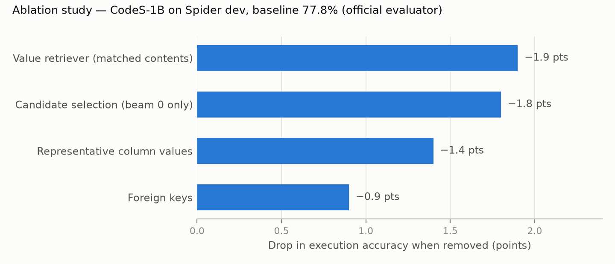
Figure 1 — Drop in Execution Accuracy when each component is removed.
Every component contributes. The value retriever matters most, and the way it matters is telling: without it almost as many queries still execute (97.2%) — the model writes runnable SQL with the wrong literal values, so the answers are silently wrong. Candidate selection works differently: it is the ablation that reduces executability most (94.1%), because it is what replaces a broken first beam with a working alternative. Without the foreign keys the model guesses join conditions, which also shows up as lower executability. These differences are 9 to 20 questions each and were not tested for significance individually.

5. Enhancement: Confidence-Aware Abstention

5.1 Choice and justification
The department rules allow one enhancement, chosen from defined tiers and approved by the guide. The Week-1 abstract had named execution-guided self-correction. The reproduction showed that 97.3% of predictions already execute, so repairing failed queries could recover at most 2.7 points and was unlikely to produce a significant gain; the ablation showed instead that the dominant error is a query that runs but returns the wrong rows. We therefore proposed confidence-aware abstention (Tier 4, a novel combination), keeping self-correction and automatic charts as application features.

5.2 Method
The pipeline already produces four beam candidates per question. All four are executed. The confidence of the returned answer is the share of candidates whose result equals it (execution agreement: 0 to 4 of 4, zero when the returned query does not run), with the beam probability of the returned candidate — the softmax of the four beam scores — used only to break ties. When confidence is below a threshold the system abstains: it shows no table and offers the distinct results of the candidates as interpretations for the user to choose from. No retraining is involved.

5.3 Hypothesis and protocol (fixed before the results were seen)
- H1: at the same coverage, accuracy on answered questions is higher with agreement-based abstention than with random abstention, and higher than the 77.8% baseline. H0: no difference.
- Protocol: 10 random 50/50 splits of the development set; on the calibration half the threshold is set for at least 90% coverage, then applied to the test half. The paired quantity is the accuracy on answered test questions minus the expected accuracy of random abstention at the same coverage (the test half’s full-coverage accuracy). One-sided paired t-test and Wilcoxon signed-rank test, α = 0.05.
- Data: one run (T2-006) recording, for every question, all four candidates with their beam scores, execution results and official correctness (checked to add up to the evaluator’s total). Original and enhanced systems are therefore compared on exactly the same predictions.

5.4 Results
System | Answered | Accuracy on answered | Wrong answers
CodeS-1B, paper (Table 5) | 1,034 (100%) | 77.9% | —
Original — CodeS-1B reproduced | 1,034 (100%) | 77.76% | 230
Enhanced — tested setting | 935 (90.4%) | 83.32% | 156
Enhanced — 3 of 4 agree | 649 (62.8%) | 86.13% | 90
Enhanced — all 4 agree | 412 (39.8%) | 88.35% | 48
Table 5 — Original against enhanced on the same 1,034 questions.
Signal | Mean gain | Paired t-test (df 9) | Wilcoxon | Bootstrap 95% CI
Execution agreement | +5.46 pts (SD 0.71) | t = 24.44, p = 7.7 × 10⁻¹⁰ | W = 55, p = 9.8 × 10⁻⁴ | [+4.51, +6.71]
Beam probability (comparison) | +3.08 pts (SD 0.90) | t = 10.81, p = 9.3 × 10⁻⁷ | W = 55, p = 9.8 × 10⁻⁴ | [+1.97, +3.94]
Table 6 — Significance tests over 10 calibration/test splits (mean coverage 90.5%) and a 5,000-sample bootstrap over questions.
H0 is rejected. All 10 splits showed a positive gain (W = 55 is the maximum, and 9.8 × 10⁻⁴ the smallest p-value the Wilcoxon test can give with 10 pairs). Because the splits reuse the same questions, the questions themselves were also resampled 5,000 times; no resample showed a gain of zero or less. At the tested setting the system declines 99 questions, 74 of which it would have answered wrongly and 25 correctly: wrong answers fall by 32% at the cost of withholding 3.1% of the correct ones.
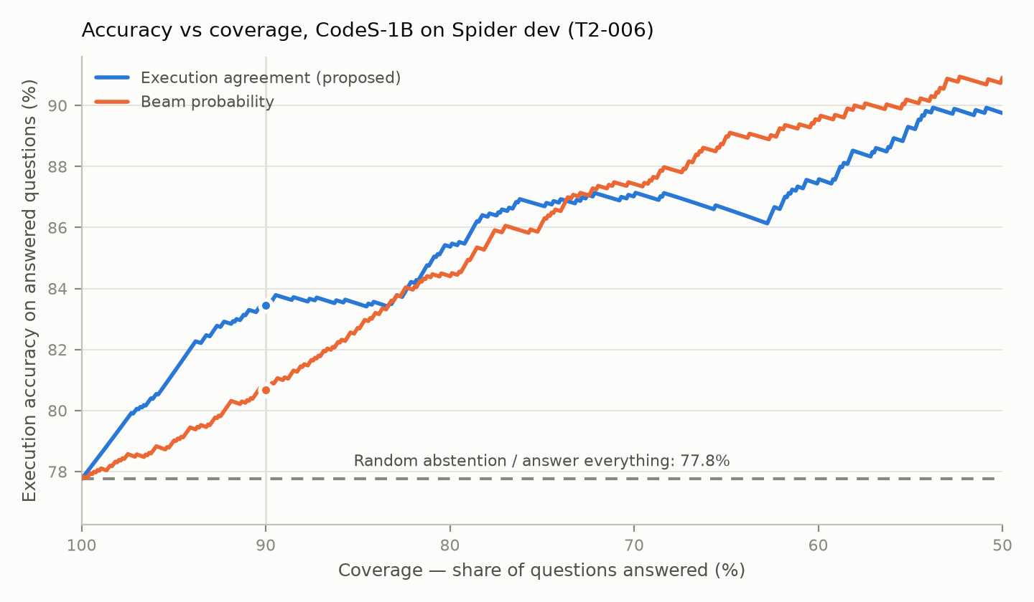
Figure 2 — Accuracy on answered questions against coverage. The dashed line is the original system (and random abstention); dots mark 90% coverage.
Candidates agreeing with the answer | Questions | Accuracy
none (selected query does not run) | 28 | 0.0%
1 of 4 | 132 | 56.8%
2 of 4 | 225 | 75.6%
3 of 4 | 237 | 82.3%
4 of 4 | 412 | 88.3%
Table 7 — Accuracy rises steadily with agreement: the signal is calibrated.

5.5 The application
The enhancement is built into QueryGenie, a desktop application for macOS and Windows that satisfies the department’s requirement for a full-stack deliverable. On first start it checks the computer and downloads the model and the sample databases; it can also open SQLite files and connect read-only to PostgreSQL and MySQL servers. It runs exactly the evaluated pipeline — the prompt, candidate and selection code is shared with the evaluation. Questions are asked in chats; for every question it shows how many of the four candidates agree, the results table with an automatically chosen chart, and the SQL behind the table. When the candidates disagree it lists the alternative interpretations; under the chosen strictness setting it withholds the table and asks the user which reading they meant. The strictness options display their measured coverage and accuracy from Table 5. A schema map shows the database’s tables, columns and keys and offers questions about them. Everything runs locally on open weights, so no schema or data leaves the machine.
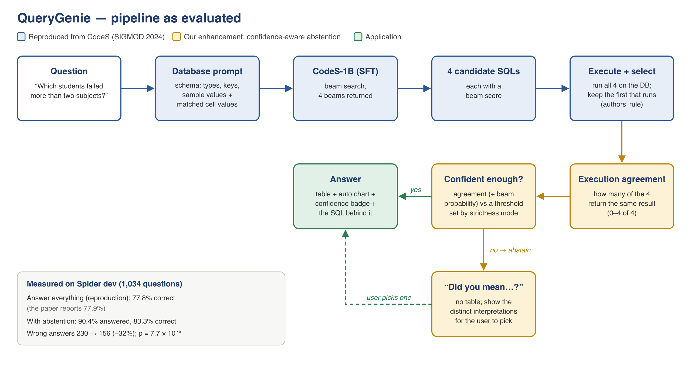
Figure 3 — The pipeline as evaluated: reproduced CodeS components (blue), the enhancement (amber) and the application (green).

6. Discussion of Differences

6.1 Reproduction against the paper
The reproduced accuracy is within 0.1 points of the paper, so the remaining deviations from the authors’ setup appear to have little effect on this benchmark. They are recorded for completeness:
Deviation | Cause | Observed or expected effect
Newer PyTorch and transformers than the pinned versions | The pinned stack does not build on current Python | The authors note newer versions shift inference slightly; no measurable gap remains
Distinct-value scan instead of Lucene BM25 coarse retrieval | Avoids the Java / pyserini dependency | Superset of the authors’ candidates; matched values may differ in number and order
Schema item classifier not applied | Checkpoints on rate-limited Google Drive | Full schema passed; Spider databases are small
Tesla T4 instead of A800 | Available hardware | Same precision (fp16) and batch size (1) as the authors’ inference
EX only; Test-suite accuracy TBD | Test-suite databases not obtained | TS (paper: 72.2%) not yet reported
Repository uses DeepSpeed ZeRO-2; the paper states ZeRO-3 | Found while annotating the paper | Affects pre-training only, which was not reproduced
Table 8 — Remaining deviations from the authors’ setup.
The largest lesson of the reproduction is about measurement rather than modelling. For a month our numbers sat 4 to 13 points below the paper, and the gap was blamed in turn on the prompt, the value retriever and the schema filter. The audit showed that about 4.4 points of it were our own scoring. Reproducing a result means reproducing the evaluation, not only the model.

6.2 Limits of the enhancement
- Beam probability is the better signal when abstaining heavily. Execution agreement is ahead from 100% down to about 74% coverage — the region where a usable assistant operates and where the proposal set its operating point — but below 74% beam probability is ahead, and over the whole curve it has the lower area under the risk–coverage curve (0.091 against 0.103; random 0.222, perfect ranking 0.027).
- Agreement is not proof. 11.7% of the answers on which all four candidates agree are still wrong; abstention reduces errors but does not remove them.
- One model, one benchmark. The threshold was calibrated on Spider with CodeS-1B; its behaviour with other models, and on real enterprise databases, is not measured.
- Statistical independence. The 10 splits reuse the same questions, so their p-values are optimistic; the question-level bootstrap is the check that does not depend on this.

6.3 Observed behaviour in the application
A qualitative check on the bundled academic database (illustrative, not a metric) shows both sides. With CodeS-1B the flagship question “Which students failed more than two subjects?” gets a wrong first answer, but the candidates split two against two, the badge shows low confidence, the correct reading is offered as an alternative, and the strict setting abstains. CodeS-3B answers the same question correctly, and on “average marks per department” it abstains rather than return a query that does not run. A system that says when it is unsure is only as useful as that signal is honest, which is why the application shows its measured operating points rather than a single headline number.

7. Conclusion and Future Work
CodeS-1B was reproduced to within 0.1 points of its published Spider result (77.8% against 77.9%), after an audit that traced most of an apparent gap to the evaluation rather than the model. An ablation study showed that every part of the CodeS database prompt contributes. On top of the reproduced model, confidence-aware abstention raised accuracy on answered questions from 77.8% to 83.3% at 90% coverage and removed about a third of the wrong answers, a significant improvement under every test applied. The system is delivered as a local application that reports how sure it is and asks for clarification when it is not.
Future work. (1) Score the saved predictions for Test-suite accuracy. (2) Evaluate CodeS-3B (paper: 83.4%) and re-calibrate the threshold for it. (3) Combine execution agreement and beam probability into one signal, tuned only on calibration data. (4) Measure the benchmark-to-reality gap on a real institutional schema. (5) Extend the application beyond SQLite: connectors for PostgreSQL and MySQL with automatic dialect translation, and NoSQL stores through a SQL gateway, with read-only access and query limits for use inside an organisation.

References
All papers are available on arXiv, as required by the department.
[1] Li, H. et al. CodeS: Towards Building Open-source Language Models for Text-to-SQL. SIGMOD 2024. arXiv:2402.16347.
[2] Li, H. et al. RESDSQL: Decoupling Schema Linking and Skeleton Parsing for Text-to-SQL. AAAI 2023. arXiv:2302.05965.
[3] Li, R. et al. StarCoder: may the source be with you! 2023. arXiv:2305.06161.
[4] Yu, T. et al. Spider: A Large-Scale Human-Labeled Dataset for Complex and Cross-Domain Semantic Parsing and Text-to-SQL Task. EMNLP 2018. arXiv:1809.08887.
[5] Zhong, R., Yu, T. and Klein, D. Semantic Evaluation for Text-to-SQL with Distilled Test Suites. EMNLP 2020. arXiv:2010.02840.
[6] Pourreza, M. and Rafiei, D. DIN-SQL: Decomposed In-Context Learning of Text-to-SQL with Self-Correction. NeurIPS 2023. arXiv:2304.11015.
[7] Wang, X. et al. Self-Consistency Improves Chain of Thought Reasoning in Language Models. ICLR 2023. arXiv:2203.11171.
[8] Geifman, Y. and El-Yaniv, R. Selective Classification for Deep Neural Networks. NeurIPS 2017. arXiv:1705.08500.
[9] Dibia, V. LIDA: A Tool for Automatic Generation of Grammar-Agnostic Visualizations and Infographics using Large Language Models. ACL 2023. arXiv:2303.02927.

Appendix A. Full run log
Run | Date | Hardware | Metric | Result | Runtime
T1-001 | 14 Aug | Colab T4 | liveness (Week-4 gate) | passed | 61.9 s (generation)
T2-001 | 26 Aug | Apple M4 (MPS) | simple EX | 64.8% | 6,538 s
T2-002 | 26 Aug | Colab T4 | simple EX | 71.7% (741/1034) | 2,211 s
T2-003 | 13 Sep | Colab T4 | simple EX | 73.8% (763/1034) | 2,111 s
T2-003r | 20 Sep | Colab T4 | simple EX | 73.8% (763/1034) | 2,270 s
AB-003–006 | 20–22 Sep | Colab T4 | simple EX (harness v1) | 72.2 / 71.1 / 72.2 / 71.7% | 1,652–2,265 s
T2-005 | 26 Sep | Colab T4 | official EX | 77.8% (simple 73.4%) | 2,865 s
AB-103–106 | 28 Sep | Colab T4 | official EX | 76.4 / 75.9 / 76.9 / 76.0% | not recorded
T2-006 | 28 Sep | Colab T4 | official EX | 77.76% (804/1034) | not recorded
Table A1 — Every logged run. Full details (seed 42, library versions, notes): results/reproduction_log.csv.

Appendix B. How to reproduce
- Reproduction and enhancement data (GPU): open research/notebooks/02_tier2_colab_eval.ipynb in Google Colab with a T4 runtime and run the Week-10 cell. It downloads Spider and the model, evaluates all 1,034 questions with the official evaluator, and saves the predictions and the four-candidate record (about one hour).
- Enhancement analysis (CPU): python research/abstention.py results/dump_T2-006.jsonl — produces the tests, the operating points and Figure 2.
- Application: pip install -r requirements.txt, then python desktop/main.py (the desktop app; the earlier web prototype is python legacy/app.py).
- Source: the project repository on GitHub (supervisor added as collaborator). Audit: results/harness_audit.md; ablation: results/week7_ablation_study.md; comparison: results/week12_comparative_results.md.

