
DEPARTMENT OF COMPUTER SCIENCE & INFORMATION TECHNOLOGY
COMPARATIVE RESULTS — WEEK 12 (Month 3)
COURSE: ENGINEERING CAPSTONE PROJECT – 1(23IE4053R) A.Y. 2026 - 2027
TITLE OF THE PROJECT | QueryGenie: A Self-Correcting Natural Language to SQL Interface
S. No. | University ID | Name
1 | 2320090050 | N V V S S Jayakanth Kamisetti
2 | 2320090009 | Boddupally Narendar
Name of the Guide |  | M Parameswar

Original vs Enhanced: Confidence-Aware Abstention on CodeS-1B
Setup. Original: SFT CodeS-1B as reproduced (run T2-006, official Spider evaluator). Enhanced: the same model and predictions plus confidence-aware abstention — the system executes its four beam candidates and declines to answer when their results disagree (Enhancement Proposal, Week 9). Both are evaluated on the same 1,034 Spider development questions from one run, so the comparison is exactly paired.
Table 1 — Side-by-side results
System | Questions answered | Accuracy on answered | Wrong answers given
CodeS-1B as reported in the paper (Table 5) | 1,034 (100%) | 77.9% | —
Original — CodeS-1B reproduced | 1,034 (100%) | 77.76% (804) | 230
Enhanced — balanced (the tested rule) | 935 (90.4%) | 83.32% (779) | 156
Enhanced — strict (≥ 3 of 4 agree) | 649 (62.8%) | 86.13% (559) | 90
Enhanced — very strict (all 4 agree) | 412 (39.8%) | 88.35% (364) | 48
Comparison signal — beam probability, ~90% coverage | 931 (90.0%) | 80.67% | —

Trade-off at the tested setting. The enhanced system declines 99 questions. 74 of them would have been answered wrongly and 25 correctly. Wrong answers fall from 230 to 156 (−32%), at the cost of withholding 25 correct answers (3.1% of the 804 the original gets right).
Table 2 — Significance tests (pre-registered protocol)
10 random 50/50 splits; the threshold is chosen on the calibration half for ≥ 90% coverage and applied to the test half. The paired quantity is accuracy on answered questions minus the expected accuracy of random abstention at the same coverage (= the original system's accuracy on that half).
Signal | Mean gain | SD | Paired t-test (df = 9) | Wilcoxon signed-rank | Question-level bootstrap, 95% CI
Execution agreement | +5.46 pts | 0.71 | t = 24.44, p = 7.7 × 10⁻¹⁰ | W = 55, p = 9.8 × 10⁻⁴ | [+4.51, +6.71]
Beam probability | +3.08 pts | 0.90 | t = 10.81, p = 9.3 × 10⁻⁷ | W = 55, p = 9.8 × 10⁻⁴ | [+1.97, +3.94]

All tests one-sided (H1: gain > 0), α = 0.05. W = 55 is the maximum (all 10 splits positive), and 9.8 × 10⁻⁴ is the smallest p the Wilcoxon test can give with 10 pairs. The bootstrap resamples the questions (5,000 times), which does not rely on the splits being independent.
Agreement vs beam probability, head to head (same splits): agreement is higher by 2.37 points (paired t = 6.31, df = 9, two-sided p = 1.4 × 10⁻⁴). Their coverages differ slightly (90.5% vs 89.7%) because each threshold is chosen separately.
Table 3 — The 10 trials (execution agreement)
Split (seed) | Threshold | Coverage | Accuracy on answered | Original accuracy | Gain | Share of declined that were wrong
0 | 0.2526 | 88.8% | 83.88% | 77.56% | +6.32 | 72.4%
1 | 0.2526 | 90.5% | 82.48% | 77.18% | +5.30 | 73.5%
2 | 0.2526 | 89.9% | 83.44% | 78.14% | +5.30 | 69.2%
3 | 0.2526 | 89.2% | 84.60% | 78.53% | +6.07 | 71.4%
4 | 0.2526 | 91.3% | 83.90% | 78.14% | +5.76 | 82.2%
5 | 0.2526 | 92.1% | 82.77% | 77.95% | +4.82 | 78.1%
6 | 0.2526 | 89.6% | 83.15% | 77.18% | +5.98 | 74.1%
7 | 0.2526 | 89.0% | 83.26% | 77.18% | +6.08 | 71.9%
8 | 0.2526 | 90.9% | 82.34% | 77.56% | +4.78 | 70.2%
9 | 0.2526 | 93.8% | 82.68% | 78.53% | +4.15 | 84.4%
Mean |  | 90.5% | 83.25% | 77.79% | +5.46

Table 4 — Whole-curve summary (area under the risk–coverage curve; lower is better)
Ranking | AURC
Random (no signal) | 0.2224
Execution agreement | 0.1025
Beam probability | 0.0905
Oracle (perfect ranking, lower bound) | 0.0269

Beam probability ranks answers better over the whole curve: it is ahead below about 74% coverage. Execution agreement is ahead from 100% down to about 74% — the region where a usable assistant operates and where the proposal set its operating point. Figure: results/figures/accuracy_coverage_T2-006.png.
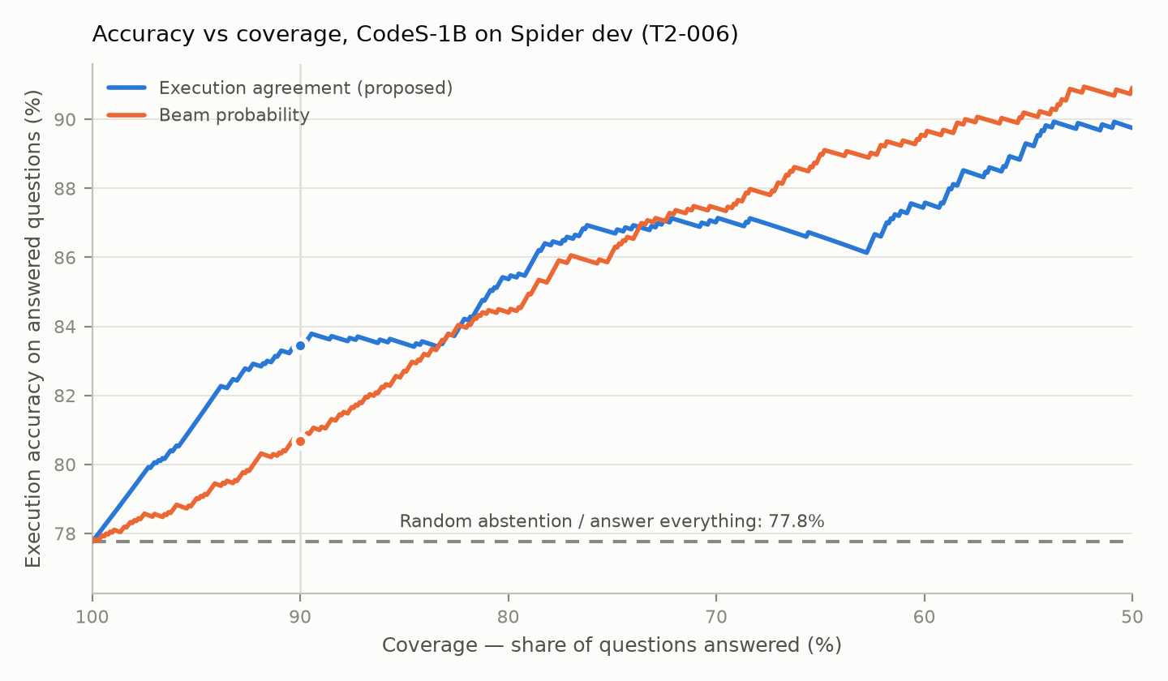
Figure 1 — Accuracy on answered questions against coverage, Spider dev (T2-006). The dots mark 90% coverage; the dashed line is the original system (and the expected accuracy of random abstention).
Conclusion
H0 is rejected. At about 90% coverage, confidence-aware abstention raises accuracy on answered questions from 77.8% to 83.3% and removes about a third of the wrong answers. This is significant under a paired t-test, a Wilcoxon signed-rank test and a question-level bootstrap. The result is always stated together with its coverage: the enhanced system answers fewer questions, and it does not change the 77.8% reproduction figure.
Limitations
• One model (CodeS-1B) and one benchmark (Spider dev); the threshold is calibrated on that data.
• The 10 splits reuse the same questions; the bootstrap is the check that does not depend on this.
• Candidates can agree on a wrong answer: 11.7% of the answers where all 4 candidates agree are wrong.
• Agreement takes only five values; the beam-probability tie-breaker is what allows intermediate coverages.

Signature of the Guide HOD

