IBMS
(Inventory and Billing Management System)
The Inventory and Billing Management System is a web-based application designed to help small and medium-sized businesses manage their inventory, billing, and reporting processes efficiently. The system automates tasks such as tracking product stock, creating invoices, updating inventory, and generating analytical reports.

PROJECT OVERVIEW
This project is a full-stack web application named IBMS, organized into two major parts:
- Backend: Django (Python)
- Frontend: Next.js (React)
It provides structured management for inventory items, billing processes, and customer information. It also includes provisions for reporting and application settings.

BACKEND TECHNOLOGIES
1. Django
- What: A high-level Python web framework.
- Why Used: Serves as the backend framework for handling models, business logic, views, and RESTful APIs.
- Importance: Provides robust ORM, admin interface, and user management.
- Suitability: Well-suited for rapid development and complex backend workflows.
Structure:
- ibms_backend/ibms_backend/: Core project settings (ASGI/WSGI, URLs, settings).
- ibms_backend/inventory/: Django app managing inventory, billing, and customers.
  - models.py: Database models
  - views.py: Logic for endpoints
  - urls.py: App-level routing
  - migrations/: Tracks database schema changes
Other Backend Components:
- manage.py: CLI for backend tasks
- venv/: Virtual environment for Python dependencies

FRONTEND TECHNOLOGIES
1. Next.js
- What: A React-based frontend framework with SSR and SSG support.
- Why Used: Enables fast, SEO-friendly, modular front-end development.
- Importance: Supports modern design structure with flexibility in routing and page rendering.
- Suitability: Excellent for scalable frontend development with React.
Structure:
- app/: Contains route-based folders like billing/, customers/, inventory/ with respective page.js files
- reports/, settings/: Future features placeholders
- layout.js: Root layout of the application
- page.js: Landing page
- globals.css: Global styling
- public/: Static assets (icons, images)
- Config Files: next.config.mjs, jsconfig.json, package.json

KEY FEATURES (INFERRED)
- Inventory Management: End-to-end flow for adding, updating, and tracking inventory items.
- Billing System: Handle invoice creation, billing records, and itemized billing details.
- Customer Management: Store and manage customer information.
- Reports & Settings: Placeholders for administrative tools and configurations.
- Modular Development: Clear separation between frontend and backend logic.

DEVELOPMENT & USAGE
- Backend: Uses Django ORM and views. Likely uses PostgreSQL, MySQL, or SQLite.
- Frontend: Built using Next.js App Router; communicates via REST API.
- Virtual Environment: Ensures isolated Python dependencies.
- Node.js + NPM: For managing frontend libraries and scripts.

SUMMARY DIAGRAM
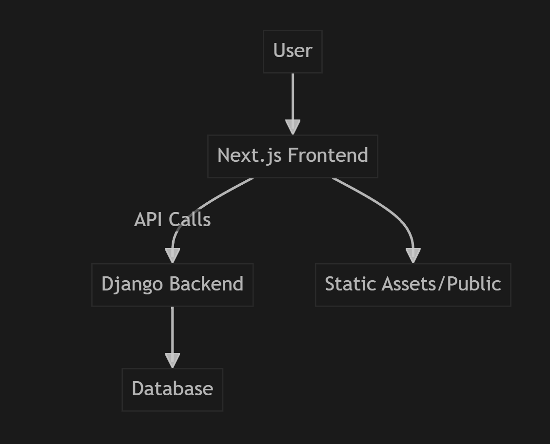
This project demonstrates solid full-stack design principles with clear modularity and maintainability using Django and Next.js.

