1.11 Given an m x n grid and a ball at a starting cell, find the number of ways to move the ball out of the grid boundary in exactly N steps.

AIM:
To find the number of ways to move the ball out of the grid boundary in exactly N steps from m*n grid.

ALGORITHM:
1. Define a recursive function dfs(m, n, N, i, j):
2. If (i, j) is outside the grid → return 1 (valid way).
3. If N == 0 → return 0 (no moves left, but not outside).
4. Otherwise, recursively try 4 directions: up, down, left, right.
5. Use memoization (cache results) to avoid recomputation.
6. Final answer = dfs(m, n, N, i, j).

PROGRAM:
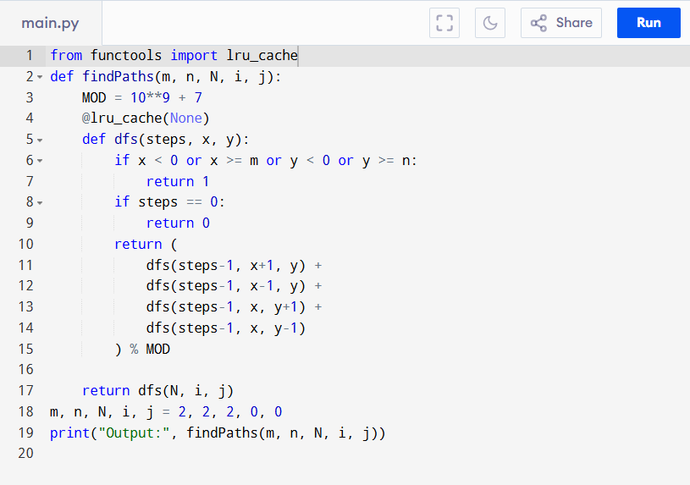

Input:
m = 2, n = 2, N = 2, i = 0, j = 0
Output:
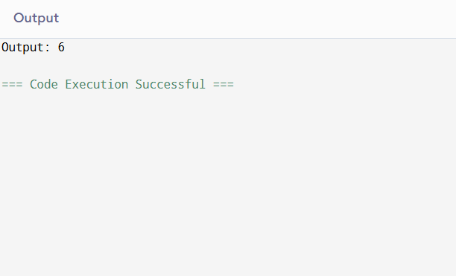
RESULT:
Thus, the program to find the number of ways to move the ball out of the grid boundary is successfully executed and the output is verified.

PERFORMANCE ANALYSIS:
- States = N × m × n
- Transitions = 4 per state
- Time Complexity = O(N × m × n)
- Space Complexity = O(N × m × n) (due to memoization table)

