1.13 You are climbing a staircase. It takes n steps to reach the top. Each time you can either climb 1 or 2 steps. In how many distinct ways can you climb to the top?

AIM:
To find the number of distinct ways to climb to the top of a staircase with n steps, where each move can be 1 step or 2 steps.
ALGORITHM:
1. Define a recursive function count(n) that returns the number of ways to reach step n.
2. If n <= 2, return n (base cases).
3. If result for n is already in memo, return it.
4. Otherwise, compute count(n-1) + count(n-2) and store it in memo.
5. Return count(n).

PROGRAM:
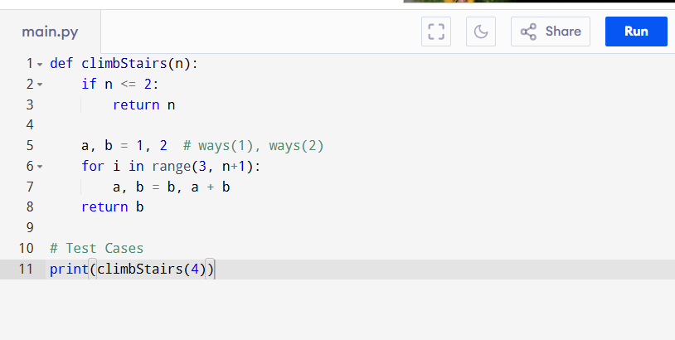

Input:
n = 4

Output:
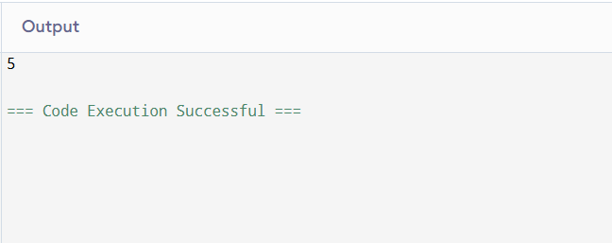
RESULT:
Thus the program to find the number of distinct ways to climb to the top of a staircase is successfully executed, and the output is verified.

PERFORMANCE ANALYSIS:
• Time Complexity: O(n)
• Space Complexity: O(1)

