1.14 A robot is located at the top-left corner of a m×n grid .The robot can only move either down or right at any point in time. The robot is trying to reach the bottom-right corner of the grid. How many possible unique paths are there?

AIM:
To calculate the number of unique paths for a robot moving from the top-left corner to the bottom-right corner of an m × n grid, moving only down or right.
ALGORITHM:
1. Create a dp[m][n] table.
2. Initialize first row & column with 1.
3. Fill the table using relation dp[i][j] = dp[i-1][j] + dp[i][j-1].
4. Answer = dp[m-1][n-1].

PROGRAM:
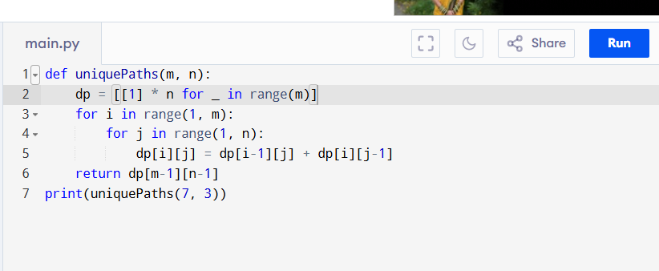

Input:
m = 7, n = 3

Output:
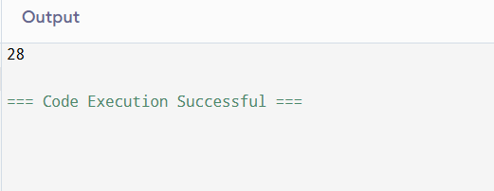

RESULT:
Thus, the program to calculate the number of unique paths for a robot is successfully executed, and the output is verified.

PERFORMANCE ANALYSIS:
• Time Complexity: O(m * n)
• Space Complexity: O(m * n) (can be reduced to O(n) with 1D DP).

