1.15 In a string S of lowercase letters, these letters form consecutive groups of the same character. For example, a string like s = "abbxxxxzyy" has the groups "a", "bb", "xxxx", "z", and "yy". A group is identified by an interval [start, end], where start and end denote the start and end indices (inclusive) of the group. In the above example, "xxxx" has the interval [3,6]. A group is considered large if it has 3 or more characters. Return the intervals of every large group sorted in increasing order by start index.

AIM:
To identify large groups (3 or more consecutive identical characters) in a string s and return their intervals [start, end].

ALGORITHM:
1.Initialize result = [].
2. Use two pointers:
• i = start index of a group.
• Traverse the string with j.
3. While traversing:
• If s[j] != s[i], it means the group ended at j-1.
• Check if group length (j-1 - i + 1) >= 3.
• If yes → append [i, j-1] to result.
• Update i = j (start new group).
4. After loop ends, check the last group as well.
5. Return result.

PROGRAM:
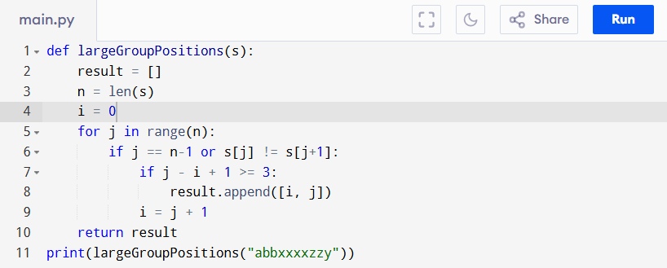
Input:
s = "abbxxxxzzy"
Output:
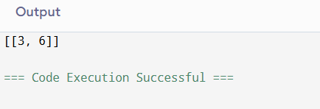
RESULT:
Thus the program to identify large groups in a string is successfully executed, and the output is verified.

PERFORMANCE ANALYSIS:
• Time Complexity: O(n) (one pass through string).
• Space Complexity: O(1) (excluding result storage).

