1.2 You are given two integer arrays nums1 and nums2 of sizes n and m, respectively. Calculate the following values: answer1 : the number of indices i such that nums1[i] exists in nums2. answer2 : the number of indices i such that nums2[i] exists in nums1 Return [answer1,answer2].

AIM:
To find how many elements of one array exist in the other array and return the counts as [answer1, answer2].

ALGORITHM:
1. Store the elements of nums1 in a set set1 for fast lookup.
2. Store the elements of nums2 in a set set2.
3. Initialize answer1 = 0, answer2 = 0.
4. Traverse each element in nums1:
• If the element exists in set2, increment answer1.
5. Traverse each element in nums2:
• If the element exists in set1, increment answer2.
6. Return [answer1, answer2].
PROGRAM:
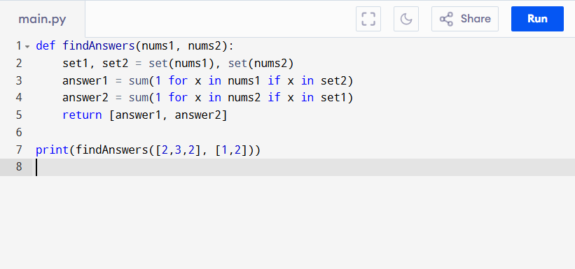

Input:
nums1 = [2,3,2]
nums2 = [1,2]

Output:
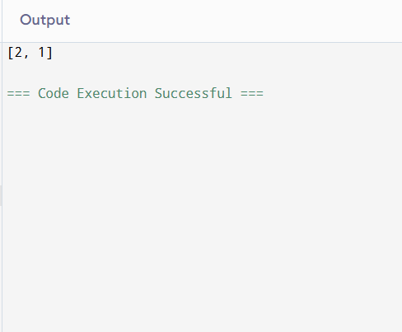

RESULT:
Thus,to find the number of elements in one array exist in the other array program is successfully executed, and the output is verified.

PERFORMANCE ANALYSIS:
• Time Complexity:
• Creating sets → O(n + m)
• Checking membership → O(n + m)
• Total: O(n + m)
- Space Complexity:
• Two sets storing up to n + m elements → O(n + m)

