1.3 You are given a 0-indexed integer array nums. The distinct count of a subarray of nums is defined as: Let nums[i..j] be a subarray of nums consisting of all the indices from i to j such that 0 <= i <= j < nums.length. Then the number of distinct values in nums[i..j] is called the distinct count of nums[i..j]. Return the sum of the squares of distinct counts of all subarrays of nums. A subarray is a contiguous non-empty sequence of elements within an array.

AIM:
To compute the sum of the squares of distinct counts of all possible subarrays of a given integer array.

ALGORITHM:
1. Initialize total sum = 0.
2. Generate all possible subarrays:
• Outer loop for starting index i.
• Inner loop for ending index j.
3. For each subarray nums[i..j]:
• Use a set to find the distinct elements.
• Let count = size of set.
• Add count * count (square of distinct count) to total sum.
- Return total sum after processing all subarrays.

PROGRAM:
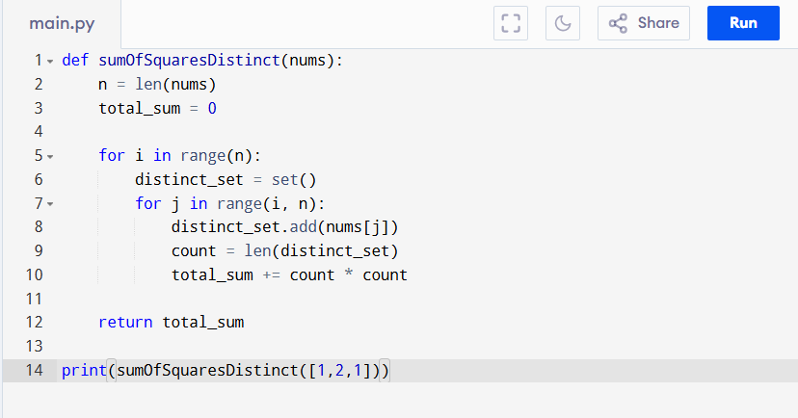

Input:
nums = [1,2,1]

Output:
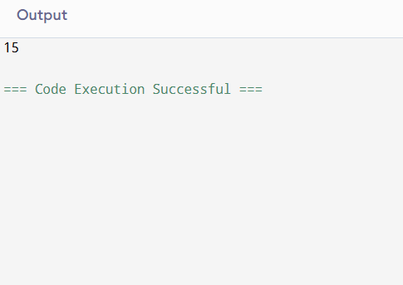

RESULT:
Thus, the sum of the squares of distinct counts program is successfully executed, and the output is verified.

PERFORMANCE ANALYSIS:
Time Complexity:
• Generating all subarrays = O(n^2)
• Counting distinct using set (up to O(n) each)
• Worst case = O(n^3)
• For small n this is fine.
Space Complexity:
• Temporary set of size up to O(n)
• So overall = O(n)

